Table of Contents

I. Introduction 1

Wildland-Urban Interface within Baker County, Oregon 1

Preparing a Community Wildfire Protection Plan 3

Overview of this Plan and its Development, and Compliance 4

II. Baker County Profile and Fire History 5

Profile 5

Fire History on Private Land 5

Fire History on Federal Land 6

III. Mission, Goals, and Objectives 8

Mission Statement 8

Goals and Objectives 8

IV. Community Participation and Education 9

Outreach 9

Fire Prevention and Education 9

V. Wildfire Hazard Assessment 13

Fire Occurrence/Risk of Ignition 13

Fuels / Vegetation 14

Topographic Hazard 14

Total Wildfire Hazard 14

Weather Hazard 14

Overall Fire Protection Capability Hazards (Structural Vulnerability) 15

Values at-Risk 15

Using the Hazard Assessment to Score WUI Areas 16

VI. Fuels Treatment, Maintenance, Biomass 19

Fuels Treatment and Forest Health1  19

Fuels Maintenance Program 19

Biomass Utilization 20

VII. Emergency Management 21

Infrastructure Protection Capabilities 21

Mitigation Action Plan for Emergency Services 21

VIII. Monitoring and Evaluation of the Plan 22

Schedule 22

Monitoring 22

Evaluation 23

***Appendices***

Appendix A: WUI Mitigation Action Plans, Accomplishments and Maps

Appendix B: ODF Fire Statistics

Appendix C: Natural Hazards

Appendix D: Fire Regime / Condition Class

Appendix E: Scoring Criteria

Appendix F: Communities at Risk - Scoring

Appendix G: Agency Fire Resources Summary – Baker County

Appendix H: List of Participants

Appendix I: Web Sites for Additional Information

Appendix J: Structures and Acres by WUI

# I. Introduction

## Wildland-Urban Interface within Baker County, Oregon

Wildland fires are a common and widespread natural hazard in Oregon; the state has a long and extensive history of wildfire. Significant portions of Oregon's wildlands and areas adjacent to rural communities are dominated by ecosystems dependent upon fire for their health and survival. [1]

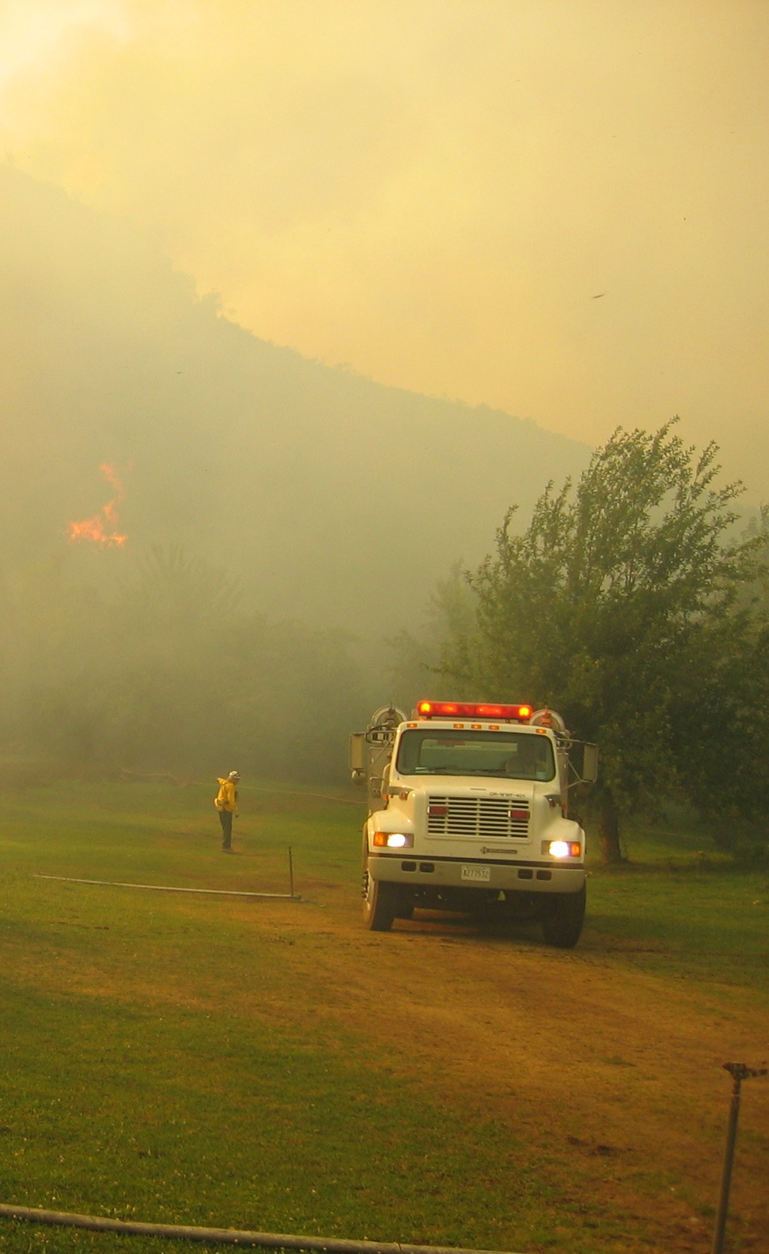 Oregon has more than 41 million acres (more than 64,000 square miles) of forest and rangeland that are susceptible to wildfire. In addition, significant agricultural areas of the Willamette Valley, north central, and northeastern Oregon grow crops, such as wheat, and raise livestock on rangelands that are prone to wildfire damage. Communities are also at risk. According to a listing in the 2001 *Federal Register*, 367 Oregon communities are at risk of damage from wildfire. In Baker County, 503,277 acres of wildland urban interface (WUI) has been identified across the county. Within those areas, 42 communities would be directly threatened or affected by a large wildfire event.

The majority of wildfires in Oregon occur between June and October. However, wildfires can occur at other times of the year, when weather and fuel conditions combine to allow ignition and spread. In 2003, fire statistics statewide showed seventy percent of Oregon's wildland fires resulted from human activity. The remaining thirty percent resulted from lightning, occurring most frequently in eastern and southern Oregon. In Baker County, averages for fire cause on private land vary slightly from that of state averages: lightning accounts for 55% of the fire starts and the remaining 45% of the fire starts can be attributed to human influence on the landscape.[2]

Foster Gulch Fire – Near Oxbow, Or –Aug 2006

The financial, social, and economic costs of wildfires demonstrate the need to reduce their impact on lives and property, as well as the short and long-term economic and environmental consequences of large-scale fires. Cost savings can be realized through preparedness and risk reduction including a coordinated effort of planning for fire protection and implementing preparedness activities among local, state, and federal agencies, the private sector, and community organizations. Individual property owners have a major role to play in this coordinated effort, especially in WUI areas.

The *Wildland-Urban Interface* (WUI) is the area or zone where structures and other human development meet or intermingle with wildland or vegetative fuels. As more people have moved into wildland urban interface areas, whether for lifestyle or economic reasons, the number of large wildfires affecting homes has escalated dramatically.

Many in the population migrating to rural Oregon from urban areas took with them an expectation of structural fire protection similar to high-density areas they were leaving. Rural fire departments combined with local mutual aid agreements, and finally the Oregon State Fire Marshall *Emergency Conflagration Act [3],* attempt to fulfill these expectations, but many homes are still located within areas with little or no structural or wildland fire protection (unprotected lands). Fires that occur within unprotected lands become the responsibility of the Baker County Commissioners; coordination is handled through the Emergency Management office and the Oregon State Fire Marshal’s County Fire Chief to determine the appropriate response.

To improve fire response in unprotected areas in southern Baker County, two Rangeland Fire Protection Associations (RFPA) have been formed; the Ironside RFPA and the Burnt River RFPA. As a long-term strategy, the Baker County CWPP (Community Wildfire Protection Plan) committee encourages efforts that would provide some level of wildland fire protection coverage for all unprotected lands. Specific strategies are listed in the Mitigation Action Plan - Section VI.

Recent fire seasons bring the WUI problem to the forefront and the problem of overabundant dense forest fuels is a focus of public discussion. The forest fuels issue is a major, continuing problem that has received presidential level attention. Work is underway to reduce fuels in WUI areas by way of community involvement and funding from *National Fire Plan (NFP)3*. NFP goals are listed below and the essence of NFP is captured in this document:

* Ensure sufficient firefighting resources for the future;
* Rehabilitate and restore fire-damaged and fire-adaptive ecosystems;
* Reduce fuels (combustible forest materials) in forests and rangelands at risk, especially near communities; and
* Work with local residents to reduce fire risk and improve fire protection.

Community Assistance grants and other grant opportunities are available through NFP to aid in achieving these goals. The goals aim high and represent a huge amount of work, with their ultimate success depending on concerned individuals, agencies, and organizations joining forces. No agency or group working alone can achieve all of the goals laid out by NFP goals.

## Preparing a Community Wildfire Protection Plan

Both the NFP and the "*Ten-Year Comprehensive Strategy for Reducing Wildland Fire Risks to Communities and the Environment"* [4]place a priority on working collaboratively within communities in the WUI to reduce their risk from large-scale wildfire. The incentive for communities to engage in comprehensive forest planning and prioritization was given new momentum with the enactment of the *Healthy Forests Restoration Act* (HFRA)[5] in 2003.

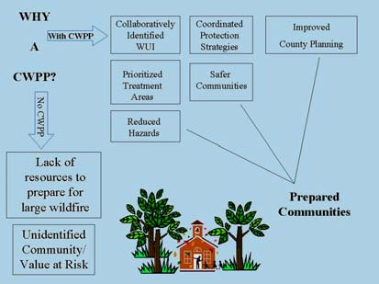The Healthy Forests Restoration Act provides maximum flexibility for communities to determine the substance and detail of their Community Wildfire Protection Plan (CWPP), and the procedures to develop them. HFRA emphasizes the need for federal agencies to work collaboratively with communities in developing hazardous fuel reduction projects, and it places priority on treatment areas identified by the communities within their CWPP. HFRA, along with the direction provided by National Fire Plan and the Ten-Year Strategy, states that collaboration and prioritization of projects by a community is essential; emphasizing the importance of preparing a CWPP. Other constraints on local government, such as FEMA direction to prepare county hazard mitigation plans and implementation of the "Oregon Forestland-Urban Interface Act of 1997 (a.k.a., SB 360)[6], emphasizes the importance of local government participation in the development and implementation of a community wildfire protection plan.

Local plans can be simple or as complex as the community desires. However, there are a few *minimum requirements* for a CWPP as described in the HFRA.

1) **Collaboration:** A CWPP must be collaboratively developed by local and state government representatives, in consultation with federal agencies and other interested parties.

2) **Prioritized Fuel Reduction:** A CWPP must identify and prioritize areas for hazardous fuel reduction treatments and recommend the types and methods of treatment that will protect one or more at-risk communities and essential infrastructure.

3) **Treatment of Structural Ignitability:** A CWPP must recommend measures that homeowners and communities can take to reduce the ignitability of structures throughout the area addressed by the plan.

HFRA requires that three entities must mutually agree to the final contents of the CWPP:

* The applicable local government (i.e., counties or cities)
* The local fire department(s)
* The state entity responsible for forest management

## Overview of this Plan and its Development, and Compliance

The Baker County Community Wildfire Protection Plan is the result of analyses, professional cooperation and collaboration, assessments of wildfire risks and other factors considered with the intent to reduce the potential for wildfires that threaten people, structures, infrastructure, and values in Baker County.

This community wildfire protection plan has been prepared in compliance with the National Fire Plan, the 10-year Comprehensive Strategy, the Tri-County Hazard Mitigation Plan (Baker, Union, and Wallowa Counties), Oregon Senate Bill 360 (The Oregon Forestland-Urban Interface Act of 1997), and Healthy Forest Restoration Act (HFRA).

This plan is endorsed by the Baker County Commissioners, Oregon Department of Forestry, and the Baker County structural fire community. These representatives mutually agree to the final contents of the plan. This plan will not be legally binding in any way; its role is to be viewed as a working document that serves as a planning tool for the fire and land managers of Baker County (see the Promulgation Statement on p. i and the Signature Page on p. ii of this plan).

The plan was first completed in 2003, and has been reviewed and updated in 2012. Participants in development and review of the Baker County CWPP can be found in Appendix H.

# II. Baker County Profile and Fire History

## Profile[7]

Baker County was established from part of Wasco County and named after Col. Edward D. Baker, an U.S. Senator from Oregon. A Union officer and close friend of President Lincoln, Colonel Baker was the only member of Congress to die in the Civil War. Baker City, which was incorporated in 1874 and which is the seventeenth oldest city in Oregon, became county seat in 1868.

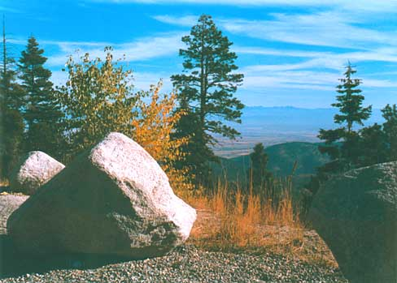Before 1861, the majority of immigrants only paused in Baker County on their way west, unaware of its vast agricultural and mineral resources. Then the great gold rush began and Baker County became one of the Northwest's largest gold producers. Farming, ranching, logging, and recreation have become the chief economic basis for an area that displays spectacular scenery, including the world's deepest gorge, Hells Canyon; an outstanding museum with the famous Cavin- Walfel rock collection; and, numerous historic buildings with interesting architectural features. The Eagle Cap Wilderness Area, Hells Canyon Recreation Area, Anthony Lakes Ski Resort, along with fishing and hunting, also draw visitors to the area.

The scenic and recreational values that attract visitors to Baker County are the same values that residents of Baker County hope to protect from the risk of wildfire. In addition, Baker County residents are concerned that economic values, such as timber, grazing, agriculture, and mining, also are at risk. The implementation of this plan will help prevent a wildfire from becoming a large- scale event, taking with it the values of Baker County.

## Fire History on Private Land

The table shown in Appendix A, located at the end of this document, displays fire history on private lands protected by Oregon Department of Forestry (ODF). Private landowners are assessed a fire patrol fee for protection of private lands within parts of Baker County. ODF will respond to and report fires that are on lands they protect, however ODF may respond and report fires that are started on unprotected lands threatening protected lands or that are started within dual-protected lands (land that ODF provides mutual aid with structural fire departments). Rural and volunteer fire department data was not available in a form that could readily be used for statistical or spatial analysis. An attempt will be made to capture rural and volunteer fire department data at a later date.

To summarize the table in Appendix A, fire starts are categorized by human or lightning. Because Baker County experiences lightning storms passing through the county during the summer and fall months, prevention of those fires is difficult. In the last five years, human activity was attributed to over half of all fire starts. The majority of the human-caused fires are a result of recreation activities, debris burning, and equipment use: all of which are preventable.

## Fire History on Federal Land

Large fires are prominent in Baker County. Large fires of major significance on federal land during the last forty-two years are listed on the next page. The summary shows fire name, year, and size. Large fires are generally categorized as larger than 300 acres. Costs associated with extinguishing large fires from 1983 to 2003 were estimated to be more than $1.3 million. A layout showing the location of large fires across the county follows the summary.

USFS Wildfires 300 acres or more in Baker County 1960-2011

|  |  |  |  |
| --- | --- | --- | --- |
| **Fire Name** | **Year** | **Acres** |  |
| Anthony Creek | 1960 | 15,015 |  |
| Gilkison | 1963 | 507 |  |
| West Camp Creek | 1965 | 749 |  |
| Rough Ridge | 1969 | 8,627 |  |
| Eagle Creek | 1978 | 1,452 |  |
| Stevens Creek | 1979 | 883 |  |
| Dark Canyon | 1986 | 2,600 |  |
| Eagle | 1986 | 305 |  |
| Cornet | 1986 | 5,000 |  |
| Huckleberry | 1986 | 8,000 |  |
| Sunflower | 1986 | 8,170 |  |
| Lost Cow | 1986 | 645 |  |
| Pine | 1989 | 1,000 |  |
| Dooley Mtn | 1989 | 19,640 |  |
| Glacier | 1989 | 9,319 |  |
| Monument Rock | 1989 | 9,822 |  |
| Bear | 1990 | 407 |  |
| Sheep Mountain | 1990 | 10,976 |  |
| Balm Creek | 1991 | 907 |  |
| Twin Lakes | 1994 | 22,330 |  |
| Little Bald Mtn | 1994 | 558 |  |
| Little Malheur | 1994 | 10,110 |  |
| Elkhorn Ridge | 1996 | 370 |  |
| Monument | 2002 | 24,667 |  |
| Fosters gulch complex | 2006 | 53,635 |  |
| Twin Lakes | 2006 | 453 |  |
| Elkhorn Complex | 2006 | 956 |  |

|  |
| --- |
|  |

# III. Mission, Goals, and Objectives

## Mission Statement

Baker County is committed to reducing the risk of large fires in wildland-urban interface areas with collaborative planning, restoration of fire-adapted ecosystems, and prevention education that involves citizens, landowners, structural fire agencies, and local, state, and federal agencies of Baker County. This working document will serve as a resource for providing information that will enhance community safety through hazard and risk reduction in the wildland-urban interface.

## Goals and Objectives

Identify areas at risk and hazards:

* + Identify factors that determine wildfire risk.
  + Evaluate areas to determine relative risk.

Reduce wildfire risk to identified areas:

* + Utilize widespread and consistent partnerships with citizens, stakeholders, and agencies.
  + Improve emergency response through training and acquisition of equipment.
  + Identify and treat hazardous fuels.
  + Promote fire prevention and education.
  + Encourage stakeholder participation in development of strategies that will reduce wildfire risk.

Restore fire-adapted ecosystems:

* + Provide for rapid assessment and treatment of burned lands, including implementation of stabilization techniques.
  + Communities will encourage land management agencies to promote the control of invasive species and consider establishment of native seed and plant material.

Establish a Monitoring and Evaluation process:

* + Evaluate the community fire plan progress and effectiveness and recommend changes as needed.
  + Conduct monitoring of selected collaboratively developed projects and activities to assess progress and effectiveness.

# IV. Community Participation and Education

## Outreach

Education and community outreach are two areas of primary focus when putting together a community plan. The community can be the best source of information and every attempt is made to gain the involvement of the community. It is important that the community view the plan as valuable to public safety and as a resource to mitigating hazards from the risk of wildfire.

During the development and revision of the Baker County CWPP, a variety of meetings were held across Baker County. This allowed the committee an opportunity to receive input and discuss with citizens and fire agency personnel the timeline for completion of the plan, risk assessment involved in determining high hazard areas around the county, values that citizens believed to be threatened by the risk of wildfire, and any concerns citizens had related to emergency services and fire agency response. During the revision, discussions also included reassessment of WUI boundaries, and projects targeting efforts of mitigation in areas described as Defensible Fuel Profile Zones (DFPZ), which are strategically located blocks or strips of land on which living and deal fuels need to be or have been treated to create a reasonably safe and effective working environment for fire suppression operations.

In addition to involving the public with the development and revision of this CWPP during community meetings, the committee also promoted the project via the Baker County Interagency Prevention Team during outreach events; allowing area citizens to highlight areas of concerns and priorities of protection.

## Fire Prevention and Education

In order to address the subject of wildfire in the wildland-urban interface (WUI) areas of Baker County, homeowners and landowners need to be aware of the hazards that are around their homes and on their property that contribute to the spread of wildfire in those areas. As mentioned in the introduction of this plan, a WUI is an area or zone where structures and other human development meet or intermingle with wildland or vegetative fuels. As more people move into WUI areas, whether for lifestyle or economic reasons, the risk of large wildfires affecting homes increases. Many of the population migrating to rural Oregon from urban areas bring with them an expectation of structural fire protection similar to high-density areas they are coming from.

Across Baker County, fire protection is provided at three levels: no protection (without any protection for the wildland or structures); single protection by either rural, city, or wildland agencies (structures are protected, but not the land; or visa versa); and dual-protection (both structural and wildland agencies available). Finding an area with dual protection is limited in the rural areas of Baker County. Also, the vastness of the county allows for increased response time which limits the capabilities of fire services.

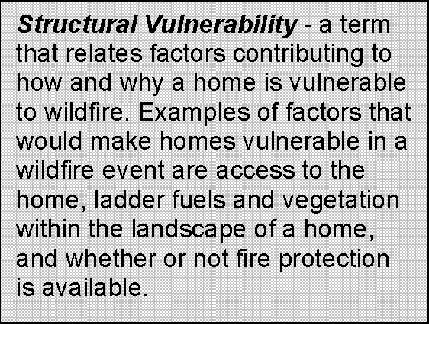Citizens of Baker County can find for themselves, through the various prevention programs mentioned below, information on how to protect themselves and their property from the risk of wildfire. These programs guide citizens through creating survivable (otherwise known as defensible) space around homes by eliminating ladder fuels, planting fire-resistant vegetation, and removing other hazardous material around the homesite. By practicing the techniques offered by the many prevention programs below, citizens can increase the survivability of their home in the event of a wildfire. The best protection is prevention, especially when the trend is to build homes farther from urban services.

### Baker County Interagency Fire Prevention Team

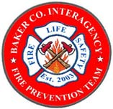Baker County has formed an interagency fire prevention and education team consisting of Baker County Rural Fire Protection Districts and Departments, and federal and state firefighting agencies. The mission of this group is to increase fire education and reduce human-caused fires. Campaigns used include *"I'm Concerned…."* , *“Fire Wise”,* and *"Home Fire Safety - It's up to You."* The group is involved with the Smokey Bear Team Teaching event that takes place in nine schools in the county, along with Wildfire Awareness Month that has been declared in Baker County. In October of each year, the team participates in National Fire Prevention Month. Examples of community events and parades the team is involved with includes Miner's Jubilee, Student Resource/Registration Fair, St. Alphonsus Health Fair, Baker County Fair, Sumpter Flea Markets during Memorial Day, 4th of July, and Labor Day, and other community events across the county.

### Living with Fire

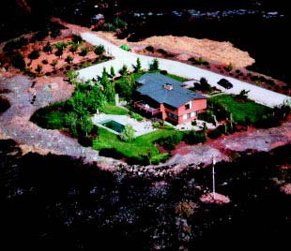This educational brochure is available on-line. The brochure displays step-by-step instructions on how to create a survivable space around your home, depending on the topography and vegetation that surrounds it. This document can be viewed at: <http://extension.oregonstate.edu/tough_times/sites/default/files/documents/livingwithfirepnw.pdf>

The pre-fire activities implemented by this homeowner (in photo to right) included a green and well-maintained landscape, reduction of wildland vegetation around the perimeter of the property, a fire resistant roof, and a good access road with a turnaround area. The charred surroundings of the home show that these pre-fire activities effectively protected it when wildfire hit.

*I’m Concerned….*

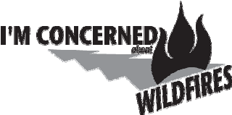

Northeast Oregon District of ODF is currently using the “I’m Concerned…” campaign for its fire prevention program. “I’m Concerned…” offers quick tips for burning debris safely, seasonal clean up tips for your property, building and extinguishing a campfire safely, burn barrel safety, and home fire safety. ODF publishes “I’m Concerned…” ads in the local newspapers and on the website as time of year dictates. You can visit <http://www.oregon.gov/odf/pages/safedebrisburning.aspx> to get a copy of burn barrel safety and home fire safety tips.

### *Firewise*

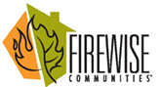*Firewise* promotes fire-wise practices by, 1) educating the public of the dangers of a wildfire in the area; 2) encouraging residents to take responsibility for reducing the risk of a wildfire and to create survivable space around their residence; and, 3) increasing awareness of the natural role of low-intensity fires and the benefits of prescribed burning or occasionally managing natural wildland fires to achieve ecological benefits, known as wildland fire use (WFU) while maintaining firefighter and public safety (visit www.firewise.org for more information).

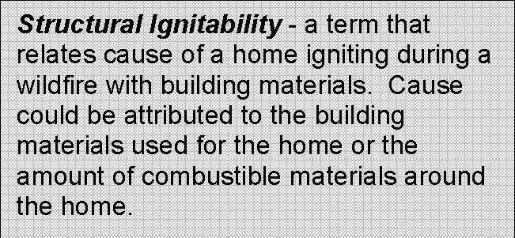A term that is emphasized in this prevention program is structural ignitability, which has to do with the flammability of building materials of the home, deck, and outbuildings attached to the home. See definition in the block to the right.

### Fire-Resistant Plants for Oregon Home Landscapes

When landscaping around a home, most homeowners are concerned with aesthetics. When homeowners are advised to remove flammable vegetation, they are worried that the aesthetics of their landscape will be compromised. Flammable plant material in the landscape of a home will increase the fire risk, especially if irrigation is not done on a regular basis. Homeowners can find information about fire-resistant plant materials that aid in improving chances of a home surviving a wildfire. The plantings listed provide aesthetically pleasing color, texture, flowers, and foliage to the landscape. Visit <http://www.fs.fed.us/r6/centraloregon/local-resources/images/fires/pimpact-plant.pdf>

### Cost-Share Grant Programs through National Fire Plan

ODF provides homeowners within the WUI areas of Baker County a free homesite inspection. After the inspection, technical advice is shared with the homeowner as to what can be done to lessen the structural vulnerability rating for the home. The removal of vegetation and amount to be removed varies depending on what amount of survivable space should be created to protect the home. There is an investment into this type of project for the homeowner, mainly time and effort; however, as stated before, the best protection is prevention.

In addition, there is also a program for the larger landowner that has land within a WUI area of Baker County, especially those adjacent to Federal land, that offers cost-share incentives for pre-commercial thinning, slash removal, and/or ladder fuel removal. Contact ODF in Baker City at (541) 523-5831 to find out more about these programs.

<http://www.fs.fed.us/r6/fire/fireplan/> -Current Link to The Pacific Northwest National Fire Plan

# V. Wildfire Hazard Assessment

To identify and prioritize wildland-urban interface areas-at-risk in Baker County, an assessment of factors was conducted; these factors contribute to large wildfire events that can leave communities vulnerable. This section will outline the process used and highlight unfamiliar definitions. Two key guidance documents were referenced in the assessment of communities-at-risk and the wildland-urban interface areas, as instructed by the State of Oregon:

1. *Field Guidance: Identifying and Prioritizing Communities at Risk*. National Association of State Foresters. June 27, 2003. (Available at: http://www.stateforesters.org/field-guidance-identifying-and-prioritizing-communities-risk-june-2003)
2. *Concept for Identifying and Assessment of Communities at Risk i*n *Oregon*. Draft prepared by Jim Wolf, Fire Behavior Analyst, Oregon Department of Forestry. July 19, 2004.

In Baker County, a ***Community-At-Risk (CAR)*** is defined as a group of homes or other structures with basic infrastructure (such as shared transportation routes) and services within or near federal land. A ***Wildland-Urban Interface (WUI)*** area surrounds a community-at-risk, including that community’s infrastructure or water source, and may extend 1 ½ miles or more beyond that community. This boundary depends on topography and geographic features that could influence wildfire, the location of an effective firebreak, or Condition Class 3 lands.

It is important to understand the meaning of risk and hazard in relation to wildfire. ***Risk*** is the chance or probability of occurrence of fire. ***Hazard*** is the exposure to risk; in a wildfire situation, those hazards can be related to either the natural or the man-made environment. Natural hazards include fuel type and amount of fuels, topography, and weather. Man-made hazards include the limited availability of water, limited access to structures, limited green space around structures, and the ignitability of structures. The capability of firefighting resources will be compromised by the severity of both natural and man-made hazards.

## Fire Occurrence/Risk of Ignition

The rate of fire occurrence is an important component of the assessment. Historical fire records were used for the period between 1994-2003. Fire history data was compiled from the Wallowa-Whitman National Forest, Oregon Department of Forestry (Baker City Sub-Unit), and the Bureau of Land Management.2

The fire occurrence rate (FOR) per 1,000 acres was used to yield a statistical analysis of the project area. The number of fires for Baker County was determined in order to calculate fire occurrence per 1,000 acres. This resulted in an overall county fire occurrence rate. Using this factor, a fire occurrence rate for each identified WUI was calculated. The majority of the WUI areas had a fire occurrence rate higher than the overall fire occurrence rate for the county.

## Fuels / Vegetation

Data used to create a fuels inventory into a GIS (Geographic Information System) was derived from Landsat imagery provided by Oregon Department of Forestry for private lands and the Wallowa-Whitman National Forest GIS library (GIS and Oracle tables derived from stand exams and photo interpretation). For Baker County, the increased risk of a large wildfire event is caused by the buildup of forest fuels and changes in vegetation composition over time. Unnaturally dense stands competing for limited water and nutrients and are at increased risk of wildfire, and from insect and disease epidemics. Discussion regarding fuels as a hazard can be found in Appendix C ­Natural Hazards.

## Topographic Hazard

Slope and aspect affect both the intensity and rate of spread of a wildfire. The topography factor was derived from the Digital Elevation Model for Baker County. For further discussion regarding the scores assigned to slope and aspect, refer to Appendix C - Natural Hazards.

## Total Wildfire Hazard

The total topographic hazard rating and the total fuels hazard rating were combined using *Spatial Analyst* (an ESRI product) to determine overall natural hazard of Baker County. Several layouts (maps) were created to display the total wildfire hazard in relation to the WUI boundaries across the county. The county was divided into four quadrants: NE Baker County, NW Baker County, SE Baker County, and SW Baker County. The maps are located in Appendix G of this plan and were used to verify the prioritization set by the steering committee.

Data from city, rural and volunteer fire departments was not available in GIS format at the time of this plan.

## Weather Hazard

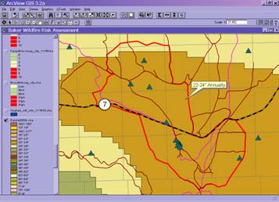In Baker County, weather patterns can produce summer lightning storms that start many fires. These multiple starts can put a strain on the wildland firefighting resources spread across the county. With the drying of fuels over time and the low relative humidity factored in, the probability for large fires can significantly increase during these lightning events. The number of days per season that forest fuels are capable of producing a significant fire event is also important to consider. Oregon Department of Forestry has already determined that eastern Oregon is at the highest hazard rating for weather. This value was assigned through an analysis of daily wildfire danger rating indices in each regulated use area of the state.

Fire Danger indices were used to prioritize WUI areas as well as reflect a more realistic assessment of weather hazard. To review the scores assigned to weather hazard, refer to Appendix C - Natural Hazards.

## Overall Fire Protection Capability Hazards (Structural Vulnerability)

For Baker County, it was decided that the local fire departments would determine for themselves what they thought their overall capability was for responding to a fire in their district. Each district was provided with a written questionnaire and asked to submit information about roads that prohibit access to structures, water shortages, unprotected locations, structure density, building materials, defensible space around structures, and any other issue(s) that might pose a hazard to their fire district. Utilizing the results of the questionnaire, consideration was given to the level of training/equipment/preparedness of firefighting resources, type of access to homes, density of structures across the county, availability of water sources, structural vulnerability and ignitability, and response time to outermost region of the fire district responding to the questionnaire. The scores were assigned as listed below:

**Capability Rating Value**

Low Hazard 1 Moderate Hazard 3 High Hazard 5

## Values at-Risk

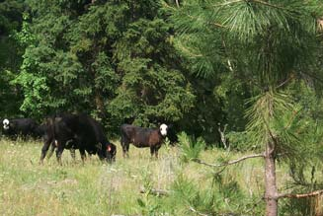This category was based on public input collected during community meetings and comments received from informational questionnaires. Steering committee members provided input based on their local experience and knowledge of the areas as well. Values at-risk are an important, but highly subjective component of the assessment. Values lost because of a devastating wildfire would affect residents in different ways.

Baker County’s economy could be impacted if a large wildfire eliminated valuable timber or rangeland for grazing, which might affect local businesses and industry. A fire could destroy recreational areas that draw tourists to the area: tourism has become a large component of the county’s economy. Social values-at-risk include home and property, animals, and cultural and historical sites. Reduced visibility can be an environmental concern and can reduce the scenic views, considered one of the great assets of rural Oregon.

Comments from property owners identified the loss of scenic beauty and natural landscape as being of a high value. Numerous families maintain their primary residential property within the identified WUI areas across the county. Loss of human life and loss of homes could be overwhelming for families, destroying the fabric of the close-knit, small-town atmosphere residents of Baker County cherish about their communities.

Ecologically, general wildlife habitat and diversity, as well as threatened and endangered species of fish, wildlife, and plant life could be wiped out or severely harmed in the long-term depending on the intensity of the wildfire. Water quality could be impacted if a moderate to high intensity wildfire burned through watersheds, affecting the health of fish and wildlife as well as domestic water supplies for residents.

Baker County has good air quality compared with larger urban areas west of the Cascades; the smaller population and fewer large industrial emission sources generally mean fewer pollutants entering the air. However, pollutants from large scale or numerous smaller wildfires can affect residents already suffering from health concerns. The Forest Service works with Oregon DEQ to ensure particulate matter from smoke from prescribed forest burns is at healthy levels through weather monitoring. Ideally, the Forest Service strives to keep smoke from entering into populated areas.

## Using the Hazard Assessment to Score WUI Areas

The Steering Committee identified communities-at-risk across the forested landscape using several factors. As previously defined, this could mean a group of homes or structures with basic infrastructure and services within or near federal land. The next step was to designate WUI boundaries that would incorporate those communities-at-risk as appropriate by using assessment information (previously described more fully). The hazard assessment information was used to develop a scoring matrix that would provide results that could be used for prioritizing the WUI areas within Baker County (see Table 2). The weighting of each element of the matrix was based on input received from the community, members of the steering committee, and information derived from the statewide assessment and scoring.

This process was meant to be community-driven, with input captured by the community and the committee involved with its development. The list of priorities helped the committee build an inventory of projects and action items that could be implemented to protect the WUI areas from large wildfire. A more complete explanation of each category is found in Appendix E. An aggregate score of 22 points was established as the overall high score.

Table 1. Scoring Matrix Factors Used for Ranking Baker County Communities At-Risk

|  |  |
| --- | --- |
| **Rating Factors for Communities-at-Risk** | **Point Breakdown** |
| **Likelihood of Fire Occurring** (historical fire starts data from ODF and USFS; based on occurrence rate per 1,000 acres ) | 1 pt – low occurrence 2 pts – moderate occurrence 3 pts – high occurrence |
| **Topographic Hazard** (slope only) | 1 pt – 0% - 25% 3 pts – 25% - 40% 5 pts – more than 40% |
| **Total Fuel Hazard** (surface and crown fuels combined) | 1 pt – low hazard 3 pts – moderate hazard 5 pts – high hazard |
| **Overall Fire Protection Capability** (equipment, training, preparedness, access to homes, structure density, etc.) | 5 pts – low capability 3 pts – moderate capability 1 pt – high capability |
| **Weather Factor** (high lightning hazard potential and low precipitation) | 1 pt – low (~ 25+” annually) 2 pts – moderate (~13-24” annually) 3 pts – high (~0-12” annually) |
| **Values at Risk** (taken from surveys and public input; major infrastructure, municipal water source, utility lines/pipelines, etc.) | 1 pt – present 0 pts – not present |
| **Total Points Possible = 22** |

While the risk of fire occurrence and topographic hazard would be hard to change in order to manipulate the scoring of a community, the total fuel hazard could be affected through fuels treatment projects and fire prevention campaigns.

The overall fire protection capacity takes into account the capability of firefighting resources to respond and suppress a wildfire in the wildland-urban interface. It combines the type of fire protection training and equipment with structural vulnerability factors such as access to structures, ingress/egress, amount of defensible space, building materials used in structures, and available water sources. Local knowledge of firefighting agencies, structural and wildland, was utilized.

As a means to reflect the unique weather patterns found in Baker County, the steering committee used annual rainfall to offset the high hazard rating assigned during the statewide assessment by Oregon Department of Forestry in Salem. This category has a high point value of three. (Note: The layer used to determine annual rainfall came from the Oregon Department of Forestry GIS library).

Even though values at-risk is a subjective category, input provided by the public and members of the planning committee was considered during the assessment process and when scoring the WUI for values protected. Citizens of Baker County identified several common themes that were of high value to them, including their homes, the rural environment and scenic beauty in which they live; wildlife, timber, grazing, mining and various recreational opportunities. Municipal watersheds and major transmission lines and utility corridors were added since those values are part of the legislation that was put forth under the Healthy Forest Restoration Act (HFRA). The score assigned was a value of one if values at-risk were noted in a particular WUI or zero for "no values at-risk present".

|  |  |  |
| --- | --- | --- |
| **Table 1. Baker County Wildland-Urban Interface Areas – Listed by Total Average CAR Score** | | |
| **Priority Level** | **WUI Name** | **Total Score** |
|  | Woodtick Village/Rattlesnake Est. | 21 |
| **HIGH Priority** (15-22 points) | Pleasant Valley | 21 |
| Stices Gulch | 19 |
|  | Bourne | 18 |
|  | Surprise Spring | 17 |
|  | Greenhorn | 16 |
|  | Auburn Gulch | 16 |
|  | Oxbow / Copperfield | 16 |
|  | Rock Creek/Bulger Flats | 16 |
|  | Elkhorn Estates / Deer Cr. / McEwen | 16 |
|  | Sparta | 16 |
|  | Huntington | 15 |
|  | Face of the Elkhorns / Baker City Watershed, | 15 |
|  | Eagle Creek, / Tamarack | 15 |
|  | East Eagle, Main Eagle | 15 |
|  | Cornucopia, | 15 |
|  | Sumpter / McCully Forks Watershed | 15 |
|  | Black Mountain | 15 |
|  | Anthony Lakes | 15 |
| **Moderate** | Whitney | 14 |
| **Priority** | Brownlee / Bridge | 14 |
| (11-14 points) | Durkee | 13 |
|  | Richland / New Bridge | 13 |
|  | Rye Valley | 13 |
|  | Keating / Wirth Junction | 12 |
|  | Carson / Pine Valley | 12 |
|  | Hereford | 12 |
| Oregon Trail Interpretive Center, | 11 |

# VI. Fuels Treatment, Maintenance, Biomass

## Fuels Treatment and Forest Health1 [8]

Thinning for fuels reduction can have the added benefit, if stocking levels are lowered enough, of increasing tree diameter growth and enhancing tree vigor. From the stand perspective, this will reduce the time to the next thinning and maintain healthier trees by increasing resistance to pests, such as bark beetles. To meet both fire risk and forest health objectives, stands need to be thinned wide enough to take advantage of the sites resources: water, nutrients, and sunlight. Spacing depends on factors such as site quality, species, and tree size (diameter): on poorer sites, trees will be spaced a bit wider; species such as Ponderosa and Lodgepole pine are spaced wider than other species; and larger trees need more space than smaller trees.

Forests are dynamic and continually growing in diameter, height, and crown width. Fuels reduction activities that include thinning are beneficial, but thinning without consideration for forest health doesn’t provide the benefits of pest resistance or good individual tree growth. Also, without future maintenance, the fire risk reduction benefits decline over time.

For more information about proper tree spacing for your stand, contact the Forestry Extension Agent for Baker and Grant Counties, at (541) 523-6418 or Oregon Department of Forestry in Baker City at (541) 523-5831.

## Fuels Maintenance Program[9]

Developing a fuels reduction maintenance program will entail knowing the plant association and defining acceptable fire behavior parameters. A flame length of 4 feet or less, particularly in or near WUI areas, is generally a more desirable fire behavior. Using plant association and predicted flame lengths, projections can be made to determine when a particular site will move beyond desired fire behavior criteria and require some level of re-treatment.

Once treated, stands undergo the process of ecological succession in which understory and overstory vegetation changes over time, resulting in incremental changes (often increases) in herbs, grasses, shrubs, and regeneration of trees because more growing space has been created by the removal of trees and other vegetation. Overstory structure changes as residual trees expand their crowns and increase in diameter, continually adding more biomass (fuel) to the site (needles, branches, downed logs). Subsequent disturbances caused by insects and disease can kill trees and add more biomass to the forest floor. Although some of this biomass decays over time, in the dry forests of southwest, central and eastern Oregon, dead biomass tends to accumulate on the forest floor faster than it decays, adding more fuel to the landscape.

Timing before treated areas will require re-treatment is dependent on several factors that are inter-related, including:

* Past treatment level (e.g., how much biomass (fuel) was removed initially in the understory and overstory);
* Plant association groups;
* Site productivity;
* Rate of fuel accumulation;
* Fuel structure (i.e., condition class)
* Historic fire regime;
* Desired fire behavior (for effective control)
* Climatic regime

## Biomass Utilization

Federal and state agencies, local government and private forest landowners are using thinning and prescribed burning in strategic locations to reduce forest fuels and wildfire risks. Most of the material generated from fuels reduction activities is not suitable for commercial wood products manufacturing. In many cases, biomass from these activities is left on-site or piled and burned at an additional cost. An outlet for small diameter wood products could help offset the costs of thinning and help mitigate environmental impacts associated with prescribed burning and wildfires.

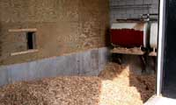Forest biomass is generated by forest fuels reduction, commercial timber harvest; non-commercial thinning and timber stand improvement (TSI) activities. Non-commercial thinning includes pruning and tree removal designed to help shape and guide development of forest stands to meet a variety of goals. It generally does not result in removal of trees that can be used to manufacture products, but it could be used in renewable energy production (heat, steam, electricity, and fuel). Timber stand improvement can accomplish similar goals, but often results in removal of some commercially valuable trees. Wood manufacturing residues including bark, sawdust, chips, and veneer cores are additional sources of raw material for renewable energy production. A biomass plant is currently operating in Grant County, but high transportation cost makes the export of small diameter wood material to the plant cost prohibitive.

Photo 2. Chip Storage, Fuels for School

# VII. Emergency Management

## Infrastructure Protection Capabilities

Questionnaires were sent to all rural and municipal structural firefighting agencies asking for an inventory of resources so that needs of each district could be assessed in the future. Also, the resource list will aid wildland fire agencies in determining where fire resources are staged across the county that can be utilized in a wildfire event.

The Baker County Emergency Management Fire Division Manager is responsible for the maintenance of the annex on an annual basis. The list can be referenced in Appendix G – Agency Emergency Response Resources.

## Mitigation Action Plan for Emergency Services

Baker County utilizes a multi-faceted approach to Wildfire Mitigation. Mitigation efforts begin with the Baker County General Plan, land use planning tools which implement Oregon State Law, and administrative rules, fire siting standards, and the Baker County Planning and Subdivision Ordinance.

Recognizing that emergencies and disasters will occur even with land use planning guidance in place, the county has adopted the *Baker County Emergency Operations Plan.* This document contains The Basic Plan, ICS/NIMS implementation, various annexes (including the Wildfire Annex), the County-wide Mutual Aid Agreement, the Tri-County Hazard Mitigation Plan, and the Baker County Emergency Response Map Book.

All resources mentioned above are available for review by interested parties at the Baker County Courthouse.

# VIII. Monitoring and Evaluation of the Plan

## Schedule

The maintenance for this plan will be directed by the Baker County Board of Commissioners, and coordinated with the committee members of the represented agencies and groups. CWPP plan maintenance will include a review the plan, re-evaluation of the priorities for action items and progress.

Review of the strategy recommendations will be necessary as various projects or tasks are accomplished and areas at-risk decline in hazard rating. Review will also be needed as County infrastructure needs change or are met and should include representation of stakeholders who participated in the development of the plan being reviewed.

A total revision of the plan every five years is recommended as Baker County infrastructure needs change, specifically: population increases, land use changes, fuels reduction projects are completed, emergency services in outlying areas improves, updates are received for computer software and data, and areas of extreme wildfire hazard decline or increase.

## Monitoring

The continued involvement of the public is needed to accomplish many of the recommendations for the Baker County Wildfire Protection Plan. It is important that the committee members make every attempt to network with the citizens of Baker County, allowing for continued collaboration with them on how best to meet their needs, while at the same time achieving the mission of this plan. In addition, multi-party monitoring among the agencies will take place, documenting accomplishments and redesigning strategies as needed.

Copies of the plan will be available at the Baker County Courthouse, Baker County public libraries, and on the web at <http://www.bakercounty.org/emergency/neor_mitigation_plan/vol3/appendix_h/baker_cwpp.pdf>

## Evaluation

Periodic assessment of the identified projects is very important to determine whether or not progress is being made. Units of measure to be considered when updating the plan in the future for the purpose of reporting accomplishments are listed below:

1. Number of projects accomplished which improve fire agency/emergency service response time.
2. Number of transportation problems resolved that improve road systems for access, ingress/egress.
3. Number of water sources added to improve firefighting response.
4. Number of pieces/types of equipment obtained and number of training courses provided.
5. Number of acres treated for fuels reduction and type(s) of treatment used.
6. Number of events with prevention message delivery, number of prevention courses attended/conducted, number of news releases or prevention campaigns conducted, and number of prevention team meetings held.
7. Number of partners/agencies/groups involved.
8. Number of people contacted (meetings, courses, etc) and number of educational items distributed (brochures, etc).

On a regular basis, representatives of local, state and federal agencies will meet to assess projects using the units of measure listed above to determine progress. Each project will adhere to any pertinent local, state or federal rules or guidelines in determining the point of project implementation. The plan is a coordinating document for projects related to education and outreach, information development, fire protection and fuels treatment.

1. 2012 Oregon Natural Hazard Mitigation Plan; Fire Chapter <http://csc.uoregon.edu/opdr/sites/csc.uoregon.edu.opdr/files/docs/ORNHMP/OR-SNHMP_FIRE_chapter.pdf>
2. See Appendix A for a spreadsheet of fire data reported by Oregon Department of Forestry in Baker City.
3. <http://www.oregon.gov/OSP/SFM/Pages/Conflagration_Information_2007.aspx>
4. <http://www.communitiescommittee.org/pdfs/cwpphandbook.pdf>
5. <http://www.house.gov/legcoun/Comps/healthy.pdf>
6. <http://www.oregon.gov/ODF/FIRE/SB360/sb360.shtml>
7. Taken from Baker County Emergency Management Resource Directory CD, January 2004.
8. Oester, Paul. Blue Mountains Renewable Resource Newsletter. Vol. 20, No. 3, Fall 2004
9. Fitzgerald, Stephen and Martin, Charlie. A Conceptual Approach for a Maintenance Strategy for Fuel Treatments in Oregon: Maintaining the Investment. Oregon State FFHM Committee Report, July 5, 2004.