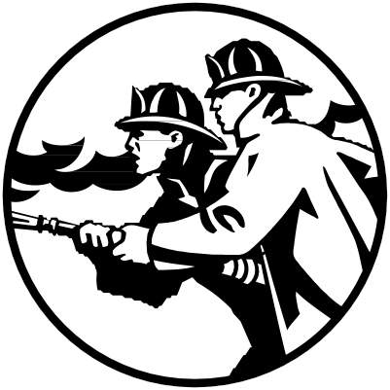

**Union County Community Wi ldfir e P r otecti on Pla n**

**A working document that will serve as a resource for providing information to enhance community safety through**

**hazard and risk reduction in the wildland-urban interface areas of**

**Union County**

**08-10-05**

***Table of Contents***

Acknowledgements ....................................................................................................... 2

List of Tables and Figures ............................................................................................. 6

Signature Page .............................................................................................................. 7

Resolution......................................................................................................................8

I. Introduction.................................................................................................................9

Plan Overview and Development .............................................................................. 9

Plan Compliance ..................................................................................................... 10

Preparing a Community Wildfire Protection Plan..................................................... 10

Wildland-Urban Interface Loss in Oregon................................................................ 11

Conversion of Resource Lands in Eastern Oregon ................................................. 12

II. Union County Profile ............................................................................................... 14

Climate, Land Use ................................................................................................... 14

Forestland Ownership ............................................................................................. 15

Population and Demographics................................................................................. 16

Employment and Industry ........................................................................................ 16

Fire History and Major Fires .................................................................................... 17

Economic Impact of Fire .......................................................................................... 18

III. Mission, Goals and Objectives ............................................................................... 20

IV. Emergency Operations........................................................................................... 21

Fire Protection ......................................................................................................... 21

Infrastructure and Structural Protection Capabilities................................................ 22

Defensible Space .................................................................................................... 22

V. Community Outreach and Education ...................................................................... 23

Outreach.................................................................................................................. 23

Blue Mountain Wildland-Urban Interface Study ....................................................... 23

Union County Values-at-Risk Questionnaire ........................................................... 24

Fire Programs and Policies...................................................................................... 24

VI. Wildfire Risk Assessment....................................................................................... 28

Fire Occurrence ....................................................................................................... 28

Fuels........................................................................................................................ 29

Topographic Hazard ................................................................................................ 30

Overall Hazard......................................................................................................... 31

Weather Hazard ...................................................................................................... 31

Overall Fire Protection Capability Hazards .............................................................. 31

Values at Risk.......................................................................................................... 32

Score and Prioritize - Category 1: Wildfire Hazard .................................................. 32

Score and Prioritize - Category 2: Overall Fire Protection Capability/Structural

Vulnerability ............................................................................................................. 33

Score and Prioritize - Category 3: Values Protected ............................................... 33

Score and Prioritize - Category 4: Weather Factor .................................................. 33

Score and Prioritize - Category 5: Opportunity for Fuels Reduction Projects .......... 34

Prioritization............................................................................................................. 34

VII. Wildland-Urban Interface Areas ............................................................................ 36

Wildland-Urban Interface Areas............................................................................... 36

Individual Interface Information................................................................................ 36

Morgan Lake............................................................................................................ 39

Cove ........................................................................................................................ 42

Mt. Emily.................................................................................................................. 45

Palmer Valley .......................................................................................................... 48

Perry / Hilgard.......................................................................................................... 51

Stubblefield Mountain .............................................................................................. 54

Beaver Creek Watershed ........................................................................................ 57

Catherine Creek ...................................................................................................... 60

Blue Springs ............................................................................................................ 63

Medical Springs ....................................................................................................... 66

Kamela .................................................................................................................... 69

Pumpkin Ridge / Ruckle Road................................................................................. 72

Elkanah ................................................................................................................... 75

Clark ........................................................................................................................ 78

Rysdam ................................................................................................................... 81

Starkey .................................................................................................................... 84

VIII. Mitigation Action Plan........................................................................................... 87

Action Items............................................................................................................. 87

Biomass Utilization .................................................................................................. 93

IX. Maintenance Plan for Fuels Treatment .................................................................. 95

Concepts to Consider in Developing a Fuels Maintenance Program....................... 95

Fuels Treatment and Forest Health ......................................................................... 96

X. Monitoring and Evaluation....................................................................................... 97

Schedule ................................................................................................................. 97

Monitoring................................................................................................................ 97

Evaluation................................................................................................................ 97

XI. Appendix A: Glossary/Acronym List ....................................................................... 99

Glossary .................................................................................................................. 99

Acronym List.......................................................................................................... 103

XII. Appendix B: Collaboration Methodology ............................................................. 104

Community Workshops ......................................................................................... 104

Press Releases ..................................................................................................... 109

Website ................................................................................................................. 112

Values at Risk Questionnaire/Blue Mountain Survey ............................................ 112

Local Radio/Newspaper ........................................................................................ 121

XIII. Appendix C: Union County Emergency Operations - Wildland Fire Annex ........ 122

XIV. Appendix D: Sources ......................................................................................... 129

***List of Tables and Figures***

**Tables:**

Table 1. Northeast Oregon Land Use ..................................................................... 14

Table 2. Federally Administered Land .................................................................... 14

Table 3. Union County Community Populations ..................................................... 15

Table 4. Fuel Group Descriptions ........................................................................... 28

Table 5. Individual Wildland Urban Interface Score Sheet ...................................... 32

Table 6. Wildland Urban Interface Ranking Summary ............................................ 34

**Figures:**

Figure 1. Union County Vicinity Map ....................................................................... 13

Figure 2. Union County Map ................................................................................... 14

Figure 3. Employment by Industry .......................................................................... 16

Figure 4. Rooster Peak Fire Photograph ................................................................ 16

Figure 5. Defensible Space Photograph ................................................................. 24

***Individual Wildland Urban Interface Area maps are provided in Section VII.***

***Acknowledgements***

This project was funded using *Title III – County Project* dollars from the *Secure*

*Rural Schools and Community Self-Determination Act of 2000*.

A special thank you to the Community Wildfire Protection Plan Steering Committee and Resource Committee who dedicated their time and effort to this project while continuing to carry out the duties of their everyday jobs.

Recognition also goes to the many citizens of Union County and to local, state and federal government organizations who assisted in this planning effort by providing historical and technical information for the project.

***Signature Page***

Transmitted herewith is the *Wildfire Protection Plan for Union County.* The Wildfire Protection Plan provides a framework in which Union County can assess the risks and hazards associated with Wildland-Urban Interface areas and identify methods of reducing the risk of ignition or eliminating hazards.

The Union County Board of Commissioners has approved this plan and both wlidland firefighting agencies and the County's structuralfire protection services have agreed upon the contents.The plan contents will be revisited annually and projects will be revised and updated as necessary. All recipients are requested to advise the Union County Emergency Services Office of any changes that might result in its improvement or increase its usefulness.

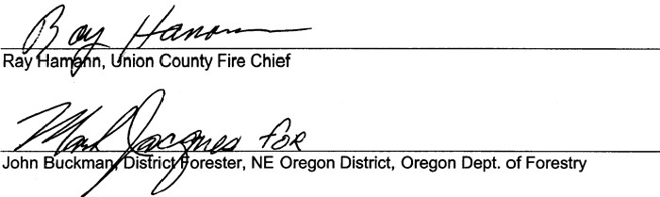Colleen Macleod,Union County Commissioner Steve McClure,Union County Commissioner John Lamoreau,Union County Commissioner

BE IT REMEMBERED,thllt at a reglllar tlnnof the Board of CommiMionera of the Stat.of Oregon, for the County of Union, slUing for the tranNetion

of County bualnMS, begun and heldat the Joeeph Building Annex Inthe City of La Grande, InaaldCounty and Stat.,on Wednesday of aald month and the time fixed by law for holding a regular tlnn of Nkl CommiMion, when_..

The Hononi!M Co!!Mn Maclfod. Chllr

S!!m McC!U!!· **Commllllo.-1!!'**

John Llmor!lu. Comm!ttfontr

WHEN,on WedMedly theday of Auqllft 200§,among others the

following proceedings _.hid to wit

INTHEMATTER OF A RESOLUTION ADOPTNI G THE UNION COUNTY COMMUNITY WILDFIRE

PROTECTION PLAN ANDESTABLISH NG

AN ANNUAL REVIEW BOARD

RESOLUTION

2005-25

WHEREAS,the Union County Board *al* Commisaionera a!locMed *TitleIll County* money from the *Secut.Rural Schoola and CommunitySelf­* Detemllnation *Act of 2000*to complete a Community Wildfire Protection Plan for Union County communities;

WHEREAS.the Union County Community WildfireProtection Plan is a non­ regulatory plan tNt Identifies 16 Woldland-UrbanInterface areuof high wildfire risk and hazard;

WHEREAS,the Union County Community Wildfire ProtectionPlanidentifies polentill projecta tNt mayreduce the hazards preMnt InWlk!IIJld.Urban lntelfaoe areu and reduce the risk of wildfire ignition;

WHEREAS,the Union County Board *al* Comrniltlonera ....,...,_the project steering c:omrnillllle a theannual review board for the plan to be coordinated through the Union County Emergency SefVioes olllc:e apring;

*-r*

BE IT RESOI,VED tNt the Union County Board *al* Commllaionera hereby

adopts the Union County Community Wildfire ProtectionPlan and establishes the

project aiBering committee as the annual review board.

DATED thisday of August 2005.

COilENMKcLEOD:iR

-07 *cet't.u.v-*

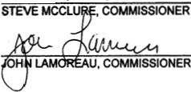

***I. Introduction***

**Plan Overview and Development**

The Community Wildfire Protection Plan for Union County is the result of analyses, professional cooperation, collaboration and wildfire risk assessments considered with the intent to reduce the potential for wildfires that threaten people, structures, infrastructure, and values in Union County.

The project steering committee began meeting in October 2003 to first revise the

Wildfire Annex for the Union County Emergency Operations Plan. Subsequent meetings were held to establish a project mission and goals and objectives for the Wildfire Protection Plan; develop the risk assessment; identify and prioritize WUIs; organize community workshops; provide guidance on plan content and organization; and

prioritize risk reduction projects.

Data from numerous sources and time periods was used to prepare the plan. Because of the different sources and data periods the transition between data sets is not always fluid and there are many gaps in data collection. Where relevant, these gaps are identified and all sources are cited.

The planning committee, made up of collaborating partners, is responsible for implementing this project and includes:

|  |  |  |
| --- | --- | --- |
| Dara Decker  Angie Johnson | Union County Emergency Services  Oregon Department of Forestry | Co-Chair  Co-Chair |
| Paul Anderes Larry Aragon Jim Beekman Rob Burnside  Jon Christensen Ray Hamann Gary Hansen Steve Henderson Mark Jacques John Lamoreau John Manwell  Pat McDonald  David Quinn  Jay Rasmussen Ron Rochna Trish Wallace Mitch Williams | Union County Forest Restoration Board Wallowa-Whitman National Forest Umatilla National Forest  Confederated Tribes of the Umatilla Indian Reservation Fire Dept. Private Forest Owner  La Grande Rural Fire Protection District/Union County Fire Chief  Cove Rural Fire Protection District Imbler Rural Fire Protection District Oregon Department of Forestry  Union County Board of Commissioners  Forest Capital  Elgin City & Rural Fire Protection District Northeast Oregon Interagency Dispatch Center Wallowa-Whitman National Forest  Citizen  Wallowa-Whitman National Forest  Oregon Department of Forestry | Member Member Member Member Member Member Member Member Member Member Member Member Member Member Member Member Member |

9

Resource members serve in an advisory capacity to the planning committee and include:

|  |  |  |
| --- | --- | --- |
| Heidi Bigler-Cole | USFS Pacific Northwest Lab | Resource Member |
| John Buckman Oregon Department of Forestry Resource Member | | |
| Jim Carter Medical Springs Rural Fire Protection District Resource Member | | |
| Renae Crippen Northeast Oregon Interagency Dispatch Center Resource Member | | |
| Brett Brownscombe Hells Canyon Preservation Council Resource Member | | |
| Dale Eckman Bureau of Land Management Resource Member | | |
| Mike Hartwell Bureau of Land Management Resource Member | | |
| Chris Heffernan Private Forest Owner Resource Member | | |
| Bill Hooker Union City & Rural Fire Protection District Resource Member | | |
| Sonny Johnson Cove Rural Fire Protection District Resource Member | | |
| Lola Lathrop 911/Dispatch Manager Resource Member | | |
| Colleen MacLeod Union County Board of Commissioners Resource Member | | |
| Michael McAllister Citizen Resource Member | | |
| Steve McClure Union County Board of Commissioners Resource Member | | |
| Paul Oester OSU Extension Service Resource Member | | |
| Boyd Rasmussen Union County Sheriff’s Office Resource Member | | |
| Matt Reidy Wallowa-Whitman National Forest Resource Member | | |
| Ken Rockwell Wallowa-Whitman National Forest Resource Member | | |
| George Russell North Powder City & Rural Fire Protection District Resource Member | | |
| Ron Warnock Cove Rural Fire Protection District Resource Member | | |
| Bruce Weimer La Grande Fire Department Resource Member | | |
| Kurt Wiedenmann Wallowa-Whitman National Forest Resource Member | | |
| Judy Wing Wallowa-Whitman National Forest Resource Member | | |

**Plan Compliance**

This community wildfire protection plan has been prepared in compliance with the National Fire Plan, the 10-year Comprehensive Strategy, the FEMA Tri- County Hazard Natural Hazard Mitigation Plan (Baker, Union, and Wallowa Counties), Union County Emergency Operations Plan, Oregon Senate Bill 360 (The Act of 1997), and Healthy Forests Restoration Act.

The Union County Commissioners with cooperation and input from the Community Wildfire Protection Plan Steering Committee endorse this plan. These representatives mutually agree to the final contents of the plan. The plan is not regulatory and does not create or place mandates or requirements on individual jurisdictions. This plan does not bypass the individual rules and procedures that govern the participating agencies, organizations and individuals.

The role of the plan is to serve as a working document to coordinate fire and land managers and their efforts in Union County.

**Preparing a Community Wildfire Protection Plani**

Both the *National Fire Plan*, and the *Ten-Year Comprehensive Strategy for Reducing Wildland Fire Risks to Communities and the Environment* place a priority on working collaboratively within communities in the WUI to reduce their risk from large-scale wildfire. The incentive for communities to engage in comprehensive forest planning and prioritization was given new momentum with the enactment of the *Healthy Forests Restoration Act* (HFRA) in 2003. The

language in HFRA provides maximum flexibility for communities to determine the substance and detail of their plans and the procedures they use to develop them. HFRA emphasizes the need for federal agencies to work collaboratively with communities in developing hazardous fuels reduction projects, the act also

places priority on treatment areas identified by communities themselves in a community fire plan. Combine this with the direction by NFP and the Ten-Year Strategy, one can see the importance of preparing a plan.

Other local government planning considerations, such as FEMA’s direction to prepare county hazard mitigation plans and the implementation of Oregon Senate Bill 360, has made it very important for local government to participate in the development and implementation of a community wildfire protection plan. A community wildfire protection plan inventories local conditions including fire risk, and coordinates fire protection and outreach projects across Union County communities.

**Wildland-Urban Interface Loss in Oregonii**

Oregon’s *Natural Hazards Mitigation Plan* says wildland fires are a common and widespread natural hazard in Oregon; the state has an extensive history of wildfire. Significant portions of Oregon's wild lands and rural communities are dominated by ecosystems dependent upon fire for health and survival.

Oregon has over 41 million acres (over 64,000 square miles) of forest and rangeland susceptible to wildfire. In addition, significant agricultural areas of the Willamette Valley, north central and northeastern Oregon support grain crops that are prone to wildfire damage. Fire danger is not exclusive to land, communities are also at risk. A federal document titled *Urban Wildland Interface Communities Within the Vicinity of Federal Lands That Are at High Risk From Wildfire* (listed in the 2001 *Federal Register*, 367) issued by the Department of Agriculture - Forest Service Department of the Interior - Bureau of Indian Affairs, Bureau of Land Management, Fish and Wildlife Service and National Park

Service states “Oregon has communities that are at risk of damage from wildfire”.

The majority of wildfires occur between June and October. However, wildfires

can occur at other times of the year when weather and fuel conditions combine to allow ignition and spread. Seventy percent of Oregon's wildland fires result from human activity. The remaining thirty percent result from lightning, occurring most frequently in eastern and southern Oregon.

The financial and social costs of wildfires demonstrate the need to reduce their impact on lives and property, as well as the short and long-term economic and environmental consequences of large-scale fires. Cost savings can be realized through preparedness and risk reduction including a coordinated effort of planning for fire protection and implementing activities among local, state, and federal agencies, the private sector, and community organizations. Individual

property owners have a major role to play in this coordinated effort, especially in wildland interface areas.

The wildland-urban interface (WUI) is the area or zone where structures and other human development meet or intermingle with wildland or vegetative fuels. As more people have moved into wildland urban interface areas, whether for lifestyle or economic reasons, the number of large wildfires affecting homes has increased dramatically. Many in the population migrating to rural Oregon from urban areas maintain the expectation of structural fire protection similar to the high-density areas they were leaving. Rural fire departments combined with local mutual aid agreements and finally the Conflagration Act attempt to fulfill these expectations. However, many homes are still located within areas with little or no structural fire protection.

Recent fire seasons bring the wildland interface problem and the problem of overabundant dense forest fuels to the forefront. The forest fuels issue is a major and continuing problem that has received presidential level attention. Work is underway to reduce fuels in WUI areas by way of community involvement and funding from the *National Fire Plan*. National Fire Plan goals are to:

 Ensure sufficient firefighting resources for the future;

 Rehabilitate and restore fire-damaged and fire-adaptive ecosystems;

 Reduce fuels (combustible forest materials) in forests and rangelands at risk, especially near communities; and

 Work with local residents to reduce fire risk and improve fire protection. Community Assistance grants and other grant opportunities are available through

*National Fire Plan* (NFP) to aid in achieving these goals. The goals aim high. They represent a substantial amount of work, and their ultimate success will depend on concerned individuals, agencies, and organizations working in concert. No agency or group working alone can achieve NFP's goals.

**Conversion of Resource Lands in Eastern Oregon**

The Oregon Department of Forestry completed a study titled, *Forest, Farms and People: Land Use Change on Non-Federal Land in Eastern Oregon, 1975-2001*iii that studies the conversion of resource lands (farm, forest and range) to residential development in Eastern Oregon. The study used aerial photographs from 1975, 1986 and 2001 to examine land development before and after the implementation of land use laws to determine whether land use laws have been successful in slowing growth on Eastern Oregon resource lands. Ultimately, the report concludes that land use laws have slowed the conversion of resource land in Eastern Oregon, but while the rates of urban and rural residential development have declined statewide, they have increased in Eastern Oregon’s non-federal

forests, leading to potential impacts like compromised forest management and fire protection capability.

Results from the study include the following facts:

1. In parts of Central Oregon, 60% of forest industry land has shifted from forest industry to non-industrial ownership.

2. There are now three times as many dwellings on non-federal wildland forest in Eastern Oregon as in 1975. This may lead to increased fire hazard, impacts to wildlife and their habitat, and a decreased timber supply.

3. Dwelling density is increasing at a faster rate in Eastern Oregon’s fire-prone private wildland forests than in Western Oregon’s private wildland forests.

4. As the number of structures in Eastern Oregon’s forests increase, the propensity to manage for timber production decreases.

5. Along with decreasing inventory volumes on timber industry lands, timber harvests in Central Oregon have decreased dramatically, and may remain depressed.

6. The remainder of Eastern Oregon’s private forests may experience the rapid development and other permanent changes currently occurring in Central Oregon.

The study results have implications for private forestland in Union County. Local land division ordinances currently contain fire-siting standards (see *Section V*) that stipulate the safest way for residential development to occur in forestland yet development is still occurring, which leads to structural protection challenges for local protection agencies. Additionally, timber production and wildlife habitat may decline as forestland is converted to residential development.

i <http://www.communitiescommittee.org/pdfs/cwpphandbook.pdf>

ii Oregon Emergency Management; *Emergency Management Plan, Natural Hazards Mitigation Plan, Fire*

*Chapter,* (December 2003).

iii Oregon Department of Forestry; *Forest, Farms and People: Land Use Change on Non-Federal Land in Eastern Oregon, 1975-2001* (August 2004). <http://www.odf.state.or.us/DIVISIONS/resource_policy/resource_planning/Annual_Reports/EORDZ.pdf>

***II. Union County Profile***

Located along the Interstate 84 corridor in northeast Oregon, Union County is approximately 250 miles east of Portland, Oregon and 160 miles northwest of Boise, Idaho. Union County lies in the Grande Ronde River and Powder River Valleys just east of the Blue Mountains. Union County is bordered by Wallowa County to the north and east, Baker and Grant Counties to the south and Umatilla County to the west.

Union County is characterized by the ridges and valleys typical of the Blue Mountains, and is part of the Grande Ronde River Basin. Total area is 2,038 square miles, or 1,304,320 square acres. The Grande Ronde River runs south to north across Union County, and supports recreational, irrigation and livestock uses.

There are eight incorporated communities in Union County including La Grande, Island City, Elgin, Imbler, Cove, Union, North Powder and Summerville. Union County also contains eight fire districts/departments providing structural fire protection and three wildland fire agencies providing wildland fire protection. Fire Protection is discussed in greater detail under *Section IV – Emergency Management*. The area draws many visitors every year to enjoy outdoor activities such as skiing, hunting, fishing, hiking and biking. Aside from the natural beauty

of the area, amenities like a university and hospital also draw visitors and new residents.

**Figure 1 - Union County Vicinity Map**

**Climate**

Union County enjoys four distinct seasons. Annual precipitation is approximately 18 inches in the valleys while high mountain areas rarely exceed 10 inches. Seasonal distribution is quite different from western Oregon. "Relatively low winter totals are nearly matched by rain from summer thunderstorms, which are much more common than western areas. Thus, much

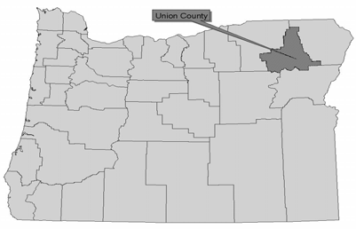

of eastern Oregon receives almost uniform

precipitation throughout the year."i Summer highs average in the 80s while winter highs linger in the 30s.ii Summer days are usually dry and clear with cool nights. The prevalence of thunderstorms in the mountainous and timbered regions of eastern Oregon suggests the potential for lightning-caused fires.

**Land Use**

Most of the county's development and population is located on the valley floor. Industrial, state and national forests occupy the higher elevations. National

Forest land comprises almost all of the 49% publicly owned land.

Today's land uses in the Grande Ronde Valley reflect land uses of the valley's early settlers. The valley floor supports extensive agricultural activities, while

livestock grazing on rangelands and timber

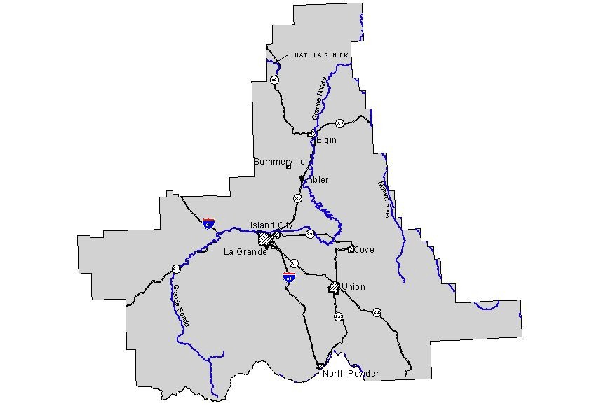

**Figure 2 - Union County Map**

N resources

flourish on

the steeper slopes surrounding the valley. Historically, development in

conjunction with farm and ranch uses occurred on the valley floor, but

today, most development occurs within cities' urban growth boundaries and rural residential zones identified in the Union County Land Use Plan. Most rural residential zones are located in wildfire risk areas due to density of development, vegetation, past fire occurrences, weather and topography.

Union County depends on the landscape to sustain its livelihood. Land is primarily suited for agriculture, but there are also forest/agriculture possibilities and mineral/aggregate locations throughout the county.

**Table 1. Northeast Oregon Land Use**

**County Percent Acreage in farms**

**Union** 40.8%

**State of Oregon** 28.4%

Source: Reid, Rebecca L., *Oregon: A Statistical Overview: 2002,* Southern Oregon Regional Services Institute, Southern

Oregon Regional Services Institute, Southern Oregon University. Ashland, Oregon, May 2002.

**Forestland Ownership and Stewardship**

Forestland in Union County is divided among federal, state and private ownership or stewardship. Table 2 displays federally administered land in Union County as compared with the state as a whole. Federal land managers include the United States Forest Service and the Bureau of Land Management. The Oregon Department of Forestry provides stewardship and fire protection patrol for state and private forestland throughout Union County.

**Table 2. Federally Administered Land**

**County Private % Total BLM % Total USFS % Total Federal Land Totaliii**

**Union** 52% 1% 47% 47.5%

**State of Oregon** 44% 25% 25% 50%

Source: Reid, Rebecca L., *Oregon: A Statistical Overview: 2002,* Southern Oregon Regional Services Institute, Southern

Oregon Regional Services Institute, Southern Oregon University. Ashland, Oregon, May 2002.

**Population and Demographics**

The Grande Ronde Valley includes six of the county's eight incorporated communities, and most of the county's population. According to the Union County Population Analysis and 2020 Forecast, the county had a year 2000 population

of 24,550 peopleiv . See Table 3 for individual community populations.

**Table 3. Union County Community Populations**

|  |  |  |  |  |
| --- | --- | --- | --- | --- |
| **Community** | **2000 PSU Revised** | **1990 U.S. Census** | **Population**  **Change 1990-2000** | **Percent Change**  **1990-2000** |
| Cove 595 507 88 17% | | | | |
| Elgin 1,655 1,586 69 4% | | | | |
| Imbler 285 299 -14 -5% | | | | |
| Island City 925 696 229 33% | | | | |
| La Grande 12,340 11,766 574 5% | | | | |
| North Powder 490 448 42 9% | | | | |
| Summerville 115 111 4 4% | | | | |
| Union 1,930 1,847 83 4% | | | | |
| ***Union County 24,550 23,598 952 4%*** | | | | |
| **Incorporated 18,335 17,260 1,075 6%** | | | | |
| **Unincorporated 6,215 6,338 -123 -2%** | | | | |

Source: Union County Population Analysis and 2020 Forecast

Increased growth (both urban and rural) impacts agency preparation for emergencies because increased population and development (especially within WUI’s) greatly increases wildfire frequency and severity.

**Employment and Industry**

The region has historically been dependent upon agriculture and timber as the primary employment in the area. Currently prominent industries include public employment (government and education), agriculture and timber. Manufacturing, trade and services are the largest employment sectors in Union County.v Timber played a key role in Union County's early economic development but has steadily declined in economic value since the late 1970s. Wood products, however, still remain as the most prominent manufacturing sector in Union County, and northeast Oregon as a whole.

Looking towards the future, agricultural, manufacturing, educational, healthcare, governmental, tourism, and retail trade sectors will continue to grow and provide goods, services and employment opportunities for area residents. Figure 4 provides a breakdown of the region’s employment by industry for the year 2000:

**Figure 3. Employment by Industry**

Educational/Health/Social Services Agriculture/Forestry/Fishing/Mining Trade--Retail/W holesale Manufacturing

Arts/Entainm ent/Recreation Services Public Administration Construction

Transportation/W arehousing/Utilities

Professional/Scientific/W aste Mgmt.

Other Services

Finance/Insurance

Communication/Information

11%

8%

6%

6%

5%

5%

5%

4%

2%

14%

13%

21%

Source: Oregon Labor Market

Information System, Oregon

0% 5% 10% 15% 20% 25%

**Fire History**

Union County and the surrounding area have a significant history of both human and lightning caused fires. A combination of climate, fuels and terrain make Union County prone to wildfire. Figure 4 shows lightning vs. human caused fires for a ten-year period.

Figure 4 shows over 600 fire starts (human and natural) were reported during the years 1994 – 2003. During that time period human causes were responsible for approximately 200 starts and lightning strikes were responsible for approximately

400 starts. Figure 5 shows the interface areas and fires over ten acres in size.

Figure 5 illustrates Union County fires greater than 10 acres over the last 20+ years. Figures 4 and 5 illustrate a stark contrast. Though Union County annually endures many fire starts from both lightning and human sources the number of fires reaching the ten-acre threshold remains relatively low. This dichotomy is

due to effective initial attack and coordinated local suppression efforts. It is worth noting that the recent absence of major

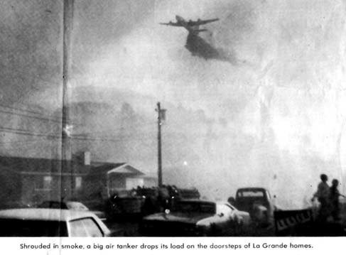

fires does not indicate that major fires are not possible in the future. As illustrated in this document many areas are at high risk for a potentially catastrophic event.

**Major Union County Fires**

Over the past twenty-five years Union County has had five fires of major significance. The fires are: Rooster Peak – 1973, Mt. Harris – 1981, Frizzel

–1986, Boulevard – 2001 and Craig

**Figure 4. Rooster Peak Fire photo courtesy of**

**The Observer, August 18, 1973.**

Loop – 2003. The fires were of significance for different reasons.

The lightning caused Rooster Peak fire was the largest and most destructive in recent history. The fire burned approximately 6,400 acres including six structures. Much of the fire was located near La Grande’s southwest City Limits. Because structures were lost and the fire threatened the City of La Grande, this is the most significant fire in recent history.

The Mt. Harris fire was an 850-acre human caused fire resulting in significant timber loss. In addition to the timber loss the fire was highly visible from La Grande, Summerville, Imbler and Cove. Much of the Mt Harris burn has never recovered to support the timber once present. One ongoing effect of the two fires is a psychological one. The Rooster Peek fire’s close proximity to La Grande and the Mt Harris fire’s high visibility left a memorable impact on long time Grande Ronde Valley residents. These fires made the wildfire threat a much more tangible danger.

The Frizzel fire (250 acres, lightning caused) and the Craig Loop fire (43 acres, human caused) were not significant fires due to their size, but were significant due to their location and potential. Both fires took place in the Mt. Emily WUI. This interface is now recognized as one of Union County’s most populated and most at risk interface areas. Though these fires were relatively small and quickly contained the potential for property damage and loss of life was substantial.

The Boulevard fire (150 acres, lighting caused) was another near miss for Union County. The fire threatened the La Grande watershed, a rugged and roadless area of high environmental value. Much like the previous fires the potential for a catastrophic fire was high, but for different reasons. The watershed contains substantial fuel and has very limited access. Had conditions been less favorable, a major event could have occurred.

Forest ecosystems depend on fires for certain functions. Under certain circumstances fire is a healthy and natural occurrence. Fast moving, low intensity burns clear understory and allow for new growth while not harming the larger fire resistant trees. The issue of reintroducing fire into an ecosystem where fire has been long absent is difficult. Resource managers must choose which fires to

allow to burn and which to suppress. This decision is made taking into account a variety of factors and conditions. As increased mitigation steps are taken and plans such as this are put in place, that decision may become easier.

**Economic Impact of Major Fires**

Timber is a valuable resource in Union County representing an economic commodity in the form of raw materials and finished products, as well as an amenity resource appreciated for its scenic beauty and outdoor opportunities. Timber resources also play key roles in water quality and wildlife habitat.

A wildfire of any magnitude in Union County would severely impact the economy by reducing the amount of wood available for market. This in turn would limit the business relationships and opportunities of those who are dependent on forest resources as the amount of available timber is in decline. A catastrophic fire would also impact tourism and recreational opportunities over the long term. As forestland is consumed by wildfire wildlife habitat diminishes and the aesthetic value declines.

Suppression costs include all costs associated with controlling wildfire. The cost of suppression for land management agencies like the Oregon Department of Forestry and United States Forest Service can mount quickly depending on fire season severity.

When wildfire consumes physical property like structures, the associated costs rise dramatically, displacing people and businesses and contributing to higher overall economic losses. The assessed value of property in Union County totals

$1,140,900,882 and should be protected to the extent possible against loss from wildfire.vi

i *The Climate of Oregon: From Rain Forest to Desert*, Taylor, George H. and Hannan, Chris, Corvallis, OR: OSU Press (1999) pp. 80.

ii Ibid, pp. 8-9.

iii Taylor, *Climate of Oregon.*

iv *Union County Population Analysis and 2020 Forecast; Final Draft*, The Benkendorf Associates

Corporation, (January 25, 2001) pp. 1.

v *Union County 2002 Strategic Plan,* Elesco Limited and Auyer Consulting, (June 2002) pp.15.

vi Union County Assessment and Tax Collection Department, (March 2005).

***III. Mission, Goals and Objectives***

**Mission Statement**

Union County and partnering agencies are committed to creating a meaningful Community Fire Plan that serves to coordinate wild land fire agencies resources and educate landowners while enhancing community safety and values through hazard reduction, risk reduction, and fire prevention.

**Goals and Objectives**

Goals and objectives were formulated by the plan committee and were later refined using input from community workshops. The plan committee then prioritized the plan goals based on identified needs in Union County. Goals are listed in priority order.

1. Improve emergency response through the protection of life, property and natural resources:

a. Identify local equipment and training needs.

b. Promote cooperation and foster relationships among agencies, organizations, jurisdictions, and communities.

c. Improve interagency communications before and during emergency situations.

d. Improve pre-suppression planning strategies among all agencies with protection responsibilities.

2. Identify and reduce hazardous fuels in Wildland Urban Interface areas and coordinate risk reduction strategies across the landscape:

a. Share data and use a common set of base information for risk assessment.

b. Use local knowledge.

c. Prioritize hazardous fuel reduction areas.

d. Utilize fuel reduction material where suitable and cost-effective.

3. Foster widespread and consistent support of the Community Wildfire

Protection Plan:

a. Form partnerships among agencies and citizens.

b. Collaborate with the community to develop a range of ideas/alternatives for protection from wildfire.

4. Use the community wildfire protection plan as a coordinated resource, tool and educational piece:

a. Fire prevention.

b. Landowner assistance.

c. Coordinated and consistent messages.

***IV. Emergency Operations***

**Fire Protection**

In October 2003, wildland and structural fire protection agencies in Union County began updating the Wildfire Annex to the *Union County Emergency Operations Plan*. The annex is a hazard-specific chapter that outlines the roles and responsibilities of the different agencies that may be involved in an

urban/wildland interface fire, with the main goal of protecting life and property during a wildfire event. To read the annex in its entirety, see Appendix C.

Union County contains eight fire protection districts/departments providing structural fire protection. Additionally, the US Forest Service (USFS) and the Oregon Department of Forestry (ODF) provide wildland fire protection for timber resources. Though some rural fire protection districts have received wildland firefighting training, wildland firefighters have not been trained in structural protection, nor do they provide structural fire protection. The Bureau of Land Management (BLM) also manages land in Union County, but coordinate with the USFS for initial attack responsibilities on BLM land. An agreement is in place between the BLM and the USFS specifying that the nearest resources to the incident regardless of ownership or suppression responsibility are deployed for initial attack.

In Union County, fire protection can be found in three tiers: unprotected (without any protection for the land or structure); single protection from rural districts, city departments, or wildland agencies (structures are protected, but not the land; or visa versa); and dually protected (both structural and wildland protection). Union County contains approximately 50,890 acres of land not protected by a structural or wildland fire agency. To the extent possible, new development abutting fire districts is annexed into the district via landowner petition. When a wildfire reaches the threshold for declaring a conflagration (per the Oregon Conflagration Act), the Union County fire chief will request assistance and support for wildland fire suppression.

In order to meet the criteria set forth in 2005 by the Office of the Sate Fire Marshall for conflagration declaration, Union County is currently compiling this plan in accordance with the following:

1. FEMA National Fire Plan

2. The 10-year Comprehensive Strategy

3. FEMA Tri-County Hazard Natural Hazard Mitigation Plan (Baker, Union, and Wallowa Counties)

4. Union County Emergency Operations Plan

5. Oregon Senate Bill 360 (The Act of 1997), and

6. Healthy Forests Restoration Act.

Additionally, the Union County Planning Department has had in place since 1983 adopted minimum fire defense standards for new construction. These have been modified over time using Oregon Department of Forestry fire siting standards as development has increased. The County’s IT Department is working on changing the designation that appears on property tax statements from “fire patrol” to “ODF non-structural protection”. Other criteria required by the Office of the State Fire Marshall for 2006 include the active implementation of this community wildfire protection plan.

**Infrastructure and Structural Protection Capabilities**

The various fire agencies in Union County provide structural and wildland fire protection that also includes infrastructure like utilities, transportation corridors and water systems. Generally, the greatest issues for local fire districts are specific roads or bridges that have been identified as load limited or are too narrow for adequate ingress / egress.

Currently the fire districts throughout Union County are working on assembling an inventory of equipment and personnel qualifications. From this inventory, fire districts will be able to determine what their training and equipment needs are in order to improve fire services for Union County. When this project is complete, the inventory will be shared among all local fire agencies and become a part of this plan.

**Defensible Space**

Defensible space is the area around a structure where the vegetation has been reduced or modified to reduce the ability for flame conduction from the ground level to the tree crowns. The defensible space is designed to be a buffer between the fire and a structure. Creating and maintaining a defensible space takes many forms, from planting and maintaining a lawn to thinning and clearing underbrush. The space will often be layered in a vertical primary, secondary and tertiary

format with different treatment and maintenance in each portion of the space. The size of a defensible space is dependent on many factors such as slope, fuels, climate and fire history. There is no standard size or type of defensible space. Dependant on conditions, each property’s size and types of defensible

space will vary greatly. From a tactical standpoint, the defensible space designed into a property’s landscaping and management may be what allows a fire agency to save a structure. The number of resources needed to protect a structure with a properly maintained defensible space is lower. Given a major fire in a WUI, conserving resources will be a priority in an effort to defend as much improved property as possible.

***V. Community Outreach and Education***

**Outreach**

Education and community outreach were two areas of primary focus when creating this community fire protection plan. The local area can be the best source of information and encouraging community involvement is an important part of this plan. It is also important that this plan be viewed as valuable to public safety, and as a resource to mitigate wildfire hazards.

During the development of this plan, two rounds of community workshops were held throughout Union County. The workshops allowed the steering committee an opportunity to discuss the plan completion timeline, the high hazard area risk assessment, values threatened by wildfire risk, and any additional concerns related to emergency services and fire agency response The first round of community workshops were held in Elgin, Imbler, Medical Springs and La Grande. Discussion topics included the importance of the planning effort, the local risk assessment and emergency operations related to wildfire events. The second round of community workshops were held in Cove, Elgin and Island City. Discussion topics included the risk assessment, formulation of WUI boundaries and potential projects (see Appendix B for Community Workshop Summaries).

In addition to community workshops, radio interviews and newspaper articles, the steering committee decided a website would also be an effective method for communicating with citizens throughout the evolution of the plan. In reality, both Union County’s and the La Grande ODF Office’s websites were used to support this project.

The steering committee also formulated a grassroots questionnaire identifying potential educational opportunities and gauging what citizens value most and how those values may be threatened by wildfire. The questionnaires were passed out at community workshops, available at all local libraries, city halls and

community centers throughout Union County. The questionnaire was also printed in the newspaper on three occasions and posted on the website for download

and completion (see Appendix B for questionnaire results).

**Blue Mountain Wildland-Urban Interface Study**

In September of 2003 the Oregon Department of Forestry completed the *Blue Mountain Wildland-Urban Interface Wildfire Study* (Appendix B). Grant funding from the National Fire Plan were used to conduct this study in cooperation with Union County and Baker County OSU Extension Services. Contact Paul Oester at 963-1010 for more detailed information. This study was conducted using statistical methods for scientific validity so potential respondents were targeted to receive the survey.

Surveys were mailed to 847 landowners within various WUI’s in Baker, Grant, Umatilla, Union and Wallowa Counties. Approximately 225 individuals responded to the survey indicating wildfire priorities and values. The study shows substantial concern for fuel loads on adjacent properties and response time/equipment/capabilities of local fire agencies. The study also indicates a majority of respondents do not have a plan for what they would do in case of a nearby wildland fire. The great majority is not concerned about the issues relating to creating defensible space such as cost, physical work, time and aesthetics and is interested in potential grant funding opportunities.

**Union County Values-At-Risk Questionnaire**

As a part of the public involvement associated with this plan the steering committee and staff crafted a *Values-At-Risk Questionnaire* to evaluate the concerns and values of Union County’s WUI residents (Appendix B). Individuals listed resources valued most, such as aesthetics, outdoor recreation, clean air and water, vegetation and wildlife habitat and indicated all could be detrimentally affected by wildfire. Most have had limited, if any contact, with Fire Wise or other fire planning efforts and have only moderate concern for wildfire in their area. In addition a substantial number of residents are only somewhat or not at all aware of defensible space principles. This questionnaire was a grassroots effort and was not conducted using statistical methods; the questionnaire was made available to anyone who had an interest in filling it out.

Both the study and the questionnaire show concern for wildfire and the resulting consequences. Both highlight a need for additional education and outreach to those landowners in WUI’s in order to promote the use of defensible space as well as other grant and educational programs.

**Fire Programs and Policies**

In order to address wildfire in Union County’s wildland-urban interface (WUI), homeowners and landowners must understand the hazards around their homes and property that contribute to increased wildfire risk. As more people move into WUI areas the number of large wildfires potentially impacting homes have increased.

Across Union County, fire protection can be found in three tiers: unprotected (without any protection for the land or structure); single protection from rural districts, city departments, or wildland agencies

(structures are protected, but not the land; or visa versa); and dually protected (both structural and wildland protection).

Finding areas with dual protection is limited to rural residential areas. Also, the large land area of the county causes increased response time and limits the capabilities of fire services.

*Structural Vulnerability -* a term that relates factors contributing to how and why a home is vulnerable to wildfire. Examples of factors that would make homes vulnerable in a wildfire event are access to the home, ladder fuels and vegetation within the landscape of a home, and whether or not fire protection

Union County citizens have available various prevention programs about self- preparation and property protection from the risk of wildfire. These programs are mentioned below. The best protection is prevention.

*Living with Fire*

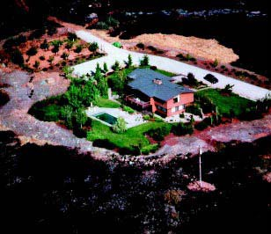This educational newspaper is available on-line. The newspaper displays step- by-step instructions on how to create a survivable space around your home taking into account topography and surrounding vegetation. Please visit [www.or.blm.gov/nwfire/docs/Livingwithfire.pdf](http://www.or.blm.gov/nwfire/docs/Livingwithfire.pdf) for more information.

The pre-fire activities implemented by this homeowner included a green and well- maintained landscape, reduction of wildland vegetation around the perimeter of the property, a fire resistant roof, and a good access road with a turnaround area. The charred surroundings of the home show that these pre-fire activities effectively protected it when wildfire hit.

**Figure 5. Photo courtesy of California**

**Department of Forestry and Fire Protection.**

*I’m Concerned….*

ODF is currently using the “I’m Concerned…” campaign for its fire prevention program. “I’m Concerned…” offers quick tips for burning debris safely, seasonal property clean up, safely building and extinguishing a campfire, burn barrel safety, and home fire safety. ODF publishes “I’m Concerned…” ads in the local newspapers and on their website as the time of year dictates. You can visit [www.odf.state.or.us/eastern/northeast/default.asp](http://www.odf.state.or.us/eastern/northeast/default.asp) anytime to get a copy of the fire safety tips.

*Firewise*

*Firewise* promotes fire-wise practices by, 1) educating citizens about the dangers of a wildfire in the area; 2) encouraging residents to take responsibility in reducing the risk of a wildfire and creating survivable space

*Structural Ignitability -* a term that relates to the cause of a home igniting during a wildfire. Cause could be attributed to the building materials used for the home or the amount of combustible materials around the home.

around their residence; and, 3) increasing awareness of the natural role of low- intensity fires and the benefits of prescribed burning or occasionally managing natural wildland fires to achieve ecological benefits while maintaining firefighter and public safety (visit [www.firewise.org](http://www.firewise.org/) for more information).

A term that is emphasized in this prevention program is structural ignitability. Structural ignitability is the ability of the building materials used for a home, deck or attached outbuilding to combust.

*Fire-Resistant Plants for Oregon Home Landscapes*

When landscaping around a home, most homeowners are concerned primarily with aesthetics. When homeowners are advised to remove flammable vegetation, they are often worried that the aesthetics of their landscape will be compromised.

Flammable plant material on the landscape can dramatically increase the fire risk around homes. Homeowners can find information about fire-resistant plant materials that aid in improving the chances of a home surviving wildfire while providing aesthetically pleasing color, texture, flowers, and foliage for the landscape. For details please visit [www.extension.oregonstate.edu/emergency/FireResPlants.pdf](http://www.extension.oregonstate.edu/emergency/FireResPlants.pdf).

*Cost-Share Grant Programs through National Fire Plan*

ODF provides homeowners within the WUI areas of Union County a free home site inspection. After the inspection, technical advice is shared with the homeowner as to what can be done to lessen the structural ignitability rating of the home. The amount and type of vegetation to be removed varies depending on the amount of survivable space needed to protect the home. This could entail

a substantial cost to the homeowner; however there may be grant funds available to share in the cost of the project.

In addition to the above-mentioned program, there is a separate program for larger landowners that have land within a Union County WUI. The larger large block landowners become an even higher priority if located in a WUI and adjacent to federal land. This program offers cost-share incentives for pre- commercial thinning, slash removal, brush removal, and/or ladder fuel removal. Contact ODF in La Grande at (541) 963-3168 to find out more about these programs.

*Land Use Planning*

Land use planning is an important part of ongoing efforts to mitigate the impact of development in WUI areas. Development in concert with the physical landscape and its inherent risks is the first line of defense against a major fire resulting in extensive private property damage and loss of life. Oregon has instituted the statewide land use planning program, which is administered by county and city planning departments. Union County administers the program through the Comprehensive Plan instituted by Union County Zoning, Partition and

Subdivision Ordinance (UCZPSO). UCZPSO requires all new development located within one quarter mile of forestland to meet Fire Siting Standards. Among other things the standards regulate access and building materials as well

as require on-site water for fire suppression. In addition they require a primary and secondary fuel break be maintained on the property.i

i Union County Zoning, Partition and Subdivision Ordinance, Siting Standards for Dwellings and Structures and Development and Fire Siting Standards (Adopted November 2, 1983).

***VI. Wildfire Risk Assessment***

**Methodology for Hazard Assessment*1***

To identify and prioritize wildland-urban interface areas-at-risk in Union County, an assessment of factors contributing to large wildfire events was conducted. This section will outline the process used and highlight any unfamiliar definitions. Two key documents were referenced for this process, as instructed by Oregon Department of Forestry:

1) *Field Guidance: Identifying and Prioritizing Communities at Risk.* National Association of State Foresters. June 27, 2003. (Available at: <http://www.stateforesters.org/reports>)

2) *Concept for Identifying and Assessment of Communities at Risk in Oregon.* Draft prepared by Jim Wolf, Fire Behavior Analyst, Oregon Department of Forestry. July 19, 2004. (Available by contacting Jim Wolf at [jwolf@odf.state.or.us](mailto:jwolf@odf.state.or.us))

These documents were used to expand the assessment of communities-at-risk to also include the assessment of wildland-urban interface areas-at-risk.

In Union County, a ***community-at-risk (CAR)*** is defined as a group of homes or other structures with basic infrastructure (such as shared transportation routes) and services within or near federal land. A ***wildland-urban interface area (WUI)*** surrounds a community at risk, including a community’s infrastructure or water source, and may extend beyond 1 ½ miles of a community, depending on topography, geographic features used as an effective firebreak, or Condition Class 3 land.

It is important that one understands the meaning of risk and hazard in relation to wildfire. Risk is the chance or probability of fire occurrence. Hazard is the exposure to risk, and in a wildfire those hazards can be related to the natural environment and the man-made environment. Natural hazards include fuel type and amount, topography, and weather. Man-made hazards include access to structures and wildland, availability of water, limited greenspace around structures, and ignitability of structures. Capability of firefighting resources will be compromised by the severity of both natural and man- made hazards.

**Fire Occurrence**

The rate of fire occurrence is an important component of the assessment. Fire history records for the last ten years (1994-2003) were used. Fire history data was compiled from the La Grande Ranger District and the Walla Walla Ranger District of the U, Oregon Department of Forestry-La Grande Unit, and the BLM. The fire occurrence rate (FOR) per 1,000 acres was used to yield a value of 1, 2, or 3 to be used to calculate overall hazard in the county.

The following are point assignments for fire occurrence per 1,000 acres for the 10-year period:

***Number of fires per 1,000 Acres***

***(1994 – 2003) Value***

1 – 2 fires for the 10 years 1

3 – 4 fires for the 10 years 2

5 + fires for the 10 years 3

**Fuels**

Data used to create a fuels inventory in a Geographical Information System (GIS) was derived from LandSat imagery provided by Oregon Department of Forestry for private lands and the

Wallowa-Whitman National Forest GIS and Oracle tables derived from stand exams and photo interpretation. For Union County, the increased risk of a large wildfire event is caused by the buildup of forest fuel and changes in vegetation composition over time. Unnaturally dense stands competing for limited water and nutrients are at increased risk of wildfire and insect and disease epidemics. Condition class for the county is minimal

at level 1, while condition class 2 and 3 dominate. This also means that fire regimes are altered from their historic range, which in turn sets Union County up for wildfires that will be larger in size, more intense and severe, causing landscape patterns to change significantly. One or more of the following activities may have caused this departure:

fire suppression, timber harvesting, livestock grazing, introduction and establishment of exotic plant species, introduced insects and disease, or other pest management activities. 2

Both surface and crown fuels were considered for the vegetation hazard. Surface fuel hazard was determined by using fire behavior fuel models and/or potential flame length. The table below displays the grouping of fuel models to determine hazard. Values were assigned for each fuel group:

***Fuel Group Value***

Group 1 (see Table 4) 1

Group 2 (see Table 4) 3

Group 3 (see Table 4) 5

**Table 4. Fuel Group Descriptions**

|  |  |
| --- | --- |
| ***Fuel***  ***Hazard Fuel Model Group Fire Characteristics***  ***Factor*** | |
| Grass, Low/less  flammable brush, and Typically produces a flame length of up to 5 feet; a wildfire that exhibits short-needle timber very little spotting, torching, or crowning, and which results in a burned  1 litter area that can normally be entered within 15 minutes. Low severity. (FM 1, 5, 8) | |
| Grass/Timber, Moderate brush,  conifer reproduction,  2 open sage and juniper  (FM 2, 6, 9) | Typically produces a flame length of 5 to 8 feet; a wildfire that exhibits sporadic spotting, torching, or crowning, and which results in a burned area that can normally be entered within one hour. Mixed severity. |
| Tall, flammable Typically produces a flame length of over 8 feet; a wildfire that exhibits grasses, frequent spotting, torching, or crowning, and which results in a burned  Heavy/flammable area that normally cannot be entered for over one hour. Stand  3 brush, timber/slash replacement severity. (FM 3, 4, 10-13) | |

Crown fuel hazard was derived from the vegetation conditions of the landscape and took into consideration the canopy closure and structure.

Total Vegetation Hazard was determined by combining the points assigned to the crown fuel hazard and points assigned to the surface fuel hazard. The total possible value for vegetation hazard is ten.

***Crown Fuel Group Value***

Low 1

Moderate 3

High 5

Historical notes have been kept for the GIS processes used and are archived at the Union County Emergency Services Office or the Oregon Department of Forestry Office in La Grande.

**Topographic Hazard**

Slope and aspect affect both the intensity and rate of wildfire spread. The topography hazard factor was derived from the Digital Elevation Model for Union County; values were assigned to the combination of slope and aspect working together on the landscape.

***Slope Value***

0 – 25% 1

25 – 50% 2

> 50% 3

***Aspect Value***

N, NE 1

NW, E 2

W, SE 3

S, SW, Flat 4

Total Topographic Hazard was determined by combining the points assigned to the slope hazard and points assigned to the aspect hazard. The total possible value for topographic hazard is seven.

**Overall Hazard**

Fire occurrence, the total topographic hazard rating, and the total fuel hazard rating were combined using *Spatial Analyst* (an ESRI product) to determine an overall hazard display of Union County. The maximum points assigned for fire occurrence was 3, the maximum points assigned for total topographic hazard was 7, and the maximum points assigned for total vegetation hazard was 10. The breakpoint used to determine high hazard was 10.5. Hence, anything with 10.5 or higher was considered high hazard, and anything lower was considered moderate / low hazard.

**Weather Hazard**

In Union County, weather patterns produce summer lightning storms that start many fires. These multiple starts put a strain on the wildland firefighting resources. Add the drying of fuels over time and low relative humidity, and the probability for large fires has increased. The number of days per season that forest fuels are capable of producing a significant fire event is important to consider. Oregon Department of Forestry has

already determined that Eastern Oregon is at the highest hazard rating for weather. This value was assigned by an analysis of daily wildfire danger rating indices in each regulated use area of the state. This value is constant across Union County; however weather patterns vary due to the mountainous landscape within the county. The high hazard value was offset with annual rainfall during the scoring of wildland-urban

interface areas in order to effectively prioritize each WUI, as well as reflect a true assessment of the local weather hazard.

**Overall Fire Protection Capability Hazards**

In Union County, local fire departments determined their overall capability for responding to a fire in their district. Each district submitted information to the Oregon Department of Forestry that included an inventory of roads that prohibit access to structures, water shortages, unprotected locations, structure density, building materials and defensible space around structures, and any other issues that pose a hazard to the fire district.

The WUI boundaries were drawn to capture the overall limitations of each fire protection district, fuel hazard, communities at risk and values-at-risk. Logical anchor points on the landscape were used to designate WUI boundaries, including natural fuel breaks, ridge lines, roads, and 6th field hydrological unit code (HUC) boundaries (identified using the GIS layer available in the Oregon Department of Forestry GIS library).

**Values at Risk**

The economic viability of Union County would suffer if a large wildfire eliminated valuable timber and destroyed recreational areas that draw tourists to the county. Citizens of Union County consistently identified the beauty and scenery as being of value. From anywhere within the Grande Ronde Valley of Union County, the forested landscape is within the viewshed of a community. A large wildfire could significantly affect that scenic value. Values-at-risk are subjective based on community input; however, it was possible to use the input in the scoring and prioritization of each WUI area. For more detailed information regarding values-at-risk derived from community input, please review the Values-At-Risk Questionnaire results found in Appendix B of this plan.

**Using the Hazard Assessment to Score and Prioritize WUI Areas** The hazard assessment information discussed previously was used to develop a scoring matrix that would provide results to be used for prioritizing the WUI areas within

Union County. The weighting of each element of the matrix was based on input received

from the community, steering committee, and statewide assessment information. The matrix is not statistically valid as the plan was designed to be community-driven. Community and steering committee input was captured in its raw form. The list of priorities helped the steering committee build a comprehensive inventory of projects and action items that could be implemented to protect the WUI areas from large wildfire.

The categories for the scoring matrix are:

9 Wildfire Hazard

9 Overall Fire Protection Capability/Structural Vulnerability

9 Values Protected

9 Weather

9 Opportunity for Fuels Reduction

A total of 150 points were established for the overall high score. Each of the categories was a percentage of that score. In Section VII of this document, the scoring matrix lists the scores received for each WUI, with a total of fifteen WUI's existing in Union County.

Cove Hazard Scoring

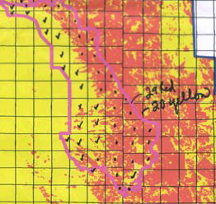**Category 1: Wildfire Hazard**

Sixty points were possible for the category of wildfire hazard, yielding 40% of the overall total score. The wildfire hazard was

based on the original layout done when total hazard was derived from ignition risk, topography, and fuels (see *Overall Hazard* in the *Methodology* section above.)

A simple GIS technique, known as majority rules, was used to determine whether a WUI

area had a low/moderate wildfire hazard rating or a high hazard rating. Sections from the public land survey (PLS) layer were counted within a WUI. Each section was analyzed based on the amount of color it had that represented high (red) or low/moderate (yellow). The dominating color of that section determined whether a section should be counted as "red" or "yellow." Then the number of "reds" and the number of "yellows" were tallied. If an area had more "yellow" sections than "red" sections, it received a score of 30. If an area had more "red" sections than "yellow" sections, it received a score of 60.

**Category 2: Overall Fire Protection Capability/Structural Vulnerability** This category of the scoring matrix consists of six areas to consider, with this category yielding 30% of the overall score. Different ranges represented low, moderate, and high

risk. A score of 0-15 gave the WUI a low hazard rating; a score of 16-30 gave the WUI a

moderate hazard rating; and a score of 31-45 gave the WUI a high hazard rating.

The six areas for consideration when assigning a score to Overall Fire Protection

Capability/Structural Vulnerability are:

9 Homesite Density

9 Ignition Risk Factors

9 Type Of Organized Fire Response

9 Structural Fire Agency Response Time

9 Level Of Community Preparedness

9 Structural Vulnerability Factors

**Category 3: Values Protected**

When scoring a WUI for values protected, a list was comprised of the values that the public noted in the questionnaire and from information gleaned from the public meetings. Also, municipal watershed and major transmission lines and corridors were added as those values are part of the legislation that was put forth under the Healthy Forest Restoration Act (HFRA). This category was 15% of the total score, with the possibility of receiving a high score of 22.5 points. If a WUI had 0-3 of those values

present, then a score of 7.5 was received; 3-5 present, then a score of 15 was received; and, 5 or more present, then a score of 22.5 was received. The scoring matrix in the appendix lists the values considered.

**Category 4: Weather Factor**

It was already mentioned in the *Methodology* section above that northeastern Oregon is considered to have a high hazard rating for weather. However, it was decided that the

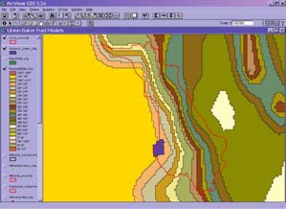high hazard rating should be offset with annual rainfall in order to reflect the unique weather patterns across

Union County. This category is 10% of the overall total score, with 15 points being the most a WUI could

receive for this category. If an area receives 25" or more annually, then a score of 5 was assigned. If an area receives 13-24" annually, then a score of 10 was assigned; and, if an area receives 12" or less annually, then a score of 15 was assigned. (Note: The layer used

Cove Annual Rainfall

to determine annual rainfall came from the Oregon Department of Forestry GIS library).

**Table 5. Individual WUI Score Sheet**

|  |
| --- |
| ***Score Sheet for Wildland Urban Interface Area at Risk*** |
| 1) Wildfire Hazard Rating (Ignition Risk, Topography, Fuels) = 40% of score  Low/Moderate = Score of 30  High = Score of 60 ***Score:*** |
| 2) Overall Fire Protection Capability / Structural Vulnerability Rating = 30% of score  Low Risk: Score 0 - 15  Moderate Risk: Score 16 - 30 ***Score:***  High Risk: 31 - 45 |
| 3) Values At Risk = 15% of score  Low = Score of 7.5 ***Score:***  Moderate = Score of 15  High = Score of 22.5 |
| 4) Weather Factor (High Hazard and Low Precipitation) = 10% of score  Low = Score of 5 (25+" annually) Moderate = Score of 10 (13-24" annually) High = Score of 15 (0-12" annually)  ***Score:*** |
| 5) Opportunity for Fuels Reduction Projects = 5% of score  Yes for Private; Yes for Federal/Other = 7.5  Yes for one; No for one = 5.0  No for both = 2.5  ***Score:***  ***Total:*** |

**Category 5: Opportunity for Fuels Reduction Projects**

To fully protect WUI areas from the risk of large wildfire, some level of fuels treatment will need to be conducted. Hence, this category was 5% of the overall total score (a high score of 7.5 is possible). If there was active fuels treatment taking place in a WUI or private landowners had expressed an interest in conducting a fuels treatment project and there

was an adjacent planned or completed project on

federal land, then the WUI received a score of 7.5. If there was a "yes" for one and a "no" for the other (with the same criteria as mentioned above), then the

WUI received a 5. If there wasn't any treatment being done or planned for the future and no interest on behalf of private landowners, then the WUI received a score of 2.5.

**Prioritization**

A list of priorities was established from the scores assigned to each WUI. The WUI with the highest score is at the top of the list and the WUI with the lowest score is at the bottom of the list. Projects and Action Items for each WUI were developed based on the reasons a WUI received a particular score in a particular category of the overall scoring matrix.

1 This document was authored by Angie Johnson, Oregon Department of Forestry-Northeast Oregon District, and edited by Trish Wallace, US Forest Service-Wallowa-Whitman office. The hazard assessment was conducted by both Trish and Angie.

2 *Expanded Fire Condition Class Definition Table.* Available at [http://www.frcc.gov](http://www.frcc.gov/).

35

***VII. Wildland-Urban Interface Areas***

**Wildland-Urban Interface Areas**

Sixteen WUI’s were identified which roughly correspond with rural residential areas in Union County. The Stubblefield Mountain and Beaver Creek Watershed areas tied for the sixth riskiest area. Table 6 identifies them in order of potential risk, with the highest risk listed first.

Each of the column headings corresponds with each category of the risk assessment. The key for Table 6 is:

|  |  |  |  |
| --- | --- | --- | --- |
| 1. | Wildfire Hazard | = | Fire occurrence, combined with vegetation and topography. |
| 2. | OFP/SV | = | Overall fire protection combined with structural vulnerability. |
| 3. | Values at Risk | = | Values at risk from wildfire as determined by VAR  questionnaire. |
| 4. | Wx Haz. | = | Weather hazard. |
| 5. | Opp. FR | = | Opportunity for fuels reduction partnerships or projects. |

**Individual Interface Information**

Each of the sixteen WUIs has a layout showing the boundaries and overall hazard of the region. Pertinent information about the interface areas is listed alongside the map. Risk assessment and project information is also listed here.

**Table 6. Wildland-Urban Interface Ranking Summary**

|  |  |  |  |  |  |  |  |
| --- | --- | --- | --- | --- | --- | --- | --- |
| **WUI Area** | **Wildfire**  **Hazard** | **OFP / SVR** | **Values at**  **Risk** | **Weather**  **Hazard** | **Opp. FR** | **Total**  **Score** | **Rank** |
|  | *Raw*  *Score/Rating* | *Raw*  *Score/Rating* | *Raw*  *Score/Rating* | *Raw*  *Score/Rating* | *Raw*  *Score/Rating* |  |  |
| ***Morgan*** | **60/H** | **37/H** | **22.5/H** | **10/M** | **5/M** | **134.5/150** | **#1** |
| ***Cove*** | **60/H** | **33/H** | **22.5/H** | **10/M** | **7.5/H** | **133/150** | **#2** |
| ***Mt. Emily*** | **60/H** | **35/H** | **22.5/H** | **5/L** | **7.5/H** | **130/150** | **#3** |
| ***Palmer*** | **60/H** | **29/M** | **22.5/H** | **10/M** | **7.5/M** | **129/150** | **#4** |
| ***Perry/Hilgard*** | **60/H** | **33/H** | **22.5/H** | **5/L** | **7.5/H** | **128/150** | **#5** |
| ***Stubblefield*** | **60/H** | **37/H** | **15/M** | **5/L** | **5/M** | **122/150** | **#6** |
| ***Beaver Creek***  ***Watershed*** | **60/H** | **32/H** | **22.5/H** | **5/L** | **2.5/L** | **122/150** | **#6** |
| ***Catherine***  ***Creek*** | **60/H** | **26/M** | **22.5/H** | **5/L** | **7.5/H** | **121/150** | **#7** |
| ***Blue Springs*** | **60/H** | **35/H** | **15/M** | **5/L** | **5/M** | **120/150** | **#8** |
| ***Medical***  ***Springs*** | **60/H** | **24/M** | **22.5/H** | **5/L** | **7.5/H** | **119/150** | **#9** |
| ***Kamela*** | **60/H** | **22/M** | **15/M** | **5/L** | **7.5/H** | **109.5/150** | **#10** |
| ***Pumpkin***  ***Ridge /Ruckle*** | **30/L-M** | **34/H** | **22.5/H** | **10/M** | **7.5/H** | **104/150** | **#11** |
| ***Elkanah*** | **30/L-M** | **39/H** | **15/M** | **10/M** | **7.5/H** | **101.5/150** | **#12** |
| ***Clark*** | **30/L-M** | **30/M** | **22.5/H** | **10/M** | **5/M** | **97.5/150** | **#13** |
| ***Rysdam*** | **30/L-M** | **29/M** | **22.5/H** | **10/M** | **5/M** | **96.5/150** | **#14** |
| ***Starkey*** | **30/L-M** | **33/H** | **15/M** | **10/M** | **7.5/H** | **95.5/150** | **#15** |
| ***L = Low M = Medium H = High*** | | | | | | | |

**WU I Areas of Union County**

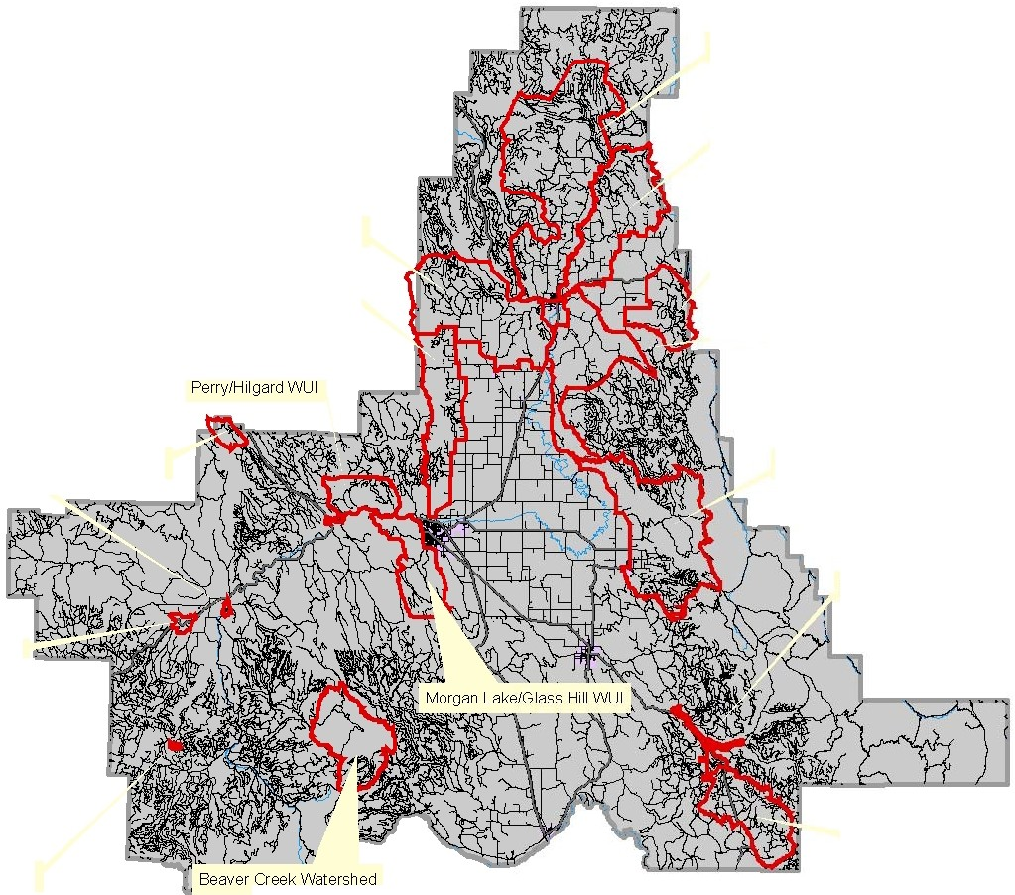

**Legend** 6

**c:J\MJI Boundary N**

PalmerWUI

Rysdam/Duncan WUI

-- **Highways/Interstate**

**Roads Rivers Cities**

**c:JUnion County**

Pumpkm/Ruckle WUI Mt.Em1yl WUI

Stubblefield Mt. WUI Clark/Indian WUI

Starkey WUI

Kamela WUI CoveWUI

Catherine Cr. WUI

Camp Elkanah WUI

® Blue Spring WUI

--

**Northeast Oregon District GIS -agj**

**La Grande,OR**

**July25,2005**

Med1cal Springs WUI

1For VisualmDisplay Only

w

Q:l

**WUI Name:** Morgan Lake / Looking Glass Hill **Priority Category:** High

|  |  |  |  |  |  |  |
| --- | --- | --- | --- | --- | --- | --- |
| **Risk Assessment Factors** | | | | | | |
| **Wildfire Hazard, including: Fire Occurrence, Topography & Total Fuels** | **Overall Fire**  **Protection & Structural Vulnerability** | **Values**  **At-Risk** | **Weather**  **Hazard** | **Opportunity for Fuels Reduction** | **Score** | **Rank** |
| **60** | **37** | **22.5** | **10** | **5** | **134.5** | **1** |

**Communities at Risk:** Morgan Lake, City of La Grande

**Structural Fire Protection Agency:** La Grande Fire Department protects to the City

Limit; otherwise it is wildland fire protection only.

**Projects:** Many projects identified in this plan apply to all wildland-urban interface areas because they are broader in scope or represent general outreach messages or educational opportunities. Those listed here are specific to individual interface areas in Union County.

|  |  |  |
| --- | --- | --- |
| **WUI – Specific Projects** | **Timeframe** | **Lead Agency/Cooperators** |
| Morgan Lake Private Lands | • 1-2 years | • ODF; Landowners, LGFD; LGRFPD |
| Prepare Morgan Lake Evacuation Plan | • 1-2 years | • UCES; UCPW; UCSO |
| Reconstruct Morgan Lake Road | • 3 + years | • UCPW; ODOT |
| Establish RFPD for Morgan Lake | • 3 + years | • Landowners; UC; Structural Agencies |

39

**Union County WUI Boundaries**

**(with Shaded Relief)**

R37 E R38 E

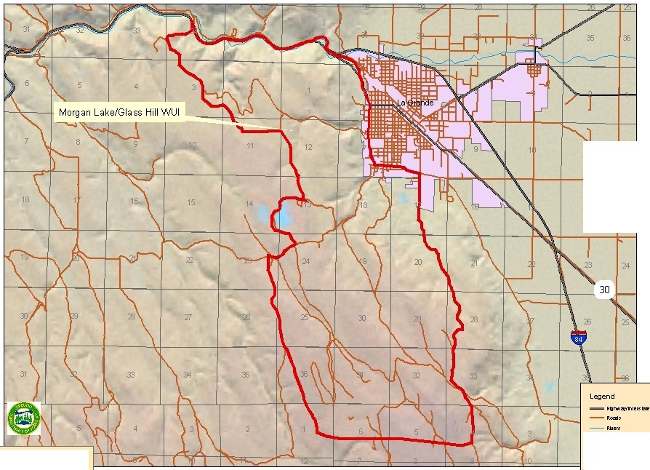

T2S

12

14 13

T3S

.[:,

6.

**c::Jc**.**•**.**•**.**u**

N

8

**Northeast Oregon District GIS - agj**

La Grande,OR

0 July 25,2005 For VisualDisplay 0nly

**UI'WI COOIItf 8o..,..sy**

**IIW18 sy**

**Union County WUI Boundaries**

**(with Wildfire Hazard)**

R38 E

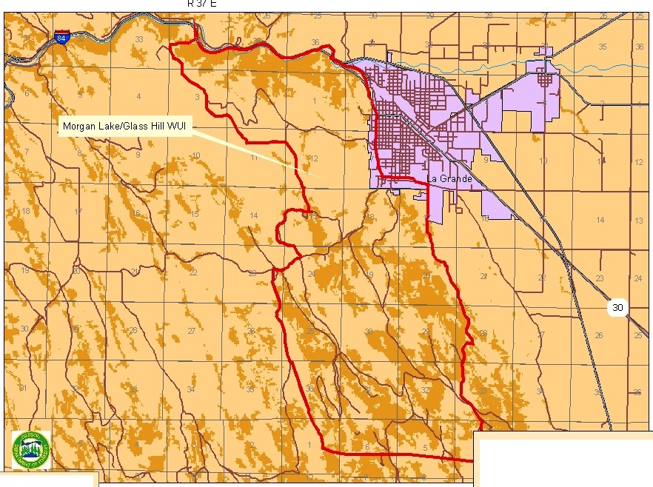

T2S

T3S

**Legend**

6.

**C IIWI&ou"ey DPLS**

N

- **.., ,..ntuat I::JIJ'ja C8oo.l'ey**

.[:,

Northeast Oregon District GIS - agj

La Grande.OR

July 25. 2005

- **Aoells c::J <llt alt (f'-£1J,'RicloO._,ry,flOoa.m )**

- **1'1 C"'"'"•u. oo..,rv.u o )**

**c::Ja•s** For VisualDisplay 0nly

**WUI Name:** Cove **Priority Category:** High

|  |  |  |  |  |  |  |
| --- | --- | --- | --- | --- | --- | --- |
| **Risk Assessment Factors** | | | | | | |
| **Wildfire Hazard, including: Fire Occurrence, Topography & Total Fuels** | **Overall Fire**  **Protection & Structural Vulnerability** | **Values**  **At-Risk** | **Weather**  **Hazard** | **Opportunity for Fuels Reduction** | **Score** | **Rank** |
| **60** | **33** | **22.5** | **10** | **7.5** | **133** | **2** |

**Communities at Risk:** City of Cove, Lower Cove, High Valley and adjacent rural residential areas.

**Structural Fire Protection Agency:** Cove Rural Fire Protection District.

**Projects:** Many projects identified in this plan apply to all wildland-urban interface areas because they are broader in scope or represent general outreach messages or educational opportunities. Those listed here are specific to individual interface areas in Union County.

|  |  |  |
| --- | --- | --- |
| **WUI – Specific Projects** | **Timeframe** | **Lead Agency/Cooperators** |
| Cove Treatment | • 3 + years | • USFS; ODF; Landowners, Cove RFPD;  UC Forest Restoration Board; Industrial  Forestland Owners |
| Cove Private Lands | • 1-2 years | • ODF; Landowners; Cove RFPD |

42

**Union County WUI Boundaries**

**(with Shaded Relief)**

R39 E R 40 E R 41 E

T2 S

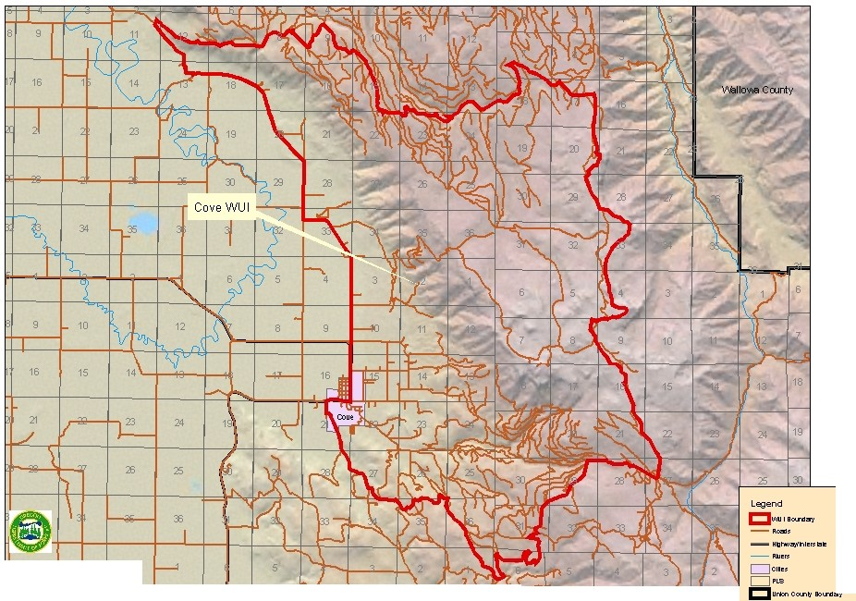

T3S

6.

N

.[:,

v:>

Northeast Oregon District GIS - agj I I \ I \ ) *II rv* cr I I / I \ I I

July 25,2005 For VisualDisplay 0nly

.-------2

LaGrande,OR I I **1** I I [V ,.

**Union County WUI Boundaries**

**(with Wildfire Hazard)**

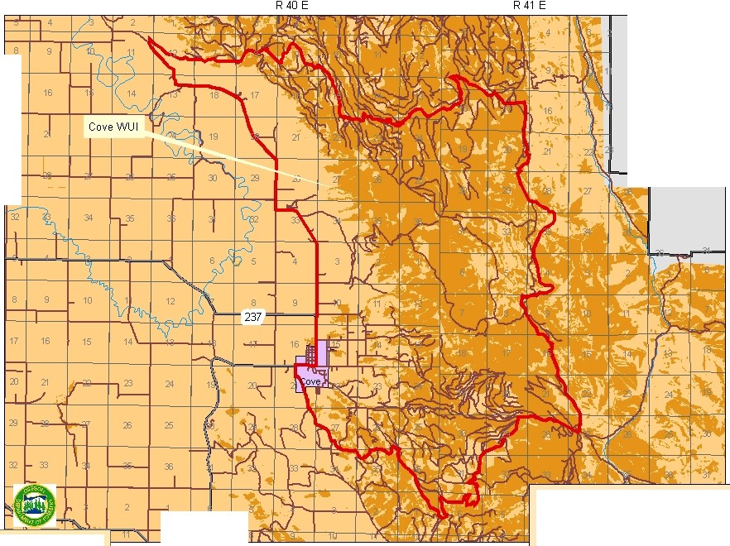

17

T2S

2J

Vlbllo'MI Ccunty

T3S

**Legend**

6.

**C IIWIIou"ey c:JPI.S**

........ **.., Nf'ltUitt CIJ'ja C8oo.l'ey** N

.[:,

.[:,

Northeast Oregon District GIS - agj 12

La Grande.OR

July 25.2005

- **Aoells D <llt alt (f'-£1J,'RicloO._,ry,uooa.mrwz)**

- **1'1 C..ol'l(h•u. oo..,rv.u o l'l!Z)**

**c::Ja•s** For Visual Display 0nly

**WUI Name:** Mt. Emily **Priority Category:** High

|  |  |  |  |  |  |  |
| --- | --- | --- | --- | --- | --- | --- |
| **Risk Assessment Factors** | | | | | | |
| **Wildfire Hazard, including: Fire Occurrence, Topography & Total Fuels** | **Overall Fire**  **Protection & Structural Vulnerability** | **Values**  **At-Risk** | **Weather**  **Hazard** | **Opportunity for Fuels Reduction** | **Score** | **Rank** |
| **60** | **35** | **22.5** | **5** | **7.5** | **130** | **3** |

**Communities at Risk:** Mt. Emily, Owsley Canyon and adjacent rural residential areas.

**Structural Fire Protection Agency:** La Grande and Imbler Rural Fire Protection

Districts.

**Projects:** Many projects identified in this plan apply to all wildland-urban interface areas because they are broader in scope or represent general outreach messages or educational opportunities. Those listed here are specific to individual interface areas in Union County.

|  |  |  |
| --- | --- | --- |
| **WUI – Specific Projects** | **Timeframe** | **Lead Agency/Cooperators** |
| Mt. Emily Treatment | • 3 + years | • USFS; ODF; Private & Industrial  Landowners; LG & Imbler RFPDs; UC Forest Restoration Board |
| Mt. Emily Private Lands | • 1-2 years | • ODF; Private & Industrial Landowners; LG & Imbler RFPDs |

45

**Union County WUI Boundaries**

**(with Shaded Relief)**

R38 E R39 E

T1S

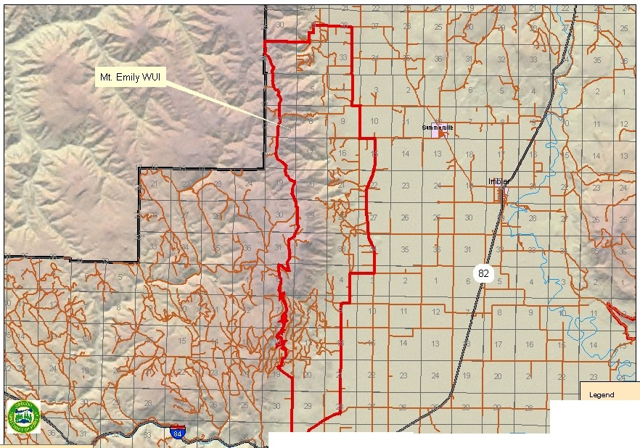

l:l::i

.[:,

m

NortheastOregonDistridGIS-agj 84 I,"' t-:--t1J\Is:

La Grande,OR

July 25.2005

For VisualDisplay 0nly

6.

--**"**-**'"'"**·**"•n•t1'11tlt N**

,.,.

**c::Jc**.**•**.**•**.**u**

8

**Ul't:ln CCU'Itf 8o.....sy**

**11W 18oonllsy**

Union County WUI Boundaries

(with Wildfire Hazard)

t'Rr38 E R39 E

:--.:. x. :

+7mily1 ; J .'

. - :?5

T1S

Umatilla County

J 11:1I f-r's I , 4 *Wir,* 1

11} t z',l)t' fm 1 11

- ·- ..

-te

1t_r 14 1 13 11

1 t *Yb*vV\l1m

*Jt¥.* $I 1 211t ;

(

'SQ.¥ t:l:?AhlfU7 I 26 I r1

)J

1. hl ,

- I J} \f. tt:J'fl;l·I ll t '1'1 ' I'

T2S

2 1

1 11 12

I

l *1*

6.

Legend

B''"

C IIWI&ou"ey

N

.....,.. ..O Nf'ltUitt IJ'ja C8oo.l'ey

-Aoells D <llt alt (f'-£1J,'RicloO._,ry,uooa.mrwz)

Northeast Oregon District GIS - agj - 1'1 .:::::::::1"' " ''uu. <11..,rv.uo l'l!Z)

.-[.:.,

La Grande,OR

July 25, 2005

c::Ja•s For VisualDisplay 0nly

**WUI Name:** Palmer Valley / Valley View **Priority Category:** High

|  |  |  |  |  |  |  |
| --- | --- | --- | --- | --- | --- | --- |
| **Risk Assessment Factors** | | | | | | |
| **Wildfire Hazard, including: Fire Occurrence, Topography & Total Fuels** | **Overall Fire**  **Protection & Structural Vulnerability** | **Values**  **At-Risk** | **Weather**  **Hazard** | **Opportunity for Fuels Reduction** | **Score** | **Rank** |
| **60** | **29** | **22.5** | **10** | **7.5** | **129** | **4** |

**Communities at Risk:** Palmer Valley, Valle View Road area, City of Elgin and adjacent rural residential areas.

**Structural Fire Protection Agency:** Elgin Rural Fire Protection District.

**Projects:** Many projects identified in this plan apply to all wildland-urban interface areas because they are broader in scope or represent general outreach messages or educational opportunities. Those listed here are specific to individual interface areas in Union County.

|  |  |  |
| --- | --- | --- |
| **WUI – Specific Projects** | **Timeframe** | **Lead Agency/Cooperators** |
| Palmer Valley Private Lands | • 1-2 years | • ODF; Landowners; Elgin RFPD |

48

**Union County WUI Boundaries**

**(with Shaded Relief)**

R38 E R39 E R 40E

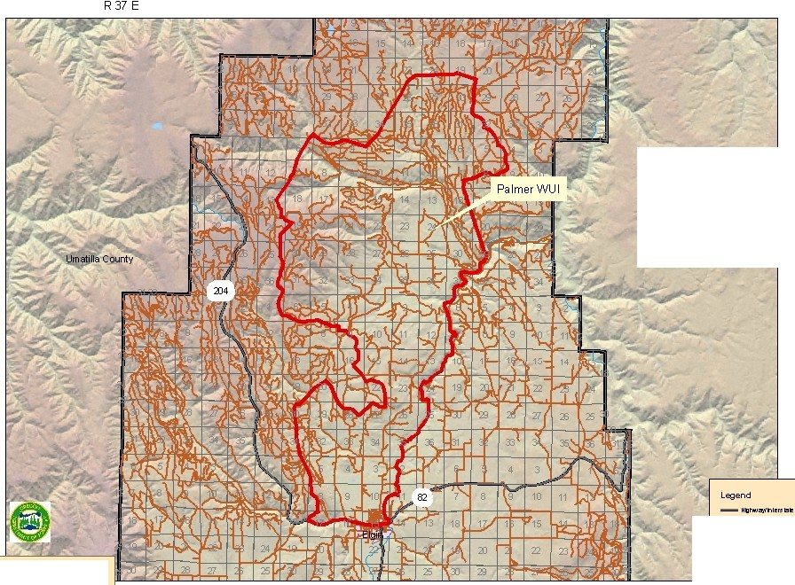

Vllollo'M> Crunty

T3N

T2N

T1N

<D

La Grande.OR

6.

--,-.,·.

N

**c::Jc**.**•**.**•**.**u**

8**W 18oonllsy**

.!:>

Northeast Oregon District GIS - agj

July 25.2005 For VisualDisplay 0nly

**Ul't:ln CCU'Itf 8o.....sy**

**11**

**Union County WUI Boundaries**

**(with Wildfire Hazard)**

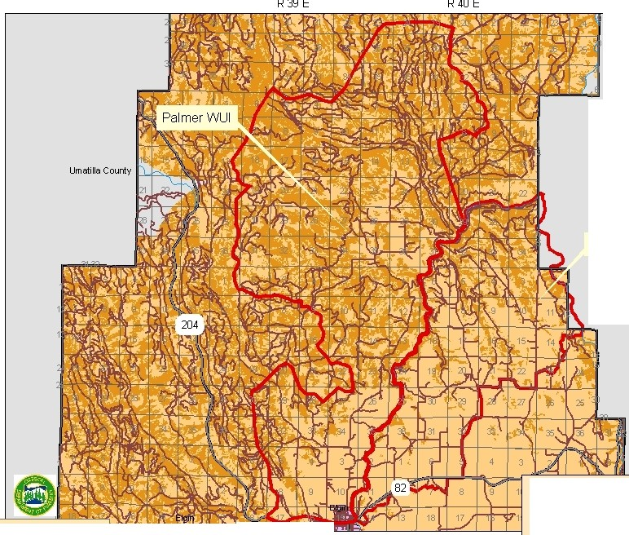

WIIIOIMI Ccunty

T3N

Rysd*amiD* uncan V\IUI

T2N

U'l

0

Northeast Oregon Dislrid GIS - agj p 'S \'" r• *I* \ l i l -,n ,'<\ I ***t1*** I - .:r ·a1'!1

La Grande. OR

July 25,2005

.egend *{j,*

**t::=satB <nC N**

- **Aoells D <llt alt (f'-£1J,'RicloO._,ry,uooa.mrwz)**

- **1'1 C..ol'l(h•u. oo..,rv.u o l'l!Z)**

**Oa•s** For VisualDisplay 0nly

**WUI Name:** Perry / Hilgard **Priority Category:** High

|  |  |  |  |  |  |  |
| --- | --- | --- | --- | --- | --- | --- |
| **Risk Assessment Factors** | | | | | | |
| **Wildfire Hazard, including: Fire Occurrence, Topography & Total Fuels** | **Overall Fire**  **Protection & Structural Vulnerability** | **Values**  **At-Risk** | **Weather**  **Hazard** | **Opportunity for Fuels Reduction** | **Score** | **Rank** |
| **60** | **33** | **22.5** | **5** | **7.5** | **128** | **5** |

**Communities at Risk:** Upper and Lower Perry, Hilgard.

**Structural Fire Protection Agency:** Wildland fire protection only.

**Projects:** Many projects identified in this plan apply to all wildland-urban interface areas because they are broader in scope or represent general outreach messages or educational opportunities. Those listed here are specific to individual interface areas in Union County.

|  |  |  |
| --- | --- | --- |
| **WUI – Specific Projects** | **Timeframe** | **Lead Agency/Cooperators** |
| Establish a Perry / Hilgard RFPD | • 3 + years | • Landowners; UC; Structural Agencies |
| Pelican Creek Treatment | • 1-2 years | • USFS |
| Three Cabin Creek Treatment | • 1-2 years | • USFS |

51

**Union County WUI Boundaries**

**(with Shaded Relief)**

R37 E

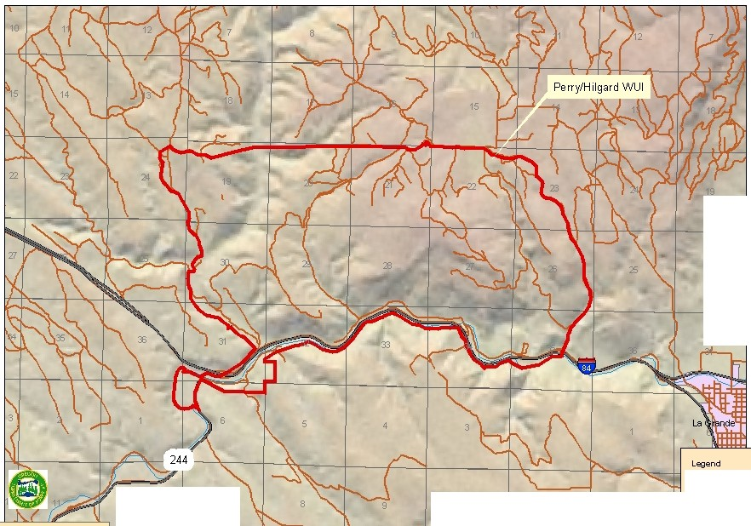

T2S

:D

12 *7*

10 11 12

6.

**"'"'""•n•t1'11tlt N**

---·

_ ,.,.

**c::Jc•**.**•**.**u**

U'l tV

NortheastGIS · agj I I I) I I\. (I I I 1 1;:,:;.,.,.., I

July 25,2005 For VisualDisplay 0nly

Union County WUI Boundaries

(with Wildfire Hazard)

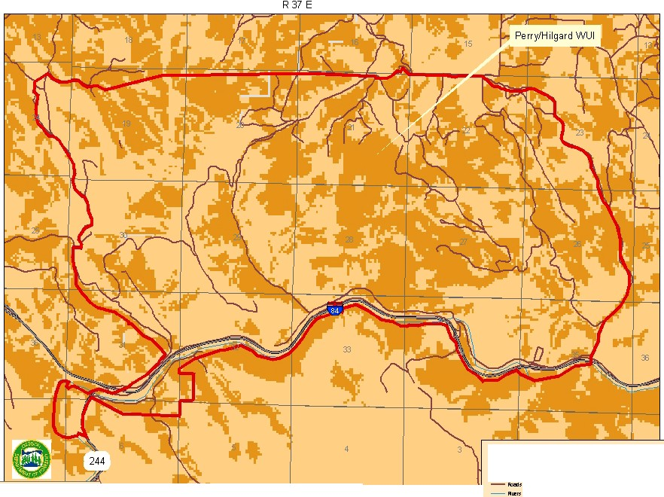

T2S

Legend

6.

C IIWI&ou"ey DPLS

N

- .., ,..ntuat I::JIJ'ja C 8oo.l'ey

U'l

v:>

Northeast Oregon District GIS - agj I

La Grande.OR July 25.2005

D <lltlalt (f'-£1J,'Riclo0..,ry,flOoa.m )

C"OI'I(fuu. oo._,ry,llo )

c::Ja•s For Visual Display 0nly

**WUI Name:** Stubblefield **Priority Category:** High

|  |  |  |  |  |  |  |
| --- | --- | --- | --- | --- | --- | --- |
| **Risk Assessment Factors** | | | | | | |
| **Wildfire Hazard, including: Fire Occurrence, Topography & Total Fuels** | **Overall Fire Protection & Structural**  **Vulnerability** | **Values**  **At-Risk** | **Weather**  **Hazard** | **Opportunity for Fuels Reduction** | **Score** | **Rank** |
| **60** | **37** | **15** | **5** | **5** | **122** | **6** |

**Communities at Risk:** Stubblefield Mountain area.

**Structural Fire Protection Agency:** Wildland fire protection only.

**Projects:** Many projects identified in this plan apply to all wildland-urban interface areas because they are broader in scope or represent general outreach messages or educational opportunities. Those listed here are specific to individual interface areas in Union County.

|  |  |  |
| --- | --- | --- |
| **WUI – Specific Projects** | **Timeframe** | **Lead Agency/Cooperators** |
|  | • | • |
|  | • | • |
|  | • | • |
|  | • | • |

54

Union County WUI Boundaries

(with Shaded Relief)

R40 E R 41 E

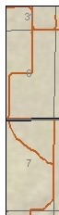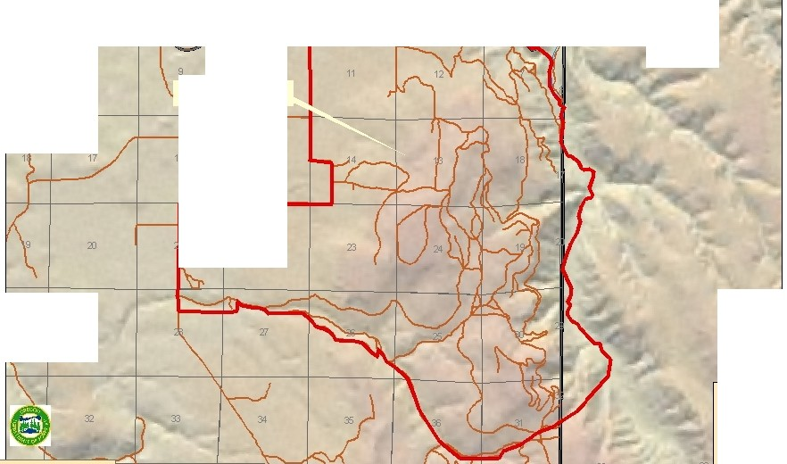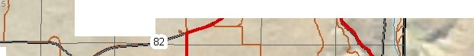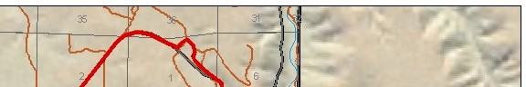

33 34

4 3

W.llo'M> Crunty

8 10

Stubblefield Mt. WUI

T1N

|  |  |  |
| --- | --- | --- |
|  | | 15 |
|  |  |
|  | 22 | |

3J *I* 29

Legend 6..

--"-'"'"·"•n•t1'11tlt N

_ ,...,..

c::Jc••u

U'l

y 25,2005 8

Northeast Oregon District GIS - agj urw

CCU'Itt

eo...-.sy

U'l

La Grande. 0R IIW ,aoon sy

Jul

**Union County WUI Boundaries**

**(with Wildfire Hazard)**

R 41 E

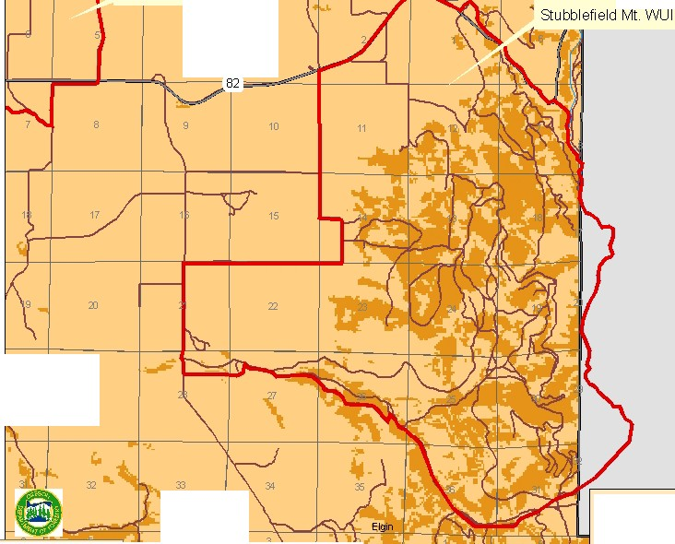

4 3

Vlbllo'MI Ccunty

T1N

I 23

Northeast Oregon Dislrid GIS - agj I'I f \ I - \ I \ \... r *I* """-J *l* ),-.. 'I *I* I

**Legend**

6.

**C IIWI&ou"ey DPLS**

N

- **.., ,..ntuat I::JIJ'ja C8oo.l'ey**

Um'l

4 Elgin

- **Aoells c::J <llt alt (f'-£1J,'RicloO._,ry,flOoa.m )**

- **1'1 C"'"'"•u. oo..,rv.u o )**

La Grande,OR

July 25,2005

**c::Ja•s**

For VisualDisplay 0nly

**WUI Name:** Beaver Creek Watershed **Priority Category:** High

|  |  |  |  |  |  |  |
| --- | --- | --- | --- | --- | --- | --- |
| **Risk Assessment Factors** | | | | | | |
| **Wildfire Hazard, including: Fire Occurrence, Topography & Total Fuels** | **Overall Fire**  **Protection & Structural Vulnerability** | **Values**  **At-Risk** | **Weather**  **Hazard** | **Opportunity for Fuels Reduction** | **Score** | **Rank** |
| **60** | **32** | **22.5** | **5** | **2.5** | **122** | **6** |

**Communities at Risk:** City of La Grande.

**Structural Fire Protection Agency:** Wildland fire protection only.

**Projects:** Many projects identified in this plan apply to all wildland-urban interface areas because they are broader in scope or represent general outreach messages or educational opportunities. Those listed here are specific to individual interface areas in Union County.

|  |  |  |
| --- | --- | --- |
| **WUI – Specific Projects** | **Timeframe** | **Lead Agency/Cooperators** |
|  | • | • |
|  | • | • |
|  | • | • |
|  | • | • |

57

Union County WUI Boundaries

(with Shaded Relief)

R37 E

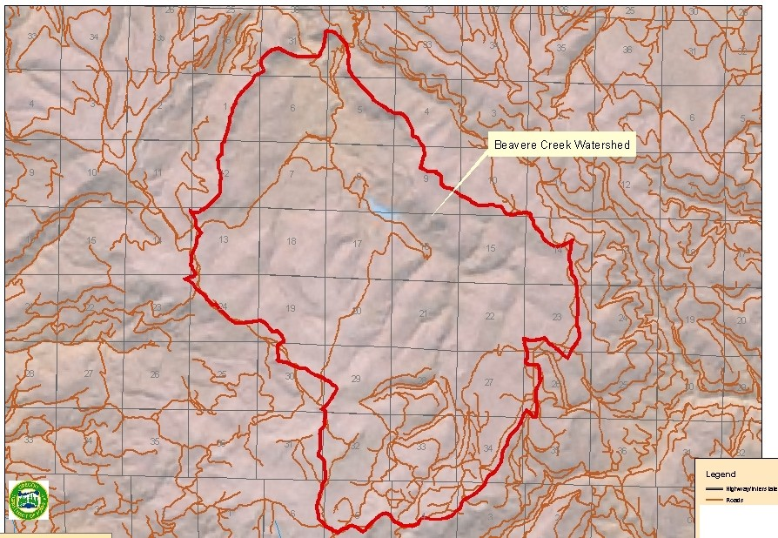

T5S

U'l

La Grande,OR

6.

_ ,.,.

...

N

c:Jc••u

8IIW.a«n sy

Northeast Oregon District GIS - agj urwc0011" eo.....sy

*(f:)*

July 25,2005

Union County WUI Boundaries

(with Wildfire Hazard)

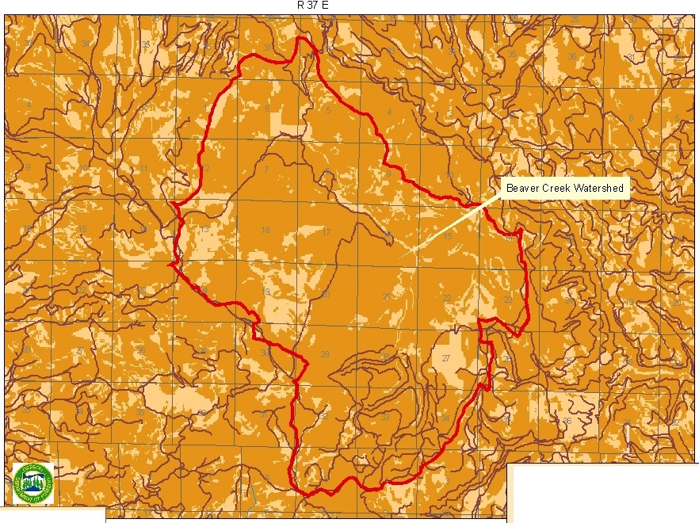

T5S

Legend /\

w

C IIWIIou"ey c:J PLS

U'l

<D

Northeast Oregon District GIS - agj

La Grande.OR

July 25. 2005

- .., ,..ntuat I:::JIJ'ja Ceoo.rey N

- Aoells c::J <llt alt (f'-£1J,'RicloO._,ry,flooa.m )

- 1'1 C"'"'"•u. oo..,rv.u o )

c::Ja•s For VisualDisplay 0nly

**WUI Name:** Catherine Creek **Priority Category:** High

|  |  |  |  |  |  |  |
| --- | --- | --- | --- | --- | --- | --- |
| **Risk Assessment Factors** | | | | | | |
| **Wildfire Hazard, including: Fire Occurrence, Topography & Total Fuels** | **Overall Fire**  **Protection & Structural Vulnerability** | **Values**  **At-Risk** | **Weather**  **Hazard** | **Opportunity for Fuels Reduction** | **Score** | **Rank** |
| **60** | **26** | **22.5** | **5** | **7.5** | **121** | **7** |

**Communities at Risk:** Catherine Creek area.

**Structural Fire Protection Agency:** Wildland fire protection only.

**Projects:** Many projects identified in this plan apply to all wildland-urban interface areas because they are broader in scope or represent general outreach messages or educational opportunities. Those listed here are specific to individual interface areas in Union County.

|  |  |  |
| --- | --- | --- |
| **WUI – Specific Projects** | **Timeframe** | **Lead Agency/Cooperators** |
| South Fork Catherine Creek | • 3 + years | • USFS; ODF; Private & Industrial  Landowners; Union RFPD; UC Forest  Restoration Board |
| Catherine Creek Corridor Private Lands | • 3 + years | • ODF; Landowners; Union RFPD |
| Catherine Creek Corridor Mapping | • 1-2 years | • ODF; Landowners; Union RFPD |

60

**Union County WUI Boundaries**

**(with Shaded Relief)**

R 41 E

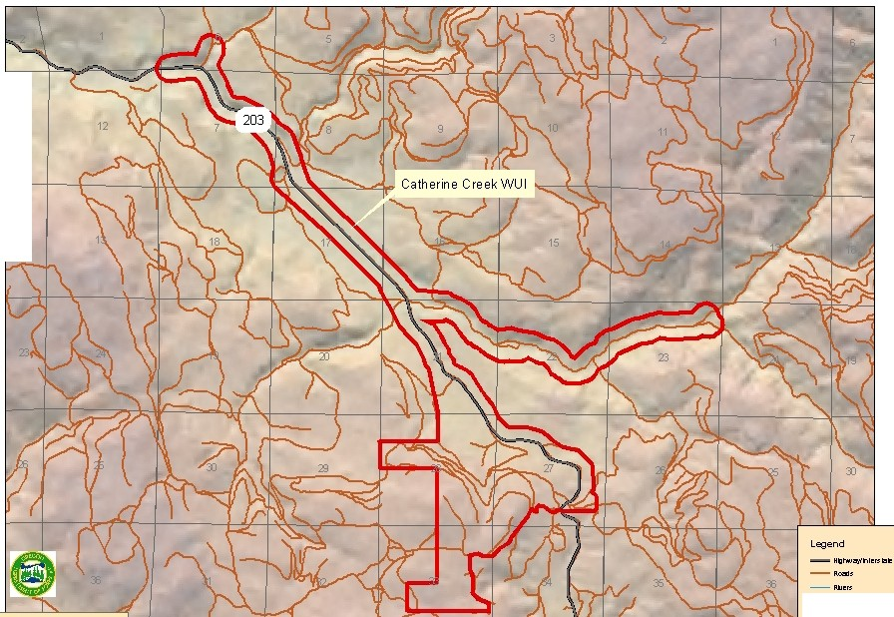

11

14

T5S

6.

N

**c::Jc•**.**•**.**u**

m NortheastGIS - agj r I 6 *I* I I *2* [ I '\\ *Uk=* . I '-, \ ' =.:.:,.:..., I

July 25,2005 For VisualDisplay 0nly

**Union County WUI Boundaries**

**(with Wildfire Hazard)**

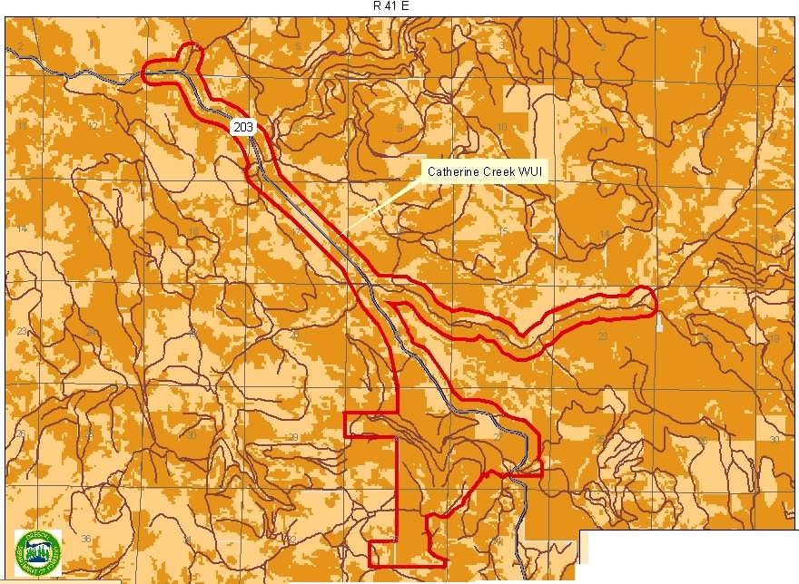

T5S

NortheastOregonDistridGIS-agj  **r** ·". I = --· o- ..· ·(1..-......... -·



**Legend *1\***

I *j* 'f1 **f ;p \\ -··-···..**

**C IIWI&oo.rey c:JPLS w**

**··C.. ·---** N

m **La Grande, OR -111 1'1 - "OI'I(Fuu. oo..,rv.uo )**

tV July 25,2005 D••• For Visual Display 0nly

**WUI Name:** Blue Springs **Priority Category:** High

|  |  |  |  |  |  |  |
| --- | --- | --- | --- | --- | --- | --- |
| **Risk Assessment Factors** | | | | | | |
| **Wildfire Hazard, including: Fire Occurrence, Topography & Total Fuels** | **Overall Fire**  **Protection & Structural Vulnerability** | **Values**  **At-Risk** | **Weather**  **Hazard** | **Opportunity for Fuels Reduction** | **Score** | **Rank** |
| **60** | **35** | **15** | **5** | **5** | **120** | **8** |

**Communities at Risk:** Blue Springs area.

**Structural Fire Protection Agency:** Wildland fire protection only.

**Projects:** Many projects identified in this plan apply to all wildland-urban interface areas because they are broader in scope or represent general outreach messages or educational opportunities. Those listed here are specific to individual interface areas in Union County.

|  |  |  |
| --- | --- | --- |
| **WUI – Specific Projects** | **Timeframe** | **Lead Agency/Cooperators** |
| Blue Springs Maintenance | • Ongoing | • USFS |

63

**Union County WUI Boundaries**

**(with Shaded Relief)**

R35 E

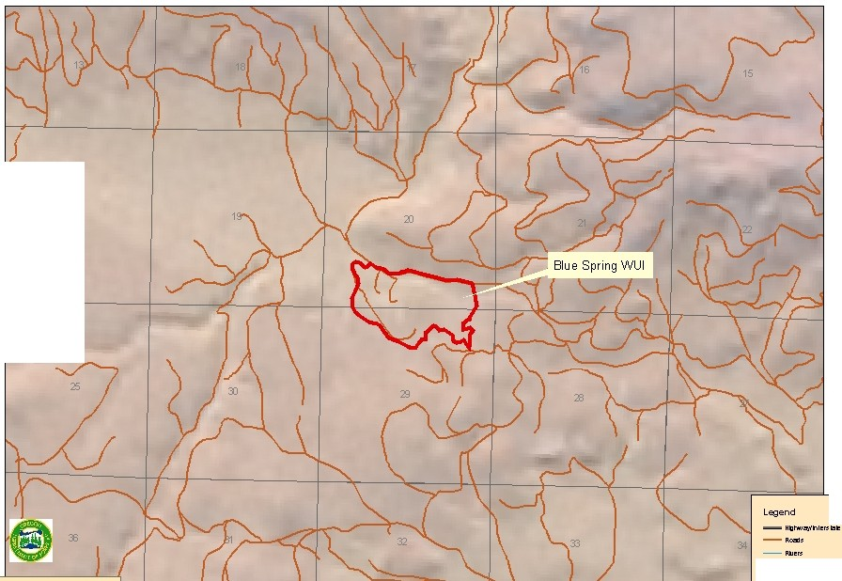

24

T5S

**Legend** 6._

N

NortheastGIS -agj I / */1* / I / - I - 1;:,:.;,:.,.., I

**c::Jc•**.**•**.**u**

July 25,2005 For VisualDisplay 0nly

**Union County WUI Boundaries**

**(with Wildfire Hazard)**

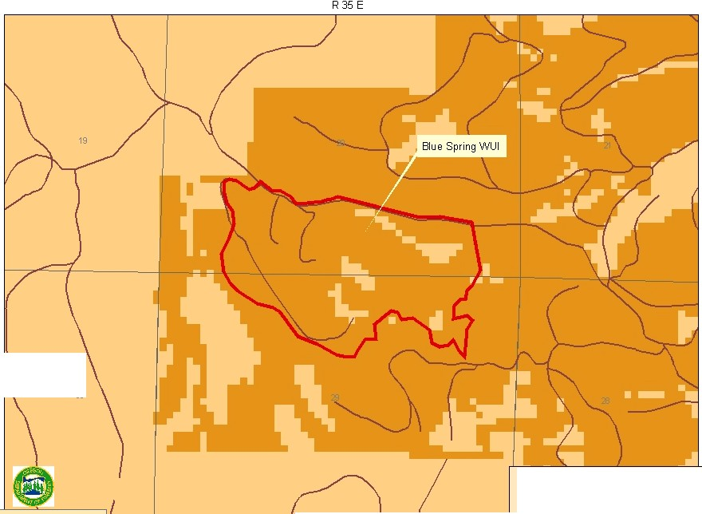

T5S

::0

**-Le=ge:nd=,.t**

6

**B <nCOOif/ N**

m

*(}1*

Northeast Oregon Dislrid GIS - agj

La Grande.OR

July 25.2005

-**Aoells c::J"-d..<llt alt (f'-£1J,'RIIIOO._,IV,IIOoa.ml'l!Z)**

- **1'1 ..OI'I(h•s. oo._,ry,u o rwz)**

**c::Ja•s** For Visual Display 0nly

**WUI Name:** Medical Springs **Priority Category:** High

|  |  |  |  |  |  |  |
| --- | --- | --- | --- | --- | --- | --- |
| **Risk Assessment Factors** | | | | | | |
| **Wildfire Hazard, including: Fire Occurrence, Topography & Total Fuels** | **Overall Fire**  **Protection & Structural Vulnerability** | **Values**  **At-Risk** | **Weather**  **Hazard** | **Opportunity for Fuels Reduction** | **Score** | **Rank** |
| **60** | **24** | **22.5** | **5** | **7.5** | **119** | **9** |

**Communities at Risk:** Medical Springs, Pondosa and adjacent rural residential areas.

**Structural Fire Protection Agency:** Medical Springs Rural Fire Protection District.

**Projects:** Many projects identified in this plan apply to all wildland-urban interface areas because they are broader in scope or represent general outreach messages or educational opportunities. Those listed here are specific to individual interface areas in Union County.

|  |  |  |
| --- | --- | --- |
| **WUI – Specific Projects** | **Timeframe** | **Lead Agency/Cooperators** |
| Medical Springs (Bald Angel) - Planning | • 3 + years | • USFS |

66

**Union County WUI Boundaries**

**(with Shaded Relief)**

R 41 E R 42 E

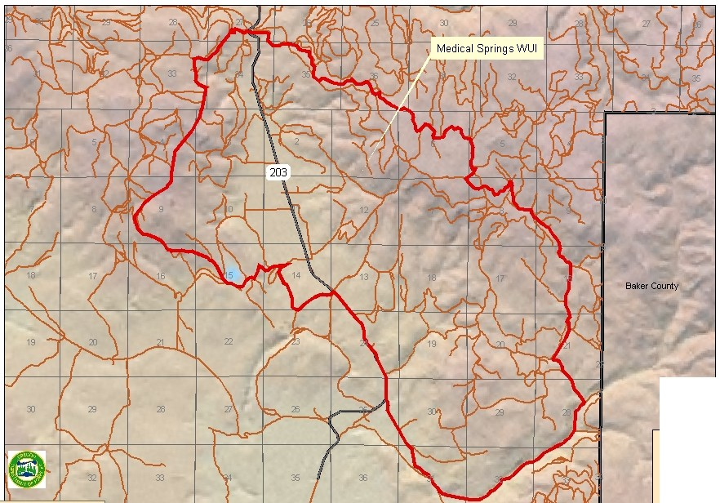

T6S

-.1

**La Grande, 0R**

**Legend** 6..

--**"**-**'"'"**·**"•n•t1'11tlt N**

_ ,...,..

**c::Jc••u**

8IIW ,**aoon sy**

m Northeast Oregon District GIS - agj I !! I *<* 0 I

a *(*

I I ) g I 5 JJI ."97: **YN** I ,,..,··""""' I

July 25.2005 For VisualDisplay 0nly

Union County WUI Boundaries

(with Wildfire Hazard)

T6S

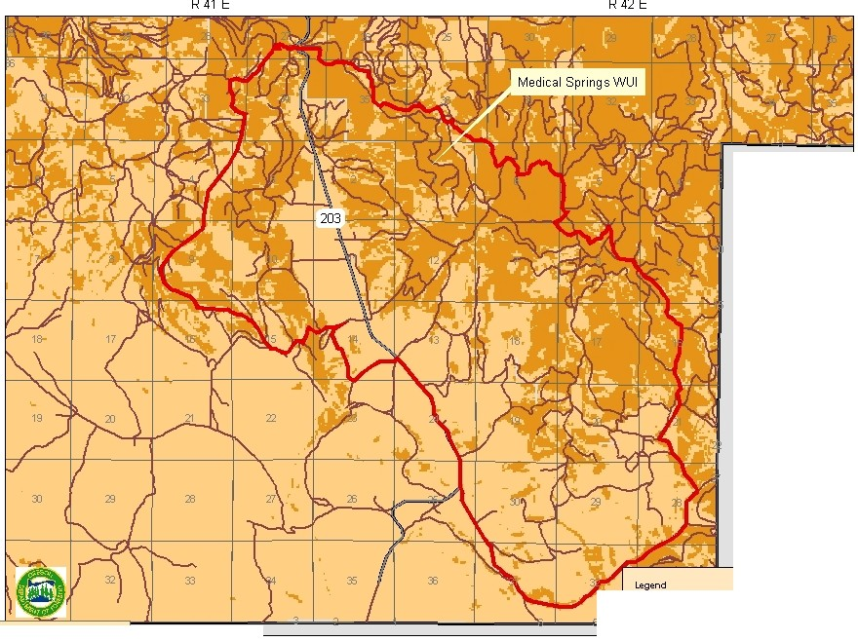

Baker County

J::IIIWI&oo.rey DPLS 6.

N

- "' "'ntuat I::JINa Ceou-ey

m

*(f:)*

Northeast Oregon Dislrid GIS - agj

La Grande.OR

July 25.2005

-Aollls D <llt alt (f'-£1J,'RICIOo..,rv.uooa.m )

- 1'1 ..OI'I(h•u. oo..,rv.u o )

c::Ja•s For Visual Display 0nly

**WUI Name:** Kamela **Priority Category:** High

|  |  |  |  |  |  |  |
| --- | --- | --- | --- | --- | --- | --- |
| **Risk Assessment Factors** | | | | | | |
| **Wildfire Hazard, including: Fire Occurrence, Topography & Total Fuels** | **Overall Fire**  **Protection & Structural Vulnerability** | **Values**  **At-Risk** | **Weather**  **Hazard** | **Opportunity for Fuels Reduction** | **Score** | **Rank** |
| **60** | **22** | **15** | **5** | **7.5** | **109.5** | **10** |

**Communities at Risk:** Kamela.

**Structural Fire Protection Agency:** Wildland fire protection only.

**Projects:** Many projects identified in this plan apply to all wildland-urban interface areas because they are broader in scope or represent general outreach messages or educational opportunities. Those listed here are specific to individual interface areas in Union County.

|  |  |  |
| --- | --- | --- |
| **WUI – Specific Projects** | **Timeframe** | **Lead Agency/Cooperators** |
|  | • | • |
|  | • | • |
|  | • | • |
|  | • | • |

69

Union County WUI Boundaries

(with Shaded Relief)

R35 E R36 E



Umatilla County

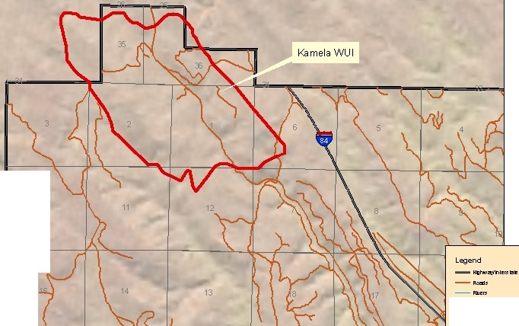

T1S



T2S

10

6.



N

c::Jc••u

D•'"

EI

-.1

0

UI't:ln C«<''ti ao.....sy

Northeast Oregon District GIS - agj _.....- IIW ••oon sy

La Grande,OR oBJ tla_IIA.IJS Zl'un un

July 25,2005

**Union County WUI Boundaries**

**(with Wildfire Hazard)**

R35 E R36 E

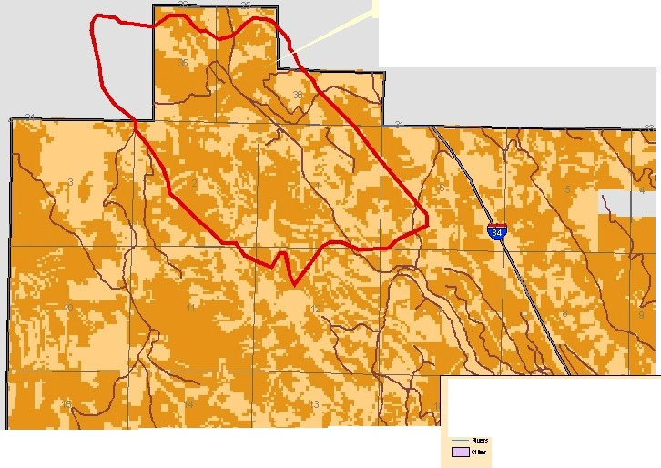

**Umatilla County**

T1S

KamelaWUI

T2S

**Legend** /\

**w**

**C IIWIIou"ey c:JPLS**

-..

Northeast Oregon Dislrid GIS - agj I I **.JJ** Jl r I '-" • '-" I • - ... -. "" I **l** 'I

La Grande,OR

July 25,2005

- **.., ,..ntuat I:::JIJ'ja Ceoo.rey N**

- **Aoells c::J <llt alt (f'-£1J,'RicloO._,ry,flooa.m )**

**C"OI'I(fuu. oo._,ry,llo )**

For VisualDisplay 0nly

**WUI Name:** Pumpkin Ridge **Priority Category:** High

|  |  |  |  |  |  |  |
| --- | --- | --- | --- | --- | --- | --- |
| **Risk Assessment Factors** | | | | | | |
| **Wildfire Hazard, including: Fire Occurrence, Topography & Total Fuels** | **Overall Fire**  **Protection & Structural Vulnerability** | **Values**  **At-Risk** | **Weather**  **Hazard** | **Opportunity for Fuels Reduction** | **Score** | **Rank** |
| **30** | **34** | **22.5** | **10** | **7.5** | **104** | **11** |

**Communities at Risk:** Pumpkin Ridge, Craig Loop, Ruckle Road and adjacent rural residential areas.

**Structural Fire Protection Agency:** Imbler Rural Fire Protection District.

**Projects:** Many projects identified in this plan apply to all wildland-urban interface areas because they are broader in scope or represent general outreach messages or educational opportunities. Those listed here are specific to individual interface areas in Union County.

|  |  |  |
| --- | --- | --- |
| **WUI – Specific Projects** | **Timeframe** | **Lead Agency/Cooperators** |
|  | • | • |
|  | • | • |
|  | • | • |
|  | • | • |

72

Union County WUI Boundaries

(with Shaded Relief)

R37 E R38 E R39 E

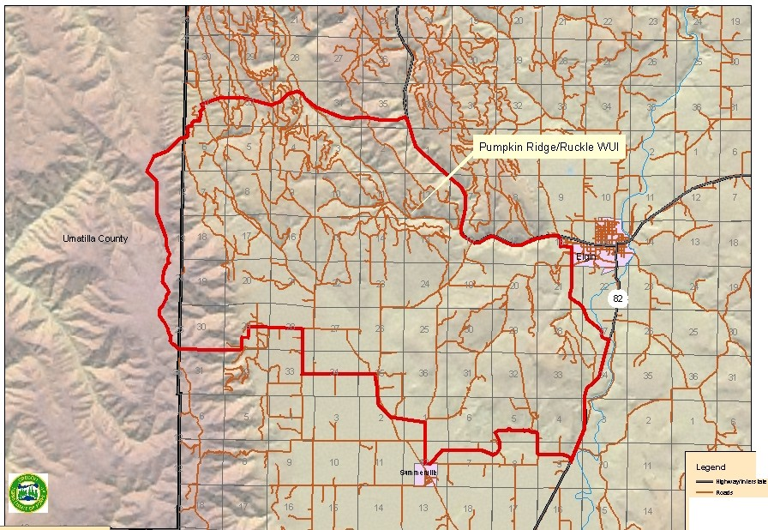T2N

T1N

Legend 6._

N

v:>

La Grande, 0R

_ ,.,.

c::Jc••u

...

8W • aoon sy

_, Northeast Oregon District GIS - agj urw CCU'Itt eo...-.sy

II

July 25,2005

**Union County WUI Boundaries**

**(with Wildfire Hazard)**

R39 E

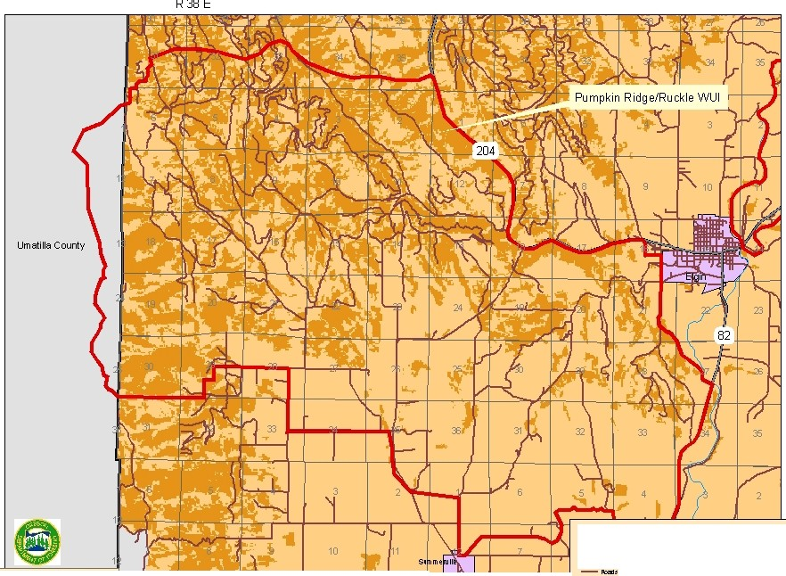

T2N

T1N

**Legend**

6.

**C IIWI&ou"ey DPLS**

N

- **.., ,..ntuat I::JIJ'ja C8oo.l'ey**

-..

Northeast Oregon District GIS . agj I I· ,.-, *-r* I l r I I I I l'li!tl **l** I I

**-111 1'1**

**D <lltlalt (f'-£1J,'Riclo0..,ry,flOoa.m )**

**C"OI'I(fuu. oo._,ry,llo )**

.[:,

La Grande,OR

July 25,2005

**c::Ja•s** For Visual Display 0nly

**WUI Name:** Elkanah **Priority Category:** High

|  |  |  |  |  |  |  |
| --- | --- | --- | --- | --- | --- | --- |
| **Risk Assessment Factors** | | | | | | |
| **Wildfire Hazard, including: Fire Occurrence, Topography & Total Fuels** | **Overall Fire**  **Protection & Structural Vulnerability** | **Values**  **At-Risk** | **Weather**  **Hazard** | **Opportunity for Fuels Reduction** | **Score** | **Rank** |
| **30** | **39** | **15** | **10** | **7.5** | **101.5** | **12** |

**Communities at Risk:** Camp Elkanah.

**Structural Fire Protection Agency:** Wildland fire protection only.

**Projects:** Many projects identified in this plan apply to all wildland-urban interface areas because they are broader in scope or represent general outreach messages or educational opportunities. Those listed here are specific to individual interface areas in Union County.

|  |  |  |
| --- | --- | --- |
| **WUI – Specific Projects** | **Timeframe** | **Lead Agency/Cooperators** |
| Camp Elkanah (Texas Heat) Maintenance | • Ongoing | • USFS; Private Permit Holders |
| Grande Ronde River Corridor Private Lands | • 3 + years | • ODF; Landowners |
| Grande Ronde River Corridor Mapping | • 1-2 years | • ODF; Landowners; La Grande RFPD |

75

**Union County WUI Boundaries**

**(with Shaded Relief)**

R35 E

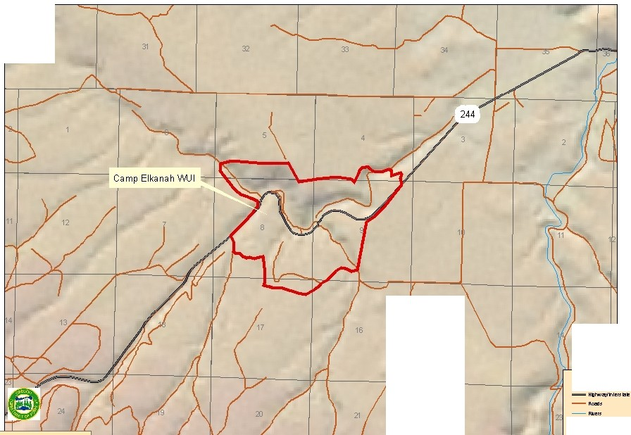

33

T4S

15 3

**Legend** !J.

N

**c::Jc•**.**•**.**u**

22

-..

m

NortheastGIS - agj I J / / J( *(* J *{)* / J J I ;:,:;"":""' I

July 25,2005 For VisualDisplay 0nly

Union County WUI Boundaries

(with Wildfire Hazard)

R35 E

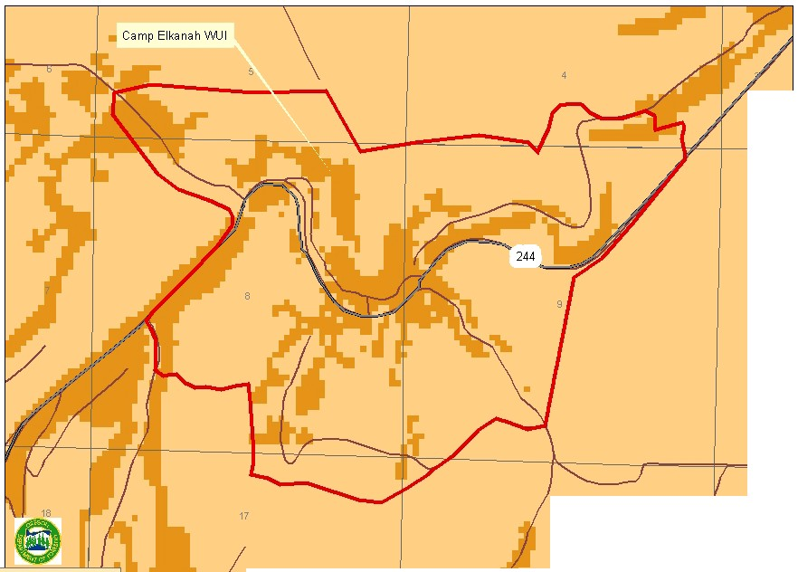

T4S

10

16

Legend /\

w

C IIWIIou"ey c:J PLS

- .., ,..ntuat

I:::JIJ'ja C

eoo.rey N

La Grande,OR I

- Aoells c::J <llt alt (f'-£1J,'RicloO._,ry,flooa.m )

- 1'1 C"'"'"•u. oo..,rv.u o )

c::Ja•s For VisualDisplay 0nly

**WUI Name:** Clark/Indian Creek **Priority Category:** High

|  |  |  |  |  |  |  |
| --- | --- | --- | --- | --- | --- | --- |
| **Risk Assessment Factors** | | | | | | |
| **Wildfire Hazard, including: Fire Occurrence, Topography & Total Fuels** | **Overall Fire**  **Protection & Structural Vulnerability** | **Values**  **At-Risk** | **Weather**  **Hazard** | **Opportunity for Fuels Reduction** | **Score** | **Rank** |
| **30** | **30** | **22.5** | **10** | **5** | **97.5** | **13** |

**Communities at Risk:** Clarks Creek, Indian Creek and adjacent rural residential areas.

**Structural Fire Protection Agency:** Elgin Rural Fire Protection District.

**Projects:** Many projects identified in this plan apply to all wildland-urban interface areas because they are broader in scope or represent general outreach messages or educational opportunities. Those listed here are specific to individual interface areas in Union County.

|  |  |  |
| --- | --- | --- |
| **WUI – Specific Projects** | **Timeframe** | **Lead Agency/Cooperators** |
| Clark Creek Planning | • 3 + years | • USFS; ODF; Landowners; Elgin RFPD;  UC Forest Restoration Board |

78

Union County WUI Boundaries

(with Shaded Relief)

R39 E R 40 E

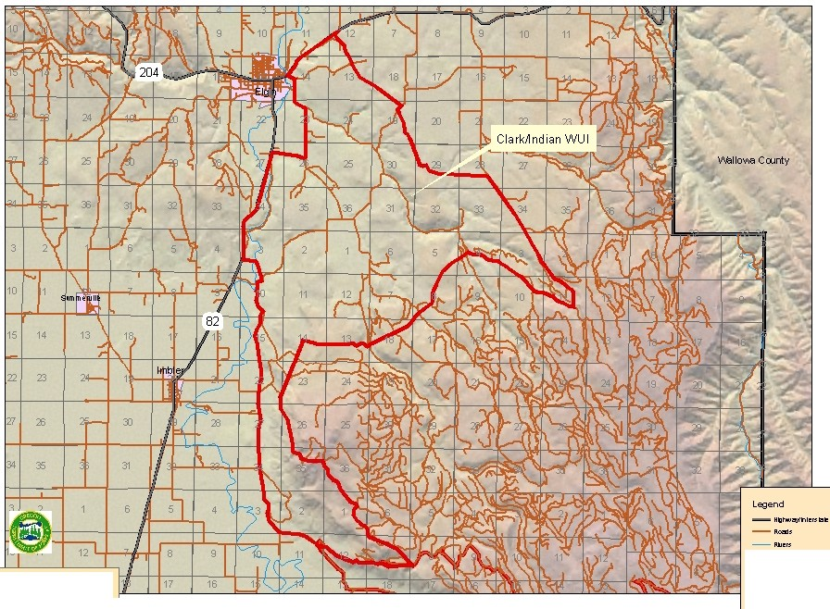

T1N

T1S

6.

N

c::Jc.•.•.u

8

-..

<D

Northeast Oregon District GIS - agj

La Grande,OR

July 25,2005 For VisualDisplay 0nly

Ul't:ln CCU'Itf 8o.....sy

11W 18oonllsy

**Union County WUI Boundaries**

**(with Wildfire Hazard)**

R39 E R 40 E

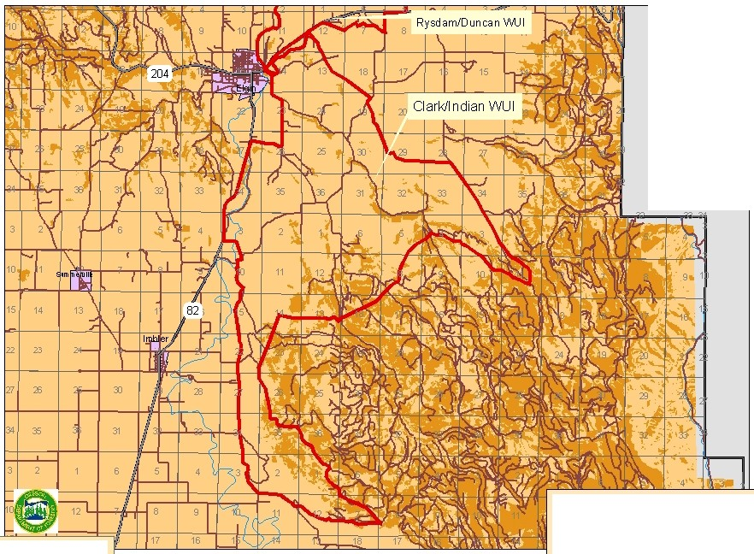

T1N

Vlbllo'MI Ccunty

T1S

**Legend**

6.

**C IIWI&ou"ey DPLS**

N

- **.., ,..ntuat I::JIJ'ja C8oo.l'ey**

*(f:)*

0

Northeast Oregon District GIS - agj

La Grande.OR

July 25. 2005

- **Aoells c::J <llt alt (f'-£1J,'RicloO._,ry,flOoa.m )**

- **1'1 C"'"'"•u. oo..,rv.u o )**

**c::Ja•s** For VisualDisplay 0nly

**WUI Name:** Rysdam **Priority Category:** High

|  |  |  |  |  |  |  |
| --- | --- | --- | --- | --- | --- | --- |
| **Risk Assessment Factors** | | | | | | |
| **Wildfire Hazard, including: Fire Occurrence, Topography & Total Fuels** | **Overall Fire**  **Protection & Structural Vulnerability** | **Values**  **At-Risk** | **Weather**  **Hazard** | **Opportunity for Fuels Reduction** | **Score** | **Rank** |
| **30** | **29** | **22.5** | **10** | **5** | **96.5** | **14** |

**Communities at Risk:** Cricket Flats, Thompson Road and adjacent rural residential areas.

**Structural Fire Protection Agency:** Elgin Rural Fire Protection District protects about

½ this WUI.

**Projects:** Many projects identified in this plan apply to all wildland-urban interface areas because they are broader in scope or represent general outreach messages or educational opportunities. Those listed here are specific to individual interface areas in Union County.

|  |  |  |
| --- | --- | --- |
| **WUI – Specific Projects** | **Timeframe** | **Lead Agency/Cooperators** |
| Replace Yarrington Road Bridge | • 1-2 years | • UCPW; ODOT |

81

**Union County WUI Boundaries**

**(with Shaded Relief)**

R 40 E R 41 E

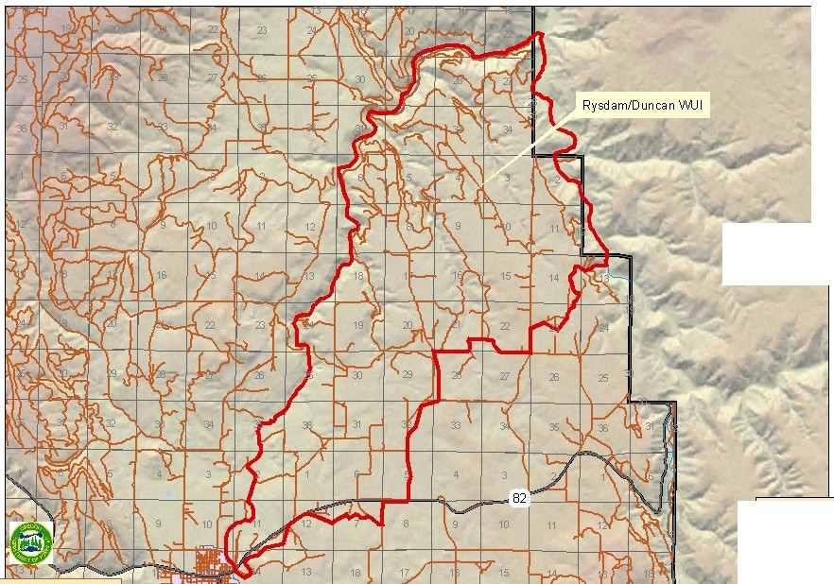

T3N

W.llo'M> County

T2N

*(f:)*

NortheastGIS - agj I d:,llaef'lloe I 21 [ 19 r=c; I **J** I I ti;*i( ;tJ L{ f ..]*

**Legend** 6..

--**"**-**'"'"**·**"•n•t1'11tlt N**

,...,.

**c:Jc••u**

8

**Ul't:ln C«<''ti 8o.....sy**

**11W 18oonllsy**

tV July 25,2005

For VisualDisplay 0nly

**Union County WUI Boundaries**

**(with Wildfire Hazard)**

R40 E

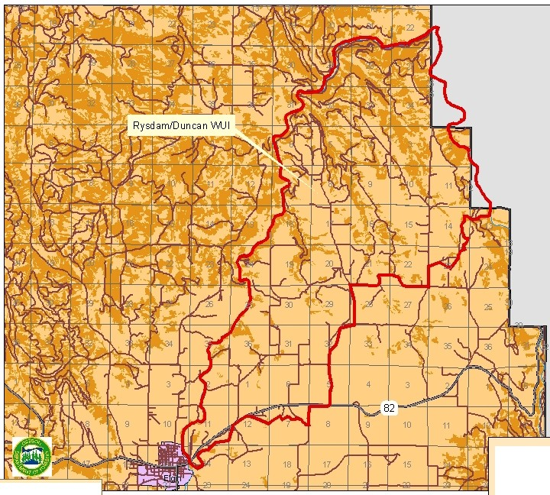

T3N

T2N

R 41 E

Vlbllo'MI County

**Legend**

6.

**C IIWI&ou"ey DPLS**

- **.., ,..ntuat I::JIJ'ja C8oo.l'ey** N

*(f:)*

v:>

Northeast Oregon District GIS - agj

La Grande.OR

July 25.2005

- **Aoells c::J <llt alt (f'-£1J,'RicloO._,ry,flOoa.m )**

- **1'1 C"'"'"•u. oo..,rv.u o )**

**c::Ja•s** For Visual Display 0nly

**WUI Name:** Starkey **Priority Category:** High

|  |  |  |  |  |  |  |
| --- | --- | --- | --- | --- | --- | --- |
| **Risk Assessment Factors** | | | | | | |
| **Wildfire Hazard, including: Fire Occurrence, Topography & Total Fuels** | **Overall Fire**  **Protection & Structural Vulnerability** | **Values**  **At-Risk** | **Weather**  **Hazard** | **Opportunity for Fuels Reduction** | **Score** | **Rank** |
| **30** | **33** | **15** | **10** | **7.5** | **95.5** | **15** |

**Communities at Risk:** Starkey and adjacent rural residential areas.

**Structural Fire Protection Agency:** Wildland fire protection only.

**Projects:** Many projects identified in this plan apply to all wildland-urban interface areas because they are broader in scope or represent general outreach messages or educational opportunities. Those listed here are specific to individual interface areas in Union County.

|  |  |  |
| --- | --- | --- |
| **WUI – Specific Projects** | **Timeframe** | **Lead Agency/Cooperators** |
| Grande Ronde River Corridor Private Lands | • 3 + years | • ODF; Landowners |
| Grande Ronde River Corridor Mapping | • 1-2 years | • ODF; Landowners; La Grande RFPD |

84

**Union County WUI Boundaries**

**(with Shaded Relief)**

R35 E R36 E

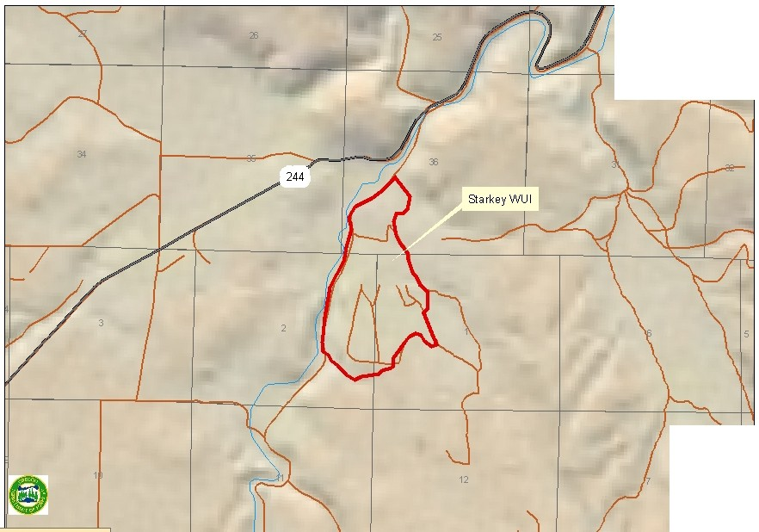

|  |  |  |
| --- | --- | --- |
| JJ |  | 29 |
|  |  |
|  |

T3S

T4S

*(f:) (}1*

**Legend** 6..

**"'"'""•n•t1'11tlt N**

---·

_ ,.,.

**c::Jc••u**

..

NortheastGIS - agj I I \\ \ / *.J* J I / I ;:,:.;,:.,.., I

July 25,2005 For VisualDisplay 0nly

**Union County WUI Boundaries**

**(with Wildfire Hazard)**

R35 E

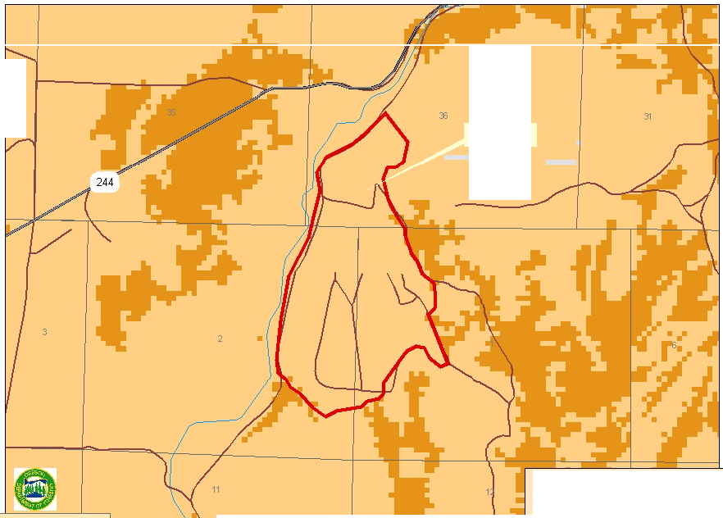

34

T3S

StarkeyWUI

T4S

*(f:)*

m

Northeast Oregon District GIS - agj **L** I

La Grande.OR

July 25,2005

**Legend *1\***

**C IIWIIoo.rey c:JPI.S**

**w**

....... **.., ,..ntuat 1:::]-.a c 8ou'ey N**

-**Aoells c::J"-d..<llt alt (f'-£1J,'RIIIOO._,IV,IIOoa.ml'l!Z)**

- **1'1 ..OI'I(h•s. oo._,ry,u o rwz)**

**c::Ja•s** For VisualDisplay 0nly

***VIII. Mitigation Action Plan***

**Action Items**

See *Section X* for a discussion about project evaluation. The projects, also called action items that were identified by the steering committee, residents, landowners, agencies and other stakeholders are listed below in the priority reflected in the plan’s goals and objectives. Projects that further emergency response are most important to the steering committee, followed by identifying and reducing fuel hazards, fostering support for the community wildfire protection plan, and using the plan as a resource and learning tool.

The projects are grouped into one of ten categories and include a brief description, list of project cooperators (the identified lead agency is listed first) and a general implementation timeframe.

**Grant Funding**

The strategies and needs to mitigate the risk of wildfire and respond to wildfire events are projects to which grant money may be directed. As such, the annual evaluation of the project list must include a consideration of other grant monies and how they are being spent towards the same goals. This ensures efficient use of the grant dollar and the potential ability to leverage grant money for greater benefit to Union County structural and wildland fire agencies. Other grant programs may include the State Homeland Security Equipment Program, Rural Firefighter Assistance / Volunteer Firefighter Assistance Equipment Program,

Title III federal funding, FEMA Pre-Hazard Mitigation Funding or Oregon

Transportation Investment Act funds, to name a few of the most likely sources.

*Response*

1. **Project Title:** Assemble and install address stakes for all county addresses.

**Description:** Stakes are old; will allow more efficient response.

**Cooperators:** UC Public Works.

**Timeframe:** Short Term (3 + years).

2. **Project Title:** Coordinate pre-suppression planning among all fire agencies.

**Description:** information is specific to topography, ingress/egress, water supply, strategic firefighting locations, staging areas, and communications.

**Cooperators:** All local structural fire agencies, including state and federal wildland fire agencies, the 911/Dispatch Center and the Northeast Oregon Interagency Fire Dispatch Center.

**Timeframe:** Short Term (1-2 years).

3. **Project Title:** Establish a rural fire protection district at Morgan Lake complete with equipment, training and personnel.

**Description:** Provided there were enough interested people.

**Cooperators:** Landowners; Union County; Structural Fire Agencies.

**Timeframe:** Long Term (3+ years).

4. **Project Title:** Establish a rural fire protection district at Perry and Hilgard area complete with equipment, training and personnel.

**Description:** Provided there were enough interested people. **Cooperators:** Landowners; Union County; Structural Fire Agencies. **Timeframe:** Long Term (3+ years).

*Communications*

1. **Project Title:** Acquire interoperable communications equipment.

**Description:** Continue to implement the UC Communications Strategic Plan and related projects.

**Cooperators:** All local structural fire agencies, including state and federal wildland fire agencies, the 911/Dispatch Center and the Northeast Oregon Interagency Fire Dispatch Center.

**Timeframe:** Short Term (1-2 years).

2. **Project Title:** Implement Union County Strategic Communications Plan.

**Description:** Plan was developed by 911 Users to strategically replace and upgrade the entire emergency communications network.

**Cooperators:** All local emergency responders, including state and federal wildland fire agencies, OSP, the 911/Dispatch Center and the Northeast Oregon

Interagency Fire Dispatch Center.

**Timeframe:** Long Term (3+ years).

*Road System Improvements*

1. **Project Title:** Replace Yarrington Road bridge.

**Description:** Bridge is load-limited and constrains response and RFPD expansion. **Cooperators:** UC Public Works; Oregon Department of Transportation. **Timeframe:** Short Term (1-2 years).

2. **Project Title:** Prepare Evacuation Plan for Morgan Lake area.

**Description:** One sub-standard road must be used by both evacuating residents and emergency response agencies.

**Cooperators:** UC Emergency Services, Public Works and Sheriff’s Office; Oregon

Department of Transportation.

**Timeframe:** Short Term (1-2 years).

3. **Project Title:** Reconstruct Morgan Lake Road.

**Description:** Travelers could benefit from engineered solutions to this road. **Cooperators:** UC Public Works; Oregon Department of Transportation. **Timeframe:** Long Term (3+ years).

*Water Source Development*

1. **Project Title:** Identify and inventory water supplies including access and deficiencies.

**Description:** Pre-identify water sources for response; updated seasonally.

**Cooperators:** ODF; USFS; Structural Fire Agencies.

**Timeframe:** Short Term (1-2 years).

*Equipment & Training*

1. **Project:** NIMS training.

**Description:** Conduct National Incident Management System (NIMS) training for emergency responders to ensure continued federal grant funding.

**Cooperators:** UC Emergency Services.

**Timeframe:** Short Term (1-2 years).

2. **Project:** Identify methods of funding to purchase up-to-date PPE.

**Description:** Pool resources in obtaining current PPE.

**Cooperators:** La Grande RFPD; North Powder RFPD; Union RFPD; Cove RFPD; Imbler RFPD; Elgin RFPD; La Grande FD and Medical Springs RFPD.

**Timeframe:** Short Term (1-2 years).

3. **Project:** Plan and conduct full-scale exercises.

**Description:** Involving fire suppression agencies and the community in drills and exercises.

**Cooperators:** All local structural fire agencies, including state and federal wildland fire agencies.

**Timeframe:** Short Term (3 + years).

1. **Project:** Identify methods of funding to purchase type III wildland fire engines.

**Description:** Each RFPD needs engines for wildland response to augment wildland agencies responding in their jurisdictions.

**Cooperators:** Structural RFPDs.

**Timeframe:** Short Term (1-2 years).

*Fuels Reduction*

1. **Project:** Pelican Creek

**Description:** Prescribed burn.

**Cooperators:** US Forest Service, La Grande Ranger District.

**Timeframe:** Short Term (1-2 years).

2. **Project:** Three Cabin Creek

**Description:** Commercial thinning.

**Cooperators:** US Forest Service, La Grande Ranger District.

**Timeframe:** Short Term (1-2 years).

3. **Project:** Mt. Emily

**Description:** The Mt Emily fuels reduction project area is approximately 7,295 acres in size and is part of a larger analysis area (approx, 40,360 acres) which includes Umatilla National Forest and private and State lands located within three watersheds. The project will utilize mechanical fuels reduction treatments followed by low intensity Rx fire. This project is being coordinated with fuel reduction and “FIREWISE” projects, and education efforts occurring on adjoining private and state lands and the Umatilla National Forest. Priority areas identified within the project area are based on proximity to private values at risk from wildfire, and/or presence of logical locations to base suppression operations. Management

activities include, thinning, hand piling, mechanical removal, pile burning as well as low intensity under burning.

**Cooperators:** US Forest service, La Grande Ranger District, Umatilla National Forest, Oregon Department of Forestry, La Grande Office, Rural Fire Protection District, Union County Community Forest Restoration Board, Private and industrial Landowners.

**Timeframe:** Long term (3+ years).

**Stage of Project:** Implementing (Beginning stage, thinning/hand piling).

4. **Project Title:** Cove WUI

**Description:** Manage Vegetation and fuels (via mechanical fuels reduction treatments, followed by low intensity Rx fire) to modify fire behavior and create survivable and defensible space on federal, state, and private lands surrounding the community. Promote “FIREWISE” communities through prevention and education measures.

**Cooperators:** US Forest service, La Grande Ranger District, Oregon Department of Forestry, La Grande Office, Rural Fire Protection District, Union County Community Forest Restoration Board, Private and industrial Landowners. **Timeframe:** Long term (3+ years).

**Stage of Project:** Planning.

5. **Project Title:** South fork Catherine Creek

**Description:** Manage Vegetation and fuels, (via mechanical removal, piling, followed by low intensity Rx fire) to modify fire behavior and create survivable and defensible space on federal, state, and private lands surrounding the community. Promote “FIREWISE” communities through prevention and education measures. **Cooperators:** US Forest service, La Grande Ranger District, Oregon Department of Forestry, La Grande Office, Rural Fire Protection District, Union County Community Forest Restoration Board, Private and industrial Landowners Private landowners.

**Timeframe:** Long term (3+ years).

**Stage of Project:** Planning.

6. **Project Title:** Clark Creek

**Description:** Manage Vegetation and fuels, (via mechanical removal, piling, followed by low intensity Rx fire) to modify fire behavior and create survivable and defensible space on federal, state, and private lands surrounding the community. Promote “FIREWISE” communities through prevention and education measures. **Cooperators:** US Forest service, La Grande Ranger District, Oregon Department of Forestry, La Grande Office, Rural Fire Protection District, Union County Community Forest Restoration Board, Private and industrial Landowners. **Timeframe:** Long term (3+ years).

**Stage of Project:** Planning.

7. **Project Title:** Medical Springs (Bald Angel)

**Description:** Reduce heavy fuel load conditions, (via mechanical fuel reduction treatments followed by low intensity Rx fire) to minimize wildfire impacts to natural resources and private land ownership.

**Cooperators:** US Forest service, La Grande Ranger District.

**Timeframe:** Long term (3+ years).

**Stage of Project:** Planning.

8. **Project Title:** Camp Elkanah (Texas Heat)

**Description:** Natural Fuels Prescribed Burn (no harvest units involved). The overall objective of this project is to reintroduce and utilize fire as a disturbance factor in order to maintain ecological systems and processes. This project lies adjacent to WUI defined Elkanah area.

**Cooperators:** US Forest service, La Grande Ranger District.

**Timeframe:** Ongoing.

**Stage of Project:** Maintenance.

9. **Project Title:** Blue Springs

**Description:** Hazardous fuels reduction, via thinning small diameter understory, hand piling, followed by pile burning.

**Cooperators:** US Forest service, La Grande Ranger District, Private Permit

Holders.

**Timeframe:** Ongoing.

**Stage of Project:** Maintenance

10. **Project Title:** Mt. Emily Private Lands

**Description:** Commercial and pre-commercial thinning and slash disposal. **Cooperators:** ODF- La Grande Unit, Private Forestland Owners, Imbler Rural Fire Department, La Grande Rural Fire Department.

**Timeframe:** Short Term (1-2 years).

11. **Project Title:** Cove Private Lands

**Description:** Commercial and pre-commercial thinning and slash disposal. **Cooperators:** ODF- La Grande Unit, Private Forestland Owners, Cove Rural Fire Department.

**Timeframe:** Short Term (1-2 years).

12. **Project Title:** Morgan Lake Private Lands

**Description:** Commercial and pre-commercial thinning and slash disposal. **Cooperators:** ODF- La Grande Unit, Private Forestland Owners, La Grande Fire Department, La Grande Rural Fire Department.

**Timeframe:** Short Term (1-2 years).

13. **Project Title:** Palmer Valley Private Lands

**Description:** Commercial and pre-commercial thinning and slash disposal. **Cooperators:** ODF- La Grande Unit, Private Forestland Owners, Elgin Rural Fire Department.

**Timeframe:** Long Term (3-5 Years).

14. **Project Title:** Catherine Creek Corridor Private Lands

**Description:** Commercial and pre-commercial thinning and slash disposal. **Cooperators:** ODF- La Grande Unit, Private Forestland Owners, Union Rural Fire Department.

**Timeframe:** Long Term (3-5 years).

15. **Project Title:** Grande Ronde River Corridor Private Lands

**Description:** Commercial and pre-commercial thinning and slash disposal. **Cooperators:** ODF- La Grande Unit, Private Forestland Owner. **Timeframe:** Long Term (3-5 years).

*Mapping & Data Development*

1. **Project Title:** Create a monitoring system to gauge fuels reduction progress over time.

**Description:** Utilize ground plots. **Cooperators:** ODF, USFS, BLM. **Timeframe:** Long Term (3+ years).

2. **Project Title:** Identify data gaps.

**Description:** Coordinate efforts to integrate data sets and share information. **Cooperators:** ODF, Union County, Structural Fire Agencies, USFS. **Timeframe:** Short Term (3 + years).

3. **Project Title:** Develop a GIS layer of all fire districts/departments including areas with no structural fire protection.

**Description:**

**Cooperators:** UC Planning Department, Emergency Services.

**Timeframe:** Short Term (1-2 years).

4. **Project Title:** Create map books using GIS containing ownership, dwelling location, and site-specific information for each fire district/department. **Description:** information is specific to ownership and dwelling location. **Cooperators:** ODF, Union County, Structural Fire Agencies, USFS. **Timeframe:** Short Term (1-2 years).

5. **Project Title:** Catherine Creek Corridor

**Description:** Map homesites and access routes to homes located in this WUI

area.

**Cooperators:** ODF- La Grande Unit, Private Forestland Owners, Union Rural Fire

Department.

**Timeframe:** Short Term (1-2 years)

6. **Project Title:** Grande Ronde River Corridor.

**Description:** Map homesites and access routes to homes located in this WUI

area.

**Cooperators:** ODF- La Grande Unit, Private Forestland Owners, Union Rural Fire

Department.

**Timeframe:** Short Term (1-2 years)

*Prevention*

1. **Project:** Resurrect and formalize the Union County Prevention Co-Op. **Description:** Co-Op members pay to belong; meet monthly and discuss prevention issues.

**Cooperators:** All local structural fire agencies, including state and federal wildland fire agencies.

**Timeframe:** Long Term (3+ years).

2. **Project:** Continue prevention efforts like Firewise and “I’m Concerned…”.

**Description:** Build on progress made with these programs; spread among Union

County communities.

**Cooperators:** All local structural fire agencies, including state and federal wildland fire agencies.

**Timeframe:** Short Term (1-2 years).

3. **Project:** Participate annually in Fire Prevention Week.

**Description:** Pool resources to spread fire prevention message. **Cooperators:** ODF, La Grande Office; UC Emergency Services. **Timeframe:** Short Term (1-2 years).

4. **Project Title:** Firewise Communities

**Description:** Present 1-day workshop to communities interested in becoming a

Firewise Community

**Cooperators:** ODF; Structural Fire Agencies.

**Timeframe: Short-Term (1-2 years).**

*Partnership Development*

1. **Project Title:** Continue workforce development.

**Description:** Programs through TEC, Oregon Youth Authority and the LHS FFA (wildland fire class) foster partnerships among those who are acquiring firefighting skills and those who need those skills.

**Cooperators:** La Grande High School; Training & Employment Consortium; RiverBend Facility; UC Commissioners, Emergency Services.

**Timeframe:** Long Term (3+ years).

*Education and Outreach*

1. **Project:** Identify common base information.

**Description:** Develop program for consistency in all public messages. **Cooperators:** All local structural fire agencies, including state and federal wildland fire agencies.

**Timeframe:** Short Term (1-2 years).

2. **Project:** Identify prescriptive parameters for fuels reduction.

**Description:** Develop to aid private property owners in achieving an ideal forest condition class.

**Cooperators:** USFS; ODF; BLM; UC Forest Restoration Board; OSU Extension

Service.

**Timeframe:** Short Term (1-2 years).

Projects are evaluated annually as described in *Section X*.

**Biomass Utilization**

Federal and state agencies, local government and private forest landowners are using thinning and prescribed burning in strategic locations to reduce forest fuels and wildfire risks. Most of the material generated from fuels reduction activities is not suitable for commercial wood products manufacturing. In many cases, biomass from these activities is left on-site or piled and burned at an additional cost. One alternative outlet for utilizing biomass now is the Warm Hearts/Warm

Homes firewood program. The program distributes firewood to limited capacity citizens across Baker, Union, and Wallowa Counties. Unfortunately the program utilizes a small percentage of the biomass generated and usually utilizes smaller thinning projects. An additional alternative outlet for small diameter wood could help reduce the costs of thinning and help mitigate environmental impacts associated with prescribed burning and wildfires.

Forest biomass is generated by forest fuels reduction, commercial timber harvest; non-commercial thinning and timber stand improvement (TSI) activities. Non-commercial thinning includes pruning and tree removal designed to help shape and guide development of forest stands to meet a variety of goals. It generally does not result in removal of trees that can be used to manufacture products, but it could be used in renewable energy production (heat, steam, electricity, and fuel). Timber stand improvement can accomplish similar goals, but often results in removal of some commercially valuable trees. Wood manufacturing residues including bark, sawdust, chips, and veneer cores are additional sources of raw material for renewable energy production. A biomass plant is currently operating in Grant County, but high transportation cost makes the exportation of small diameter wood material cost prohibitive.

Union County’s Forest Restoration Board is exploring co-generation opportunities that utilize biomass as fuel. Heating and cooling public buildings using small biomass generators to offset the cost of electricity and oil is being explored. This appears to be the direction communities want to move in order to address biomass utilization at a manageable scale. Once the Union County Forest Restoration Board has determined the feasibility of this project and more conclusive information is available this section of the plan will be updated.

***IX. Maintenance Plan for Fuels Treatmenti***

Fuels reduction programs require knowledge of how fire interacts with different vegetation and defining acceptable fire behavior parameters. For example, if one determines that near WUI areas a flame of four feet or less is acceptable, one can then prioritize projects accordingly.

**Concepts to Consider in Developing a Fuels Maintenance**

**Program**

Once treated timber stands undergo the process of ecological succession in which under story and over story vegetation change over time resulting in incremental changes (often increases) in herbs, grasses, shrubs, and tree regeneration. The regeneration takes place because removing trees and other vegetation creates more growing space. Over story structure changes as residual trees expand their crowns and increase in diameter. These changes continually add biomass (fuel) such as needles, branches and downed logs to the site. Subsequent disturbances caused by insects and disease can kill trees and add more biomass to the forest floor. Although some biomass decays over time in dry southwest, central and eastern Oregon forests dead biomass tends to

accumulate faster than it decays resulting in more fuel.

How long before treated areas require re-treatment is dependent on several inter-related factors including:

• Past treatment level (e.g., how much biomass [fuel] was removed initially in the under story and over story);

• Plant association groups;

• Site productivity;

• Rate of fuel accumulation;

• Fuel structure (i.e., condition class)

• Historic fire regime;

• Desired fire behavior (for effective control)

• Climatic regime.

Although condition class and fire regime are primary factors in prioritizing initial treatment areas, strategic location is factored as well. This prioritization method may have less bearing on which areas should be prioritized for future *re-*

*treatment*. For example, it’s probably unlikely that managers would allow sites

that were condition class 2 or 3 before treatment and treated to condition class 1, to revert back to condition class 2 or 3 before conducting a re-treatment, particularly in the WUI. It seems more likely they would allow a site that was originally in a condition class 2 or 3 and treated to condition class 1 to re- accumulate fuels only to a point or phase that resemble a condition class 1 *transitioning* into a condition class 2. Allowing fuels to accumulate any further would entail a more expensive re-treatment and increase the risk of losing the initial investment made in fuel reduction.

**Fuels Treatment and Forest Healthii**

Fuels treatment has an added benefit beyond reducing danger. Thinning overstocked stands will increase tree diameter growth and enhance tree vigor. Healthier trees are more resistant to pests and disease. Treatment should be site and species specific. Thinning spacing should be managed to take advantage of site specific resources such as water, nutrients and sunlight.

Remember that forests are dynamic and continually growing in diameter, height, and crown width. Fuels reduction activities that include thinning are a good thing, but thinning without consideration for forest health doesn’t provide the benefits of pest resistance or good individual tree growth. Also, without future maintenance, the fire risk reduction benefits decline over time.

For more information about proper tree spacing for your timber stand, please contact Paul Oester, OSU Extension Forester, at (541) 963-1010 or Oregon Department of Forestry in La Grande at (541) 963-3168.

i A Conceptual Approach for a Maintenance Strategy for Fuel Treatments in Oregon: Maintaining the

Investment, Fitzgerald, Stephen and Martin, Charlie, Oregon State FFHM Committee Report. (July 5, 2004).

ii Oester, Paul. *Blue Mountains Renewable Resource Newsletter*. Vol. 20, No. 3, (Fall 2004).

***X. Monitoring and Evaluation***

**Schedule**

Plan maintenance will be directed by the Union County Commissioners, via the Emergency Services Office and coordinated with the plan’s steering committee members, a core group of who have agreed to be a standing committee to assist with monitoring and evaluation. Proposed plan maintenance will be set annually and will consist of a plan review, priority action item re-evaluation and progress evaluation, with a total revision of the plan set for every five years.

A total plan revision every five years is recommended, as the infrastructure needs of Union County change. Specific considerations include: population fluctuations, land use changes, completion of fuels reduction projects, emergency service improvements, computer software/hardware updates, new and revised data, and extreme wildfire hazard fluctuations.

Annual strategies and recommendations will be necessary as various projects and tasks are accomplished and areas at-risk decline in hazard rating. Annual review will be necessary, as county infrastructure needs change. Annual review will be advertised to include representation from the stakeholders who participated in the development of the Community Wildfire Protection Plan.

**Monitoring**

Continued public collaboration on the Union County Wildfire Protection Plan is necessary to meet identified needs while accomplishing the plan’s mission.

Copies of the Community Wildfire Protection Plan are available at the Union County Emergency Services Office, at the Oregon Department of Forestry Office in La Grande, Wallowa-Whitman National Forest headquarters in La Grande, in Union County public libraries. It will also be available both electronically and via the Union County and ODF websites. The websites will provide citizens an opportunity to send comments or questions regarding the plan at any time.

**Evaluation**

Annual assessment of the identified projects is very important to determine whether or not progress is being made. Units of evaluation were identified corresponding with each of the ten project categories:

1. **Response:** number of projects accomplished, which improve fire agency/emergency service response time.

2. **Communications:** number of identified communication issues resolved that were identified in the plan.

3. **Road System Improvements:** number of transportation problems resolved.

4. **Water Source Development:** number of water sources added.

5. **Equipment/Training:**

a) Equipment - number of identified/needed equipment obtained b) Training - number of courses provided.

6. **Fuels Reduction:**

a) Number of acres treated for fuels reduction (loading reduction, increased spacing, and/or ladder fuel reduction).

7. **Mapping & Data Development:** number of projects completed or issues resolved.

8. **Prevention:**

a) Number of events with prevention message delivery b) Number of prevention courses conducted

c) Number of news releases or prevention campaigns conducted d) Number of prevention co-op meetings held.

9. **Partnership Development:** number of partners/agencies/groups involved.

10. **Education and Outreach:**

a) Number of people contacted (meetings, courses, etc)

b) Number of educational items distributed (brochures, etc).

On an annual basis, the standing steering committee members will assess each identified project using these units of measure to determine progress. This plan does not serve as a means of bypassing the individual processes and regulations of the participating agencies. Each project must adhere to any pertinent local, state or federal rules or guidelines in determining the point of project implementation. The plan is a coordinating document for forest projects related to education and outreach, information development, fire protection and fuels treatment.

**Questionnaire Outcomes**

***Real Numbers***

**Q1 - What community are you from?**

Elgin 5 Summerville 19

Imbler 1 Island City 3

La Grande 83 Cove 10

Union 16 North Powder 5

Outside UC -

Rural Union County 4

Did Not Specify 9

***Total 167***

EOU 12

**ISLAND LA**

**NORTH**

**RURAL**

**OUTSIDE UC -**

**DID NOT**

**Q2 - Concerned about wildfire?**

**ELGIN SUMMERVILLE IMBLER**

**CITY**

**GRANDE COVE UNION**

**POWDER UC**

**EOU**

**SPECIFY Total # Total %**

|  |  |  |  |  |  |  |  |  |  |  |  |  |  |
| --- | --- | --- | --- | --- | --- | --- | --- | --- | --- | --- | --- | --- | --- |
| Very concerned?  Moderately concerned? | 3  0 | 8  5 | 1  0 | 0  1 | 17  18 | 4  3 | 3  3 | 2  0 | 0  3 | 2  0 | 3  1 | ***43***  ***34*** | 25.75%  20.36% |
| Somewhat concerned? | 2 | 5 | 0 | 2 | 23 | 3 | 4 | 1 | 0 | 3 | 3 | ***46*** | 27.54% |
| Not concerned | 0 | 1 | 0 | 0 | 25 | 0 | 6 | 2 | 1 | 7 | 2 | ***44*** | 26.35% |
| **Q3 - Aware of defensible space?** |  |  |  |  |  |  |  |  |  |  |  |  |  |
| Very aware? | 2 | 10 | 0 | 0 | 19 | 1 | 5 | 3 | 2 | 0 | 4 | ***46*** | 27.54% |
| Moderately aware? | 2 | 6 | 0 | 2 | 21 | 5 | 3 | 0 | 1 | 0 | 0 | ***40*** | 23.95% |
| Somewhat aware? | 0 | 3 | 0 | 0 | 17 | 2 | 2 | 1 | 0 | 2 | 1 | ***28*** | 16.77% |
| Not aware | 1 | 0 | 1 | 1 | 26 | 2 | 6 | 1 | 1 | 10 | 4 | ***53*** | 31.74% |
| **Q4 - Had Firewise in your community?** |  |  |  |  |  |  |  |  |  |  |  |  |  |
| yes | 1 | 8 | 0 | 0 | 9 | 2 | 1 | 0 | 0 | 0 | 0 | ***21*** | 12.57% |
| no | 4 | 11 | 1 | 3 | 74 | 8 | 15 | 5 | 4 | 12 | 9 | ***146*** | 87.43% |

**Q5 - List 3 values…**

***see list***

**Q6 - Would those values be threatened by wildfire?**

|  |  |  |  |  |  |  |  |  |  |  |  |  |  |
| --- | --- | --- | --- | --- | --- | --- | --- | --- | --- | --- | --- | --- | --- |
| yes | 4 | 16 | 1 | 3 | 53 | 7 | 5 | 4 | 2 | 7 | 6 | ***108*** | 64.67% |
| no | 1 | 3 | 0 | 0 | 30 | 3 | 11 | 1 | 2 | 5 | 3 | ***59*** | 35.33% |
| **Q7 - If yes, list how…** |  |  |  |  |  |  |  |  |  |  |  |  |  |
| ***see list*** |  |  |  |  |  |  |  |  |  |  |  |  |  |

**Q8 - Heard of Community WF Protection Planning?**

yes 3 13 0 2 29 6 4 2 2 0 3 ***64*** 38.32%

no 2 6 1 1 54 4 12 3 2 12 6 ***103*** 61.68%

**Q9 - Interested in reviewing & commenting on plan?**

|  |  |  |  |  |  |  |  |  |  |  |  |  |  |
| --- | --- | --- | --- | --- | --- | --- | --- | --- | --- | --- | --- | --- | --- |
| yes | 2 | 11 | 0 | 1 | 28 | 4 | 8 | 4 | 3 | 2 | 4 | ***67*** | 40.12% |
| no | 3 | 8 | 1 | 2 | 55 | 6 | 8 | 1 | 1 | 10 | 5 | ***100*** | 59.88% |

***XI. Appendix A: Glossary/Acronym List***

***Glossary***

**At-Risk Community:** a group of homes or other improvements (such as utilities or transportation routes) within or adjacent to federal land in which conditions are conducive to a large-scale wildland fire and pose a significant threat to human life or property.

**Community Wildfire Protection Plan:** a plan for at-risk communities identifying and prioritizing areas for hazardous fuels treatments, and recommending methods of treatment.

**Conflagration:** a raging, destructive fire. Often used to describe a fire burning under extreme fire weather. The term is also used when a wildland fire burns into a wildland- urban interface, destroying many structures.

**Crown Fire:** a fire tha advances from treetop to treetop or shrubs independent of a surface fire.

**Defensible Space:** an area, typically a width of 30 feet or more, between an improved property and a potential wildfire where the combustibles have been removed or modified.

**Escape Route:** route away from dangerous areas on a fire and should be pre-planned.

**Evacuation:** the temporary movement of people and their possessions from locations threatened by wildfire.

**Extreme Fire Behavior:** a level of fire behavior characteristics that ordinarily precludes methods of direct control. One or more of the following is usually involved: high rates of speed, prolific crowning and/or spotting, presence of fire whirls, a strong convection column. Predictability is difficult because such fires often exercise some degree of influence on their environments and behave erratically, sometimes dangerously.

**Fire Behavior:** the manner in which a fire reacts to the influences of fuel, weather and topography.

**Fire Front:** that part of the fire within which continuous flaming combustion is taking place. Unless otherwise specified it is assumed to be the leading edge of the fire perimeter.

**Hazard:** a fuel complex defined by volume, type condition, arrangement and location (topography) that determine the ease of ignition and resistance to control. Hazards may also include the built environment such as constructed improvements, access to those improvements, and water availability.

**Fire Prevention:** activities, including education, engineering, enforcement and administration that are directed at reducing the number of wildfires, the costs of suppression and fire-caused damage to resources and property.

**Fire Protection:** the actions taken to limit the adverse environmental, social, political and economical effects of fire.

**Fire Regime:** periodicity and pattern of naturally occurring fires in a particular area or vegetative type, described in terms of frequency, biological severity and area extent.

**Fire Storm:** violent convection caused by a large continuous area of intense fire. Often characterized by destructively violent surface indrafts, near and beyond the perimeter, and sometimes by tornado-like whirls.

**Fire Weather:** weather conditions that influence fire starts, fire behavior or fire suppression.

**Firebrand:** any source of heat, natural or human made, capable of igniting wildland fuels. Flaming or glowing fuel particles that can be carried naturally by wind, convection currents, or by gravity into unburned fuels. Examples include leaves, pine cones, glowing charcoal and sparks.

**Fuel Condition:** relative flammability of fuel as determined by fuel type and environmental conditions.

**Fuel Loading:** the volume of fuel in a given area generally expressed in tons per acre.

**Fuel Modification:** any manipulation or removal of fuels to reduce the likelihood of ignition or the resistance to fire control.

**Fuels:** all combustible material within the wildland-urban interface, including vegetation and structures.

**Fuel Break:** an area, strategically located for fighting anticipated fires, where the native vegetation has been permanently modified or replaced so that fires burning into it can be more easily controlled. Fuel breaks divide fire-prone areas into smaller areas for easier fire control and to provide access for fire fighting.

**Greenbelt:** a fuel break designated for use other than fire protection.

**Ground Fuels:** all combustible materials such as grass, duff, loose surface litter, tree or shrub roots, rotting wood, leaves, peat or sawdust that typically support combustion.

**Hazardous Areas:** those wildland areas where the combination of vegetation, topography, weather and the threat of fire to life and property create difficult and dangerous problems.

**Hazard Reduction (see also Mitigation):** any treatment of living and dead fuels that reduces the threat of ignition and spread of fire.

**Ignition Probability:** chance that a firebrand will cause an ignition when it lands on receptive fuels.

**Initial Attack:** the actions taken by the first resources to arrive at a wildfire to protect lives and property, and prevent further extension of the fire.

**Ladder Fuels:** fuels that provide vertical continuity allowing fire to carry from surface fuels into the crowns of trees or shrubs with relative ease.

**Mitigation:** action that alleviates the severity of a fire hazard or risk.

**Overstory:** that portion of the trees in a forest that forms the upper or uppermost layer.

**Preparedness:** 1) Condition or degree of being ready to cope with a potential fire situation. 2) Mental readiness to recognize changes in fire danger and act promptly when action is appropriate.

**Prescribed Burning:** controlled application of fire to wildland fuels in either their natural or modified state, under specified environmental conditions, which allows the fire to be confined to a predetermined area, and to produce the fire behavior and fire characteristics required to attain planned fire treatment and resource management objectives.

**Risk:** the chance of a fire starting from any cause.

**Structural Fire Agency:** a firefighting organization, usually at the local level, trained and equipped to fight structure fires. Local structural fire agencies may also be trained and equipped to combat wildland fires.

**Suppression:** the most aggressive fire protection strategy, it leads to the total extinguishment of a fire.

**Surface Fuel:** fuels lying on or near the surface of the ground, consisting of leaf and needle litter, dead branch material, downed logs, bark, tree cones, and low stature living plants.

**Survivable Space:** the characteristics of a home, its materials and design, in concert with the flammable materials in a home’s immediate surroundings that result in high ignition resistance from flames and firebrands (burning embers). Survivable space characteristics relate to the ignitability of a home without necessarily including the higher thermal vulnerability of firefighters.

**Tree Crown:** the primary and secondary branches growing out from the main stem, together with twigs and foliage.

**Understory:** low-growing vegetation under a stand of trees. Also, that portion of trees in a forest stand below the overstory.

**Wildfire:** an unplanned and uncontrolled fir spreading through vegetative fuels, at times involving structures.

**Wildfire Causes:** the general causes of wildland fires are 1) natural, like lightning; 2)

accidental, like debris burning; and 3) intentional, like arson.

**Wildland:** an area in which development is essentially non-existent, except for roads, railroads, power lines and similar transportation facilities. Structures, if any, are widely scattered.

**Wildland Fire:** any fire occurring on the wildlands, regardless of ignition source, damages or benefits.

**Wildland Fire Agency:** a firefighting organization, usually at the state or federal level, trained and equipped to fight wildland fires. Typically, wildland fire agencies are not trained and equipped to combat structure fires.

**Wildland-Urban Interface:** an area within or adjacent to an at-risk community where wildland fuels intermix with combustible homes and structures. Wildland-Urban Interface areas in Union County are identified in the Union County Community Wildfire Protection Plan.

***Acronym List***

**BLM** – Bureau of Land Management

**CAR** – Community at Risk

**CTUIR** – Confederated Tribes of the Umatilla Indian Reservation

**EOC** – Emergency Operations Center

**EOP** – Emergency Operations Plan

**FEMA** – Federal Emergency Management Agency

**HFRA** – Healthy Forests Restoration Act

**NFP** – National Fire Plan

**NOIDC** – Northeast Oregon Interagency Dispatch Center

**ODF** – Oregon Department of Forestry

**ODOT** – Oregon Department of Transportation

**OEM** – Oregon Emergency Management

**OSP** – Oregon State Police

**PLS** – Public Land Survey

**RFPD** – Rural Fire Protection District

**TSI** – Timber Stand Improvement

**UCES** – Union County Emergency Services

**UCZPSO** – Union County Zoning, Partition & Subdivision Ordinance

**USFS** – United States Forest Service

**WUI** – Wildland-Urban Interface

103

***XII. Appendix B: Collaboration Methodology***

**Steering Committee**

The Steering Committee met approximately every six weeks to guide the plan’s progress. Meetings were held:

August 20, 2003

November 5, 2003

January 21, 2004

February 18, 2004

April 14, 2004

May 24, 2004

June 30, 2004

July 28, 2004

September 2, 2004

September 23, 2004

October 21, 2004

December 1, 2005

February 9, 2005

March 9, 2005

March 16, 2005

July 13, 2005

The Steering Committee met at either the Oregon Department of Forestry Office in La Grande or at the Union County Courthouse. Agendas, sign-in sheets and meeting notes are on file at both the ODF Office and the Union County Emergency Services Office in La Grande.

**Community Workshops**

The first round of community meetings were held:

*Tuesday, October 12, 2004, at the Elgin Community Center*

*Thursday, October 14, 2004, at the Imbler City Hall*

*Tuesday, October 19, 2004, at the Medical Springs Rural Fire Department*

*Wednesday, October 20, 2004, at the City of La Grande Fire Station.*

The purpose of the meetings was to inform citizens of Union County about the progress of the committee tasked with developing a Community Wildfire Protection Plan for Union County. Topics included discussion of the risk assessment involved in determining high hazard areas around the county, discussion of Union County Emergency Services operations related to wildfire response, and involvement of citizens in defining wildland- urban interface boundaries using hazard, risk, and values that may be affected by threat of wildfire.

***City of Elgin***

***Elgin Community Center***

Values at Risk included Spout Springs Ski Resort, Looking Glass Fish Hatchery, and

North End of Union County for hunting value.

Concerns that were raised were the possibility of a structure fire carrying out into the wildland and concern for the number of elderly that live outside the City of Elgin, for example Palmer Valley, that may not have the capacity to deal with creating defensible space around their homes.

Idea for outreaching to the public with the questionnaire was to go to the Senior Meals hour at the community center and ask the citizens that attend to fill out the questionnaire.

***City of Imbler***

***City Hall***

Values at Risk included Phillips Creek coming down into the Pumpkin Ridge area, homes, children, animals. Concerns were many:

1) Pumpkin Ridge is an island in itself. Difficulties responding to incidents in the area include extended response time and lack of visibility with road dust from large vehicles traveling on the gravel roads in the area.

2) Ruckle Road, as far as fuels and structural ignitability, seems to be "worse off" than the End Road area.

3) Annexation within the Imbler Rural Fire District contains "skips" in assessments. Hence, landowners that are within the fire district may not be covered if the property was never assessed during annexation. Landowner A, B, and C on the same road may be covered, but Landowner D (next parcel up from A, B, and C) may not be covered by the protection of the fire district.

4) There have been many "close calls" in the Pumpkin Ridge area, showing risk of ignition and potential for a large fire.

5) Fire resources need to make sure they tie in with local people living within a community. Those community residents, in the event of a wildfire, will likely know who to contact in an evacuation, and will know which roads are fit for

travel for emergency vehicles and evacuation routes. (It was felt this isn't done enough.)

6) Some of the smaller areas/neighborhoods outside of a city, rural, or volunteer fire protection district "may have to take care of themselves and take more responsibility for their protection." Communities should prepare themselves by developing phone trees and all-hazard neighborhood plans similar to the kind of preparation the citizens living in the Pumpkin Ridge area have done.

Ideas for fire prevention or hazard mitigation:

1) Beth Burry, citizen of Pumpkin Ridge and volunteer for the Imbler Rural Fire Department, has tried to outreach to other neighborhoods within the fire district to develop phone trees and all-hazard plans. She has succeeded with the Pumpkin Ridge residents and feels it is because she makes it more of a potluck gathering than a meeting. People seem to respond to that method.

Pumpkin Ridge does have an active phone tree and they have made an agreement with Summerville Baptist to use the church as an evacuation site.

2) Union County should come up with some sort of campaign on behalf of the fire districts that informs citizens of the possibility that they may not be covered by a fire district. They should encourage landowners to check with the tax

assessor's office to find out what protection they do have.

3) Fire prevention shouldn't stop after elementary school. It was felt that 7th

through 12th grade students should be targeted.

4) The possibility of adding a substation for Imbler Rural should be explored. With the expansion of fire protection boundaries, responding to an incident is taking longer. Other districts in the county are adding substations, e.g., North Powder.

***Medical Springs***

***Medical Springs Rural Fire District - Pondosa Station***

Values at risk included homes and people, and the new fire station. Attendees also mentioned that there were three old cemeteries and the old post office that represented historical value for them. The discussion of values at risk and a boundary for their wildland-urban interface will continue in a meeting the citizens will hold later. They decided to draw in the boundary themselves and contact Angie when the map is complete. Some of their ideas for a boundary included using the rural fire protection district boundary or expanding a 1/2 of a mile on either side of the highway [203] and a 1/4 of a mile from houses. The rural fire district boundary is 120 square miles and the fire district protects 60 homes.

Medical Springs is an active community that takes fire protection seriously. They have worked hard to establish a fire district and build a fire station, buy fire

equipment, and train personnel purely on grant funds. They also have a phone tree that was established as a way to notify them in case of an escaped inmate from Powder River Correctional Facility.

Concerns:

1) During past events, the county has not activated the phone tree, possibly because not everyone knew about it. The people of Medical Springs want to be notified in the event of an emergency. Just call the first person on the list to activate the tree.

2) Telephone is the best way to get a hold of folks in the Medical Springs area.

Some of them, depending on location of residence, only get mail three times a week and radio signal is weak. Radio stations they do get are KCMB-104.7 on FM and 1490 AM.

***La Grande***

***City of La Grande Fire Station***

Values at Risk include:

1) Roadless areas, wildlife, old growth, and water quality.

2) Consider fire use before suppression. Let fire run its course.

3) "I'd like to see money spent on protecting public lands rather than human interests."

4) Consider the "big-scape."

5) Looking at burned areas left behind by wildfires is not necessarily bad or ugly.

Fire has a positive role to play. Concerns:

1) There should be restrictions on building homes in the wildland-urban interface.

For example, Owsley Canyon represents an area where access is poor, vegetation hazard is high and close to homes, and building materials would not withstand a large fire. "Should restrictions be put in place for current structures?"

2) Long-term planning should include planning for liabilities and outcomes of hazards.

3) "Other values of the forest" won't be considered when planning for fuels treatment projects.

4) "We should fight fire with fire. Prescribed burning should be aggressive, both in planning and use. However, we need to make sure we keep in mind the best use of the land, wildlife, smoke management, etc."

5) We are passifying ourselves when just using a mechanical approach.

Prescribed fire needs used more as a tool for reducing the fine fuels.

6) "Should you use a soils layer to determine potential fuel hazard?"

7) The county planning department needs to establish stringent regulations for new building or modification of existing buildings located in the wildland-urban interface.

8) There was a concern raised regarding the use of federal money used to help people that can "afford to clean up." But, some money should still be made available.

9) "Offering a one-time amount of grant money for initial clean-up is ok, but maintenance should be the responsibility of the landowner" from that point forward.

10)Use of National Fire Plan funds should be funneled more toward emergency services needs like improving access routes. It should be used to promote emergency service and fire response.

11)There is a tendency to save forest products and resources by preventing fire from running its course.

12)Too much money is spent for treating a small amount of acres.

13)Priorities should be well thought out in order to gain the most protection. We aren't going to completely prevent a large fire event.

The second round of community meetings were held:

*Monday, April 18, 2005, at the Cove Ascension School*

*Tuesday, April 19, 2005, at the Elgin City Hall*

*Thursday, April 21, 2005, at the La Grande Rural Fire Hall (Island City)*

The purpose of the meetings was to view and discuss draft Wildland-Urban Interface area boundaries. Topics also included communities at risk from wildfire and potential project ideas to address fire hazard and risk.

***Cove***

***Ascension School***

Comments:

1) Increased communication about cost-share opportunities and other financial benefits should take place between the ODF and Cove RFPD / residents.

2) More promotion of agency projects should take place in the Cove area to increase awareness of risk reduction.

3) Explore the possibility of bio-mass opportunities (such as Fuels for Schools).

***Elgin***

***City Hall***

Comments:

1) Several minor comments were made specific to identified Wildland-Urban

Interface areas that slightly changed the boundary.

2) General support of the plan was voiced.

***Island City***

***La Grande Rural Fire Hall***

Comments:

1) Support for fuels reduction projects in high-risk areas was expressed by a landowner in the Mt. Emily Wildland-Urban Interface area.

**Press Releases Submitted**

October 1, 2004

NEWS RELEASE

FOR IMMEDIATE RELEASE

Contact: Dara Decker (541) 963-1009

**PUBLIC WORKSHOPS SET FOR UNION COUNTY’S COMMUNITY WILDFIRE PROTECTION PLAN**

A series of community workshops will take place during October 2004 to review fire risk, identify community priorities for wildfire protection, and discuss emergency services relevant to wildfires. The workshops will take place on (pick the workshop that fits your schedule):

October 12, 2004 Tuesday Elgin Community Center 6:30 to 8 p.m. October 14, 2004 Thursday Imbler City Hall 6:30 to 8 p.m. October 19, 2004 Tuesday Medical Springs RFPD 6:30 to 8 p.m. October 20, 2004 Wednesday La Grande Fire Station 6:30 to 8 p.m.

Representatives from the County Board of Commissioners, County Emergency Services and Sheriff’s Office, Oregon Department of Forestry (ODF) and United States Forest Service (USFS) will attend and lead the discussions.

This is the first of two rounds of community workshops for you to learn about the Union

County Community Wildfire Protection Planning process, to understand areas of Union

County that are at risk of wildfires and to tell us the forestland attributes of Union County that you value the most. The second round of community workshops will use GIS mapping to combine the areas-at-risk information with values identified by you to produce maps for discussion and refinement. The maps will become part of the Union County Community Wildfire Protection Plan and will guide risk reduction strategies. The second round of workshops will take place in communities other than those listed above to allow greater opportunity for citizens to participate.

Union County’s fire planning effort is part of a broader national initiative launched by the White House and the Western Governor’s Association following the extreme fire season of 2000. A report assessing the impacts of those wildfires highlighted the need for investment to reduce fire risk, and the importance of expanding local collaboration in the planning and implementation of such projects.

The planning process includes an evaluation of wildfire risk in relation to important community values, including private and commercial property, watersheds, wildlife habitat, and recreational areas. The process will also evaluate and prioritize strategies to protect areas of high risk. Union County could potentially benefit from grant opportunities that become available for community projects where community wildfire protection plans have been developed through a collaborative process.

The guiding principle is to have states and local governments as full partners with federal agencies in making decisions that relate to the goals of wildfire risk reduction, including prioritizing fuels reduction on private land. Union County is supporting the effort with Title III funds from the U. S. Department of Agriculture. The USFS and ODF provide additional funding and support.

Any questions about this process may be directed to:

Dara Decker (541) 963-1009, UC Emergency Services Officer and Committee Co-Chair

Angie Johnson (541) 963-3168, National Fire Plan Planning Coordinator, ODF-NE Oregon District and Committee Co-Chair

# # # #

April 11, 2005

NEWS RELEASE

FOR IMMEDIATE RELEASE

Contact: Dara Decker (541) 963-1009

**FINAL ROUND OF WORKSHOPS SET FOR COMPLETION OF UNION COUNTY COMMUNITY WILDFIRE PROTECTION PLAN**

Citizens of Union County participated in a series of public meetings that were held throughout Union County last October meant to introduce them to the committee members who are preparing the county's Community Wildfire Protection Plan, and familiarize them with the process involved with putting a CWPP together. The second round of community workshops is set for this month. Citizens are encouraged to pick the meeting most convenient to them; the material presented will be the same at all

meetings. The workshops will consist of discussing high hazard wildland-urban interface (WUI) areas and communities-at-risk, review the list of priority WUI areas of the county, and discuss ideas for projects within the WUI areas based on outcomes of the hazard assessment conducted. Also, a rough draft of the plan is available for review and comment. Representatives from the County and Oregon Department of Forestry will provide information and lead the discussions. Other agencies and fire departments that are participating in the planning effort will also be available for questions. The schedule for meetings is as follows (all will be from 6:30 p.m. to 8:30 p.m.):

|  |  |  |
| --- | --- | --- |
| April 18, 2005 | Monday | Cove Ascension School (Kimsey Commons) |
| April 19, 2005 | Tuesday | Elgin City Hall |
| April 21, 2005 | Thursday | La Grande Rural FPD (Island City) |

Union County’s fire planning effort is part of a broader national initiative launched by the White House and the Western Governor’s Association. Assessing the consequence of wildfire in Union County highlighted the need for investment to reduce fire risk. The importance of expanding local collaboration in the planning and implementation of projects geared at influencing the work plans of both the USFS and BLM improves fire prevention and suppression, reduces hazardous fuels, restores fire-adapted ecosystems, and promotes community assistance. Grant opportunities exist for community projects where community wildfire protection plans have been developed through a collaborative process.

Any questions about this process may be directed to:

Angie Johnson, NFP Planning Coordinator, ODF (541) 963-3168

Dara Decker, Union County Emergency Services Officer (541) 963-1009

###

**Website**

The Union County website ([www.union-county.org](http://www.union-county.org/)) and the Oregon Department of Forestry website ([www.odf.state.or.us/areas/eastern/northeast/default.asp](http://www.odf.state.or.us/areas/eastern/northeast/default.asp)) were utilized to post copies of the draft plan, share risk assessment information, advertise community workshops and display the Values-At-Risk Questionnaire for download and completion. A final copy of the plan will be posted to both websites after adoption and the websites will be available for the duration as a communication tool for communities to express comment or concern about protection from wildfire.

**Values-At-Risk Questionnaire / Blue Mountain Survey**

***Values-At-Risk Questionnaire***

The Values-At-Risk Questionnaire was a grassroots effort by the Steering Committee to invite comments on the forest attributes valued most by residents. The questionnaire was posted on the Emergency Services website and was published in The Observer October 14-16, 2004 and October 19-21, 2004. It was also made available at

community workshops and placed in community libraries and city halls throughout Union County (specifically: North Powder City Hall, La Grande Library, La Grande City Hall, La Grande Senior Center, Island City City Hall, Summerville City Hall, Union City Hall, Union Library, Cove City Hall, Cove Library, Imbler City Hall, Elgin City Hall and Elgin Library). The questionnaire was also distributed on the Eastern Oregon University campus and with the Union County Search and Rescue Unit. Questionnaire outcomes are included on the next page.

This page intentionally blank. Placeholder to insert 11x17 page for questionnaire results.

Responses to Question #5 from questionnaire

**Union County Community Wildfire**

**Protection Plan Questionnaire Values List**

**Q5 – List 3 attributes you value most about your community:**

***Elgin***

1. Small community atmosphere

2. Quiet and peaceful (3)

3. Beauty/scenic value (1)

4. Clean air/water

5. Timber resource/productivity

6. Wildlife/habitat

7. Natural trees and vegetation

8. Water resource

9. Friends

**Q5 – List 3 attributes you value most about your community:**

***Imbler***

1. No tavern

2. No cemetery

3. No taxi

**Q5 – List 3 attributes you value most about your community:**

***Island City***

1. Clean air/water (1)

2. Small community atmosphere (1)

3. Neat and attractive community

4. Natural trees and vegetation

5. Good government

6. Good retail mix

**Q5 – List 3 attributes you value most about your community:**

***Pumpkin Ridge/Summerville***

1. Forest/land (3)

2. Wildlife/habitat (4)

3. Friends/neighbors (8)

4. Family (1)

5. Animals

6. Home/property (1)

7. Open space (1)

8. Love the location (2)

9. Beauty/scenic value (4)

10. Community safety

11. Rural character (2)

12. Willingness to work together (1)

13. Small community atmosphere (1)

14. Forgiving

15. Quiet and peaceful

16. Mixed uses

17. Transition between forest and agricultural land

18. Hiking trails

19. Private land adjacent to federal land

**Q5 – List 3 attributes you value most about your community:**

***Cove***

1. The town

2. Love the location

3. Friends/neighbors (3)

4. Beauty/scenic value (2)

5. Schools

6. Helpful

7. Quiet and peaceful

8. Freshness

9. Mountains

10. Small community atmosphere

11. Timber

12. Home/property

13. Recreation

14. Wine

15. Knowing how to help in case of fire

**Q5 – List 3 attributes you value most about your community:**

***Union***

1. Small community atmosphere (3)

2. Historical nature of community (3)

3. Rural character

4. Fishing

5. Hiking

6. Horseback riding

7. Sense of community/community pride (5)

8. Volunteerism (1)

9. Quiet and peaceful (2)

10. Clean air/water

11. Beauty/scenic value (2)

12. Friends/neighbors (2)

13. Community safety

14. Catherine Creek (1)

15. Open space

16. Wildlife/habitat

**Q5 – List 3 attributes you value most about your community:**

***North Powder***

1. Beauty/scenic value

2. Climate

3. Rural character

4. Agriculture

5. Quiet and peaceful

6. Small community atmosphere

|  |  |  |
| --- | --- | --- |
| **Q5 – List 3 attributes you value most about** | 13. | Quiet and peaceful |
| **your community:** | 14. | Livability (3) |
| ***Rural County*** | 15. | Fishing (3) |

1. Beauty/scenic value

2. Quiet and peaceful

3. Rural character

4. Forested habitat

5. Hunting

6. Fishing

7. Skiing

8. Horseback riding

16. Hunting (2)

17. Clean air/water (6)

18. Forest/land (11)

19. Mountains (4)

20. University (12)

21. Community safety (5)

22. Diversity

23. Climate (2)

24. Rural character (5)

|  |  |  |
| --- | --- | --- |
| **Q5 – List 3 attributes you value most about** | 25. | Many churches |
| **your community:** | 26. | Downtown |
| ***Outside Union County*** | 27. | Few hazards |

1. People (2)

2. Green lawns

3. Small community atmosphere (3)

4. Clean air/water (2)

5. Open space

6. Home/property

7. No traffic

8. Clean community

9. Community safety (1)

10. Convenient to larger cities

**Q5 – List 3 attributes you value most about your community:**

***Did not specify***

1. Wildlife/habitat (1)

2. Forest

3. Recreation

4. Home/property

5. Clean air/water

6. Electrical power

7. The town

8. People

9. Environment (1)

10. Greenery

11. Conservation

**Q5 – List 3 attributes you value most about your community:**

***La Grande***

1. Communication

2. Social support

3. Rural character (2)

4. Friends/neighbors (22)

5. Small community atmosphere (13)

6. Sense of community/community pride (10)

7. Community appearance (6)

8. Recreation (5)

9. Wildlife/habitat (16)

10. Timber resource/productivity (4)

11. Beauty/scenic value (11)

12. Economy (1)

28. Love the location (1)

29. Possessions (1)

30. 30’ from fire hydrant

31. Inexpensive cost of living (2)

32. Agriculture (2)

33. Wilderness

34. Fun

35. Bowling alley

36. Home/property (4)

37. Public services

38. Search and Rescue

39. Open Space (1)

40. Medical facilities

Responses to Question #7 from

Questionnaire

**Union County Community Wildfire**

**Protection Plan Questionnaire Values List**

**Q7 – If you answered yes to #6, please list how:**

***Elgin***

10. Fire threatens my home and the beauty of the area.

11. A wildfire would devastate the scenic value,

timber resources and clean air and water.

12. Our 30 acres would be devastated and our timber lost.

**Q7 – If you answered yes to #6, please list how:**

***Island City***

1. Fire would threaten local business.

2. Dense smoke would be difficult to endure.

**Q7 – If you answered yes to #6, please list how:**

***Pumpkin Ridge/Summerville***

1. Fire would destroy wildlife and their habitat.

(2)

2. Fire would destroy houses. (2)

3. Fire would destroy trees and land. (1)

4. Fire would destroy the scenic beauty of our area. (2)

5. I live by a non-treatable wilderness.

6. Wildfire could lead to death.

7. Fire could destroy the view of trees on Mt.

Emily like it did Mt. Harris.

**Q7 – If you answered yes to #6, please list how:**

***Cove***

1. Fire could burn down the town.

2. Burned stuff isn’t pretty and my house might burn down.

3. Fire is both good and bad; it helps the mountains but if out of control will take the freshness of the landscape away.

4. The backdrop may burn and homes may be

destroyed.

5. I want to be helpful to other people in case of fire.

**Q7 – If you answered yes to #6, please list how:**

***Union***

1. If mountains are charred, why hike them?

2. We don’t have the urban interface area like

Cove, Starkey, Mt. Emily, etc.

3. Loss of life, natural resources and community.

4. Burning causes poor air quality and degrades scenery.

5. Wildfire would ruin the trees and streams.

**Q7 – If you answered yes to #6, please list how:**

***North Powder***

1. A fire would destroy the view of the forest, harm wildlife habitat and encourage the

growth of noxious weeds.

2. Fire would burn crops and ranching.

3. People would move away.

**Q7 – If you answered yes to #6, please list how:**

***Rural County***

1. A wildfire would affect the beauty of the area by destroying the trees.

2. Threaten wildlife, erode soils, pollute waterways and desecrate the landscape.

**Q7 – If you answered yes to #6, please list how:**

***Outside Union County***

1. Values are burned up.

2. Fire would ruin the landscape and the air would stink.

3. Smog…

4. The air would get smoky.

**Q7 – If you answered yes to #6, please list how:**

***Did not specify***

1. Fire would affect the landscape in many ways; the trees would be gone.

2. Management is needed to prevent fires.

**Q7 – If you answered yes to #6, please list how:**

***La Grande***

1. Fire would destroy appearance and habitat.

2. All could be destroyed in a major event.

3. Loss of scenery for decades and a loss in real estate values.

4. Destruction of habitat, view sheds and trees.

5. The safety of the community would be compromised by an unchecked threat of wildfire.

6. I wouldn’t be able to enjoy the livability, recreation and wildlife of the area.

7. I live at the base of the mountains and I

enjoy the wildlife.

8. It would destroy habitat for the wildlife, which would affect sportsman’s activities.

9. Physical beauty would be impacted.

10. Fire would destroy property, lives and

39. The town, land and wildlife could be destroyed.

40. There would be no trees, no deer/elk and no

Tree City USA for the 14th year.

41. The town, natural resources and jobs would be reduced by a large wildfire.

42. Fire would destroy the clean and beautiful scenery; it would take years to replenish.

wildlife. 43. People and trees could be burned to death.

11. Wildfire would burn timber, kill animals and possibly ruin habitat.

12. Fire would ruin some of the buildings and homes that have been here for years.

13. Fire would burn the trees on the mountains.

14. There would be dust but no trees, shrubs, beauty, wildlife or erosion control.

15. The scenic beauty, nice neighborhood and wonderful downtown would be destroyed.

16. Lost landscape, life and timber.

17. The views, air quality and recreational opportunities would be impacted.

18. There would be no hunting, camping or nature.

19. I recreate in the woods and fire would be a threat; thin and hand pile.

20. The landscape wouldn’t be so great

anymore.

21. Fire would burn the trees to nothing.

22. Possible destruction of the land.

23. The scenery and wildlife would no longer exist.

24. Loss of habitat for animals.

25. Fire would affect the wildlife population.

26. Fire could burn down the fun.

27. Wildlife!

28. There could be structural damage and love ones lost.

29. Fire damages the looks.

30. My home or school could burn!

31. Fire could burn over the highway when I

want to go home.

32. Wildfire would burn down my house, be expensive to local government and cause loss of my neighborhood.

33. Wildfire could be detrimental to safety.

34. A wildfire would burn the grazing land and the trees.

35. There would be total destruction, loss of homes and life.

36. The surrounding area could burn down.

37. If a wildfire went through, the mountains would be burned and not as pretty.

38. Fire would burn private property (homes), cause smoke and smog and trees would

burn.

***Blue Mountain Survey***

The Blue Mountain Wildland-Urban Interface Wildfire Study was a scientifically engineered study meant to gage residents’ understanding of wildfire issues in high-risk areas. The survey was mailed out using statistical sampling techniques in Union, Baker and Wallowa Counties. Survey outcomes are included here:

**Blue Mountain**

**Wildland-Urban Interface Wildfire Study** S U M M A R Y O F R E S U L T S September 2003

**Surveys Mailed:** 847

**Surveys Returned:** 225 (26.6%)

**Question 1. Are you a forest landowner?**

Yes: 86% No: 14%

Total Responses: 218

**Question 2. Do you live on your forested property?**

Yes: 72%

No: 28%

Total Responses: 184

**Question 3. How many forested acres do you own?**

Total Acres: 14,814

*(345,814 with Boise Solutions)*

Average Acres per Respondent: 84

Total Responses: 176

**Question 4. Please indicate the geographic area in which your forested property is located. (If you own property in more**

**than one area, please mark all that apply).**

Mt Emily: 42

Cove: 9

Morgan Lake: 10

Pumpkin Ridge: 23

Ruckle Rd: 23

Upper Lostine Subdivision: 0

Wallowa Lake Basin: 0

West of Wallowa Lk: 0

Alder Slope: 0

Imnaha River Woods: 0

Ferguson Ridge/Prairie Ck: 0

Sumpter Valley: 25

Stices Gulch: 5

Base of Elkhorn Mtns: 55

Sparta: 0

Halfway/Pine Valley: 1

Ukiah: 0

Meacham: 2

Weston Mtn/Tollgate: 1

Total Responses: 196

**Question 5. How high do you feel the risk of a wildfire is in your neighborhood?**

High: 31%

Med: 57% Low: 12%

Total Responses: 183

**Question 6. If a wildfire occurred in your area, what factors would place you and/or your home at risk?**

A. Neighboring properties with high fuel load.

High: 70% Low: 30%

B. Response time/capability/equipment of local fire agencies.

High: 54% Low: 46%

C. Fuel loads on your properties.

High: 41% Low: 59%

D. Flammability of your structures.

High: 43% Low: 57%

E. Access to your property.

High: 25% Low: 75%

F. Construction material used on home.

High: 43% Low: 57%

G. Position of home on slope.

High: 24% Low: 76%

H. Loss of services and utilities.

High: 45% Low: 55%

Total Responses: 147

**Question 7. Do you have a plan for what you would do if there were a fire in your neighborhood?**

Yes: 54% No: 46%

Total Responses: 184

**Question 8. Have you participated in**

**National Fire Plan activities?**

Yes: 28% No: 72%

Total Responses: 185

**Question 9. Defensible space refers to the area between a house and an oncoming wildfire where the vegetation has been modified to reduce the wildfire threat and to provide an opportunity for firefighters to effectively defend the house. Sometimes a defensible space is simply a**

**homeowner’s properly maintained back yard. How knowledgeable do you feel you are regarding creating defensible space?**

High: 54% Med: 38%

Low: 8%

Total Responses: 179

**Question 10. Have you worked around your home to create a defensible space?**

Yes: 83% No: 17%

Total Responses: 172

**Question 11. If you did do this work, did you use National Fire Plan cost share assistance?**

Yes: 18% No: 82%

Total Responses: 166

**Question 12. How interested are you in learning more about creating defensible space?**

High: 36% Med: 38% Low: 26%

Total Responses: 176

**Question 13. Where is the greatest need for fuels reduction work?**

Private lands: 41%

U.S. Forest Service: 53% Industrial Forest Land: 6%

Total Responses: 203

**Question 14. How concerned are you about your scenic view being impacted by National Fire Plan Fuels Reduction**

**work?**

Very Concerned: 16% Somewhat Concerned: 29%

No Concern: 55%

Total Responses: 185

**Question 15. If you were interested in learning more, what kind of informational format would you prefer?**

A. Direct mailed brochures: 22% B. Centralized workshops

or classes: 9% C. Video: 9%

D. Hands-on demonstrations: 8%

E. Self-guided tour of demonstration areas: 8%

F. Local television: 2%

G. Radio: 2%

H. Internet website: 9%

I. Neighborhood workshop: 10% J. Individual consultation: 14% K. Newspaper insert: 7%

**Question 16. Please rate your level of concern regarding building a defensible space around your home (1=very little concern; 4=extreme concern).**

Amount of physical work required.

1: 44%

2: 31%

3: 17%

4: 8%

Amount of time required.

1: 39%

2: 32%

3. 18%

4. 11%

Financial cost required.

1: 31%

2: 18%

3: 28%

4. 23%

Doing the work yourself.

1: 51%

2: 25%

3: 11%

4: 13%

Hiring a contractor/forestry professional.

1: 39%

2: 14%

3: 19%

4: 28%

The aesthetic value of your property.

1: 28%

2: 20%

3: 26%

4: 26%

Neighborhood covenants/restrictions.

1: 72%

2: 12%

3: 8%

4: 8%

Amount of maintenance required.

1: 48%

2: 34%

3: 10%

4. 8%

**Question 17. How much would you be willing to pay to reduce the wildfire risk that your home faces?**

Very little: 40% Some: 55%

A lot: 5%

Total Responses: 166

**Question 18. Are you aware of the financial assistance available for treating fuels on homeowners’/**

**landowners’ properties?**

Yes: 55% No: 45%

Total Responses: 183

**Question 19. If so, are you interested in applying for some of these funds?**

Yes: 58% No: 42%

Total Responses: 160

**Question 20. If not, why would you be reluctant?**

A. Not interested in assistance: 19% B. Don’t need it: 45%

C. Don’t want to do any work: 0

D. Government requirement/

regulation issues: 36% Total Responses: 91

**Question 21. Would you be willing to put on an educational program for your neighborhood?**

Yes: 25% No: 75%

**Total Responses: 173**

**Local Radio / Newspaper**

The Observer and two local radio groups, KCMB and KUBQ, were utilized to advertise the planning effort and promote participation opportunities. The Observer also provided copies of photos from the 1973 Rooster Peak Fire. Copies of articles and ads are included in the next five pages (not numbered - photocopies and faxed material).

***(If you are viewing this document on-line, then you will need to contact Angie Johnson, (541) 963-3168, or Dara Decker, (541) 963-1009, to see copies of the articles and ad.)***

***XIII. Appendix C: Union County Emergency***

***Operations Plan - Wildland Fire Annex***

**Wildland Fire**

**I. PURPOSE**

The purpose of this hazard specific annex is to provide an outline of the roles and responsibilities of the different agencies that may be involved in an urban / wildland interface fire.

The goal of this wildland fire annex is to ensure the safety of life and property during a wildfire event.

Many agencies and jurisdictions within the county could be involved if a wildfire threatens people and property. It will take coordination and cooperation of all agencies to adequately protect the lives and property of Union County citizens.

**II. SITUATIONS AND ASSUMPTIONS Situation**

Union County is predominately rural, with many outlying farms and ranches. Some areas in Union County have no available structural fire protection.

Union County covers approximately 2,038 square miles of land committed to various uses. Resource land uses like agriculture, timber, grazing and aggregate mining, along with other uses such as residential, commercial and industrial development are present in Union County, and may be protected by several different agencies, each with specific boundaries and jurisdictions.

All areas of the county are subject to thunder and lightning storms throughout the spring, summer, and fall months, which can cause many fires per year. As 49%

of Union County is publicly owned, many hunters, hikers and other outdoor enthusiasts take advantage of outdoor recreation in Union County, which can be a cause for concern related to human-caused wildfire ignitions.

**Assumptions**

The protection of life and property is paramount in decisions relating to firefighting procedures.

With numerous agencies and jurisdictions potentially becoming involved, coordination and cooperation among agencies is vital in achieving maximum fire suppression.

Assistance through mutual aid agreements may be necessary, and mutual aid agreements are in place among rural fire protection districts (RFPDs) and wildland fire suppression agencies.

Resource procurement assistance may be necessary through the county and private contractors.

The first responding RFPD or agency will assume Incident Command (regardless of jurisdiction) until relieved by the responsible agency. If the wildland fire

remains within one jurisdiction, that RFPD/agency assumes Incident Command and uses the Incident Command structure. If the wildland fire incident involves more than one state/federal agency or any municipality and a state/federal agency, then the Unified Command structure will be used.

All affected agencies or municipalities will be notified through the 911 Center, Northeast Oregon Interagency Dispatch Center (NOIDC), or the Emergency Services Officer.

**III. CONCEPT OF OPERATIONS General**

Primary responsibility for incident command and control rests with agency representatives. The on-scene commander has the authority to deploy departmental resources. The incident command/unified command system will be

used in all county emergency situations. Each agency will maintain contact as

best as they can to ensure proper coordination.

**Preparedness**

1. Update mapping of area jurisdictions, and provide to all mutual aid agencies.

2. Preplan and coordinate communications and frequency use.

3. Identify vulnerable areas and plan for their defense or evacuation.

4. Pre-plan and be familiar with evacuation plans and routes.

5. Be familiar with requirements for requesting State and Federal disaster assistance in a timely manner.

6. Agencies will ensure all equipment is in operational working order.

7. Make available public information handouts on how citizens can prevent and defend their property, and lives.

8. Train and exercise regularly; then review and update. Overall response among affected agencies will be strengthened and streamlined by practicing together in drills and scenarios on a regular basis.

**Response**

All affected departments/agencies within the county with response obligations are as follows:

*1. 911/DISPATCH RESPONSE:*

• Maintain standard 911 service.

• Maintain standard dispatch protocol.

• Maintain incident communications unless the lead dispatcher determines that the EOC must be opened to assume incident communications.

• Relay emergency warning as directed by the Incident Commander.

• Notify NOIDC of wildland fires burning within one mile of the protection boundary.

2. *FIRE SERVICE RESPONSE:*

• Containment and control of fires.

• Related rescue events (if trained).

• Hazardous materials expertise (up to their individual qualifications) and containment (if trained).

• Request additional resources from existing mutual aid agreements.

• Request activation of the State Conflagration Act (County Fire Chief)

according to state guidelines.

3. *LAW ENFORCEMENT RESPONSE*:

• Preservation of law and order.

• Implementation of warning system.

• Provide security, traffic and crowd control.

• Assist in evacuation and egress procedures.

4. *PUBLIC WORKS RESPONSE:*

• Logistical support associated with the incident.

• Debris removal.

• Road maintenance on a priority basis.

**IV. ORGANIZATION AND ASSIGNMENT OF RESPONSIBILITIES General**

Organizational response procedures practiced on a day-to-day basis will be familiar during disaster situations and augmented as necessary. Support will be provided by other agencies or through contractors as the events dictate.

**Task Assignments**

*Union County Fire Agencies*:

1. Coordinate all fire control and rescue activities between all affected

agencies within fiscal policies.

2. Provide on-scene hazardous materials expertise up to qualifications, then request hazardous materials regional team.

3. Request and coordinate mutual aid response from other agencies.

4. Provide on-scene prevention and code enforcement to minimize the incident.

5. Provide support and assistance for warning, sheltering, evacuation, and other public safety operations as needed.

Those duties (as outlined above) pertain to all activities within district boundaries. Mutual aid assistance to Union County cities or RFPDs is outlined in current agreements.

*Oregon Department of Forestry* will take the lead role in fire suppression and manpower relating to private forested lands.

*U.S. Forest Service* will take the lead role in fire suppression and manpower relating to federal forest lands.

The *Bureau of Land Management* has contracted with the US Forest Service for initial attack responsibilities on BLM land in Union County. An agreement is in place between the BLM and the USFS specifying that the nearest resources to the incident, regardless of ownership or suppression responsibility, are deployed for initial attack.

*Union County Law Enforcement Agencies*:

1. Responsible for uninterrupted law enforcement activities, to the extent possible, within the unincorporated areas of Union County during emergency conditions.

2. Request the evacuation of residents affected by incident.

3. Coordinate outside law enforcement assistance in unincorporated areas.

4. Initiate Warning and Communications functions.

5. Provide direction and support for other response departments and public safety agencies (fire, public works).

6. Direct traffic control.

7. Assist with affected area security.

8. Coordinate, assist with evacuation procedures.

9. Assist the Sheriff and coordinate outside resources when necessary.

*Oregon State Police* will assist county law enforcement with site security, evacuation, and technical expertise as requested.

Law enforcement is responsible for those duties, as outlined above, within their jurisdiction.

*Union County Public Works Agencies*:

1. Provide equipment, manpower, and materials necessary for logistical support to assist in fire suppression.

2. Maintain communications link with EOC.

3. Be available to support cities inquiries and requests.

4. Repair and restore vital facilities and essential services.

5. Utilize and coordinate outside private resources at the county’s disposal.

6. Assist utilities in essential emergency repairs.

7. Assist other public safety agencies in search and rescue, evacuation, site security, and other pertinent response functions as time and manpower permit.

*ODOT* will participate in wildland fire emergencies as outlined in the *ODOT Emergency Operations Plan, Annex E – Incident Management, Appendix 4 – Wildland Fire*. ODOT may also provide assistance and coordination for road maintenance and debris removal activities on the city/county road system in concert with public works officials.

*Union County Emergency Services:*

1. Notify and update Union County Commissioners on the situation.

2. Activate the EOC if required.

3. Notify Oregon Emergency Management of situation.

4. Advise adjacent counties of potential mutual aid requests.

5. Alert sheltering organizations of crisis potential.

6. Prepare emergency declaration if required.

7. Prepare a county public information release.

*State of Oregon Departments*:

Involvement of state agencies other than what is normally provided for on a day- to-day basis will require a local emergency declaration requested by the county and approved by the Governor.

*Union County Unprotected Areas:*

Union County has approximately 50,890 acres of unprotected land. When a wildfire event is imminent and meets the criteria for activating the State Conflagration Act, the Union County Fire Chief will request assistance and support for wildland fire suppression.

**V. DIRECTION AND CONTROL**

Routine operations will be handled by individual departments/agencies’ standard operating procedures. During heightened emergency conditions requiring activation of the EOC, the department head/agency representatives will coordinate activities from the EOC. Each department/agency will name an alternate to cover any shift change or the absence of the primary responder.

It may also be necessary to staff individual command posts (incident command) with supervisory personnel. The major activity at the site will dictate overall incident command. Each department ranking officer at the command post will establish and maintain communications, direct emergency operations, and coordinate all requests for assistance through agency representatives at the EOC. When on-scene capabilities are exceeded, outside assistance will be requested and coordinated from the EOC.

**VI. CONTINUITY OF GOVERNMENT**

Lines of succession within each department and division are outlined in established standard operating procedures. The Incident Commander (IC) and Command Post (CP) location will be quickly identified and relayed to all responding agencies.

The Union County line of authority succession is listed in the Basic Plan, Section

XI.

During a "declared" emergency event, consideration may be given to utilizing

State Emergency Management personnel to fill vacant key positions.

Procedures must be followed to ensure protection of all vital county and individual departmental records, whether disaster related or from everyday operations. Safe storage facilities, not prone to disaster events (i.e. flood damage) should be utilized where possible.

**VII. ADMINISTRATION AND SUPPORT Communications**

Communications play a vital role during department/agency response, which are primarily handled through the Union County 911/Dispatch Center and supported by EOC participation. Any resources responding to a county wildfire incident will be assigned a radio frequency from either 911 or NOIDC.

To the extent possible, state/federal agency radio frequencies should be programmed into local fire agency radios and local fire agency radio frequencies should be programmed into state/federal agency radios. Additionally, any new frequencies used in Union County should be programmed into all agencies’ handheld and mobile radios.

**911 Center / NE Oregon Interagency Dispatch Center Interface**

Due to the fact that numerous agencies and departments will respond to a wildland fire of any size, communications can become hectic, especially for dispatching agencies. To minimize confusion and streamline communications as much as possible, 911 and NOIDC have come to the following agreement:

At this time, NOIDC and 911 do not share radio frequencies. If a fire occurs on or near a mutual boundary, federal, state and rural fire agencies shall be

dispatched. 911 will dispatch rural fire districts via radio and call NOIDC to advise them of the incident. Since the dispatch centers do not share radio frequencies,

911 will maintain radio communications with the rural fire districts and NOIDC will maintain radio communications with federal and state responders. Incident Command may maintain radio contact with NOIDC and may choose federal or state frequencies to handle all communications. NOIDC and 911 will communicate via phone when necessary.

**Administration**

The timely and efficient response of public safety agencies during emergency events requires extraordinary coordination between field units and the EOC. Priorities assigned by department heads will facilitate an orderly and efficient use of response personnel. Records generated during emergency events will be collected and filed chronologically. Good record keeping procedures are

essential for review, future planning, and event reconstruction. Resource lists are available in the Emergency Services Office.

**VIII. ANNEX DEVELOPMENT AND MAINTENANCE**

It is the responsibility of the county and each city’s public safety agencies to ensure its own operational capability.

The Emergency Services Officer will coordinate with all agencies for the maintenance of this Annex and coordinate input from each response agency.

**APPENDICES** *(inquire at Emergency Services Office)*

• Appendix 1 – Emergency Response Log

• Appendix 2 – Disaster Area Permit

• Appendix 3 – Conflagration Act

• Appendix 4 – Resource Lists

***XIV. Appendix D: Sources***

*Website Sources*

<http://www.fireplan.gov/reports/351-358-en.pdf>

[http://www.nwfireplan.gov](http://www.nwfireplan.gov/)

<http://www.fireplan.gov/content/home>

<http://www.fireplan.gov/reports/7-19-en.pdf>

<http://www.whitehouse.gov/infocus/healthyforests/toc.html>

<http://www.fema.gov/fima/planning10.shtm>

[http://www.odf.state.or.us/DIVISIONS/protection/fire_protection/prev/sb360/docs/overview.pdf](http://www.odf.state.or.us/DIVISIONS/protection/fire_protection/prev/sb360/docs/overview.pdf))

*CWPP References*

**Section I - Introduction**

i<http://www.communitiescommittee.org/pdfs/cwpphandbook.pdf>

ii Oregon Emergency Management; *Emergency Management Plan, Natural Hazards Mitigation Plan, Fire*

*Chapter,* (December 2003).

iii Oregon Department of Forestry; *Forest, Farms and People: Land Use Change on Non-Federal Land in Eastern Oregon, 1975-2001* (August 2004). <http://www.odf.state.or.us/DIVISIONS/resource_policy/resource_planning/Annual_Reports/EORDZ.pdf>

**Section II - Union County Profile**

i *The Climate of Oregon: From Rain Forest to Desert*, Taylor, George H. and Hannan, Chris, Corvallis, OR: OSU Press (1999) pp. 80.

ii Ibid, pp. 8-9.

iii Taylor, *Climate of Oregon.*

iv *Union County Population Analysis and 2020 Forecast; Final Draft*, The Benkendorf Associates

Corporation, (January 25, 2001) pp. 1.

v *Union County 2002 Strategic Plan,* Elesco Limited and Auyer Consulting, (June 2002) pp.15.

vi Union County Assessment and Tax Collection Department, (March 2005).

**Section V - Community Outreach and Education**

i Union County Zoning, Partition and Subdivision Ordinance, Siting Standards for Dwellings and Structures and Development and Fire Siting Standards (Adopted November 2, 1983).

**Section VI - Wildfire Risk Assessment**

1 This document was authored by Angie Johnson, Oregon Department of Forestry-Northeast Oregon District, and edited by Trish Wallace, US Forest Service-Wallowa-Whitman office. The hazard assessment was conducted by both Trish and Angie.

2 *Expanded Fire Condition Class Definition Table.* Available at [http://www.frcc.gov](http://www.frcc.gov/).

**Section IX - Maintenance Plan for Fuels Treatment**

i A Conceptual Approach for a Maintenance Strategy for Fuel Treatments in Oregon: Maintaining the

Investment, Fitzgerald, Stephen and Martin, Charlie, Oregon State FFHM Committee Report. (July 5, 2004).

ii Oester, Paul. *Blue Mountains Renewable Resource Newsletter*. Vol. 20, No. 3, (Fall 2004).