Silvicultural thinning from “below”, followed by slash treatments and prescribed fire are tools that can restore historical forest stand structure and species composition. These management activities can also be used to reduce the homogeneity of fuel across the landscape, reducing the potential spread of high severity fires. Where western larch is being eliminated it will be necessary to create adequate openings to ensure the successful natural or artificial regeneration and establishment of this seral species (Schmidt and

Shearer 1992). In the long term, these treatments should improve ecosystem integrity by creating forest structure that is sustainable under the inherent disturbance regime (Agee and Johnson 1988, Everett et al. 1999b).

Fire suppression in the Muddy Sled area has eliminated the opportunities for fire to naturally thin and maintain a more fire resistant stand. Several units within the Muddy Sled project are designed to reduce down woody fuels, ladder fuels and basal area to more historic conditions. Thinning reduces the flammability in the mid-story and over-story, while treating surface fuels, including those resulting from thinning, decreases surface fire potential (Influence of Forest Structure on Wildfire Behavior and the Severity of its Effects). A combination of mechanical treatment followed up by prescribe burning of residual slash where appropriate will increase the stands defense from fire and disease and insects disturbances. The process of converting stands to historical condition classes may require numerous entries. In forests that have not experienced fire for many decades, multiple fuel treatments are often required to achieve the desired fuel conditions (Peterson and others 2003). It’s important to note that, with the current forest conditions in the western United States, one treatment may not be sufficient to achieve desired conditions. Once desired conditions have been attained, maintenance treatments, such as prescribed fire, will be required to prevent excess fuel accumulation as plants regenerate and regrow following treatment (Influence of Forest Structure on Wildfire Behavior and the Severity of its Effects, USDA 2003). Thinning followed by prescribed burning reduces canopy, ladder, and surface fuels, thereby providing maximum protection from severe fires in the future (Peterson and others 2003). Potential fire intensity and/or severity in thinned stands are significantly reduced if thinnings are accompanied by reducing the surface fuels (woody fuel stratum) created from the thinning operations (Alexander and Yancik 1977, Hirsch and Pengelly 1999, graham and others 1999).

Although the stands will be more open and less shaded the amount of trees being removed is not expected to significantly change the site to a higher fire severity. The study by Pollet and Omi did not support the assertion that more open stands experience higher fire severity. Fuel moistures may be affected by microclimate and probably do vary between the untreated and treated stands. A more open stand allows more wind and solar radiation resulting in a drier microclimate compared to a closed stand. A drier microclimate generally contributes to more severe fire behavior. However, Pollet and Omi’s study does not support the assertion that more open stands experience higher fire severity. More open stands had significantly less fire severity compared to the more densely stocked untreated stands in the study. More than 90 years of fire research shows that four factors working in concert can result in the type of catastrophic wildfires witnessed in 2000 and 2002: weather, an abundance of fuel (combustible forest materials), lack of moisture, and terrain characteristics. Of these four factors, only fuel abundance can be directly influenced through human intervention; however the treatments to reduce fuels can significantly modify fire behavior and severity and reduce environmental damage caused by fire (Influence of Forest Structure on Wildfire Behavior and the Severity of its Effects). USDA 2003

Some areas within the Muddy Sled area are scheduled for natural prescribed burning without mechanical treatment. These areas account for a total of 4,316 acres. These units range from ponderosa pine to Douglas-fir mixed conifer. Areas selected for natural prescribed burning without mechanical are primarily located on slopes too steep for ground based equipment, dry sites supporting fire tolerant species, dense stands where ladder fuels will likely contribute to heavy torching and crown fire potential. Several dense stands within the natural fuels blocks have been identified for ladder fuel reduction prior to prescribed burning to maintain the integrity of the overstory. Large scale prescribed burning is likely to be effective in stands that have moderate or low tree densities, little encroachment of ladder fuels, moderate to steep slopes which preclude mechanical treatment, and expertise in personnel to plan and implement such large prescribed burns (Pollet and Omi, 2000).

**III. ALTERNATIVE DESCRIPTIONS**

Alternative 1 No Action

Direct Effects

The no action alternative will address current conditions that are no longer consistent with the natural disturbance process and possible outcomes of stands if allowed to continue in their existing conditions. Fire was a primary component to help mold the landscape vegetation by interacting with the topography and vegetation (see fire history in chapter ????). The forests of the Blue Mountains have evolved in the context of a disturbance regime dominated by fire (Agee 1996). Fire suppression over the past 80 years has led to significant accumulation of fuel, increasing the probability of catastrophic wildfire over much of the Blue Mountains landscape (Gast et al. 1991, Agee 1996). The lack of activity in identified stands allows for additional increase in both stand density and fuels accumulation. If left untreated stands will continue to experience non-historical high fire severities and larger patches of torching or crown fires.

In an unpublished study comparison of historical and current stand structure in Douglas-fir and ponderosa pine forest, Peter Ohlson and Richard Schellhass found there was considerable variability among the plant association groups and there was an overall increase in tree density, measured in terms of trees/acre and total basal area, between historical and current conditions. Increases in the mean total trees/acre in the different plant association groups are listed in the table below.

|  |  |
| --- | --- |
| **PLANT ASSOCIATION GROUP** | **PERCENT CHANGE from historic** |
| Hot/Dry/Shrub/Grass | + 100 % |
| Warm/Dry/Shrub/Herb | + 209 % |
| Warm/Dry/Tall Shrub | + 12 % |
| Warm/Mesic/Shrub/Herb | + 43 % |
| Cool/Dry/Grass | + 92 % |

In plant association group Warm/Dry/Shrub/Herb the average number of trees/acre less than 5” dbh increased by 156 (a 217% increase). This study is consistent with other research in the eastern Cascades indicating current stand density increases of 2 –7 fold over historical conditions (Everett et al. 1996, Ohlson 1996, Camp 1999).

Based on a combination of field review and use of photos series roughly 69 percent of the proposed units in Muddy Sled are a fuel model 10. The remaining 31% are broke out with 11 % in fuel model 2/10 and 20% are transitioning from a fuel model 8 to a 10. The continued increase in stand densities will augment fuel loadings even further. Under this alternative both standing and down fuels will be allowed to progress further outside the historical range.

Fire management direction on fire starts remains full suppression in this area. Fires will continue to be extinguished and fuels will increase allowing ecosystems to burn uncharacteristic than historic wildfires. (See fire history section for additional large fire information)

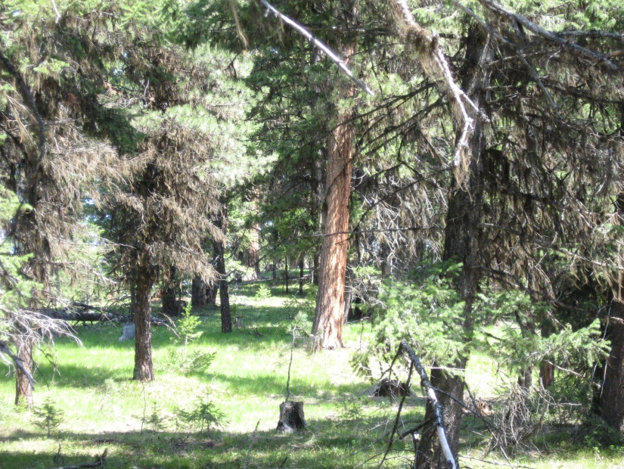Although the area is currently fragmented with previous harvest units and grass slope the individual stands identified for treatment are outside of their historic condition. The no action allows for wildfire disturbance as the only avenue for treatment in the stands identified.

Historically disturbance would be an acceptable option, however, with stand densities and high fuels accumulation not consistent with past levels the results could be costly to resources and fire fighter safety. Direct effects of a no action will result in continued conditions outside of the historic range in many areas of Muddy Sled.

Current conditions of proposed units are a result from “no action” outside of suppressing all fire starts in this area. The long-term exclusion of both natural and prescribed fire can cause significant shifts in vegetation density and species composition. (Natural and Prescribed Fire, 1990) Stand conditions are the indirect effect of fire suppression. Fires historically provided a method of sanitation. Effective suppression has eliminated burning of any type and therefore indirectly affected the stand structure, bark beetle levels, ecosystem health, and an increase in fire consequences.

In mixed-conifer forests, periodic fires left the fire-tolerant ponderosa pine and western larch but eliminated most of the fire-sensitive fir species. Beginning in the early 1900s, humans, seeing only the destructive side of fires, aggressively suppressed them. Inadvertently, this absence of fire over 80- to 100-year period allowed Douglas-fir and grand or white fir to take over the forest, slowly replacing the pine and larch (Oester, et al. 1992. Forest Health in eastern Oregon).

Without fire to thin out the small trees, tree density increases so much that individual trees must compete intensely for water and nutrients. Under this stress, all trees become more vulnerable to insect attack. In recent years, *drought*, which is particularly stressful to the more moisture-dependent fires, has aggravated this already critical situation. (Oester, et al. 1992. Forest Health in eastern Oregon).

Without mechanical and prescribe burning treatments the forests are allowed to continue in their current condition. This will result in a significantly higher mortality of the stand from not only wildfire but from insect and disease.

Under the current condition with no treatment action the stands have a greater potential for high severity burning in the event of a wildfire compared to how they historically burned. Active crown fire spread begins with torching, but is sustained by the density of the overstory crowns and the rate of spread of the crown fire (Agee and Skinner, 2005 Basic Principles of forest fuel reduction treatments

Fire behavior predictions were developed based on existing fuel loading. Outputs determined that if a wildfire occurred in these areas, initial attack suppression forces (two engines staffed with three person crews, and a one hour time delay) would be inadequate to contain the fire.

Fire behavior can be expected to be 8 to 45+ chains per hour with flame lengths of 5 to 17 feet or greater, depending on weather conditions at the time. Four foot flame lengths are the threshold for the use of ground forces.

ALTERNATIVE B

Units are proposed for treatments depending on several stand considerations such as: existing stand conditions, plant association, biophysical group, geographic location to sensitive sites, and resource needs outside of fire and fuels. Treatments for each unit are identified in the alternatives comparison table ????.

This alternative is proposed to mechanically treat selected timbered areas through thinning of suppressed and intermediate trees, provide structure protection around Sled Springs Administrative Site, handpile heavy sites of created debris, and re-introduce prescribed fire to landscape. This area has already missed several burn cycles and is exhibiting obvious signs of increased stand density with high levels of fire intolerant species. Treating areas will increase the stands overall health and resiliency to wildfires. Mechanical treatment will, when necessary, be followed by prescribed burning to treat the residual fuels to lessen fire potential in treated stands.

Fires interaction with ecosystem has departed from historical disturbance by multiple fire return intervals, resulting in increased vegetation accumulation and small tree encroachment. Increases in fuels have increased the potential for high intensity fire, torching (ability of fire to reach tree crowns), and crown fire spread (ability of fire to move through tree crowns) due to greater canopy densities. As a result, fire impacts are often more severe than occurred historically. Wildfires burning in these conditions threaten high value forest resources, private property, wildland firefighter safety, and are more costly to suppress.

Alternative B will accomplish several objectives through understory thinning. Thinning will raise the canopy base height from its current condition to a level where the probability of torching and crown fire initiation will be lessened. Canopy base height is the lowest height above the ground at which there is sufficient canopy fuel to propagate fire (van Wagner 1993). Mechanical treatment will increase the base height to around an average of 20 feet above ground level thereby reducing potential overstory mortality during wildfires.

Mechanical treatment will reduce the canopy bulk density in treated units. Reducing ladder fuels with mechanical thinning can lessen the likelihood of a ground fire transitioning to the tree crowns by reducing vertical fuel connectivity. Mechanical thinning followed by prescribed burning, is a first step in returning forests and grasslands to the historic range by lowering the Fire Regime Condition Class. Several treatments are often necessary to achieve a reduction in condition class.

Prescribed underburning will occur in both commercial units and non-commercial units (see table ???? on alternative comparison) ranging from 3 acres to as large as 187 acres. There is also three large natural fuels burn blocks proposed for this alternative totaling 4,315 acres. Prior to prescribe burning there are several areas proposed for ladder fuel reduction in the form of whipfelling followed by hand-piling before the area is underburned. Prescribe burning of the three larger natural fuels units will occur in both spring and fall using both hand and aerial ignition methods, depending on what is best for meeting resource objectives. The bulk of the natural fuels units are comprised of a combination of grass and open timber stand with pockets of down woody. Several intermittent channels are within proposed prescribed burning blocks. Prescribed fire ignition would not occur within 100 feet on any class 1 or 2 streams, however, fire would be allowed to back into these draws. Past experience shows that fire rarely burns within the riparian areas. Stream influences on surrounding vegetation often result in higher humidities and fuel moistures with riparian areas.

Surface fuels will be reduced through handpiling and/or prescribed burning in effect reducing fire rates of spread and fire flame lengths. BEHAVE fire modeling program was used to demonstrate the difference between a fuel model 10, 2, and 8.

A fuel model 10 exhibits much higher fire behavior than a fuel model 8. Fires burn in the surface and ground fuels with greater fire intensity than the other timber litter models. Dead-down fuels include greater quantities of 3-inch (7.6-cm) or larger limbwood resulting from over maturity or natural events that create a large load of dead material on the forest floor. Crowning out, spotting, and torching of individual trees are more frequent in this fuel situation, leading to potential fire control difficulties. Any forest type may be considered if heavy down material is present; examples are insect- or disease-ridden stands, wind thrown

stands, over mature situations with deadfall, and aged light thinning or partial-cut slash (Anderson, 1982). This fuel model is represented in many of the proposed treatment stands and without treatment will further accumulate down woody contributing to the fire behavior.

A fuel model 8 has the least fire activity of all the timber types. It represents the fuel model that is slow-burning ground fires with low flame lengths aregenerally the case, although the fire may encounter anoccasional “jackpot” or heavy fuel concentration thatcan flare up. Only under severe weather conditions involvinghigh temperatures, low humidities, and highwinds do the fuels pose fire hazards (Anderson, 1982). Fuel model 8 conditions are typically the results after all treatment is completed in the proposed units.

The following graphs show a comparison of fire behavior in each fuel model, a fuel model 10 describing the No Action where conditions are allowed to persist and worsen and a fuel model 8 displaying post treatment conditions.





In addition to reducing surface fire intensity, the proposed treatments would reduce the potential for torching and crown spread in most units. Not all units within the Muddy Sled area will receive prescribed burning. Some stands will have reduction in canopy density followed by whipfelling and handpiling. These units often times do not receive full acreage coverage of treatment but instead a reduction of fuel loading with some areas still containing jackpots of fuel within the unit.

Although some areas may require several treatments, the current proposed treatment would begin moving identified areas toward the historic range (Condition Class I). Periodic maintenance burning would occur on the same combined acres treated with mechanical and prescribed burning methods described above. All of the design features will apply. If site conditions change or new information becomes available, a new assessment of effects will occur prior to any future burning. Periodic maintenance burning will be applied to maintain the effects of fuel reduction treatments, continue to move stands to a more historic condition, and prevent losing the initial investment of work.

Whip-felling consists of live conifer trees (ponderosa pine, Douglas-fir, grand fir and lodgepole pine) 5” dbh and less that remain on site after commercial removal. The greatest majority of trees to be removed by fire and mechanical means combined are between 1 and 12 inches in diameter.

The larger thinning material (5 inches DBH and above) will be cut and removed with ground based equipment. The preferred approach is whole-tree-yarding (includes removal of tree limbs and tops)of larger thinning material. Whole tree harvest, with disposal of tops at the landing (chipping, burning) is most effective at preventing surface fuel increases in the residual stand (Agee and Skinner; 2005). **Non commercial material left at landings may be separated for possible biomass utilization. Limb wood and fiber wood (down to 3-4” tops) should be divided into two piles. The limb wood would be comprised of needles, limbs, less than 3” tops and eventually burned on site. The fiber wood should be placed in an additional pile for possible chipping or other biomass use. Most sub-merchantable material is available for removal as well for fiber.**

Small diameter material (ladder fuels) less than 5 inches DBH, left on site, will be treated through whip-felling after ground based equipment work is completed unless under optional item the purchaser chooses to remove while on site. The post mechanical fuels whip-fell will be allowed to cure, this may take up to 1 year, the identified units will be burned through prescribed burning under controlled weather parameters and fuel moistures. Snow pack and weather will contribute to decomposition. Under Alternative B and C this material will be reduced to change surface fire spread rates. Treatment of activity fuels will be followed up with underburning on identified acres within the fuels treatment table. Handpiling will occur where appropriate in order to protect residual trees and further reduce fuel loadings prior to or in place of prescribed burning. These units will be re-visited to determine if hand piling will be necessary once ground based equipment work is completed.

The mortality graphs (located in seciton Comparison of Alternatives) demonstrate how the use of prescribe burning can in fact sustain a higher percentage of stand structure. Levels of mortality under the current conditions will be anywhere from 50 to 90% higher from a wildfire. If allowed to treat the areas through mechanical treatment and prescribed burning the mortality will be significantly less. Prescribed burning will be applied to the natural fuels units. Fire managers have the ability to introduce fire during acceptable weather and fuel moisture conditions to minimize the impacts. Based upon recent results obtained from landscape under-burning projects in similar habitat types (Biomass 3, Sled, and Buck projects) and mortality modeling, it is estimated that 40 percent of the remaining coniferous vegetation less than 5 inches in diameter may be killed in the proposed underburn. In addition, within the large natural fuels blocks it is estimated that approximately 2 to 5 percent of the area would experience some torching, from heavy pockets of down fuels and adjacent ladder fuels. Under this alternative the areas proposed for natural fuels prescribed burning are less dense than those proposed for understory thinning and prescribed burning or thinning only.

Smoke emissions under this alternative will be significantly less than under the No Action alternative. This alternative allows for the use of prescribed burning that provides prescribed fire managers the opportunity to monitor weather and winds to determine the best day to initiate a prescribe burn to minimize impacts into sensitive areas. The Wallowa Fire Zone utilizes the Pendleton Weather Service and Salem Smoke Management Forecasters to determine favorable days for burning (see Air Quality section). Wildfire incidents occur when nature decides, while management ignited prescribed fire can be initiated when conditions are conducive to minimizing impacts to the environment and ecosystem. Additional treatments to reduce emissions is through removal of ladder fuels (raising crown base height) and reducing crown density under this alternative will create a more fire resilient stand. Removing and utilizing as much ladder fuels as possible will assist in lower levels of emissions.

Elevated fuels within the Muddy Sled area consist of both dead and down fuels as well as standing live trees that also are considered fuels. Since fire suppression, the fire potential has increased in three definable ways: surface fire intensity has increased due to increased fuels; torching potential, or the ability of a fire to move into the crowns, has increased due to vertical “fuel ladders” and low height to live crown; and the ability of fire to move through the crown has increase due to higher crown bulk densities (Graham et al. 1999, Agee et al. 2000, Edmonds et al. 2000). The change in crown bulk and fuel loadings can alter fire behavior. This project is designed to raise the canopy base height of the live crown, reduce the crown bulk, and modify the down fuel loadings to a lesser level.

In Effects of Thinning and Prescribed Burning on Wildfire Severity in Ponderosa Pine Forests, fire ecologist Jolie Pollet and Professor Philip N. Omi from Colorado State University completed a study examining fire severity in treated versus untreated ponderosa pine stands in selected western wildlands. Their main objective was to compare the severity of wildfires in adjacent untreated versus treated ponderosa pine stands. The results of this study revealed that treated plots have lower fire severity ratings and less crown scorch than the untreated plots. Based on statistical results and field reconnaissance, sites with mechanical fuel treatment appear to have more dramatically reduced fire severity compared to sites with prescribed fire only (Pollet and Omi 2000). Stand characteristics contributed to the difference in fire severity. The fuel treatments resulted in forests with much lower density and larger trees. Stands with fewer trees have less continuous crown and ladder fuels. Larger trees generally have crowns higher off the ground and have thicker bark with makes them more fire resistant. When prescribed burning is applied in stands that are not over stocked or in need of mechanical fuel treatment a reduced fire severity occurs. Findings indicate that fuel treatments do mitigate fire severity.

Thinning and logging may increase fire if fuels are left untreated. Mechanical treatment can decrease fire risk if:

* Resulting debris (slash) is treated (removed or burned),
* The larger or old growth trees are retained, but smaller, more flammable young trees are removed,
* The stand is effectively thinned removing ladder fuels and dense tree conditions (Weatherspoon and Skinner 1995; Huff and others 1995; Weatherspoon 1996).

This alternative addresses the above concerns through the proposal of treatments identified under Alternative B. Resulting fuels from thinning will either be handpiles and burning or will be reduced through prescribed burning. Residual stocking densities following thinning from below coupled with slash abatement treatments would reduce the potential for crown fire initiation. For a crown fire to initiate, the fire must transition from a surface fire. Crown fires would not develop without a surface fire of certain intensity. The intensity, for a given fuel and stand profile, sufficient for transitioning from a surface fire to crown fire initiation is known as the threshold intensity. Van Wagner (1977, 1993) identified the stand characteristics of height to the crown base and the crown foliar moisture content as the critical elements leading to crown fire initiation. These variables then determine a critical flame length (tied to intensity) that would allow the surface fire to become a crown fire.

Thinning and other thinning-like stand treatments can substantially influence subsequent fire behavior at the stand level by either increasing or decreasing fire intensity and associated severity of effects. Depending on intensity, thinning from below and possibly free thinning can most effectively alter fire behavior by reducing crown bulk density, increasing crown base height, and changing species composition to lighter crowned and fire-adapted species. Such intermediate treatments can reduce the severity and intensity of wildfires for a given set of physical and weather variables. The best success in modifying fire behavior through the use of thinning throughout the west is when applied in conjunction with prescribed fire (Graham et al. 1999). Also, Pollet and Omi, 2000, compared the effects of treated versus untreated ponderosa pine stands. They concluded that fuels treatments do mitigate fire severity. Although topography and weather may play a more important role than fuels in governing fire behavior (Bessie and Jonson 1995), topography and weather cannot be realistically manipulated to reduce fire severity. Fuels are the leg of the fire environment triangle (Countryman 1972) that land managers can change to achieve desired post fire conditions. Pollet and Omi’s study show that fuels treatments are effective in reducing severity in short fire-return interval ecosystems. The treated plots in the study had a lower fire severity rating and less crown scorch than the untreated plots.

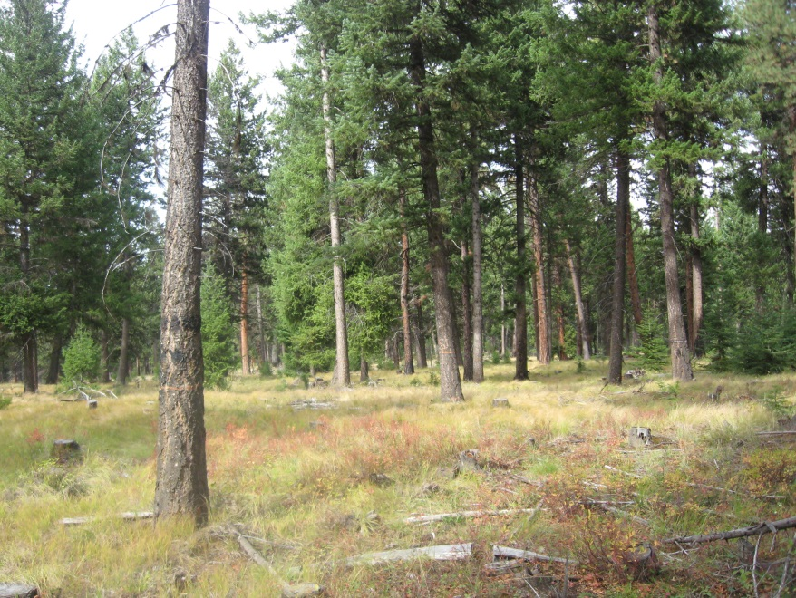

The photo to the left is a Vantage project unit that was thinned and is similar to what is expected after treatment in the Muddy Sled units. The stand continues to support overstory after receiving ladder fuel reduction. In the existing conditions photo above the tree crowns were averaging within 3 feet of the ground. After treatment in the units, as in this photo, the tree crowns will be raised to an average of 20 feet. Even though there is some small diameter regeneration left on site mortality within the stand after a wildfire will be far less than in the stand under the No Action.

The combination of mechanical and prescribed burning treatments in the stands will in fact reduce wildfire severity. Martin et al. (1988) modeled the degree to which the fuel reduction from prescribed burning would affect fire behavior. They analyzed post-burn fuels in one Washington location, four Oregon locations and two central California locations. Not too surprisingly, the wildfire potential was reduced in all of the cases studied. Swanson (1976) found that a series of strip head fires applied between mid-July and mid-September in second-growth Douglas-fir greatly reduced half-inch and smaller fuels. According to Swanson, “the trial burns largely eliminated the wildfire problem”.

Since fire suppression, the fire potential has increased in three definable ways: surface fire intensity has increased due to increased fuels; torching potential, or the ability of a fire to move into the crowns, has increased due to vertical “fuel ladders” and low height to live crown; and the ability of fire to move through the crown has increase due to higher crown bulk densities (Graham et al. 1999, Agee et al. 2000, Edmonds et al. 2000). The change in crown bulk can in fact alter fire behavior. This alternative will be increasing the crown base height through ladder fuel reduction and decreasing the crown bulk through thinning of the overstory in some areas. The mechanical thinning reduces tree density and canopy layer that allows for a low-intensity prescribed fire to be performed following completion of harvest. In addition to underburning, prescribed thinning techniques that retain many of the dominant trees, create an opportunity to maintain healthy, low fire-hazard conditions over broader areas of the landscape.

This alternative provides several option to reduce existing fuels in effect reducing the fire severity to the stands being treated. Although the entire landscape will not be completely fire resilient, treatment of these units will allow for more mosaic and diverse results.

PROTECTION PROPOSAL

Wildand-urban fire occurs when a fire burning in wildland vegetation fuels gets close enough with its flames and/or firebrands (lofted burning embers) to potentially create ignitions of the residential fuels (Butler 1974). Butler identifies homes (“urban”) as potential fuel and indicates that the distance between the wildland fire and the home (“close enough”) is an important factor for structure ignition.

Fire spreads as a continually propagating process, not as a moving mass. Unlike a flash flood or an avalanche where a mass engulfs objects in its path, fire spreads because the locations along the path meet the requirements for combustion. A wildland fire does not spread to homes unless the homes meet the fuel and heat requirements sufficient for ignition and continued combustion (Cohen, 1999). Three principal factors are responsible for structure ignitions: flame radiation, flame impingement – convection, and firebrands (burning embers) (Cohen and Butler 1996). Thus, decreasing potential structure ignitions involves decreasing the exposure to each of the ignition factors (Cohen and Butler 1996).

Recent research indicates that the potential for home ignitions during wildfires including those of high intensity principally depends on a home’s fuel characteristic and the heat sources within 100 -200 feet adjacent to a home (Cohen 1995; Cohen 2000; Cohen and Butler 1998). Based on severe-case assumptions of flame radiation and exposure time, Structure Ignition Assessment Model (SIAM) calculations indicate that wild-land flame fronts comparable to crowning and torching trees (flames 20 meters high and 50 meters wide) will not ignite wood surfaces at distances greater than 40 meters (Cohen and Butler, in press). The radiant heat a wall would receive from flames depending on its distance from the fire (Cohen, 2000). Radiant heat put off by a flaming front decreases as the distance increases.

The Structure Ignition Assessment Model (SIAM) (Cohen 1995) assesses the potential ignitability of a structure related to the W-UI fire context. SIAM calculates the amount of heat transferred to a structure from a flame source on the basis of the flame characteristics and the flame distance from a structure. Then, given this thermal exposure, SIAM calculates the amount of time required for the occurrence of wood ignition and flaming (Tran and others 1992). On the basis of severe-case assumptions of flame radiation and exposure time, SIAM calculations indicate that large wildland flame fronts (e.g., forest crown fires) will not ignite wood surfaces (e.g., the typical variety of exterior wood walls) at distances greater than 40 meters (Cohen and Butler [In press]). For example, the incident radiant heat flux, the amount of radiant heat a wall would receive from flames, depends on its distance from the fire. That is, the rate of radiant energy per unit wall area decreases as the distance increases (Cohen, 1995).

The Pacific Northwest Wildfire Coordinating Group developed a guide for defensible space around buildings. In *Living With fire – A Guide for the Homeowner (the Guide),* defensible space is identified as the area between a house and an oncoming wildfire where the vegetation has been modified to reduce the wildfire threat and to provide an opportunity for firefighters to effectively defend the house. In this case, the structures and living quarters of the Sled Springs guard station. The Guide describes the distance needed for structure protection based on biophysical conditions. These predictions assume a wind speed of 20 mph, flat terrain, typical moisture contents of living and dead vegetation for summertime, and normal August weather for our area (Pacific NW Wildfire Coord. Group).

Structure protection and defensible space treatments will occur on approximately 12 to 14 acres surrounding the buildings at Sled Springs Guard Station and Historic sites. This protection area will be dropped from the old-growth stand and replaced with up to comparable acres of land adjacent to the old-growth. See map.

The treatment activities within the protection area will be listed in 2 geographic zones.

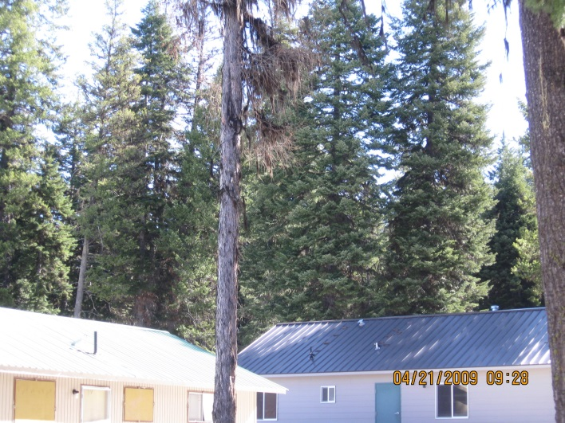Zone 1 is the area closest to the building up to 30 feet away and approximately 2 acres in size. This area should have most of the trees and brush, down woody material, and other burnable material removed. In addition to the 30 feet this zone also includes the actual structures. Building preparation will need to take place in combination with the woodland fuels treatment.



Zone 2, roughly 12 acres, is the area up to two times the tree height or 200 feet. This area should have trees and brush thinned out. Thin stand where there is a minimum of 8 feet between overstory canopy limbs. This will require felling of selected overstory retaining the healthiest and largest trees.

8 feet

Flat to Gently Sloping

0 – 20 %

For forested areas, the recommended

amount of separation between tree canopies is determined

by steepness of slope. The specific recommendations are

presented above ((Pacific NW Wildfire Coord. Group).

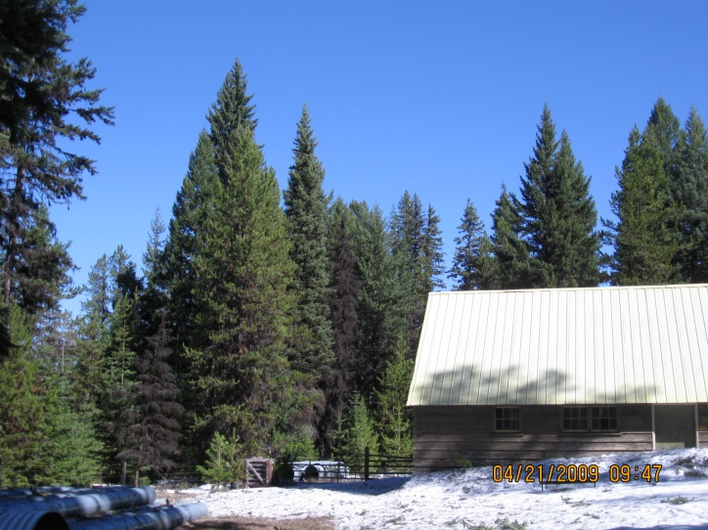Common to both Zones 1 and 2: Remove down woody material, prune residual trees up to 12 feet above the ground. These areas will not be designated old-growth and will receive more intensive management for safety and structure protection.

**Trees removed near structures or within the 200 foot protection zone will be utilized for their commercial value as logs, reduced into firewood, or made available for biomass processing.**

Zone 3 is the remaining Old-growth stand outside of the 200 foot protection area. ***All work within the actual old-growth will be accomplished through close coordination with the wildlife biologist and archeologist.***

A. There will be an untreated buffer of 50 to 100 feet on the perimeter of the old-growth to provide a thick boundary for the old-growth and discourage entry of hunters and woodcutters.

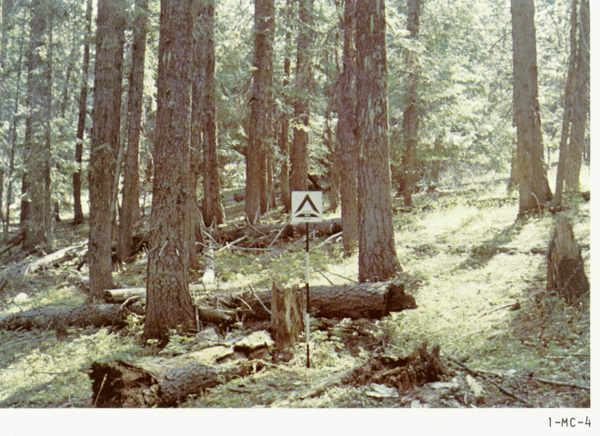B. The area within the perimeter of the untreated buffer will have a percentage of the down woody hand-piled and pile burned. Fuels reduction treatments should meet Chapter 4; page 4-90 and 4-91 of the Forest Plan. Fuels left on site will meet Forest Plan recommendations of PNW 105 photo series 1 – MC – 4 fuel loadings plus any 20”+ logs will be left on site as well. Fuels loadings based on the fuel profile average 20 tons to the acre with at least 10 tons to the acre of material larger than 9 inch diameter. Treatment will occur with hand crews only. There will be no heavy equipment in the old-growth.

PNW 105 Photo 1-MC-4

C. Treatment of the suppressed understory will also occur within this area. Whip fell and handpile of all material treated. Retain areas of healthy trees less than 5 inch dbh (diameter breast height), without pruning to maintain the multi-storied structure where appropriate. Treatments should be identified to meet the stand information identified in Chapter 4; page 4-90 and 4-91 of the Forest Plan and Green Tree Retention Guidelines. Areas currently meeting post treatment conditions will not be entered.

Maintaining defensible space on a regular basis will be an important part of the structure protection plan for this site. Preserving the initial investment will save values and implementation costs. Keeping your defensible space effective is a continual process. At least annually, review these defensible space steps and take action accordingly. An effective defensible space can be quickly diminished through neglect (Pacific NW Wildfire Coord. Group).

MONITORING

Two types of monitoring will occur in and around the site. First, annual periodic checks of defensible space will take place. This involves:

1. A walk around and within the 200 feet protection zone of the structures for buildup of debris and/or fire hazards.
2. Crown growth to ensure 8 feet between crowns is maintained.
3. Structural inspections should be conducted and recommendations of improved fire proofing to buildings should be acted upon.

Secondly, to ensure the old-growth integrity is retained fixed monitoring plots will be randomly placed throughout the old growth and looked at for pre, post, 1, 3, and 5 years. The fuels organization’s current monitoring plan for fixed plots will be used. The following is recorded in fixed plots.

1. Down woody fuel loading of all size material. Sound and Rotten
2. Duff depth
3. Standing live and dead, species, diameter
4. Seedling count <6” height and >6” height, species
5. % area ground cover Grasses/forbes species
6. Stand Density

Due to the proximity of the old-growth to Highway 3 and Enterprise new signs will be posted around the old-growth as well as No Wood Cutting Signs. All viable snags will be tagged with Wildlife tree signs.

Alternative C

Alternative C varies from Alternative B in the number of acres planned for treatment.

This alternative treats 96 acres less of commercial units, 4 acres less of whipfelling and handpiling, and 2 acres less of underburning.

Natural fuels underburning is reduced 708 acres by dropping unit 503 located east of Evans Creek. This unit was dropped based on fish biologist concerns in the head waters of Evans Creek.

The impacts at a landscape level are less significant than at a stand level.

**Effects - Comparison of Alternatives**

Effect of Stand Treatment

There is empirical evidence that treated verse untreated stands result in lesser fire severity when units are treated through mechanical and/or underburning. James K. Agee and Carl N. Skinner produced a paper in 2005 on Basic Principles of Forest Fuel Reduction Treatments. They reviewed the effects of treated verse untreated areas after a wildfire in 5 geographic areas. Table 1 identifies the outcome of no-treatment (current conditions) verse treated stands (selective cutting of trees with or without follow up fuels treatment.

Crown fires occur when surface fires create enough energy to preheat and combust live fuels well above the ground. There are two stages to the crown fire process: the initiation of crown fire activity, know as “torching”, and the process of active crown fire spread, where fire moves from tree crown to tree crown (Van Wagner, 1977; Agee it al., 2000). In comparing some principles of treatments to dry forests Agee and Hessburg provide a table identifying some effects, advantages, and concerns around those treatments.

Table 1.   
Principles of fire resistance for dry forests (adapted from [Agee, 2002](http://www.sciencedirect.com/science?_ob=MiamiCaptionURL&_method=retrieve&_udi=B6T6X-4FN4VT1-2&_image=tbl1&_ba=&_user=4250274&_rdoc=1&_fmt=full&_orig=search&_cdi=5042&view=c&_isTablePopup=Y&_acct=C000052423&_version=1&_urlVersion=0&_userid=4250274&md5=caa1274a016a3d63cfa86edd2b820a75" \l "bib4#bib4) and [Hessburg and Agee, 2003](http://www.sciencedirect.com/science?_ob=MiamiCaptionURL&_method=retrieve&_udi=B6T6X-4FN4VT1-2&_image=tbl1&_ba=&_user=4250274&_rdoc=1&_fmt=full&_orig=search&_cdi=5042&view=c&_isTablePopup=Y&_acct=C000052423&_version=1&_urlVersion=0&_userid=4250274&md5=caa1274a016a3d63cfa86edd2b820a75" \l "bib27#bib27))

| **Principle** | **Effect** | **Advantage** | **Concerns** |
| --- | --- | --- | --- |
| 1. Reduce surface fuels | Reduces potential flame length | Control easier; less torching[a](http://www.sciencedirect.com/science?_ob=MiamiCaptionURL&_method=retrieve&_udi=B6T6X-4FN4VT1-2&_image=tbl1&_ba=&_user=4250274&_rdoc=1&_fmt=full&_orig=search&_cdi=5042&view=c&_isTablePopup=Y&_acct=C000052423&_version=1&_urlVersion=0&_userid=4250274&md5=caa1274a016a3d63cfa86edd2b820a75" \l "tbl1fn1#tbl1fn1) | Surface disturbance less with fire than other techniques |
| 2. Increase height to live crown | Requires longer flame length to begin torching[a](http://www.sciencedirect.com/science?_ob=MiamiCaptionURL&_method=retrieve&_udi=B6T6X-4FN4VT1-2&_image=tbl1&_ba=&_user=4250274&_rdoc=1&_fmt=full&_orig=search&_cdi=5042&view=c&_isTablePopup=Y&_acct=C000052423&_version=1&_urlVersion=0&_userid=4250274&md5=caa1274a016a3d63cfa86edd2b820a75#tbl1fn1#tbl1fn1) | Less torching[a](http://www.sciencedirect.com/science?_ob=MiamiCaptionURL&_method=retrieve&_udi=B6T6X-4FN4VT1-2&_image=tbl1&_ba=&_user=4250274&_rdoc=1&_fmt=full&_orig=search&_cdi=5042&view=c&_isTablePopup=Y&_acct=C000052423&_version=1&_urlVersion=0&_userid=4250274&md5=caa1274a016a3d63cfa86edd2b820a75#tbl1fn1#tbl1fn1) | Opens understory; may allow surface wind to increase |
| 3. Decrease crown density | Makes tree-to-tree crown fire less probable | Reduces crown fire potential | Surface wind may increase and surface fuels may be drier |
| 4. Keep big trees of resistant species | Less mortality for same fire intensity | Generally restores historic structure | Less economical; may keep trees at risk of insect attack |

a Torching is the initiation of crown fire.

The proposed treatments for alternatives B and C are similar to all 4 principles described above. A combination of these treatments will generate a more fire resilient stand that once existed. Forest treated with these principles will be more resilient to wildfires (Agee and Skinner; 2005).

The photo below is an example of a change in fire severity due to fuel treatment on the Megram fire. Upper left portion of photo is untreated forest that was affected by a windsnap event in 1996. Lower right is a fuel-treated area where surface and ladder fuels were removed. The fire burned in 1999. USDA Forest Service photo. These areas were planned for or had undergone, follow-up treatments to reduce remaining fuels when the fire occurred. These treatments ranged from no further treatment to almost complete removal of small diameter and fine fuels through under burning. The complete treatment resulted in significant reductions in high severity fire effects.

These results provide evidence that the practice of stand management in high fuel hazard areas, with specific fuel reduction goals, may prove to be valuable in reducing fire severity in forested environments. These results are particularly applicable to land managers in the Pacific Northwest where maintenance of late-seral and riparian habitat is a concern (Jimerson and Jones, Ecological and Watershed Implications of the Megram Fire).

The following photo displays wildfire results in treated areas within the Cone Fire during the 2002 fire season. The fire behavior at the interface between untreated forest A. (left) and B (Unit 41), results in a defined line where treated verse untreated lie. The Cone Fire dropped from the crowns (flame lengths 1.5 times tree height or about 100 feet) to the ground when it entered Unit 41, but the radiant heat from the adjacent crown fire was sufficient to scorch and likely kill trees a few hundred feet into Unit 41. The 2002 **Cone Fire**, Lassen National Forest,

occurred under very severe fire conditions of low humidity, very low fuel moistures, and 10 – 20 mph winds, following a long, dry period. It burned into the Blacks Mountain

Experimental Forest which had received a series of thinning and prescribed burning

treatments designed to study the ecological effects of creating very different stand structures. Fuel reduction and fire hazard reduction were secondary objectives of the

treatments. Nonetheless, the crown fire in the untreated forest dropped to the ground and

went out when it entered a unit which had been biomass thinned and subsequently

prescribe burned to remove surface fuels. Where the thinning alone had been done

without prescribe burning the surface fuels, the crown fire dropped to the ground and

continued to burn as a surface fire which fire suppression crews could put out. The Cone

Fire at Blacks Mountain Experimental Forest represents the best documented example of the effect of biomass harvesting and prescribed burning to treat fuels and modify wildfire

Behavior (Gary Nakamura, 2004).

The stands today support a species composition that was kept in check through fire disturbance. Historically, fires were usually geographically large because of the availability of long-needled pine litter and dried grasses on the forest floor which created a continuous source of fuel on the soil surface (Agee, 1994). Rates of growth are faster for trees that are grown in the open with good root systems, but are generally slow for the regeneration and old tree stages in dense forest communities.

As dry forests transition toward moist forests, tree species such as Douglas-fir, grand fir and white fir may become the dominant species. If forests have frequent low intensity fires burning close to the ground (under-burning), fire will thin tree stands, and will favor ponderosa pine and western larch that are relatively resistant to fire damage and grow best in open, well spaced stands (Eastside ICBEMP). Stands that are more densely stocked with trees provide increased shade, and reduced wind speeds within stands (Eastside ICBEMP). Levels of carbon and nutrients tied up in woody material are higher than they were historically. Fuel moisture is greater in dense stands, particularly in small diameter fuels, because increased shading and reduced wind speed decrease the drying rate of forest fuels.

Through these treatments the Muddy Sled units will be slowly transitioned to a more historic condition. Where stands were more open, received more direct light, and allowed some level of wind to dry the forest floor. Even though the treatments will likely change the microclimate of that specific site it will be moved toward what existed historically. A study by Pollet and Omi titled *Effect of Thinning and Prescribed Burning on Wildfire Severity* *In Ponderosa Pine Forests*, did not support the assertion that more open stands experience higher fire severity. More open stands had significantly less fire severity compared to the more densely stocked untreated stands in the study. The historic microclimates within these units were drier and more open. Although the stands will be more open and less shaded the amount of trees being removed is not expected to significantly change the site to a higher fire severity but lower the expected fire severity to the residual stand.

**Mortality**

Tree mortality estimates were based on flame length and species bark thickness. The flame length was input along with species, tree height, crown ratio, and diameter breast height (dbh) in inches to determine mortality. All mortality runs were based on a *wildfire* occurring at the 90th percentile weather. For example during a wildfire a fuel model 2, 8, 10, and 11 generated average flame lengths in feet of 14.6, 1.7, 11.5, and 5.7 respectively. Mortality percentages were based on immediate effects of the fire and not indirect causes.

Flame lengths were determined using BEHAVE: fire behavior program. Fuel moisture inputs into the program were based on 14 years (1993 to 2007) of historical weather data recorded at: Bobcat (changed to Roberts Butte in 1998), Harl Butte, Point Prominence, and Minam remote weather stations. Eighty percent of all fire starts on the Wallowa Fire Zone occur July 20th and August 20th, based on this, the season of year selected for the weather data was July 10th through August 30th in an attempt to capture the most active fire days. Fire FamilyPlus was used to sort data and identify the worst 10% of wildfire days (90th percentile) that may occur based on the historic data. These weather stations are located in various locations throughout the district to provide a more representative weather and fuel moistures that are likely to occur. The Minam, Harl Butte, Point Prominence and Roberts Butte RAWS were used to provide full coverage of weather across the district. The following fuel moistures readings were used from 1993 – 2007 the 90th percentile readings used as input into BEHAVE are:

1 hour = 3.0% fuel moisture 10 hour = 3.0% fuel moisture 100 hour = 5.0 % fuel moisture Herbaceous fuel moisture = 49.0% wind speed of 13.0 mph

Prescribe burning parameters used were based on several years of burn plan writing for the local area and obtaining information from other local prescribed burning experts. Prescribe burning parameters used in BEHAVE are: 1 hour = 9 % fuel moisture 10 hour = 11 % fuel moisture 100 hour = 16 % fuel moisture Herbaceous fuel moisture = 100% wind speed of 3 mph

Additional factors input into the model for determining flame lengths were slope, wind direction, and direction of fire spread in regard to slope. Slope used was 20% based on the average slope of the activity units, wind direction of upslope was used for both wildfire and prescribe fire. Direction of fire spread however differed for wildfire and prescribed fire. Since prescribe fire is a planned application of fire direction of spread was shown as a backing fire or down slope spread against the wind, where a wildfire often travels with the wind and slope characteristic of a head fire traveling with the wind.

Each fuel model was evaluated in the 90th percentile weather parameters (wildfire) generating an average flame length, these outputs were use to determine a range in crown scorch height and tree mortality. The following graph displays the difference in flame length between wildfire and prescribed burning. The highest average flame length for a prescribed burn is 1.4 feet for fuel model 10 but can range from 1 to 3 foot in length, as compared to a forward spread wildfire in the same fuel model with flame lengths of 12 feet in length. Fuel model 11 is light slash and representative of fuels left on sight post understory thinning or where a light pre-commercial thinning has occurred. The spacing of the rather light fuel load, shading from overstory, or the aging of the fine fuels can contribute to limiting the fire potential. Light partial cuts or thinning operations in mixed conifer stands, hardwood stands, and southern pine harvests are considered under fuel model 11 (Anderson, 1982). Flame lengths generated from a fuel model 11, in both wildfire and prescribed burning, are significantly lower than those generated in a natural fuels accumulation of a fuel model 10.



Wildfire – NO ACTION ALTERNATIVE

Prescribed burn – Post mechanical treatments – ALTERNATIVES B and C

The importance of the flame length graph is that it demonstrates that under natural fuels build up (and at times unnatural fuels buildup) the fuel model 10 generates a higher more damaging wildfire than a light slash condition found in fuel model 11. Part of the reason for this is that the fuel model 10 has a higher level of large woody material (3” in diameter and bigger) still on sight that creates higher burning intensities and longer residence time of the flaming front fuel model 10 also has a higher level of ¼” material on the ground and live fuel load. Ninety percent of the units proposed for mechanical treatment in Muddy Sled are currently fuel model 10. The no action alternative would allow these units to remain in their current state, accumulate additional fuels and potentially sustain a higher level of damage in the event of a wildfire. Once treated fire intensities and severity in these units will have far less effects than results the stand will receive under current conditions.

The lighting pattern of a prescribed burn is typically initiated from the top of the slope and gradually worked down to the bottom of the slope of unit. Fire managers can reasonably control locations, areas of coverage, frequency, season of burns, and especially the intensity of controlled burns. By having the ability to determine time of year, method, weather parameters fire managers can minimize fire severity as compared to mid-summer wildfire. The potential impacts of controlled burns on streams should be dramatically less (Vic Kaczynski, Wildfire Impacts on stream Habitats, 1994).

Fuel models 8, 10 and 11 were used for mortality since these models are representative of post treatment with mechanical with slash residue treatment, current condition, and post mechanical treatment (without slash residue treatment proposed) respectively. Fuel model 8 exhibits low flame lengths under both wildfire and prescribed burning conditions and the goal is to convert these currently proposed stands to a fuel model 8.

The following graph was developed using a FOFEM (First Order Fire Effects Model). Analysis were completed for each of the species using the wildfire scenario in 90th percentile weather and an average burning prescription using prescribed fire. Flame lengths for the fuel model 10 were 11.5 feet for wildfire and 1.9 feet for prescribed burning.

Mortality sustained in both scenarios is a combination of bark thickness and scorch height. The no action alternative has potential for substantially increasing mortality for all species in their current state. Under Atlernatives B, and C controlled prescribed burning after raising the canopy base height will have lower mortality rates than under the current conditions.

WF – represents Wildfire - NO ACTION ALTERNATIVE RX – Represents Prescribed burning - ALTERNATIVES B, C after treatments

WF – represents Wildfire - NO ACTION ALTERNATIVE RX – Represents Prescribed burning - ALTERNATIVES B, C after treatments



WF – Represents Wildfire - NO ACTION ALTERNATIVE

RX – Represents Prescribed burning - ALTERNATIVES B, C after treatments

A fuel model 8 contains little enough fuels that the fire will spread and burn, but with very low intensities resulting in mortality due to bark thickness of species verse exhibiting high scorch heights that occur in a fuel model 10 or 11. Because the flame lengths in a fuel model 8 for a wildfire and prescribe fire are so close 2 feet and .8 feet respectfully there is no difference in the amount of mortality sustained between the two scenarios when modeling this fuel model in FOFEM.

One of the purposes of this project is to raise the crown base height to an appropriate level where the stand will be more fire resilient. In determining the crown fire potential based on current conditions and comparing it to crown fire potential after all treatments are completed the computer software program NEXUS was utilized. Nexus takes into account surface fuel models and crown fire behavior to provide the user with indices of relative crown fire potential. Nexus was used to compare the effects of alternative fuel treatments on crown fire potential during a wildfire.

In both current and post treatment scenarios 90th percentile fuels conditions for a wildfire were input to determine crown fire potential on the stand. Unit 14 was used as the average stand being treated under Muddy Sled. The (no action) current condition of the stand used was a fuel model 10, with a canopy base height of 1 foot presently due to the high amount of suppressed understory present and large down woody material on site. Based on number of trees per acre within the unit the available canopy fuel load was also determined before and after treatments. While alternatives B and C (post treatment conditions) were based on proposed treatment prescriptions changing the stand conditions to represent a fuel model 8 with a canopy base height to an *average* of 20 feet. The two scenarios, No Action and Alternative B and C (proposed treatment) were input into Nexus and calculated for percent crown fraction that would burn under 90th percentile fuels conditions. The following tables and charts provide the outputs of those comparisons.

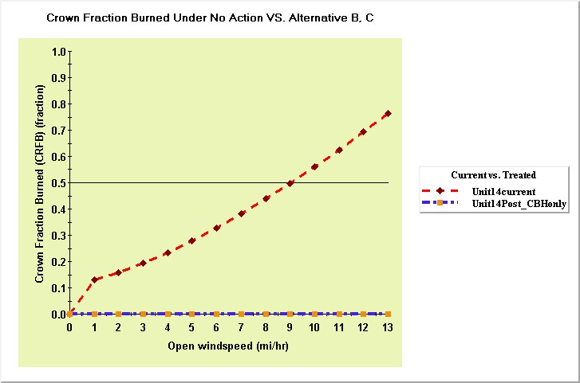

Nexus outputs show the amount of canopy crown fraction burned from a wildfire under current conditions is significantly higher and requires very little wind than crown fraction burned from a wildfire after treatment. Crown fraction numbers are from 0.0 to 1.0 with 1.0 representing a fully active crown fire. Current conditions are represented by a fuel model 10 and a 3 foot canopy base height while post treatment conditions represent a fuel model 8 and a twenty foot canopy base height. Under current conditions light winds have the potential to initiate a crown fire. Post treatment will result in a higher crown base height, reduced canopy density and surface fuels. These stand structure changes show that the sites have a much higher probability for survival than untreated stands. Under current conditions a nine mile per hour wind is enough to generate up to 50% of the crown burned.

There are considerable differences in the impacts to the proposed units under the no action and alternatives B and C. Progress toward healthier stands will promote more tolerant stands from not only wildfires but insect and decease as well.

The changes in fire behavior resulting from live and dead fuels modification show significant benefits in treating proposed units within the Muddysled planning area.

Potential for stand survival in increased post treatment even under extreme weather conditions as indicated on the Cone Fire. Stand changes from management treatments will better prepare these units for more positive outcomes during wilfires.