February 4, 2015.

CWPP committee:

There are 9 full committee members involved in working through the CWPP process.

These include representatives from: Emergency Services, Oregon Dept. Forestry, Rural Fire Dept., Wallowa-Whitman Forest Service, Bureau of Land Mgmt., and FS Rep from Umatilla National Forest. There is overlap of some member from the Cohesive Wildfire Strategy (CWS) group.

**The CWPP Development Process:**

Our approach to developing the CWPP is summarized as follows[1]:

1. Northeast Oregon is a pilot for addressing the CWS approach within a CWPP. As such, the CWPP incorporates guidance from the Cohesive Wildfire Strategy with emphasis on its three goals: Restore and Maintain Landscapes, Wildfire Response, and Fire-adapted Communities. The CWS recommends four guidelines for establishing priorities:
2. The primary emphasis is for safe and effective response to wildfire. The plan will recognize the importance of preparedness in both structural protection and wildfire prevention, emphasizing advanced preparedness for full effectiveness.
3. Second, and most challenging, is fuels and vegetation management including the analysis, design, and prioritization of treatments. Guidance includes strategic placement of fuels treatment; increasing the use of all approaches to further advance toward resilient forests and rangelands; and increasing the use of wildland fire to meet resource objectives.
4. The third priority is preparedness through working with homeowners and communities in proactive approaches prior to wildfires. Homeowner and community involvement is essential for successful landscape preparation in advance of potential wildfires.
5. Fourth, emphasis is given to the design of programs and activities to meet the needs of the local population and strengthen efforts to prevent human caused ignitions.

We are also using several other key policies and directions to help guide the CWPP rationale. These include but are not limited to:

**The Federal Register** specifically discusses the need to identify highest risk and priorities as a key for funding allocation. *"Interagency groups of land managers at the State and/or Tribal level to collaboratively identify priority areas within their jurisdictions that would benefit from hazard reduction activity. This will ensure that available funding is focused on areas of local importance and where opportunities are most conducive to reducing risks on a meaningful scale.”*

**The Community Guide to Preparing and Implementing a CWPP - August 2008** states, *"According to HFRA, the wildland urban interface is considered “any area within or adjacent to an at-risk community that is identified in recommendations to the Secretary in a Community Wildfire Protection Plan. Communities have the ability to establish the definition and boundary of a localized WUI. Community-established WUI boundaries can help meet local management needs, can include both public and private land, and can help improve access to funding sources.”*

The **August 2014 Wildland Urban Interface Wildfire Mitigation Desk guide (PMS 051)** states, *"Quantitative risk assessment requires calculations of the two primary components of risk: the magnitude of the potential loss and the probability that the loss will occur. For the wildland urban interface, a risk assessment is a step in the planning process that identifies the probability that any feature/element of the landscape and structures that will create potential harm to a homeowner or community.”*

**Oregon Administrative Rules** including: Oregon Department of Forestry Division 44 Criteria for Determination of Wildfire Hazard Zones - states, *"As used in OAR chapter 629, division 044, unless otherwise required by context: (1) "Geographic Area" means the areas which result from the partitioning of all or portions of a jurisdiction into smaller segments, based on the presence of differing hazard values.”*

**The Risk Assessment Process:**

The CWPP process began with a county wide distribution of 18 individual WUIs. **Within the last week** we have met and are considering merging the WUIs adjacent to one another, 15 total WUIs, into one large area we are considering calling a WUI zone with three other geographic areas that are remote and lack adjacency. These WUI zones are distributed around the perimeter of the La Grande Valley with three outliers in remote areas. The rationale behind this method is taking a geographic approach on landscape conditions including the “middle ground” areas between communities and the more distant wildlands as described in the CWS.

While this approach provides certain practical planning, mapping and administrative advantages to the CWPP, it may undermine the ability to identify priority areas per the federal guidance, and compete for available funding.

The 2005 Union County CWPP identified a WUI as, *“ wildland-urban interface area (WUI) surrounds a community at risk, including a community’s infrastructure or water source, and may extend beyond 1 ½ miles of a community, depending on topography, geographic features used as an effective firebreak, or Condition Class 3 land.”*

Compared to the original 2005 CWPP the identified WUI zone extends further into the general forests where it strategically makes sense such as; ridges, roads, changes in landscape conditions that would provide more opportunities for forest restoration and defensible space outside of the “typical” WUI and to meet changing demographics and policy direction.

The risk assessment process is based off of a 17 western state assessment called the West Wide Wildfire Risk Assessment (WWRA). The WWRA mathematically evaluated landscape conditions at the 17 state (regional) level and a county by county (state) level. I have included a diagram of all the input that was used for calculating fire threat, fire effects, and fire risk.

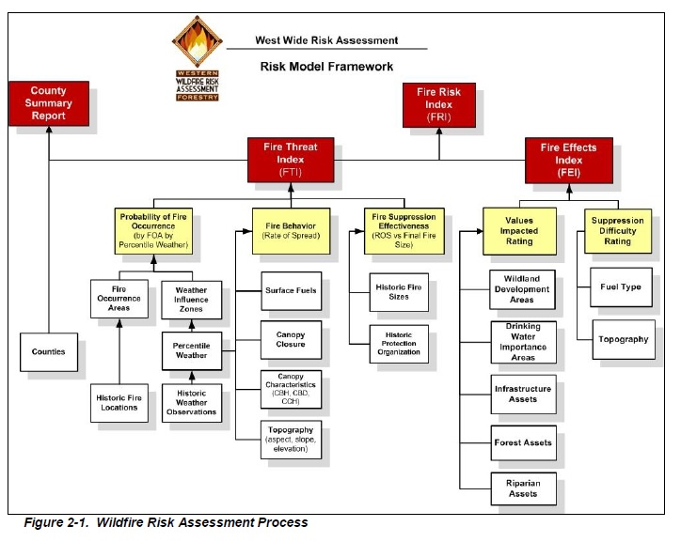

Using the mapping layers available in the WWRA and local knowledge we are currently identifying Union County conditions for prioritization. We are in the process of developing categories that can umbrella specific criteria. Categories include:

1. Fire Threat that includes criteria such as: fire density and fire probability, fire Rates of spread, Probability of Canopy fire, and Suppression Effectiveness
2. Fire Effects that may evaluate risks to housing density and developed areas, impacts to infrastructure, etc.
3. Local Issues and Social Issues that can impact or enhance success for implementation, fire response, etc. These could include proximity to mill, overall road access, current community involvement, ingress/egress to communities, etc.

We will be prioritizing geographic areas through a spread sheet using rating criteria with numerical values comparing overall conditions in an effort to maintain objectivity. This spread sheet is still in development but one possible rating could be:

Fire Threat Category –

Probability of Fire Occurrence (see above diagram) is displayed in a numerical format in the mapping of the WWRA. This allows us to evaluate areas using an approach similar to the following:

-4 = Geographic area contains fire occurrence levels of up to 0.773348 -3 = Geographic area contains fire occurrence levels up to .442102 - 2 = Geographic area contains fire occurrence levels up to 0.266566 -1 = Geographic area contains fire occurrence levels up to 0.165468 0 = Geographic area contains fire occurrence level < = 0.116419

The more negative the total outcome on the spread sheet the greater need for attention on the landscape compared to other locations.

I originally set this up based on the individual WUIs but will now work with the CWPP group to identify geographic areas (larger than the original WUIs) to provide a logical comparison.

1. A template for the document content is available upon request.