Jenny,

Hope all is well and thanks for the email.

To clarify, your email mentioned the three primary ratings which I assume you mean the Fire Risk Index (FRI), the Fire Threat Index (FTI) and the Fire Effects Index (FEI).

Here are a few thoughts. The reason many non-analytical folks like three categories is because it is simple. The instructions for reporting in the 2000 Fire Plan data call for "Communities-at-Risk" (another term I do not like) were to label each community as Low, Moderate or High.

The purpose of the class breaks is to aid in decision making. As you may recall from page 2 of the document titled 7-WWA-Detailed_Process_Description6.pdf that is on the flash drive I handed out at the Workshop, the existing nine breaks are percentiles as shown in Figure 1.
Figure 1
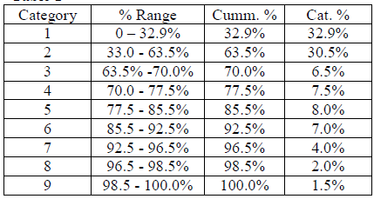

What is key here is to recognize that there are a lot of cells in the lower class values.

Fir your info, I am working with a company called Timmons Group to build a web portal for Arizona similar to the ones currently built for Colorado and Texas. It is to be completed June 30 so based on the Arizona rollout plan, I soon should be able to share a URL with you. We have done some very neat things with this and also made the portal more representative of the WWA as opposed to the "creative changes" made in Colorado.

The reason I mention this is that the opening screen is called Assess Your Location. We use two measures, Fire Threat Index and the Expected Flame Length (expected fire intensity). The first is a measure of the likelihood a fire will reach a location and the second is the expected flame length or intensity = potential for damage. I mention this as you might consider the use of Expected Flame Length in your thoughts. I can share additional thoughts in the use of flame length if you desire.

This all said, in developing the Assess Your Location and writing text specifically for the FTI, I did not try to write 9 different descriptions. For the text writing purpose, I debated between grouping the FTI into 3 or 4 classes. See Figure 2 on the next page. It shows a 3 and 4 class system. The values are FTI and are the state specific data for Arizona. Examine this Figure and I am sure the Oregon data would be similar. Note the ratios of the average of the low to high class breaks for classes 2-9. I set the average value for Class 1 at 0.002.

Figure 2
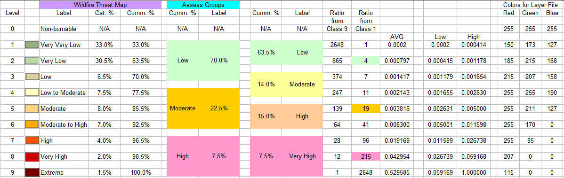

Best regards,
Don
~~~~~~~~~~~~~~~~~~~~~~~~~~~~~~
Fire Program Solutions, LLC
Donald Carlton
17067 Hood Court
Sandy, Oregon 97055
(503) 668-1390 (Voice)
(503) 668-1392 (FAX)
(503) 887-6536 (Cell/Paging/Voice Mail)
Email: dcarlton1@aol.com
Home Page: http://www.fireps.com
~~~~~~~~~~~~~~~~~~~~~~~~~~~~~~

