Testing Kernel Processing for Jenny
20150723
TzA

- Reproject Union CWPP structures shapefile (10,145 records) to match WWRA WDA
From: Oregon State Plane, NAD 83 HARN, Units Feet
To: Oregon Lambert NAD 83, Units Feet
- Kernel to find density of point structures per 40-acre area
40 acres / 43,560 = 1,742,400 sq. ft
40 acre dimensions in feet: 1,320 feet per side, a² + b² = c² 1,867 Ft. Search Radius
Output Raster to match WWRA WDA cell size = 98.4252 Ft.
Output Area Units: ACRES
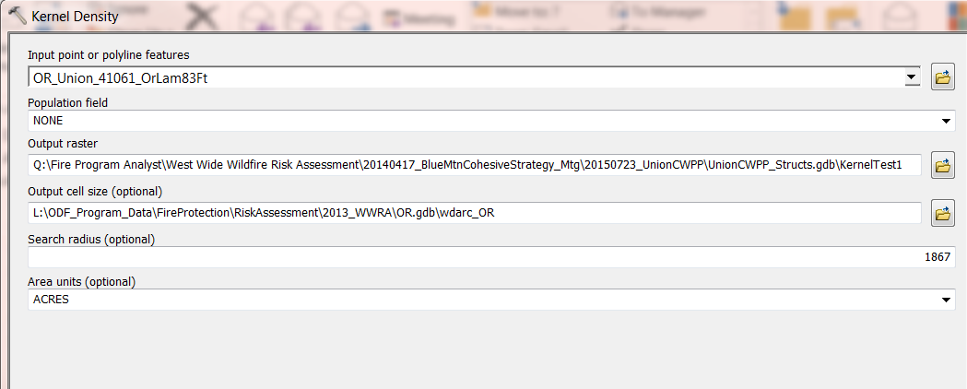
- Results Floating Point Raster = KernelTest1
Count (Cells): 8,491,620
Rows: 3,070
Cols: 2,766
Cell Size = 98.4252 Ft.
Min Value: 0
Max Value: 3.5759
Mean Value: 0.00469
Std. Dev: 0.07764
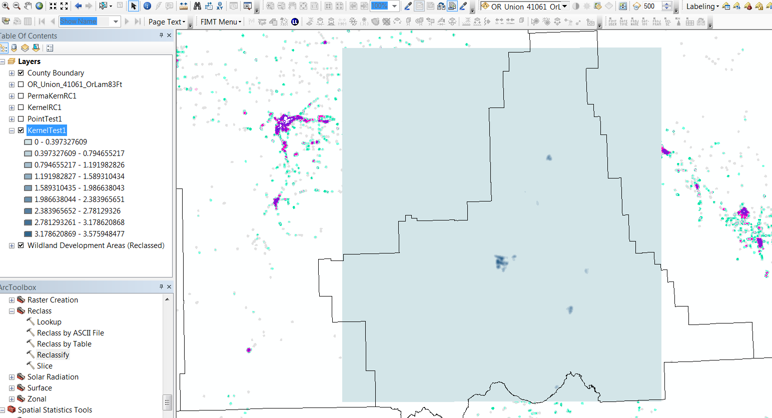
- Test Point Density
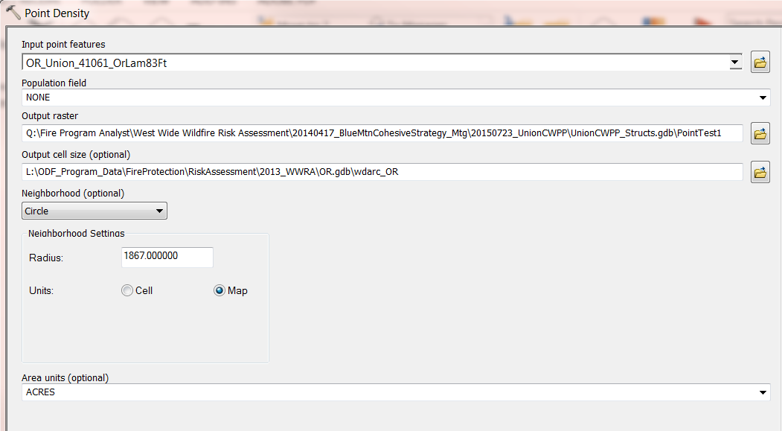
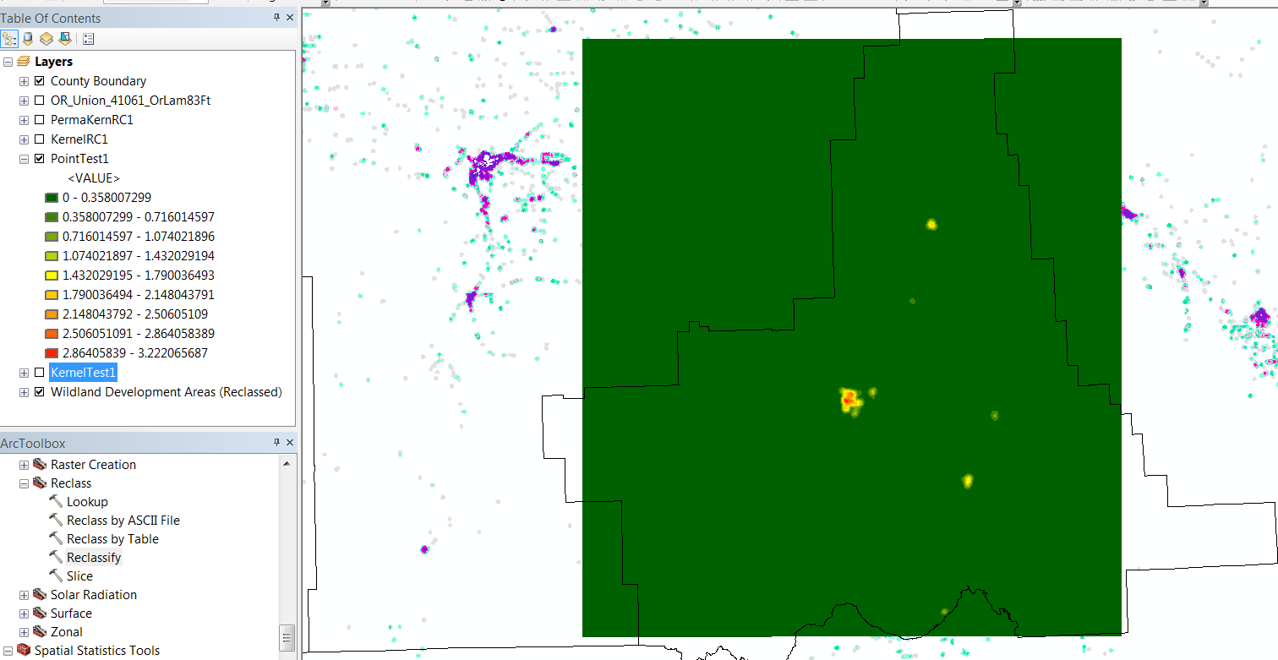
- Test Reclass of Kernel (one test reclass, can be reclassed with other groupings)
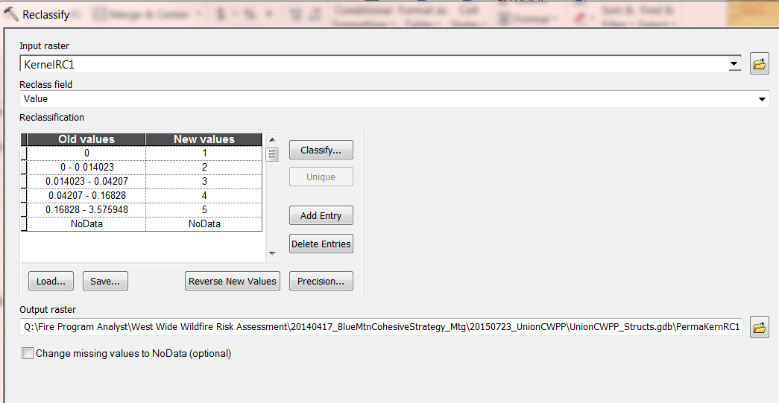
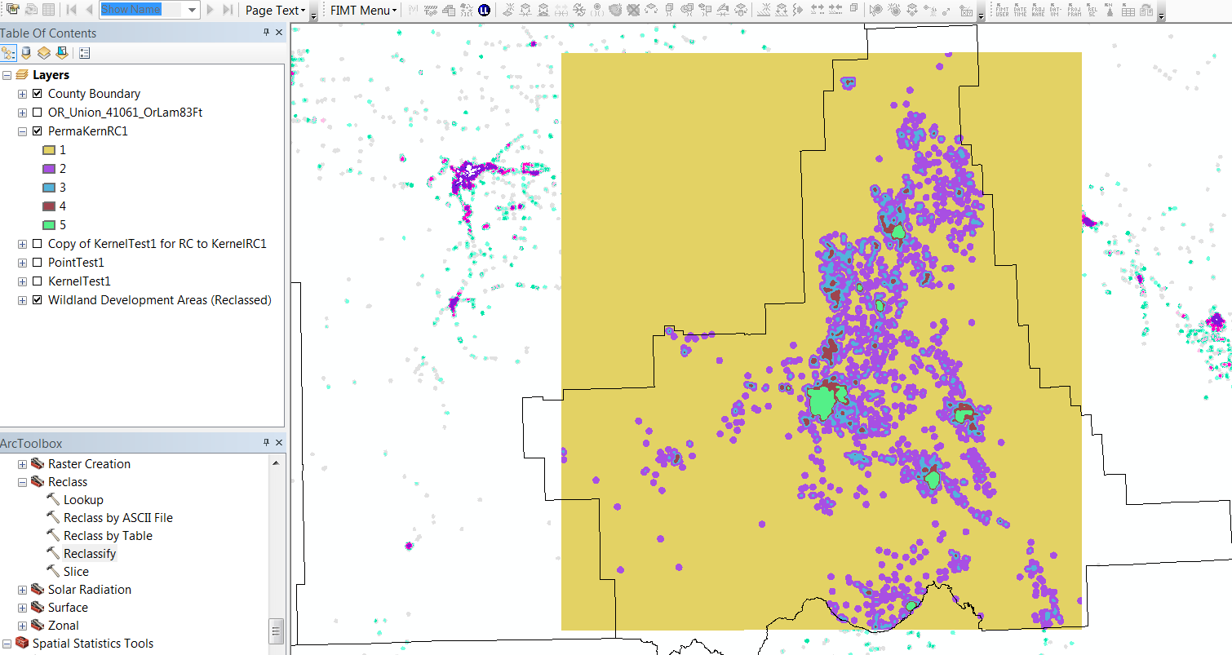
Reclass Zoomed in (Structure Points in very light green)
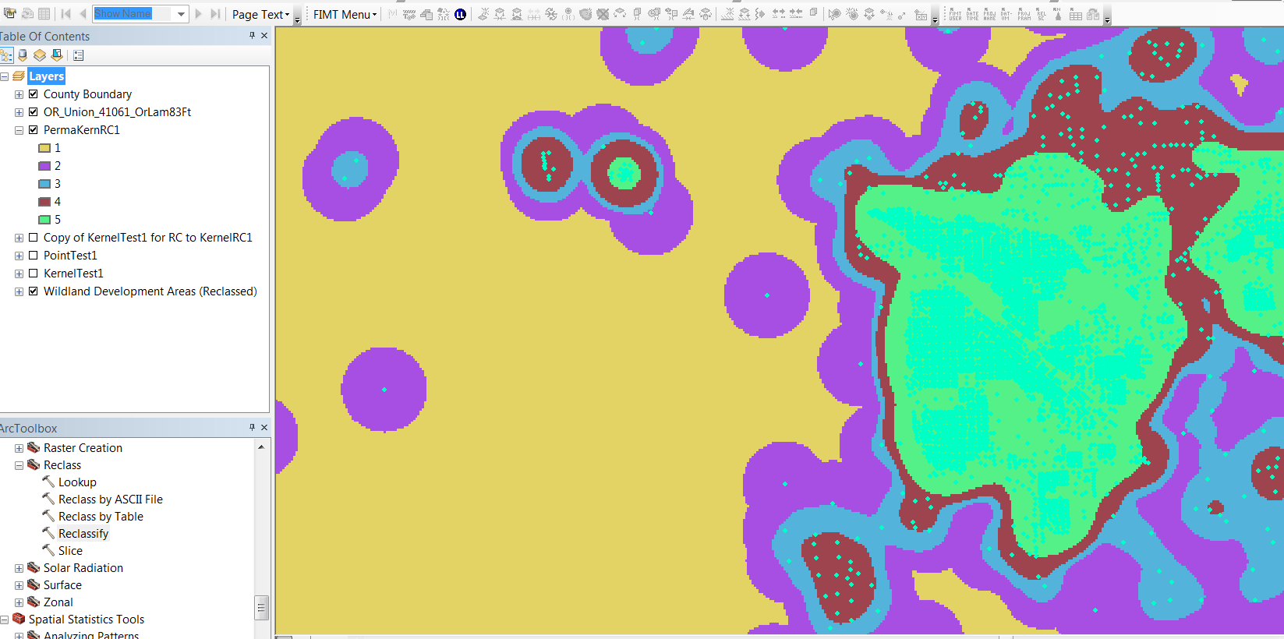
- Added Acreage to the Reclass Attribute Table
Count field give # cells in each class, and Cell size is 98.4252 ft² (= 9,687.5 Sq. Ft Area), so
(Count * 9.687.5 Sq. Ft) / 43560 = Acres in Each Class
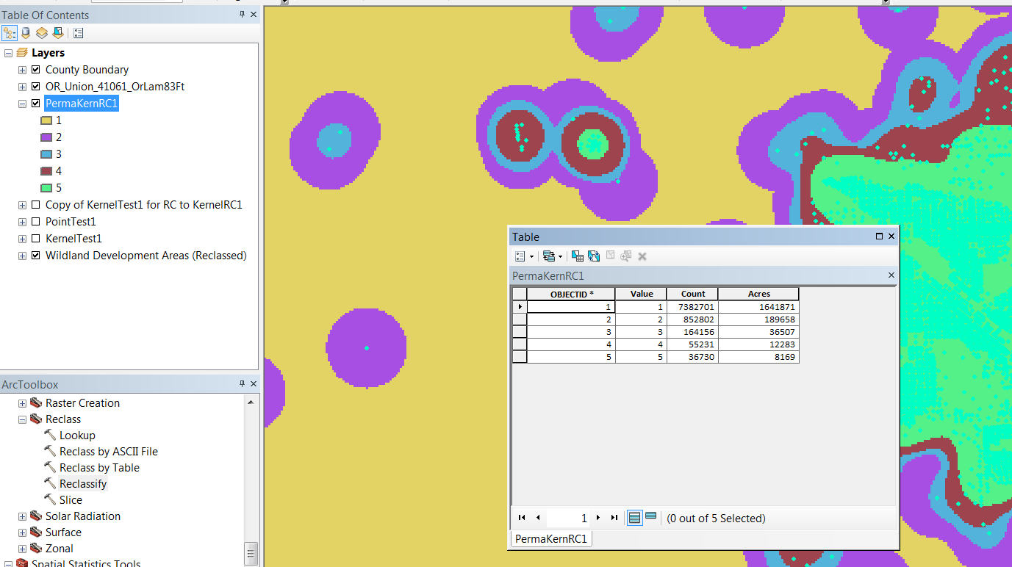

- Testing Raster to Vector Conversion, Dissolve By Grid Code and Point in Poly
