Subject: Union County Community Wildfire Protection Plan January 7, 2015

All Union County Rural Fire Chiefs,

Union County fire protection agencies are in the process of revising the 2005 CWPP. The update is a collaborative effort by a core group of the following participants: Union County Emergency Service, Oregon Department of Forestry, Wallowa-Whitman and Umatilla National Forests, Bureau of Land Management, and Union County Fire Defense Board. The updates are intended to meet changing conditions in several arenas including on the ground environmental conditions, new guidance and policy direction, continued shifting demographics of the area, and technological advances. In addition, the update will reflect accomplishments that have occurred since the 2005 version.

The CWPP core group has begun assessing the County utilizing the most current data available through the West Wide Risk Assessment, a recently completed assessment of 17 western states and local existing data.

It is our intention to collectively work with all rural fire departments and their community members through partnership in developing the CWPP. Through this partnership a holistic approach toward community fire protection is the desired outcome. Using the new National Cohesive Wildfire Strategy as a planned approach, we have incorporated the three key goals as our foundation for achieving the new CWPP.

1. **Fire-Adapted Communities** take into consideration of how human populations and infrastructure can withstand a wildfire without loss of life and property. Included in this goal is the education of community members on the considerations of home protection, ingress/egress, “Ready, Set, Go”; their role in the three phases of wildfire: pre-fire preparation, during the fire, post fire and recognizing the role of fire in ecosystem development. This goal also includes opportunities to evaluate the current infrastructure and identify obstacles, deficiencies, or opportunities for protecting life and property.
2. **Wildfire Response** is a means of building an all jurisdictional participation in making and implementing safe, effective, and efficient risk-based wildfire management decisions. The CWPP group is currently identifying a number of threat and risk issues within Union County, and is further narrowing down any additional issues relevant to individual WUI areas. This goal is anticipated to further substantiate the need for any additional improvements to assist in wildfire response including geographic pre-positioning of suppression needs (ie: water sources, communications), ecological treatments, and capability shortages (ie: training, equipment, etc.)
3. **Restore and Maintain Landscape** is designed to recognize fire-related disturbances from an ecological stand point of fire resiliency and an expansion of fire protection consideration to include all jurisdictions by promoting a landscape level approach. Developing a program that actively manages the land to make it more resilient to disturbance, in accordance to management objectives and to expand treatment opportunities to include middle ground and beyond that will assist in altering potential for extreme fire severities. This will provide the foundation for building a platform toward living with fire for both communities and ecosystems.

It is our hope that through these three goals that you as Fire Chiefs can begin to consider what and where improvements are needed, shortfalls exist, and opportunities for new innovative ideas can occur. We encourage you to approach your needs and recommendation on the premise that,

“In a perfect world with available finances, what needs to be done to better protect life (firefighter and public) and property in the WUIs within your jurisdiction?”

We have provided you with two additional supplements in an attempt to generate ideas, but WUI needs are by no means limited to these attachments.

1. A map displaying any changes to WUI boundaries and their intersections with your rural protection jurisdiction area overlaying those WUIs.
2. A thorough list of specific issues that could potentially impact or enhance your ability to respond to, plan for, or provide protection during a wildfire. This list is not all encompassing, therefor you are encouraged to provide additional thoughts, ideas, or needs that may not be mentioned, specific to you area.

As follow-up to this letter we would like to invite you to attend the Fire Defense Board Meeting on January 22, 2015, 6:00 PM, at the La Grande Fire Station. The meeting is designed to provide a good fundamental understanding of the CWPP’s revision process and gain your input specific to the rural protection areas. If you are interested in submitting your specific input in advance of the meeting, please feel free to send them to Joe Hessel or JB Brock, emails provided below.

We would also like to invite you to additional CWPP meetings scheduled through the beginning of 2015 that will correspond to individual WUIs. You will be notified in advance when those WUIs affecting your protection area are on the agenda. We look forward to your input.

Thank you for your time.

Joe Hessel JB Brock

Oregon Department of Forestry Emergency Manager

La Grande Unit Forester La Grande, Oregon

541 963-3168 541 963-1009

[jhessel@odf.state.or.us](mailto:jhessel@odf.state.or.us) [jbrock@union-county.org](mailto:jbrock@union-county.org)

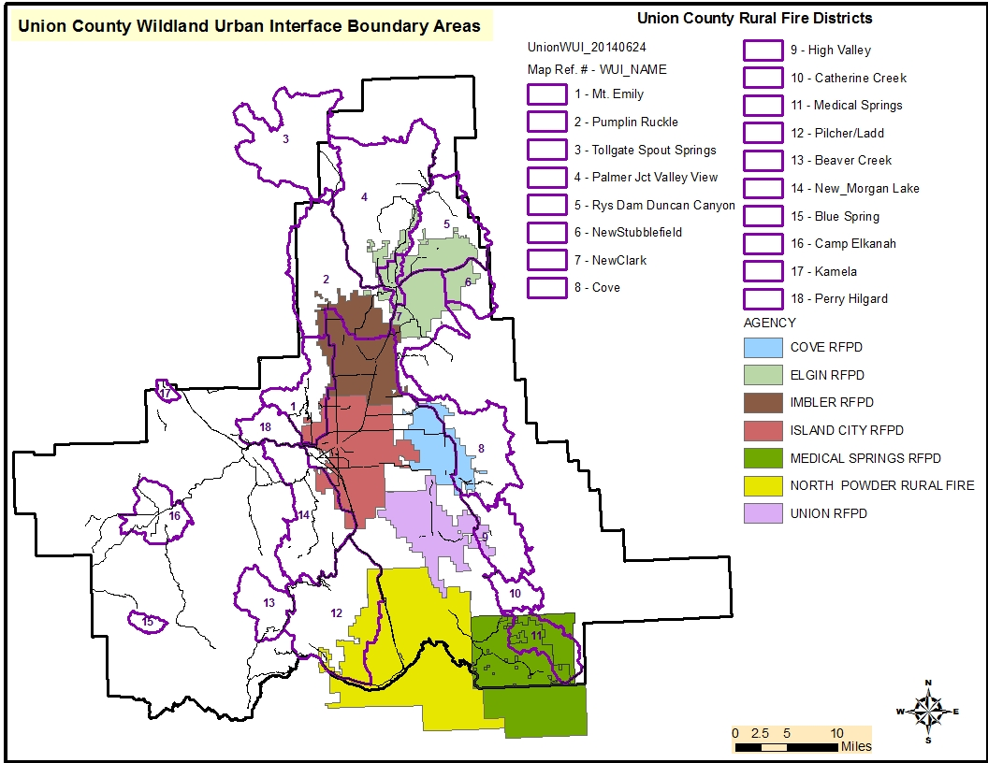

Considerations for CWPP. Feedback is NOT limited to below list!

Risk Assessment – to life and property.

1. Transportation -
2. Ingress/egress/access – road conditions, closures, issues, etc.
3. Potential for bottlenecking during evacuation and/or wildfire response
4. Response times – changes over past 5 years, impediments - where, why
5. Radio Frequencies and area of non-coverage
6. Vulnerable locations –

a. Most critical areas and areas likely for significant loss – geographically – why?

1. Water sources available or needed – hydrants, ponds, streams/rivers
2. Bridges - issues, new, planned
3. Vulnerable populations – single parent, elderly, remoteness, or likely unwilling to evacuate
4. OTHER?

Potential - Structure Loss or survivability

1. Current codes, regulations, zoning standards – effectiveness or deficiencies
2. are codes related to residential or forest areas - What are they? Are they working?
3. municipal or county codes
4. High potential structure loss or key resource loss/Specific Vulnerabilities

3. Firewise communities/homeowners - locations, needs, defendable locations

4. Capacity/availability for local fire agencies to respond to fires – possible shortfalls

5. Equipment access and maneuverability - known trouble spots/locations

7. OTHER?

Fuels Treatment Options/Reduction

1. Economic Stability
2. Infrastructure support or needs – biomass utilization, fiber, small material use
3. In woods, community Job opportunities – who, what equipment, where
4. All Hands/All Lands -Cross boundary and landscape approach – education opportunities
5. Time and spatial landscape priorities/opportunities - Who, where, what, when
6. Strategic placement of treatments - Strategic types of treatments- Defensible Space
7. Pilot project possibilities for across boundary – where, size, description
8. Available Demonstration projects in areas
9. Firewise – treatment options. In Use?
10. Treatment tool options currently working or lacking.
11. Stand manipulation mechanisms – over story harvest, prescribed fire, hand piling, ladder fuel reduction, etc.
12. Current, completed, or desired activities for reducing wildfires
13. Opportunities for Maintenance treatment of completed fuels reduction
14. OTHER?

Emergency Management

1. Substations - Infrastructure – Type, location

a. threatened, deficiencies, compatibilities?

1. Equipment – insufficiencies and capabilities
2. Needs, does it meets changing demographics
3. Opportunities or need for - Collaboration, Agreements, Easements
4. Training Qualifications – number trained/certified, number needed
5. Currency of Training – personnel and Content Material
6. Evaluation Notification Plan, Evacuation Plan, Post Fire Rehabilitation Plan
7. Possible or anticipated wildfire scenarios – under expected vs. extreme wildfire behavior – potential trouble spots
8. Options for Emergency Fire Simulation Training – locations, participation, etc.
9. Vulnerable populations – single parent, elderly, remoteness, likely unwilling to evacuate
10. Communications – radios, phones, etc.
11. OTHER?

Collaboration/Partnerships and Education/Outreach

1. Opportunities and existing partnerships – who, level of partnership
2. Integration of Education Forums
3. Education toward Pre, during, post fire
4. Fire Prevention
5. Outreach – Interagency Blog, media
6. Local contacts, organizations, partners
7. Community Responsibility

a. ownership in CWPP approach

b. willing partners in treatments

c. Collaboration in decisions

5. Building capacity for communities to reduce wildfire risk

a. Firewise/Ready Set Go/communication

b. Fire protection

6. Why Education

1. Eliminate confusion of public
2. Knowing, understanding builds trust
3. Reach out to schools
4. Pre, During, and Post fire – anticipated needs; what can be expected

7. Activities already in place

8. Known Homeowners Associations

9. OTHER?

Technology and Reporting Systems

1. Reporting mechanisms of fire starts and treatment activities
2. Web sites
3. Forms
4. Equipment – computers, mapping
5. Fire Response Equipment
6. GIS
7. GPS
8. Tablets, Computers, Mapping
9. Reporting Protocol
10. Issues, benefits, needs
11. Consistency or inconsistency with other agencies
12. Technology Use Training needs for personnel
13. Cell phones / radios
14. Consistency with other agencies – updates needed
15. New technology being used/tested that would be beneficial to others

OTHER Items specific to your protection area: