Agenda

Fire Defense Board Meeting

La Grande City Fire Department

1806 Cove Avenue

January 22, 2014, 1800 (6pm)

The CWPP core group has begun assessing the County utilizing the most current data available through the West Wide Risk Assessment, a recently completed assessment of 17 western states and local existing data.

It is the CWPP group’s intention is to collectively work with all rural fire departments and their community members through partnership in developing the CWPP. Through this partnership a holistic approach toward community fire protection is the desired outcome. Using the new National Cohesive Wildfire Strategy as a planned approach, we have incorporated the three key goals as our foundation for achieving the new CWPP.

It is important first to provide a clear understanding of the CWPP, however the majority of the meeting time will be given to Agenda Item #6, Identifying Rural Fire Districts issues and needs.

1. Introduction – JB Brock
2. Discuss Cohesive Wildfire Strategy – 3 goals – (Joe Hessel) Fire-Adapted Communities
3. Wildfire Response
4. Restore and Maintain Landscapes
5. Overview of CWPP – Local Plan to address local needs and issues
6. History of Union County CWPP (1st revision) - Mitch
7. How the 2005 CWPP benefited the county - Mitch Accomplishments/Funding/Projects
8. Significance and benefits of updating the current CWPP – JB Brock
9. Importance of collaborative involvement - JB Brock
10. CWPP Decision Support Information - Jenny

* Supporting data, local knowledge, etc.

1. Highlight West Wide Assessment Role vs. local knowledge role - Jenny
2. Brief display of County information mapping, individual WUIs, Rural - fire occurrence – Jenny
3. Identify Rural Fire District’s issues/needs list
4. Timeline for final input from Rural Departments

We have attached the map and list that was sent out with the original letter announcing the meeting and request for information.

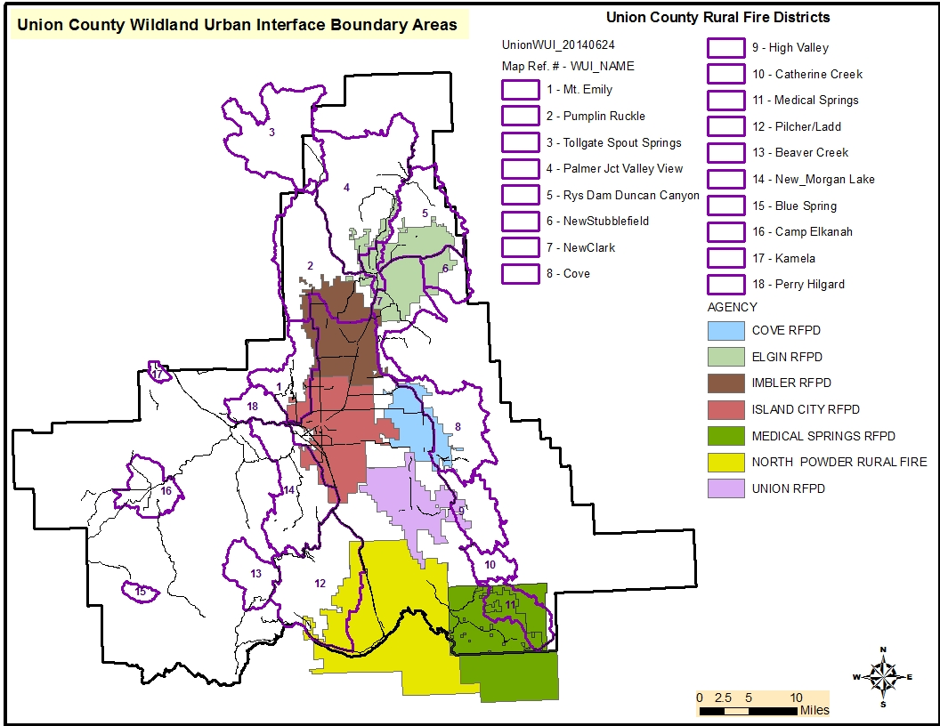

Considerations for CWPP. Discussion and feedback is NOT limited to below list!

Risk Assessment – to life and property.

1. Transportation -
2. Ingress/egress/access – road conditions, closures, issues, etc.
3. Potential for bottlenecking during evacuation and/or wildfire response
4. Response times – changes over past 5 years, impediments - where, why
5. Radio Frequencies and area of non-coverage
6. Vulnerable locations –

a. Most critical areas and areas likely for significant loss – geographically – why?

1. Water sources available or needed – hydrants, ponds, streams/rivers
2. Bridges - issues, new, planned
3. Vulnerable populations – single parent, elderly, remoteness, or likely unwilling to evacuate
4. OTHER?

Potential - Structure Loss or survivability

1. Current codes, regulations, zoning standards – effectiveness or deficiencies
2. are codes related to residential or forest areas - What are they? Are they working?
3. municipal or county codes
4. High potential structure loss or key resource loss/Specific Vulnerabilities

3. Firewise communities/homeowners - locations, needs, defendable locations

4. Capacity/availability for local fire agencies to respond to fires – possible shortfalls

5. Equipment access and maneuverability - known trouble spots/locations

7. OTHER?

Fuels Treatment Options/Reduction

1. Economic Stability
2. Infrastructure support or needs – biomass utilization, fiber, small material use
3. In woods, community Job opportunities – who, what equipment, where
4. All Hands/All Lands -Cross boundary and landscape approach – education opportunities
5. Time and spatial landscape priorities/opportunities - Who, where, what, when
6. Strategic placement of treatments - Strategic types of treatments- Defensible Space
7. Pilot project possibilities for across boundary – where, size, description
8. Available Demonstration projects in areas
9. Firewise – treatment options. In Use?
10. Treatment tool options currently working or lacking.
11. Stand manipulation mechanisms – over story harvest, prescribed fire, hand piling, ladder fuel reduction, etc.
12. Current, completed, or desired activities for reducing wildfires
13. Opportunities for Maintenance treatment of completed fuels reduction
14. OTHER?

Emergency Management

1. Substations - Infrastructure – Type, location

a. threatened, deficiencies, compatibilities?

1. Equipment – insufficiencies and capabilities
2. Needs, does it meets changing demographics
3. Opportunities or need for - Collaboration, Agreements, Easements
4. Training Qualifications – number trained/certified, number needed
5. Currency of Training – personnel and Content Material
6. Evaluation Notification Plan, Evacuation Plan, Post Fire Rehabilitation Plan
7. Possible or anticipated wildfire scenarios – under expected vs. extreme wildfire behavior – potential trouble spots
8. Options for Emergency Fire Simulation Training – locations, participation, etc.
9. Vulnerable populations – single parent, elderly, remoteness, likely unwilling to evacuate
10. Communications – radios, phones, etc.
11. OTHER?

Collaboration/Partnerships and Education/Outreach

1. Opportunities and existing partnerships – who, level of partnership
2. Integration of Education Forums
3. Education toward Pre, during, post fire
4. Fire Prevention
5. Outreach – Interagency Blog, media
6. Local contacts, organizations, partners
7. Community Responsibility

a. ownership in CWPP approach

b. willing partners in treatments

c. Collaboration in decisions

5. Building capacity for communities to reduce wildfire risk

a. Firewise/Ready Set Go/communication

b. Fire protection

6. Why Education

1. Eliminate confusion of public
2. Knowing, understanding builds trust
3. Reach out to schools
4. Pre, During, and Post fire – anticipated needs; what can be expected

7. Activities already in place

8. Known Homeowners Associations

9. OTHER?

Technology and Reporting Systems

1. Reporting mechanisms of fire starts and treatment activities
2. Web sites
3. Forms
4. Equipment – computers, mapping
5. Fire Response Equipment
6. GIS
7. GPS
8. Tablets, Computers, Mapping
9. Reporting Protocol
10. Issues, benefits, needs
11. Consistency or inconsistency with other agencies
12. Technology Use Training needs for personnel
13. Cell phones / radios
14. Consistency with other agencies – updates needed
15. New technology being used/tested that would be beneficial to others

OTHER Items specific to your protection area: