CWPP Meeting Notes

April 8, 2015

In Attendance: Joe Hessel, Larry Woolridge, Scott English, Katy Nesbitt, Mike McDonnell, Jenny Reinheardt

**PUBLIC MEETING:**

1. Review Public Meeting Ideas

The CWPP group discussed key points (the intent) for the public meeting. The following was the result:

1. to build upon existing partnerships and create new opportunities with the communities,
2. to provide Union County communities members with tools to participate in in wildfire risk reduction.
3. Links to webs sites Firewise, Ready-Set-Go, etc
4. Links to funding access
5. Demonstrate the importance of shared responsibility in Public & Firefighter Safety, wildfire prevention, risk reduction, and forest management.
6. Discuss possible additional informational meetings likely to occur that would be beneficial.
7. Rural fire department meetings on preparing for and what to expect in the three phases of evacuation situations – (pre, during, post)
8. Ways to improve successful fire response and suppression

It was suggested to invite a member of the public that participated in fuels reduction projects from the 2005 CWPP. Having a non-agency, community member discuss their experience may help bring folks on board with all hands-all lands. Adding it just after Mitch talks about how the 2005 CWPP benefitted the county.

Before and after photos were also looked at during the CWPP meeting and everyone agreed to display a few of them at the public meetings. Mechanical treatment for risk reduction is not equal to heavy impacts.

Example:

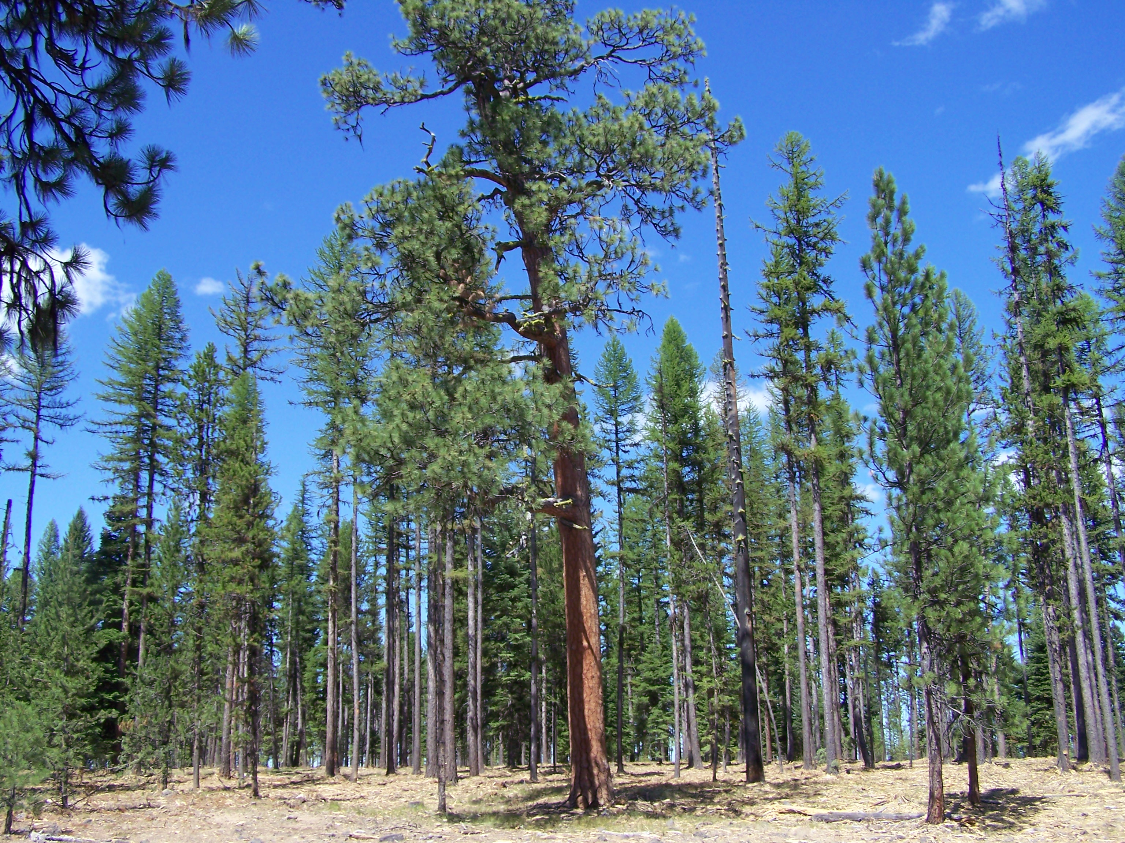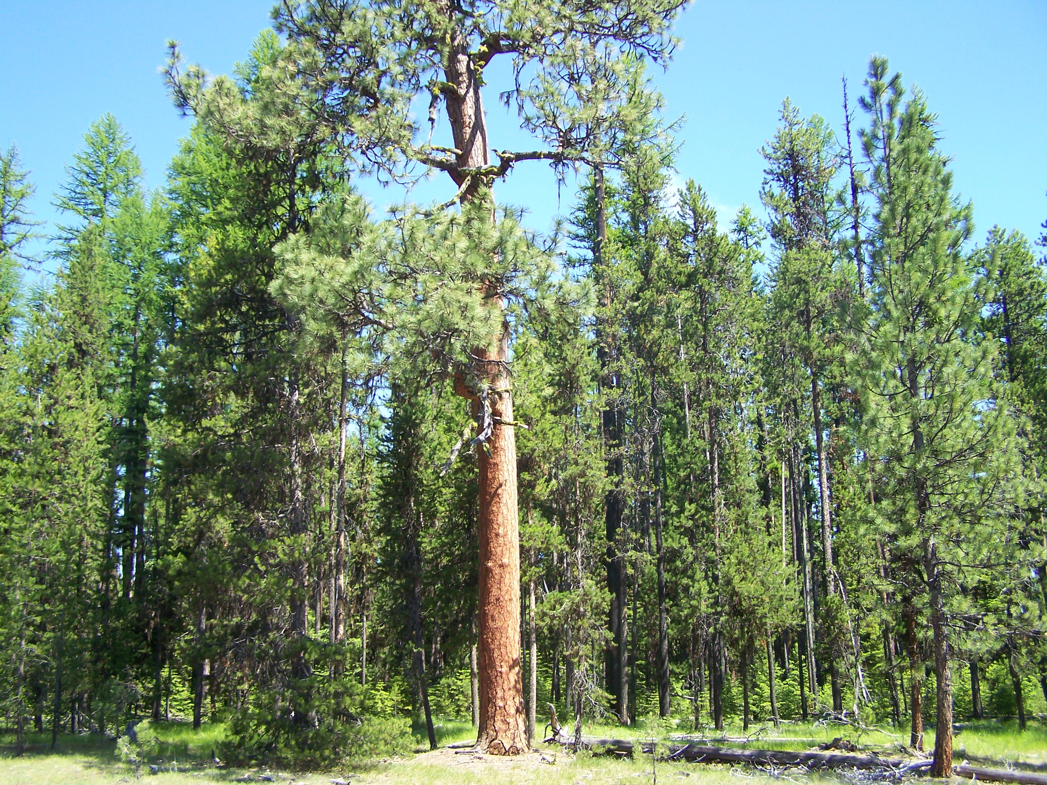

Primary focus of the meeting after presentations will be to:

Identify Community member concerns, roles, and assistance in safety and wildfire risk reduction and protection. Determine any changes that may have occurred since last CWPP.

Also, the rural tickler list will be modified for the public meetings to provoke some ideas/thoughts.

Standard Equipment will be needed at the Public Meetings: Projector, flip charts (at least two)/ or dry erase boards,

Handout - Brochures for Firewise, Getting Started with Firewise Kit – these are free (quantity limit of 4 each) from National Fire Protection Association – **do I need to order any?** Also any handouts for Ready-Set-Go

It was mentioned that presenting at smaller venues may have a greater benefit due to the travel distance, comfort of grange halls etc. and results from past FS projects. It is recolonized this may require extra effort and don’t recommend applying to our current project unless the turnout is poor at the locations we have identified and the additional venues would be beneficial. Also if there is a public request for a community meeting it may be worth considering.

PUBLIC SURVEY QUESTIONNAIRE

Old CWPP questionnaire was found in CWPP binder (thank you) and reviewed. We will be doing another questionnaire with same questions from the 2005 CWPP. Katy is reviewing these to see if there is a need for additional information and what questions would help fulfill those needs.

The 2005 CWPP group put the Questionnaire in the Observer with drop offs in any City Hall or Library or mail into Emergency Services in La Grande – this is being worked on.

The other option we talked about is putting the questionnaire on the Emergency Service Facebook, and web site and have interested folks email them to a CWPP email account.

I have already set up a gmail account where surveys can be mailed to:

[unioncountycwpp@gmail.com](mailto:unioncountycwpp@gmail.com)

The Public Meeting Agenda is **attached (Page 5)** with new modifications.

The public meeting announcement will be published in this Fridays Observer. There will also be radio announcements.

**Further discussion needed:**

**Meeting attendance:**

1. The low attendance of the Cooperators meeting was discussed. It was suggested to come up with a some general questions and have a few people make direct contact (via phone) with each cooperator. - Unresolved
2. **QUESTION - needs answered soon –**

Do we want to send out letters to cooperators and businesses removed from cooperators list announcing the public meetings? Can we get the meeting information posted asap on Emerg. Service web site and Facebook -  who does this and when?

**WUI Zone Unique Values and Hazards**

The group finished reviewing the remainder of the WUI Zone and surrounding areas for Unique Values and/or Hazards that are specific to a geographical area.

We started north of Elgin where the Transmission lines and fish hatchery are located - from there we moved east/southeast through Mt. Harris area, Cove, Union, Medical Springs, North Powder , etc. and finished at Mount Emily where we originally started.

Some areas identified were: OSU Research Study Area, Point Prominence, Mt. Fanny structures and Radio Towers, Catherine Creek State Park, Power lines, Gas Pipelines, Cell towers, Recreations sites, etc.

There was discussion when we got to Anthony Lakes Ski Area since Union County did not identify it as a WUI Zone. Baker County had incorporated the entire area into a WUI.

Jenny now has the Baker County – Mitigation Action Plan and shape file for the area. Further discussion will be needed on this.

Jenny will look at 2005 CWPP for any additional Unique Values/Hazards that were identified that may have been overlooked. A list will be developed and a GIS Layer identifying them geographically.

Agenda

Union County

Community Wildfire Protection Plan

Community Meetings

Location: La Grande City Fire Department, 1806 Cove Avenue

Date and Time: April 21, 2015 at 6 pm.

The Union County Community Wildfire Protection Plan (CWPP) core group is assessing the county’s fire threat and fire risk conditions, utilizing the most current data available through the West Wide Risk Assessment, a recently completed assessment of 17 western states utilizing information from federal, state, and local data bases.

The CWPP group’s intention is to collectively work with rural fire departments, cooperators, and community members to develop the wildfire protection plan. Through this process it is our intent:

1. to build upon existing partnerships and create new opportunities with the communities,
2. to provide Union County communities members with tools to participate in in wildfire risk reduction.
3. Links to webs sites Firewise, Ready-Set-Go, etc
4. Links to funding access
5. Demonstrate the importance of shared responsibility in Public & Firefighter Safety, wildfire prevention, risk reduction, and forest management.
6. Discuss possible additional informational meetings likely to occur that would be beneficial.
7. Rural fire department meetings on preparing for and what to expect in the three phases of evacuation situations – (pre, during, post)
8. Ways to improve successful fire response and suppression

Through this partnership a holistic approach toward community fire protection is the desired outcome. Using the new National Cohesive Wildfire Strategy we have incorporated its three key goals as our foundation in achieving a synergistic planned approach in the new CWPP.

It is important first to provide a clear understanding of the CWPP. However, the majority of the meeting time will be given to Agenda Item #4, Identifying Community Members concerns, roles, and assistance in wildfire risk reduction and protection.

1. Overview of CWPP – Local Plan to address local needs and issues
2. History of Union County CWPP (1st revision) - **Mitch**
3. How the 2005 CWPP benefited the county - **Mitch** Accomplishments/Funding/Projects
4. Significance and benefits of updating the current CWPP – **JB Brock**
5. Importance of collaborative involvement - **JB Brock**Discuss
6. Cohesive Wildfire Strategy – 3 goals – (**Mark Jacques**)

a. Fire-Adapted Communities

b. Wildfire Response

c. Restore and Maintain Landscapes

1. Highlight West Wide Assessment Role vs. local knowledge role – **Jenny**
2. Brief display of County information mapping, WUI Zone, Fire Occurrence, Fire Threat, Fire Risk - **Jenny**
3. CWPP Decision Support Information – supporting data, local knowledge, etc. - **Jenny**
4. Identify Community member concerns, roles, and assistance in wildfire risk reduction and protection.
5. Public Survey form available for handout – fill it in or mail it in - options
6. Timeline for final input from Community Members on CWPP and surveys.

SCHEDULES DATES:

**PUBLIC MEETINGS –**

1. La Grande – La Grande Fire Dept. April 21st at 6 pm (1800 hrs)
2. Elgin – Elgin Fire Station – April 30th at 6 pm (1800 hrs)
3. Union – Union Oregon City Hall – May 6th at 6 pm (1800 hrs)