**Prioritization of Communities-at-Risk and Wildland Urban Interface Zone**

This appendix applies to prioritizing Communities-At-Risk (CAR) and the Wildland Urban Interface Zone (WUIZ) using results from the West Wide Fire Risk Framework, described in Chapter VI, along with other pertinent local issues to determine areas of priority, particularly in regard to at-risk communities.

The intended outcome is to provide management an assessment of conditions contributing to fire risk relative to other geographic areas in the County. The level of fire interaction at which these communities are expected to encounter are exhibited in Chapter VI mapping that shows the overall Fire Threat Index (FTI), Fire Effects Index (FEI), and Fire Risk Index (FRI). This appendix describes the process and attributes used in the priority rating. Attributes were applied to the risk framework and county data to geographic locations to determine areas of priority and management opportunities for wildfire mitigation, infrastructure and property improvements, prevention and education.

**Prioritization Table Attributes**

**West Wide Risk Assessment Data Overview**

Data from the WWRA accounted for all the attributes under the Wildland Fire Potential section as well as Wildland Development Area, Suppression Difficulty, and a portion of the input for Values Impacted located under Fire Protection and Fire Structure Vulnerability.

1. If the layer was provided by the WWRA it received a ranking of low to extreme based on breakout recommendations from one of the core technical team members, Don Carlton.
2. All agricultural acres from LandFire data were defined with a no burnable fuel model and showed “0” zero fire behavior. It was important to put emphasis on the burnable acres that surrounded communities and had potential impacts. This was validated to through discussions with the core technical team member. The resulting ratings were based on burnable acres only.
3. Ratings were initially assigned due to the highest percent area covered for that ranking level. Once the overall coverage was determined the proximity or each rating was assessed in relationship to structure locations. This could potentially change a rating based on local expert knowledge of conditions and juxtaposition of conditions to structures. For example: If the largest coverage area was from flame lengths of 2 to 3.9 feet and all other individual rankings covered less area a moderate would be assigned, unless flame lengths greater than 4 feet were geographically located adjacent to the structures over an area that put the community in imminent danger of wildfire impacts. Then a more representative ranking may be assigned.

**Agency Data**

Data obtained from the local agencies provided some important information for ranking communities at risk. The local data was used in the following attributes under Fire Protection and Fire Structure Vulnerability: Protection – Structure to Square Mile Coverage ratio, Protected vs. non-protected, Level of Community Preparedness, and a data input into Values Impacted.

1. A key factor was assuring the data was the most updated current information available.
2. Developing appropriate breakpoints was done based on discussions with the CWPP committee leaders and most numerically logical divisions.
3. The attribute Structure Protection verses No Protection received much discussion from the CWPP committee and the decision was made that there is no such thing as full proof structure protection and a low ranking would lead to misinterpretation of all structures would be successfully protected, therefor assigning a low ranking was not appropriate for this attribute.
4. Level of Community Preparedness data was State and Federal Agency data of landowner treatments for structure protection and fire risk reduction were taken into account near communities. These treatments did not include structural improvements of home composition toward fire-resistant or non-combustible features.

**Attributes Used to Rate Wildland Fire Potential**

The following attributes were evaluated in the geographic setting against each community to determine potential level of impacts. Geographic Information System (GIS) was used to display a visual account of each element.

**Fire Occurrence**

Using historical fire occurrences from 1999 – 2008, this was based on the frequency of fire starts both temporal and spatial near communities at risk. Ranked based on number of fires per 1000 ac per year. In addition to the likelihood of a fire occurring in or near the community at risk it allows managers to assess fire cause in a particular geographical area. Mount Emily for example has a high fire occurrence; however, 76% of those fires are human caused within the 1.5 mile buffered area based on data cause codes. The most common human caused fires are accidental and occur both during the summer and shoulder seasons of the year. The highest probability for natural wildfire ignition (lightning) occurs during the months of July and August, which is consistent with seasonal weather conditions.

**Flame Lengths**

This reflects the “expected” flame length size with outcomes in terms of negative impacts and potential for suppression resource effectiveness. Although fire outcomes can be related to any fire characteristic, response is typically related to some measure of fire intensity such as flame length. Fire intensity is a robust fire characteristic because it integrates two important fire characteristics: fuel consumption and spread rate (Ager and others 2007; Finney 2005).

Suppression resource effectiveness to direct attack a fire, especially during the initial detection phase, can be impeded by flame length. Because flame lengths can dictate the type of suppression resources needed and are related to safety of firefighters and their susceptibility to heat exposure it plays an important role in overall suppression.

* Hand crews can be used if flames are less than < 4 feet,
* equipment (dozers), engines, and aircraft are needed between 4 and 8 foot flame lengths,
* 8 to 11 foot flame lengths - fires present serious control problems at the head of fire, suppression resources will likely be ineffective
* 11 + foot – major fire runs probable, suppression resources ineffective

**Rate of Fire Spread (ROS)**

The expected rate of spread of a wildfire under “typical” weather conditions was used for this attribute. This displays what is likely to occur once an ignition is established. It provides decision makers with knowledge of fire spread that is coupled with response delays, suppression rates, and proximity to communities.

Rates of Spread (ROS), measured in a forestry unit of chains per hour (66 feet), were used for part of the rating for priority. It provides the speed at which the fire could potentially travel in a given area and threaten a community. It is based on a multitude of conditions including ground and canopy fuels (live and dead), weather conditions, and the topographic features that promote fire spread. Rate of spread has a direct relationship to a fires potential for quickly reaching a community as well as its final fire size. Identifying locations where wildfires move quickly provides opportunities for applying mitigation actions to change the fire behavior.

Rate of spread ratings were as follows:

low 0 – 9 chains/hr;

moderate 10 – 19.9 chains/hr;

high 20 – 39.9 chains/hr; and

extreme 40 chains plus per hour (40 chains is equivalent to a ½ mile).

**Probability of a Canopy Fire**

Canopy fires pose a number of significant issues for communities.

* First, when canopies burn there is a higher potential for spot fires (new ignitions) out in front of the main fire posing safety threats to firefighters and members of the public.
* Secondly, where the probability of canopy fires exist there is increased possibilities for active crown fires, where wildfire spread is horizontally across the stand and long range spotting both contributing to rapid fire growth.
* Third, fire severity effects can be significant often killing a high percentage of overstory vegetation.

In areas where there is a tree canopy and where the needles or leaves of the trees can support fire movement vertically into the crowns of these trees, canopy fire occurrence can occur. The word canopy is used here as it refers to stands of trees which have canopies, whereas individual trees have crowns (WWRA 2013).

**Fire Threat Index**

This provides an index related to the likelihood of an acre burning. It integrates the probability of an acre burning and the expected final fire size, based on rates of spread in all four weather percentile categories into one single measure of a wildfire threat. It is a valuable input in displaying the “possibility of suffering harm or loss” (WWRA).

**Fire Effects Index**

Fire effects is used to identify those areas that have important values that can be affected by fire as well as to identify those areas that are difficult or costly to suppress.

It is a valuable input in displaying the “possibility of suffering harm or loss” (WWRA). This takes into considerate a total of seven separate attributes that could influence the potential outcome of rating scores based on values impacted and suppression difficulty.

**Fire Risk Index**

It accounts for all 19 sets of input data used in the WWRA and provides a final Fire Risk Index displays the measure of overall fire risk. The Fire Risk Index provides a number of opportunities to agencies and landowners.

1. This can be used to identify areas where mitigation options may be of value
2. Allows for agencies and landowners to work together and better define priorities
3. Displays the risks across a complex landscape and potential fire situations
4. Provides a foundation for common knowledge and improved communication for all landowners in addressing priorities and needs.

Knowledge of the overall Fire Risk is extremely beneficial for decision makers and can be used, if necessary, as a separate rational for mitigations. The Low through Extreme ratings of individual attributes can be used as standalone rational to apply mitigation measures to an area if the conditions warrant the need, even though the overall Fire Risk and Priority are not high. This is particularly important where funding allocation is specific to a certain treatment application for fire risk. Two examples are:

1. An area that shows the overall Fire Risk as moderate (Blue Springs CAR for example) but fuel and stand conditions were ranked Extreme conditions, with the likelihood of a canopy fire. Those areas may need mitigation measures in the event a fire were to spread from another area. Use of funds specific to vegetation or fuels modification would be applicable.
2. The area is rated lower than others but an important infrastructure exists that if lost would have significant impacts to communities in the entire county or reaching beyond the county boundary, i.e. Transmission Powerlines.

**Overall Fire Protection Capability/Structural Vulnerability**

In order to determine the overall fire protection capabilities and structural vulnerability it was necessary to develop a new category with its own individual sub-tally. Several characteristics were considered when identifying the overall community susceptibility to wildfire. The approach for this category took into consideration 6 characteristics that contributed to 46% of the final score.

1. How predisposed the community structures are to wildfire
2. Is the area currently under protection responsibility
3. The level of protection capabilities based on suppression resource coverage area and the structure ratio to the size of the protection area.
4. Additional infrastructure values that may be impacted in addition to community structures.
5. Overall fire defense difficulty that would identify areas of impeded fire suppression efforts that may result in wildfire spread into the communities.
6. Currently community level of preparedness in the event a wildfire should occur.

**Protection Area to Structure Density**

Using the Rural Fire protection boundary the rural department coverage area was calculated into square miles. This same protection area was then overlaid with the structure layer to determine the number of structures, homes and outbuildings that are within the protection district. The square miles was then divided by the number of structures present with resulting numbers ranging between 0 and 1.6.

Ratings were based on the greater the number of structures per square mile (ratio), the more overtaxed the protection resources, the more critical the protection coverage. Break points were then developed to determine low through extreme ratings.

**Structure Protection verse No Protection**

Protection availability and type of protection in Union County is scattered depending on agency. There are approximately 295,822 (23%) acres protected under various Rural Fire Departments within the county. Oregon Department of Forestry has approximately 27% of the land base under their protection and US Forest Service protects 47% of the county’s acreage.

There are protected lands without structure protection. Structures that are not part of a Rural Fire District are not under fire protection. Properties without structure or land protection comprise around 45,611 acres (3%) of the county with the bulk of the acres located on the eastern side of the valley near the towns of Cove and Union. The areas outside of rural fire protection make up approximately 74% of the county and are strictly under land protection without structure protection including communities of Blue Springs, Camp Elkhana, and Kamela. See Chapter XI.

It was important to include the protection coverage as part of the vulnerability portion for local communities. Three possible ratings were developed to display fire protection recognizing that a low score was not realistic under the current protection resource capabilities and their coverage acreages. Possible ratings were: moderate where structure protection coverage is occurring in the area, high where varied protection areas of both protected and unprotected areas, and extreme where there is no local protection provided for the area.

**Wildland Development Areas**

This attribute define where people live within the wildland areas and is represented by the number of housing units per acre. Some areas supported structures but were low enough to have very little ratings displayed during mapping. The Wildland Development Areas Response Function Score represents a relative measure of the impact of fire on Wildland Development Areas based on the response function values provided by the individual states. Response functions are a means of assigning a net change in the value to a resource or asset based on susceptibility to fire that exhibits different intensity levels. The assets in the WWRA are the values datasets and each one has a corresponding response function output, or score. The Response Function Score for each values dataset will be a number from 0 to -9, with a more negative number indicating a more negative impact from fire. Positive effects from fire were not considered in the West Wide Risk Assessment (West Wide Wildfire Risk Assessment - March 31, 2013 Final Report – Addendum VII VII-17)

**Values Impacted**

Approximately 49.7% of the land base is publicly owned and 50.3% privately owned with the highest percentage of private lands within the La Grande Valley and surrounding foothills. Farm lands make up 13% of the total lands of Union County. Based on a 2012 Profile of Union County Agriculture conducted by Oregon State University the principle industries are: Agriculture, Timber, Government, Education, and Manufacturing. Non-farm employment accounts for 10,070 jobs.

Primary road access is by Interstate 84 with 5 primary local community and scenic byway access through highways; 244 Ukiah/Hilgard, 237 La Grande/Baker, 203 Medical Springs, 204 Tollgate, 82 Wallowa Lake. Interruption of access could significantly impact not only the local economy but the economy of the surrounding counties. During August of 2015, Interstate 84, 204 Tollgate highway, and 203 Medical Springs highway were shut down periodically due to wildfires in Eastern Oregon, one of the fires occurring in Union County. There are 6 freight transport companies operating out of Union County and 10 various types of utility companies that support communities in the county (Union County Chamber Commerce 2014).

Power transmission lines pass through Union County at two separate locations. One on the north end of the county in the vicinity of Lookingglass Creek and the second line parallels Interstate 84 (I-84) crossing I-84 twice from Kamela to Spring Creek and then remains south of the interstate pass the city of La Grande and exiting the county at the town of North Powder.

Railway is another primary means of transporting cargo from the Portland area, through Union County eastward into Idaho. La Grande is the regional operations center for Union Pacific Railroad. Sixteen million tons of goods produced in Oregon are shipped out of state by railroad per year and over 23 million tons of products originating in other states are annually shipped into Oregon by rail.

**Level of Community Preparedness**

Property owner preparedness is a key factor in land and structure vulnerability and defensible space. Treatments designed to reduce wildfire risk in and near structures are often intended to modified fire behavior characteristics. Through proactive cross boundary treatments suppression resources can be more highly effective in defending properties.

Two data sources were obtained to assess the level of work completed in each community area. Data of public lands treatments were provided by the US Forest Service Wallowa Whitman National Forest. Fire risk reduction treatment data that occurred on private and non-public lands were provided by the Oregon Department of Forestry.

Treatment areas were intersected with the community boundary perimeters to determine the quantity of land area that had wildfire risk reduction work applied. If all the properties in the community boundary perimeters had been treated a low rating was applied; there were no low ratings. If 50 – 75% of the area was treated a moderate rating was assigned. High rating was between 25 and 50 % of the area and extreme was less than 25% of the area.

**Suppression Difficulty Rating**

This identifies areas that would exhibit increased difficulty for fire suppression resources and the potential cost for a wildfire to be suppressed. Fuel type and slope were the two primary factors in the rating of suppression difficulty.

Suppression resources ability to produce fire line is compared against these conditions to determine the success of containing a fire. Fire line construction rates are associated with suppression resource type in various fuel and vegetation types. Knowledge of rates of spread allow for anticipating fireline production rates needed to control a wildfire. The breakouts for low through extreme were based on the ability to produce fireline when fuels and slope are factors.

1. Low - areas that supported a high percentage of slope that were 25% or less and fireline production rates are expected to be fast to medium;
2. Moderate - when slopes are 25% or less and fireline production rates were slow or slopes were 26 – 40 with fast to medium fireline production rates;
3. High - if the slope was 26 – 40 percent and production rate was slow or slopes were 41-55% and production rates were fast to medium;
4. Extreme - slopes exceeded 56% regardless of fireline production rate speeds.

The highest percentage of fireline production capabilities was evaluated within the identified community area. The ranking was assigned based on the highest percentage of area covered on the above 4 criteria along with their spatial location. Knowledge and experience could not be discounted, particularly if the high and extreme categories that were directly adjacent to or intermingled with community structures and private lands. There were communities where the percent area covered for a particular ranking was not the highest percent of area covered, however with protection of lives and property as a number one priority combined with a higher ranking in close proximity to structures justified a higher ranking.

All ratings were given a 1, 2, 3, or 4 for corresponding low, moderate, high, and extreme impacts respectively.

The following table outlines what those represent for each characteristic examined. Final selection of rating was centered on highest percent of land area that fell into the rating category, unless it was deemed that proximity to communities warranted a different rating due to imminent impacts to communities. It was determine that local knowledge was important in finalizing the ratings.

|  |  |  |  |  |  |
| --- | --- | --- | --- | --- | --- |
| WILDLAND FIRE POTENTIAL | | | | | |
| **Attributes**  **Being**  **Rated** | Low = 1 | Moderate = 2 | High = 3 | Extreme = 4 | Comments |
| Probability of Fire Occurrence | Fires per 1000 ac/yr. = 0.022485 or less | Fires per 1000 ac/yr. between 0.071825 and 0.116419 | Fires per 1000 ac/yr. between 0.116420 and 0.266566 | Fires per 1000 ac/yr. greater than 0.266567 |  |
| Flame Lengths  in feet | Less than 2 foot | 2 to 3.9 feet | 4 to 11.9 feet | 12 foot plus |  |
| Rate of Spread  Chains/hour* | 0 – 9.9 chs/hr | 10 – 19.9 chs/hr | 20 – 39.9 chs/hr | 40 + chs/hr | *one chain (ch) = 66 feet  40 chains = ½ mile |
| Probability of a Canopy Fire | 0 – 25% Prob. | 25 – 50% Prob. | 50% - 75% Prob. | 75% + Prob. | Percent Chance of Canopy Fire – Prob. |
| Overall Fire Threat Index | 0 - 0.001619 | 0.001620 to 0.002588 | 0.002589 to 0.008316 | 0.008317 to 1.000000 | Based on WWRA map numerical ranges |
| Overall Fire Effects Index | -0.001000 to -0.53104 | -0.531041 to -0.728161 | -0.728162 to -1.035111 | -1.035112 to -9.000000 | Based on WWRA map numerical ranges |
| Overall Fire Risk Index | >= -1.54 to - 4.73 | - 4.731 to – 10.6 | - 10.601 to – 51.46 | - 51.461 to < - 284.77 | Based on WWRA map numerical ranges |

|  |  |  |  |  |  |  |
| --- | --- | --- | --- | --- | --- | --- |
| Fire Protection and Fire Structure Vulnerability | | | | | | |
| Characteristic  being  Rated | Low = 1 | Moderate = 2 | High = 3 | Extreme = 4 | | Comments |
| Protection District Structures to SQ miles coverage | > 1.6 | 1.6 to .40 value | .3999 to .08 | .0799 to 0 | | Calculations were based on the number of structures per square mile in rural protection jurisdictions. Communities without protection were given a 1.5 mile buffer then calculated for the number of structures per square mile. Rating is based on square miles divided by number of structures. |
| Structure  Protection  verse  No Protection |  | Full protection - Local Structure  Protection Available | Mixed Protection areas of both protected and non-protected | No Local Structural Protection exists for the area | | If full protection to all structures is occurring than a 2 rating was given;  If there is protection occurring for some, but not all than a 3 rating is assigned.  A 4 rating was given if there is no local structure protection. |
| Wildland Development Areas | 0 to -1.691651 | -1.691652 to  -2.374715 | -2.374716 to  -3.619995 | -3.619996 to  -9.000000 | | This is a relative measure of impact of fire on Wildland Development Areas. The greater the negative number the more negative impact from fire. Based on WWRA map. |
| Values Impacted Rating | No values exist within area, rarely do areas fall into this category. | Area supports basic Infrastructure such as home utilities, non-primary road systems. | Supports basic infrastructure, non-primary roads, and no more than one important infrastructure | Multiple important access roads, transmission lines, railroad, or a combination of them. | | This includes where people live only but not all structures  Infrastructure includes: powerlines, primary connecting road systems, gas lines, railroads. |
| Level of Community Preparedness | All properties have been treated for wildfire risk reduction. | 50 to 75% of the area is treated for wildfire risk reduction. | 25 to 50% of the area has been treated for wildfire risk reduction | 25% or less of the area has been treated for wildfire risk reduction | |  |
| Suppression  Difficulty  Rating | -1.50; Fast 0-25  Or  -3.19; Med 0-25 | -3.96; Fast 26-40 or  -4.49 ; Slow 0-25 or  -5.19 ; Med 26-40 | -6.16 ; Slow 26-40  -7.04 ; Fast 41-55  -7.64 ; Med 41-55  -8.06 ; Slow 41-55 | -8.54 ; Med 56-74 or  -8.74 ; Fast 56-74 or  -8.88 ; Med 75+ or  -8.91 ; Slow 56-74  -9.00 ; Slow/Fast 75+ | | Based on the difficulty and potentially the cost for a wildfire to be suppressed. How Slope and Fuel Models influences hand crew fireline production capabilities. The higher the negative number the more difficult for suppression. The more area near and around communities that are difficult to suppress the higher the rating. |
| WUI ZONE ATTRIBUTES NOT LISTED ABOVE | | | | | | |
| Fire Regime Condition Class (FRCC) | Locations such as Agriculture, water, urban, barren lands. | Fire Regime Condition Class I | Fire Regime Condition Class II | | Fire Regime Condition Class III | Based on the following references: Hann and Bunnell 2001; Hardy and others 2001; Schmidt and others 2002 |
| Fire Type | 0 = Not likely to burn | 1 – 3 ; Surface fire | 4 – 5; Passive Fire | | 6 – 8; Active Fire | WWRA 2014 |
| Canopy Base Height (CBH) | CBH of 12 foot or higher | CBH of 8 – 12 feet above ground | CBH of 5 – 7 feet above ground | | CBH of 5 foot or less above ground | Height is relative to average height of stand canopy above ground level. Has direct impact on torching trees, transition to crown fire, and spot fires. |

Figure Appendix F - 1. Attributes assessed for the development for establishing a numerical rating system in prioritizing fire management efforts on the ground.

|  |  |  |  |  |  |  |  |  |  |  |  |  |  |  |  |  |
| --- | --- | --- | --- | --- | --- | --- | --- | --- | --- | --- | --- | --- | --- | --- | --- | --- |
| Communities  At Risk | Wildland Fire Potential | | | | | | |  | Fire Protection and Fire structure vulnerability | | | | | | |  |
| Fire  Occurrence | Flame Lengths | Rate of Fire Spread | Probability of Canopy Fire | Fire Threat | Fire Effects | Fire Risk | Sub Total Score | Protection - Structures to Sq. mile ratio | Protected verse  non-protected | Wildland Development Area | Values Impacted | Level of Community Preparedness | Suppression Difficulty | Sub Total Score | Grand Total |
| Anthony Lakes | 3/H | 4/E | 2/M | 4/E | 4/E | 2/M | 4/E | 23 | 3/H | 4/E | 2/M | 3/H | 4/E | 2/M | 18 | 41 |
| Blue Springs | 3/H | 2/M | 2/M | 4/E | 2/M | 1/L | 2/M | 16 | 4/E | 4/E | 1/L | 2/M | 2/M | 2/M | 15 | 30 |
| Camp Elkanah | 3/H | 2/M | 2/M | 1/L | 2/M | 2/M | 3/H | 15 | 3/H | 4/E | 1/L | 3/H | 4/E | 1/L | 16 | 31 |
| Cove | 3/H | 2/M | 2/M | 4/E | 4/E | 2/M | 4/E | 21 | 4/E | 2/M | 3/H | 2/M | 4/E | 3/H | 17 | 38 |
| Elgin, Palmer Junction | 2/M | 4/E | 2/M | 4/E | 2/M | 3/H | 3/H | 20 | 4/E | 2/M | 3/H | 4/E | 4/E | 2/M | 19 | 39 |
| Hilgard, Perry | 3H | 2/M | 2/M | 3/H | 4/E | 4/E | 4/E | 22 | 2/M | 4/E | 2/M | 4/E | 4/E | 3/H | 19 | 41 |
| Imbler, Summerville | 3/H | 4/E | 2/M | 4/E | 4/E | 3/H | 4/E | 24 | 3/H | 2/M | 3/H | 2/M | 4/E | 3/H | 17 | 41 |
| Island City, La Grande | 3/H | 2/M | 2/M | 1/L | 3/H | 4/E | 3/H | 18 | 4/E | 2/M | 4/E | 4/E | 4/E | 1/L | 19 | 37 |

|  |  |  |  |  |  |  |  |  |  |  |  |  |  |  |  |  |
| --- | --- | --- | --- | --- | --- | --- | --- | --- | --- | --- | --- | --- | --- | --- | --- | --- |
| Communities  At Risk Issues | Wildland Fire Potential | | | | | | |  | Fire Protection and Fire structure vulnerability | | | | | |  |  |
| Fire Occurrence | Flame Length | Rate of Fire Spread | Probability of Canopy Fire | Fire Threat | Fire Effects | Fire Risk | Sub Total Score | Protection – Structures to Sq, Mile Ratio ** | Available Structure Protection ** | Wildland Development Areas | Values Impacted | Level of community Preparedness | Suppression Difficulty | Sub Total Score | Grand Total |
| Kamela | 3/H | 3/H | 2/M | 4/E | 1/L | 4/E | 3/H | 20 | 2/M | 4/E | 1/L | 3/H | 4/E | 2/M | 16 | 36 |
| Medical Springs | 1/L | 2/M | 2/M | 4/E | 2/M | 2/M | 3/H | 16 | 2/M | 2/M | 2/M | 2/M | 4/E | 2/M | 14 | 30 |
| Mount Emily  (mention MERA and recreation use) | 3/H | 4/E | 2/M | 4/E | 3/H | 2/M | 4/E | 22 | 3/H | 3/H | 3/H | 2/M | 4/E | 3/H | 18 | 40 |
| North Powder | 3/H | 2/M | 2/M | 2/M | 2/M | 2/M | 2/M | 15 | 2/M | 2/M | 2/M | 4/E | 4/E | 1/L | 15 | 30 |
| Spout Springs | 1/L | 4/E | 3/H | 4/E | 4/E | 4/E | 4/E | 24 | 3/H | 4/E | 2/M | 3/H | 4/E | 4/E | 20 | 44 |
| Union | 1/L | 2/M | 2/M | 1/L | 2/M | 2/M | 2/M | 12 | 3/H | 2/M | 3/H | 3/H | 4/E | 2/M | 17 | 28 |

Figure Appendix F – 2. Identified communities at risk and their corresponding attribute rankings. ** Does not have a corresponding map for this attribute.

Individual corresponding CAR mapping of attributes can be found as an attached file to this appendix.

**WUI Zone and Middle Ground Assessment**

Large blocks of publicly owned land characterize the West. Public lands comprise more than half the total land area. Fires that start on public lands and move onto private land, threatening communities, are a major problem in the West. This is compounded by the finite amount of fire protection resources. Vast expanses of the West have less than 1 fire station per 100 square miles. This leads to extended response times in rural areas—areas often characterized by Federal ownership, steep slopes, beetle-killed trees, and poor road access (CWS 2014). Since many wildland fires do not necessarily occur immediately next to communities at risk, but will often burn toward communities from more remote areas it was important to evaluate the surrounding “middle ground” areas away from community perimeters.

**Vegetation and Surface Fuels**

There is an extensive amount of research on wildfires ecological role in the ecosystem. Vegetative communities throughout the west historically burned, with many areas on a frequent basis. The frequency of fires was both natural and human caused, dating back long before European settlement. The intensities of wildfires were a result of the biophysical environment such as weather, topography, and vegetation. The frequency of fire occurrence on the landscape, when they did occur, was often associated with less fire intensity and severity. Union County itself is a highly fire prone area that has historically experienced large low severity fires, where fires provided stand cleansing yet retained healthy overstory vegetation.

Vegetation accumulations of dead and down and stand composition is related to the absence of fire. The removal of fire as a cleansing agent leads to higher fuel accumulations and correspondingly an increase in fire severity and intensities. If allowed to accumulate long enough (fuels) unprecedented fire behavior can and has been the outcome in recent decades.

Grass and Timber (conifer stands) comprise 23% and 61% of the WUIZ respectively. Grass fuels are primarily composed of what is referred to a 1 hour fuels or fine fuels. These fuels react quickly (within 1 hour give or take) to environmental conditions such as humidity, moisture, and drying. Grass also generally dries quickly from the radiant heat of the sun and/or fire, exhibits fast rates of spread particularly with wind and/or slope and provides opportunities for fireline production and suppression resource effectiveness. Because of it’s quick reaction to moisture water and retardant are often very effective as well as line construction and burning out where adequate open grass areas can be utilized.

Timber stands, particularly today, are supporting significant tons per acre of down woody material that historically were not present. Fire exclusion has impacted stand conditions which in turn is having a direct effect of vegetation composition and surface fuels. Fire prone areas have felt the effects of fire omission as a natural stand cleansing agent. Dry forests that supported low stems per acre and light surface fuels such as grass and brush are now dense stands with heavy down woody and very little surface vegetation. This has multiple impacts for fire managers such as: hampering suppression resources efforts to construct fire line, non-typical fire behavior resulting in higher mortality, uncharacteristic rates of spread and flame lengths from historic, increased safety risks to public and firefighters, and potential for high economic impacts post fire to name a few.

When surface fuels have accumulated, well beyond conditions under frequent fires, surface fires (fires that burn across the forest floor in surface fuels) can create enough heat intensity to preheat and combust aerial fuels above the ground, this can come in the form of torching of isolated trees and small groups of trees or as a crown fire moving through the canopy of a large forested area. Active crown fire spread begin with tree torching, but is sustained by the density of the overstory crowns and rate of spread of the crown fire (Agee 2005).

Because large fires pose significant challenges in suppression duration, ecological and social damages, commitment of an already moderate suppression resource quantity, determining where these large high severity - high intensity fires may likely occur will provide fire managers with preparation opportunities in advance of a fire occurring.

**Landscape Changes**

As mentioned previously fire played a significant role in the ecosystem for several reasons one of which was a cleansing agent and control mechanism for forest fuels and vegetation. Wildfire removed forest debris and less fire tolerant species establishing an ecosystem that was resilient and sustainable post wildfire events. Through this process, especially in wildfire prone areas fire behavior was often less intense and severe as compared to today’s wildfires. A century of widespread fire exclusion and changes in active forest management have resulted in a buildup of surface fuels and the overstocking of forests with trees and ladder fuels (CWS 2014).

This deviation of vegetation from historic, pre-EuroAmerican era, is commonly referred to as fire regime condition class (FRCC). A natural fire regime is a general classification of the role fire would play across a landscape in the absence of modern human intervention but including the possible influence of aboriginal fire use (Agee 1993; Brown 1995; Brown and Smith 2000). Union County is primarily represented by fire regimes 1, 2 and 3 as described in Chapter VI. The frequency of which fire burns plays a key role in vegetation composition and natural woody debris buildup which establishes the landscape ecosystem conditions.

This concept it accepted at an interagency national level that is supported by nine agencies including the U.S. Forest Service and Bureau of Land Management (BLM) and locally by the state level in Oregon as part of their Forestry Program for Oregon Strategy. FRCC represents the level of departure from a defined reference period where landscapes, in terms of vegetation and ecosystems, are either still within the natural or historic range of conditions or they are displaying a degree of changes.

**Landscape Conditions**

It was important to visually display a breakout of the four rankings – low, moderate, high, and extreme - spatially to assess where landscape conditions could be compared and where treatments would be most appropriate.

The fire risk layer takes ALL attributes from the WWRA into account to identify on the land where fire threat and fire effects are the highest levels. Those areas identified as Extreme and High Risk are the areas that contain the worst conditions “overall” within the WUIZ.

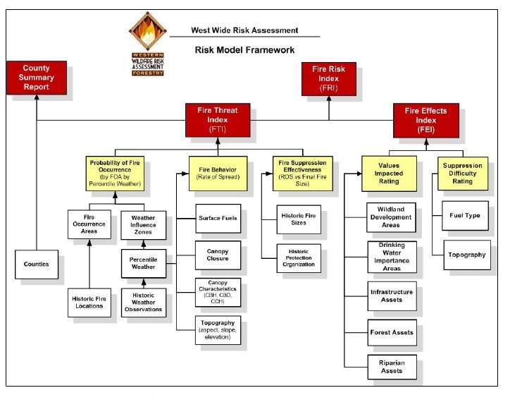

Figure Appendix F - 3. Wildfire Risk Assessment Process – Figure 2-1 – WWRA 2014.

Display of stand conditions promoting extreme fire behavior, high occurrence areas of ignition, and locations of anticipated worst case fire effects provide decision makers with knowledge and opportunities to potentially alter an otherwise poor outcome should a fire occur.

**Attributes of Landscape Conditions**

**Fire Regime Condition Class**

Obtained from the Forest Service and BLM Interagency Clearinghouse of Ecological Information 2010 - (<http://ecoshare.info/category/fire-regime-condition-class/>) fire regime condition class (FRCC) was mapped for the WUIZ. Data was developed at the sub-basin level using LandFire Data Access Tool, Biophysical Settings (describing moisture regimes and plant associations) and succession class stand layers. Data used was already delineated for all sixteen National Forests in Region 6 (Oregon and Washington) as well as the states as a whole. Condition Class represents the deviation or departure of ecosystems from what is considered historical ranges, which in this case are pre-EuroAmerican era (FRCC Guidebook, 2013).

The three fire regime condition classes have been defined (Schmidt and others 2002) and ranked as follows:

1. Low – Areas that are not associated with forested areas such as: Agriculture, water, urban, barren lands.
2. Moderate - FRCC 1 represents ecosystems with low (<33 percent) departure and that

are still within an estimated historical range of variation as determined by modeling for

the pre-EuroAmerican era (discussed below);

1. High - FRCC 2 indicates ecosystems with moderate (33 to 66 percent) departure; and
2. Extreme - FRCC 3 indicates ecosystems with high (>66 percent) departure from reference conditions (Hann and Bunnell 2001; Hardy and others 2001; Schmidt and others 2002).

**Fire Threat Sub-Layers**

**Probability of Fire Occurrence**

Historical fire locations from 1999 – 2008 were utilized from state and federal agencies to develop the probability of fire occurrence mapping. The fire occurrence area is an area where the probability of each acre igniting is the same. This information was used in a spatial filtering calculation to create the surface grid of mean fire ignition rates (WWRA 2014). The more concentrated historic fire ignitions an increase in the probability is identified on the landscape.

**Fire Behavior**

Fire behavior mapping incorporates both topographic conditions and stand conditions of fuels and vegetation based on four weather percentile categories that account for herbaceous curing and fuel moisture assumptions. WWRA utilized five data themes in GIS; elevation, slope, aspect, surface fuel model and canopy cover. Three additional optional data themes were as follows: canopy height, canopy base height and canopy bulk density. All fuels and topographic data used in the prediction were gathered from the LANDFIRE project (WWRA 2014).

Fire behavior layers included are wildfire rates of spread, expected flame lengths from wildfire, probability of a canopy fire, and fire type. The first three are described under the CAR and the latter (fire type) is described below.

**Canopy Base Height (CBH)**

Canopy base height is the lowest height above the ground at which there is a sufficient amount of canopy fuel to propagate fire vertically into the canopy; if foliage can be ignited at this height, then a tree or small group of trees is assumed to torch (Intro to fire behavior 2012). The CBH is the characteristic of an area taking into accounts a stand or a small group of trees, whereas a single tree would be called crown base height. CBH is an effective value that incorporates ladder fuel, such as tall shrubs, small understory trees, low-hanging branches, lichen, moss, and needle drape (intro fire behavior 2012). It provides information on determining the possibility of fire initiation into the canopy and crown fire potential. The lower the CBH the more likely it leads to prevalent and faster-spreading active crown fires (Intro fire behave 2012). At 100% foliar moisture, a 2 m canopy base height ( 6.5 feet) will require a flame length of 1.3 m (4.2 feet) to initiate torching, while a 6 m canopy base height (19.68 feet) will require a 2.8 m (9.18 feet) flame length (Agee, 1996). In the canopy fire calculations, the foliar moisture content for all percentile weather categories was set at 100% (WWRA 2014). This information was used to assist in developing the ratings.

**Canopy Base Height Rating**

Rating design was based on the height of the canopy from the ground. A low rating would support a higher canopy base height resulting in a lower potential for fire propagation into the canopy.

Rating

Low – 12 foot or greater Canopy Base Height

Moderate – 8 – 12 foot Canopy Base Height

High – 5 – 7 foot Canopy Base Height

Extreme – less than 5 foot Canopy Base Height

**Surface Fuels**

Fuel Models are typically separated into four classifications – grasses, brush, timber and slash (management activity created debris). Each group exhibits a difference in fire behavior based on its fuel loading (measured in tons per acre) and the distribution of various sizes of the fuel particles. Grasses and brush are vertically oriented fuel groups, which rapidly increase in depth with increasing load. Timber litter and slash are horizontally positioned and slowly increase in depth as the load is increased (Anderson 1982). Fuel type, arrangement, and distribution play a significant role in both fire behavior and fire suppression.

1. Fuel load and depth are significant fuel properties for predicting if a fire will be ignited, its rate of spread, and its intensity (Anderson 1982).
2. The surface fuels affect the ability of firefighters to construct and hold fireline.

Surface fuels are the primary component affecting wildfire spread and fire intensities. As mentioned above there are four basic fuel groups, each comprised of various sizes of down woody material, some with herbaceous components and live woody material. The type of fuel model plays a role in the effectiveness of suppression resources and influence on fire behavior. Speeds at which fire control lines are constructed vary depending on the type of fuel model. Each fuel model group presents its own management challenges and opportunities. Grass and Timber (conifer stands) will be the primary focus of this document since they comprise 23% and 61% of the WUIZ respectively. *Utilizing the Fireline Handbook, Appendix A (March 2004)* to compare production rates between grass and timber a Type I – Hotshot Crew can construct fire line 4 times faster in grass and a type II – regular Agency crew can construct fire line 3.5 times faster in grass.

Surface fuels data used in the WWRA were gathered from the LANDFIRE project, Refresh (LF 1.1.0) (Appendix B). The fuel model set used is defined by Scott and Burgan (2005) and is referred to as the 2005 FBPS fuel model set. The 1982 Fire Behavior Prediction System fuel model set (Anderson 1982) is also included in Addendum I since a fuel model map using this fuel model set was a deliverable for this project (WWRA 2014). Anderson’s 13 fuel models have been mapped only for this section, listed below is the percent area covered by each fuel model.

|  |  |  |  |  |  |  |  |  |  |  |  |  |  |  |  |
| --- | --- | --- | --- | --- | --- | --- | --- | --- | --- | --- | --- | --- | --- | --- | --- |
|  | Fuel Model Group | | | | | | | | | | | | | Agriculture | Other: Urban, water, barren |
| Grass | | | Brush | | | | Timber | | | Slash | | |
| Fuel Model Number | 1 | 2 | 3 | 4 | 5 | 6 | 7 | 8 | 9 | 10 | 11 | 12 | 13 |  |  |
| Percent (%) of WUIZ | 7 | 16 | 0 | 0 | 2 | .03 | .5 | 20 | 8 | 33 | 0 | 0 | 0 | 12 | 1 |

Figure Appendix F – 4. Union County Fuel Models. Percent of each fuel model represented in Union County WUIZ.

**Fire Type**

Fire type is derived from fire behavior data, along with Fire Occurrence and Fire Suppression Effectiveness data. It provides whether the fire remain on the ground or if there is potential for fire spread into the crown of a tree or group of trees. Canopy involvement during wildfires often leads to increase spread rates through spotting (lofting of hot embers ahead of the main fire) and safety concerns for suppression resources.

Output ratings for fire type are represented in the following manner:

Low 0 = Non Burnable – no anticipated combustion or fire spread

Moderate 1-3 = Surface Fire - fire spreads in the surface fuels or in the ground level fuel model

High 4-5 = Passive Fire – refers to fire spreading vertically into the crown of a tree or a group of trees (WWRA 2014).

Extreme 6-8 = Active Fire – vertical fire movement into the tree canopy and due to conditions present, generally high wind speeds or steep slopes or both, the fire then actually spreads laterally primarily through the

canopy of the tree stand but with the support of the surface fire intensity (WWRA 2014).

Areas where passive and active fires occur involve stand canopies, often generated by a surface fire. They are typically supported by either heavy dead and down woody material on the forest floor or vegetation growth close to the surface fuels where the fire can transition from a surface fire to tree canopy involvement. These fuels such as woody material and/or vegetation between the surface and overstory canopy area are referred to as ladder fuels.

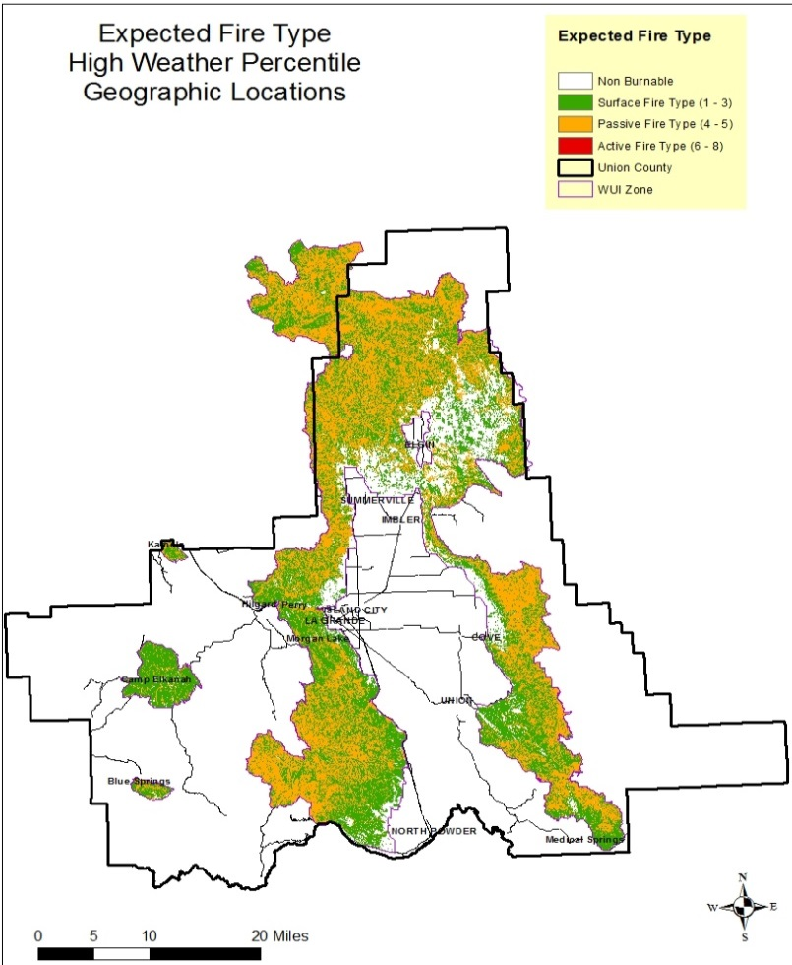

Because fire type is directly correlated to probability of canopy fire this map was not included in the main body of Chapter VII.

**Additional Map Availability**

.

**Structural Density**

The WWRA developed a two datasets, Where People Lived and Wildland Developed Areas, to represent the number of houses per square kilometer, consistent with the Federal Register and USFS Silvis datasets (WWRA 2014). It was found in comparing this to a local structural map that many structures and some residents were not accounted for, most likely based partially on methods used to obtain the information. Local data for structures and residence were analyzed and processed to determine the number of structures per 40 acres within Union County. The higher the number of structures the higher density displayed. The highest density was an average of 1 structure per .5 acre parcel acres in the city of La Grande.

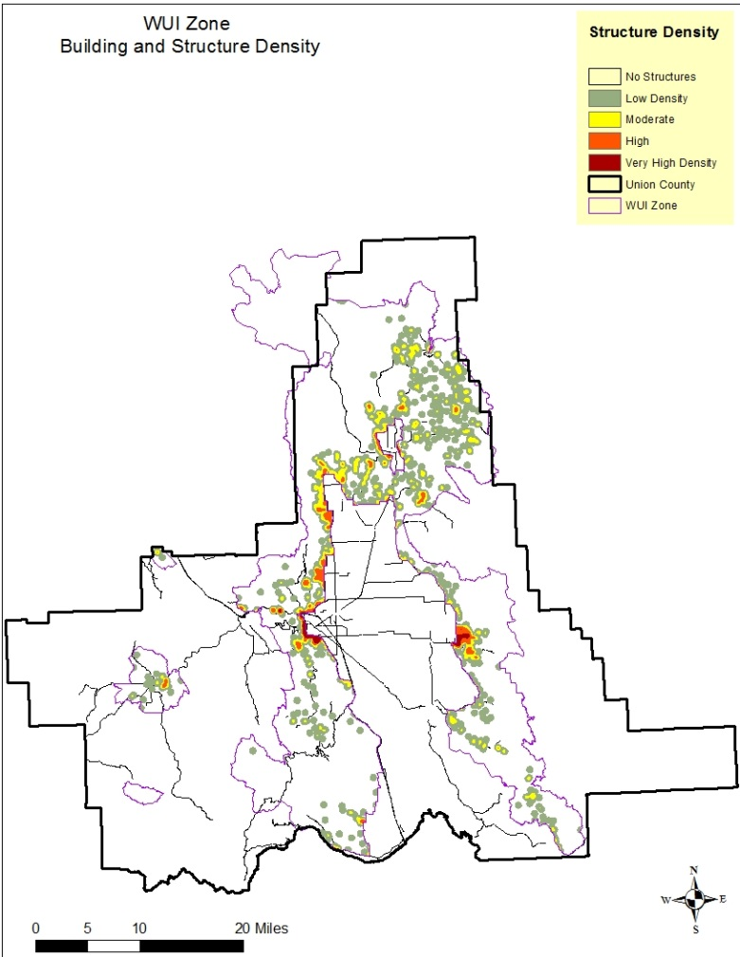 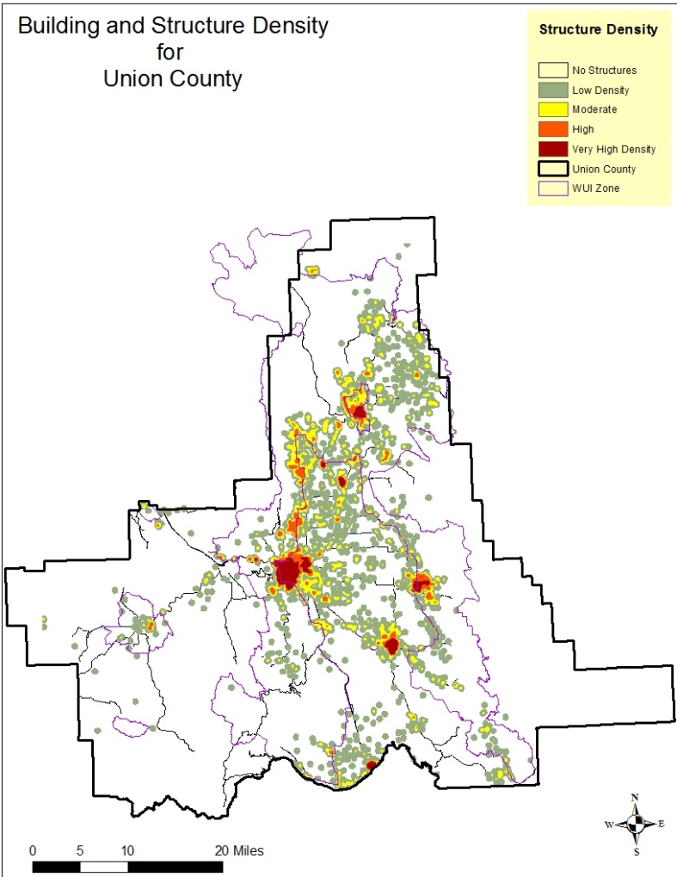

Individual CAR mapping of attributes corresponding to attributes in Figure Appendix F – 1 are available upon request.

Federal Register:

1. Anthony Lakes Resort, Outside La Grande Valley La Grande Valley
2. Camp Elkanah, Outside La Grande Valley La Grande Valley
3. Cove, Within the La Grande Valley of Valley
4. Elgin, Within the La Grande Valley of Valley
5. Hilgard, Outside La Grande Valley
6. Medical Springs, Outside La Grande Valley
7. Morgan Lake, Within the La Grande Valley - On edge
8. Mount Emily, Within the La Grande Valley
9. Palmer Junction, Outside La Grande Valley
10. S. Fork Catherine Creek, Outside La Grande Valley
11. Starkey, Outside La Grande Valley
12. Union. Within the La Grande Valley

State of Oregon in 2006, the cities of:

1. La Grande, Within the La Grande Valley
2. Island City, Within the La Grande Valley
3. North Powder, Outside La Grande Valley
4. Summerville Within the La Grande Valley

Union County:

1. Blue Springs, Outside La Grande Valley
2. Perry, Outside La Grande Valley
3. Kamela, Outside La Grande Valley
4. Spout Sprgs Ski Area including resort cabins. Outside La Grande Valley